Talend Job: LW_HPS_Focus_Attributes

Overview
This job extracts the same fixed set of 32 call-audit compliance attribute scores as LW_Delaware_Focus_Attributes, but for the HPS client relationship, from a Snowflake view (PUB_LWASHINGTON.HPS_FOCUS_ATTRIBUTE) and writes the result to HPS_Focus_Attributes_Report.csv. It is structurally and column-for-column identical to LW_Delaware_Focus_Attributes and LW_Lurie_Focus_Attributes — the only differences across the three are the source view name and output filename.

Detail table
Field | Value
Job name | LW_HPS_Focus_Attributes
Version | 0.1
Project | EDW2SF
Author | jmach@harriscollect.com
Created | 2024-08-12T10:24:45.282-0700
Last Modified | 2025-11-16T20:06:13.841-0800

Step-by-step data flow
Setup subjob: tPrejob_1 → tJava_1 opens a per-run log file → on subjob-ok, tSetKeystore_1 configures SSL → on subjob-ok, tDBConnection_1 opens the Snowflake connection.
Main flow (no explicit trigger link into it): tDBInput_1 runs the 32-column query below → tFlowMeter_1 counts rows → tFileOutputDelimited_1 writes the result (with header, file recreated each run) to context.outputDir+"HPS_Focus_Attributes_Report.csv".
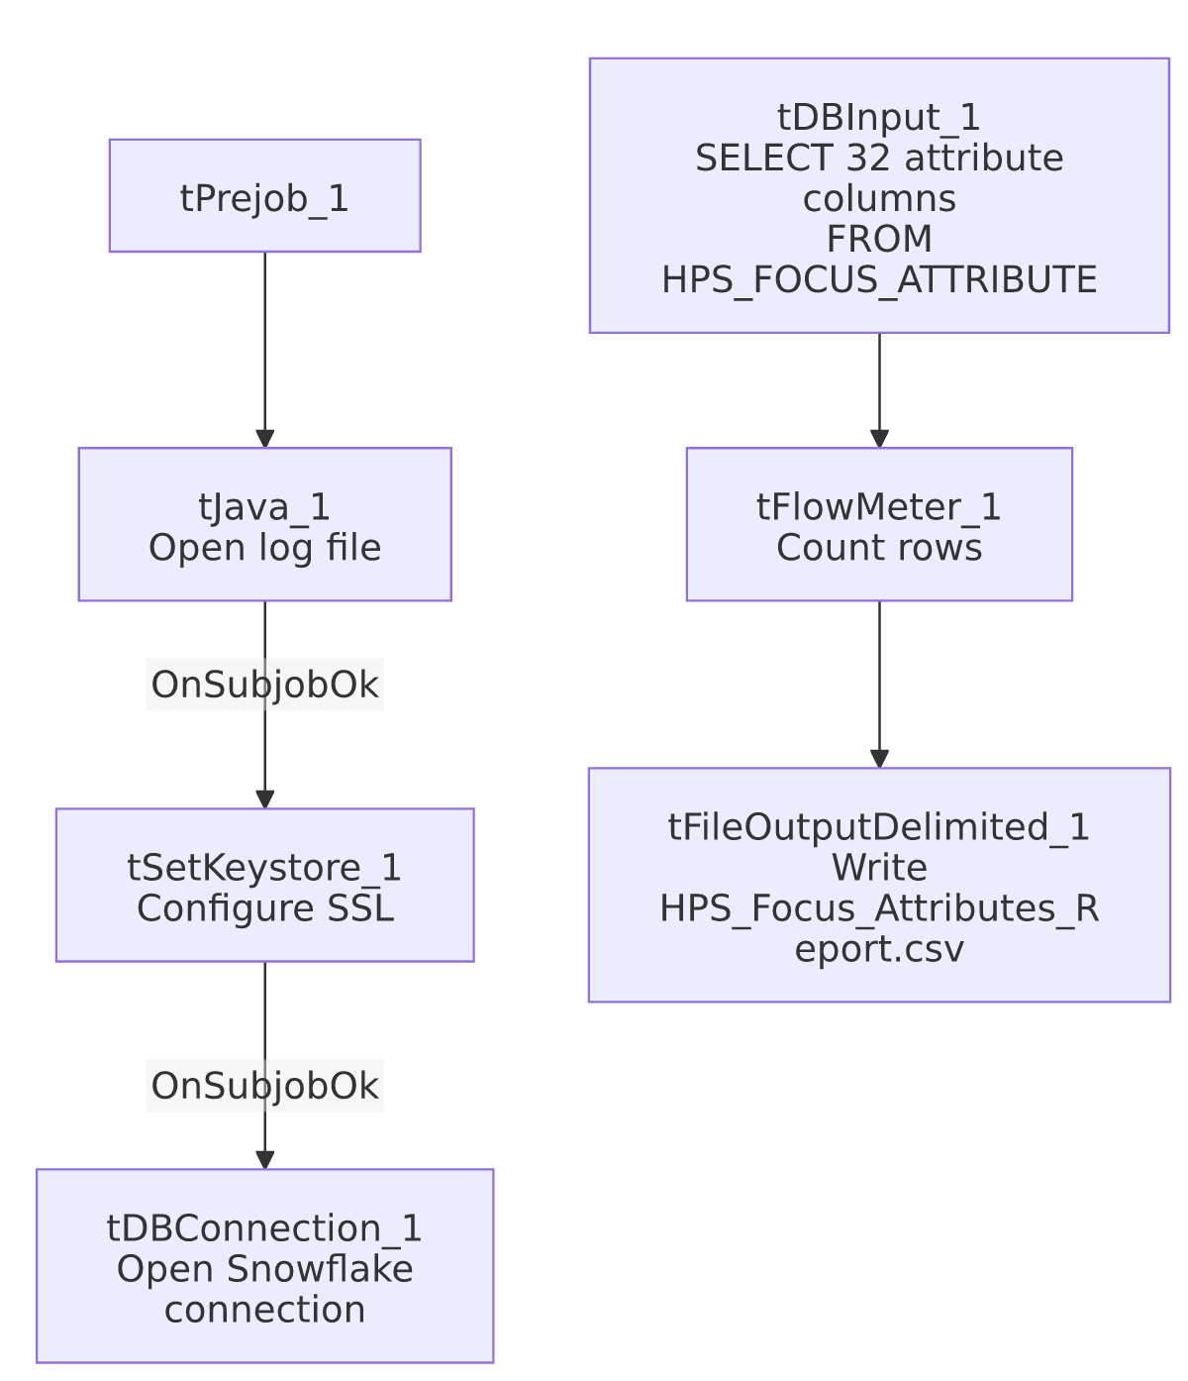

Settings tables

Source: `tDBInput_1` (`tSnowflakeInput`)
Setting | Value | What it means
Query | SELECT SECOND_IDENTIFIER, IDENTIFY_SELF, COMPLIANCE_STATEMENT, ... ACTION_CODE, ACC_DOCUMENTATION FROM PUB_LWASHINGTON.HPS_FOCUS_ATTRIBUTE; (same 32-column list as LW_Delaware_Focus_Attributes) | Identical column list to the Delaware and Lurie siblings — only HPS_FOCUS_ATTRIBUTE differs as the source view.

Target: `tFileOutputDelimited_1`
Setting | Value | What it means
FILENAME | context.outputDir+"HPS_Focus_Attributes_Report.csv"
APPEND / INCLUDEHEADER | false / true

Dependencies & configuration
- Triggers/depends on other jobs: none.
- Context variables used: keystorePath, logDir, outputDir.
- Hardcoded paths: tSetKeystore_1.SSL_TRUSTSERVER_TRUSTSTORE.
- Sibling comparison: Identical structure to LW_Delaware_Focus_Attributes and LW_Lurie_Focus_Attributes; differs only in source view (HPS_FOCUS_ATTRIBUTE) and output filename. LW_HPS_Focus_Attributes_Granular is the related 2-column name/value variant for HPS.

Glossary
Component type | Plain-English meaning
tSnowflakeConnection / tSnowflakeInput | Open a Snowflake connection and run a query against it.
tFlowMeter | Counts rows passing a point in the flow.
tFileOutputDelimited | Writes rows to a CSV file.
tSetKeystore | Configures SSL trust store/keystore for the Snowflake JDBC connection.

Issues observed
- Same missing explicit trigger link between the connection-setup subjob and the query subjob as its Delaware/Lurie siblings — see LW_Delaware_Focus_Attributes's doc for detail; not repeated in full here since it's the identical finding.
- No client/debtor identifying columns and no email/notification component — same as the Delaware sibling; nothing in this job's own metadata distinguishes normal completion from an empty result set.
- This job is copy-paste identical to its Delaware/Lurie siblings apart from the table name and filename — a genuine defect introduced in one (e.g., the Insurance_Report_Extract-style hardcoded-path issue, or the truncated-header-write bug seen in the Dashboard jobs) would very likely also exist in the other two; conversely, a fix applied to one should be checked against the others.

