Talend Job: LW_Insurance_Pmt_Tracking

Overview
This job extracts insurance-payment tracking records — CUBS account numbers, client info, payment/commission status and posted amounts, principal balance after transaction, CUBS desk assignment, and payment type — from a Snowflake view (PUB_LWASHINGTON.INSURANCE_PAYMENT_TRACKING_REPORT), writes them to a CSV file, and conditionally emails the report to a distribution list. It follows the same query→write→mail template as the other LW_* report jobs in this batch, but is the only one in this batch where the mail step is wired as a conditional (RUN_IF) branch rather than an unconditional on-success (SUBJOB_OK) trigger — see Issues observed.

Detail table
Field | Value
Job name | LW_Insurance_Pmt_Tracking
Version | 0.1
Project | EDW2SF
Author | jmach@harriscollect.com
Created | 2024-05-02T14:48:58.772-0700
Last Modified | 2025-11-16T20:11:17.477-0800

Step-by-step data flow
Setup subjob: tPrejob_1 → tJava_1 opens a per-run log file → on subjob-ok, tSetKeystore_1 configures SSL → on subjob-ok, tDBConnection_1 opens the Snowflake connection.
Main flow (no explicit trigger link into it): tDBInput_1 runs the query below. Its MAIN output feeds tFlowMeter_1 (row count) → tFileOutputDelimited_1 (writes the CSV). Separately, tDBInput_1 has a `RUN_IF` connector (not SUBJOB_OK) to tSendMail_1 — meaning the email is sent only if some condition evaluates true, not unconditionally on query success (the specific condition expression is not captured in this metadata).
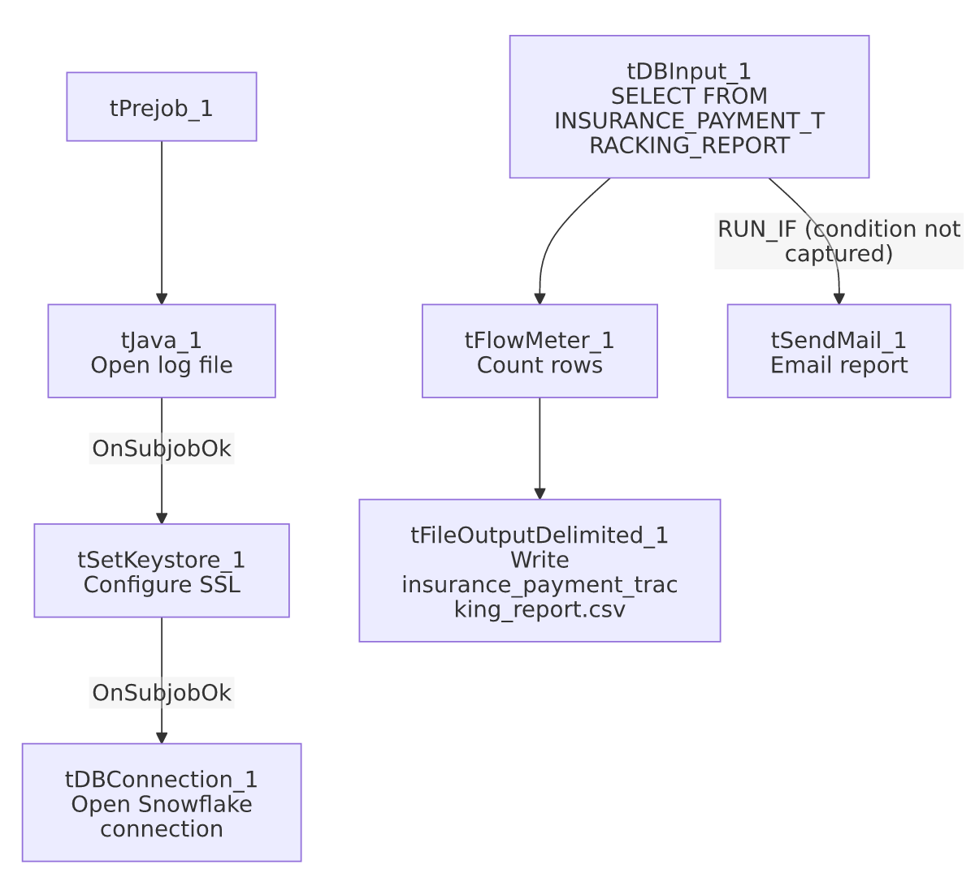

Settings tables

Source: `tDBInput_1` (`tSnowflakeInput`)
Setting | Value | What it means
Query | SELECT "CUBS#" AS CUBS_NUM, "Primary CUBS#" AS PRIMARY_CUBS_NUM, "Client Number", "Payment Status", "Current Status", "Payment Posted", "Commission Posted", "Date of Payment Posted", PRIN_BAL_AFTER_TRANS, "Payment CUBS Desk", "Current CUBS Desk", "Client Name", TCODE, PL_GROUP, "Pmt Type" FROM PUB_LWASHINGTON.INSURANCE_PAYMENT_TRACKING_REPORT; | 15 columns tracking insurance payment posting status per account, including both the "payment" desk and "current" desk (suggesting accounts can move desks after a payment is posted).

Target: `tFileOutputDelimited_1`
Setting | Value | What it means
FILENAME | context.outputDir+"insurance_payment_tracking_report.csv"
APPEND / INCLUDEHEADER | false / true

Mail: `tSendMail_1`
Setting | Value | What it means
Trigger | RUN_IF from tDBInput_1 (not SUBJOB_OK) | Email is conditional — the job's wiring only sends it when some (uncaptured) condition holds, unlike every other tSendMail-using job in this batch, where the mail step is unconditional on subjob success.
SUBJECT / MESSAGE | "Insurance Payment Tracking Report" / "The insurance payment tracking report is attached."
DIE_ON_ERROR | true

Dependencies & configuration
- Triggers/depends on other jobs: none.
- Context variables used: keystorePath, logDir, mailRecipients, outputDir.
- Hardcoded paths: tSetKeystore_1.SSL_TRUSTSERVER_TRUSTSTORE.
- Per 05_operational_runbook.md, LW_Insurance_Pmt_Tracking is listed among the jobs that send email on completion — but see Issues observed regarding the conditional wiring, which means "on completion" may not always be accurate for this specific job.

Glossary
Component type | Plain-English meaning
tSnowflakeConnection / tSnowflakeInput | Open a Snowflake connection and run a query against it.
tFlowMeter | Counts rows passing a point in the flow.
tFileOutputDelimited | Writes rows to a CSV file.
tSendMail | Sends an email with the finished report attached — here, conditionally rather than unconditionally.
tSetKeystore | Configures SSL trust store/keystore for the Snowflake JDBC connection.

Issues observed
- The email is wired as a `RUN_IF` (conditional) branch off `tDBInput_1`, not an unconditional `SUBJOB_OK` trigger — every other tSendMail-using job in this batch (LW_COC_Water_Scrub, LW_Carle_Asset_Scrub, LW_ProMedica_Scrub) fires its mail step unconditionally once the query subjob succeeds. Here, the actual RUN_IF condition expression is not captured in this job's extracted metadata, so it's unable to determine from metadata what governs whether the email actually gets sent on a given run (e.g., "only if row count > 0," or some other business rule). This is worth confirming directly in Talend Studio, since a silently-skipped email (if the condition evaluates false) with no accompanying warning or log message would leave the report generated but never delivered, with nothing in this job's own logic to flag that gap.
- Same missing explicit trigger link between the connection-setup subjob and the query subjob as the rest of this batch.
- No `tWarn`/`tDie` logic tied to the RUN_IF's alternate (false) branch — if the condition is false and the mail is skipped, there is no visible fallback logging that would tell an operator the email didn't go out.

