Talend Job: LW_Lurie_Audit_Scorecard

Overview
This job extracts a per-call audit scorecard for the Lurie client relationship — collector name, call/audit dates, overall score, 7 category percentage scores, the 32 underlying pass/fail attribute flags, and free-text summary columns — from a Snowflake view (PUB_LWASHINGTON.LURIE_AUDIT_SCORECARD_REPORT) and writes the full result to Lurie_Audit_Scorecard_Report.csv. It is structurally and column-for-column identical to LW_Deleware_Audit_Scorecard and LW_HPS_Audit_Scorecard, differing only in source view and output filename.

Detail table
Field | Value
Job name | LW_Lurie_Audit_Scorecard
Version | 0.1
Project | EDW2SF
Author | jmach@harriscollect.com
Created | 2024-07-09T11:17:34.434-0700
Last Modified | 2025-11-16T20:12:02.820-0800

Step-by-step data flow
Setup subjob: tPrejob_1 → tJava_1 opens a per-run log file → on subjob-ok, tSetKeystore_1 configures SSL → on subjob-ok, tDBConnection_1 opens the Snowflake connection.
Main flow (no explicit trigger link into it): tDBInput_1 runs the 46-column query below → tFlowMeter_1 counts rows → tFileOutputDelimited_1 writes the result (with header, file recreated each run) to context.outputDir+"Lurie_Audit_Scorecard_Report.csv".
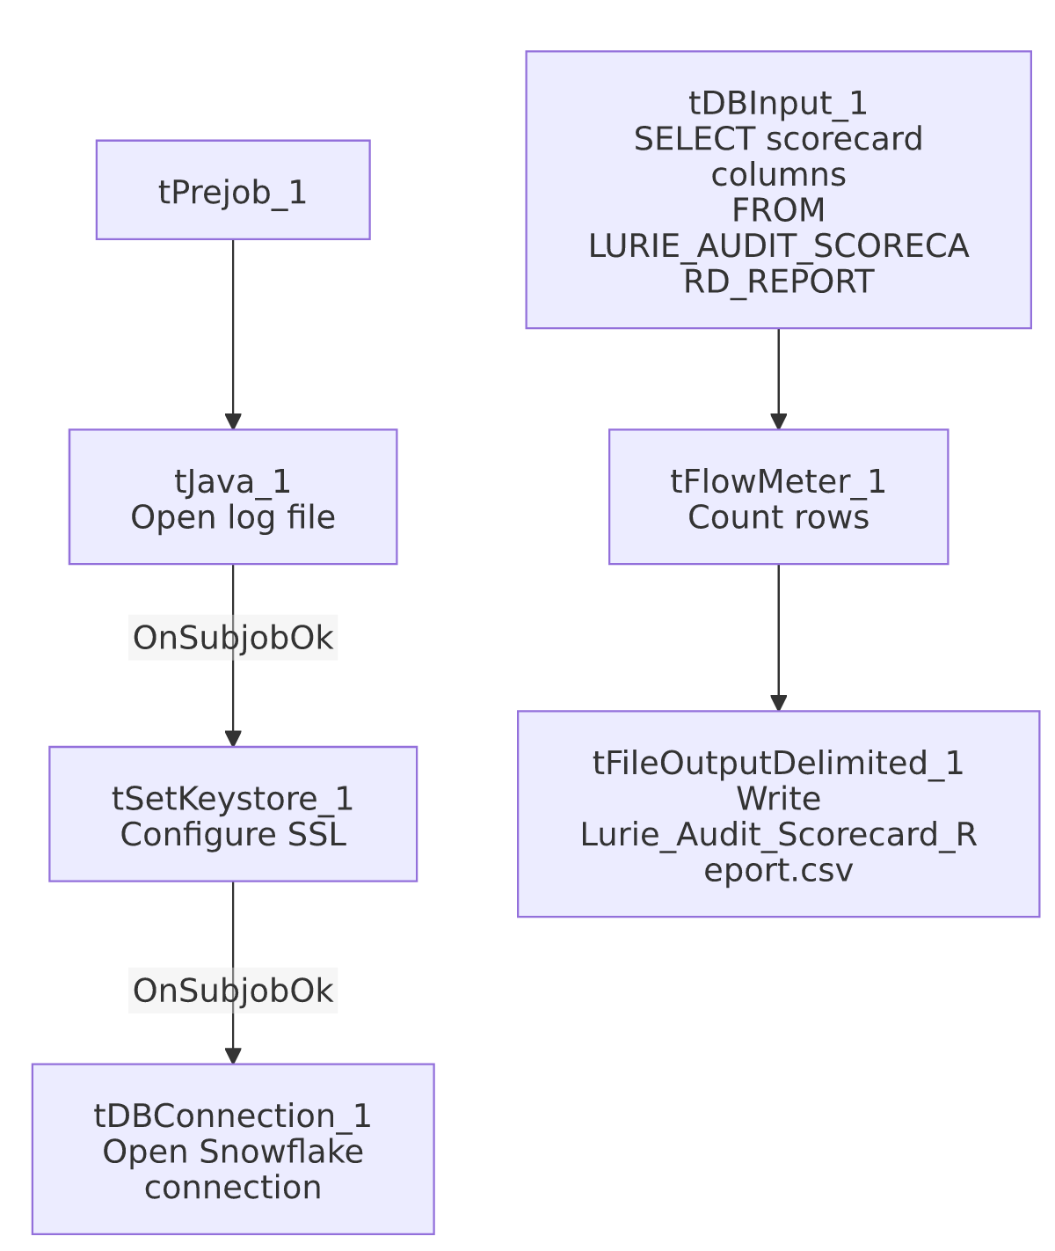

Settings tables

Source: `tDBInput_1` (`tSnowflakeInput`)
Setting | Value | What it means
Query | SELECT COLLECTOR_NAME, "CALL DATE", "AUDIT DATE", "OVERALL SCORE", OPENING_SCORE_PCT, ... ACTION_CODE, ACC_DOCUMENTATION, "AREA OF OPPORTUNITY", COMPLIANCE_STATUS FROM PUB_LWASHINGTON.LURIE_AUDIT_SCORECARD_REPORT; (same 46-column list as the Delaware/HPS siblings) | Identical shape; only LURIE_AUDIT_SCORECARD_REPORT differs as the source view. Note the source view name here already includes "SCORECARD" in it, unlike Delaware's DELAWARE_AUDIT_REPORT and HPS's HPS_AUDIT_REPORT — a minor naming-convention difference across the three, though not a functional one.

Target: `tFileOutputDelimited_1`
Setting | Value | What it means
FILENAME | context.outputDir+"Lurie_Audit_Scorecard_Report.csv"
APPEND / INCLUDEHEADER | false / true

Dependencies & configuration
- Triggers/depends on other jobs: none.
- Context variables used: keystorePath, logDir, outputDir.
- Hardcoded paths: tSetKeystore_1.SSL_TRUSTSERVER_TRUSTSTORE.
- Sibling comparison: Identical structure to LW_Deleware_Audit_Scorecard and LW_HPS_Audit_Scorecard. This is the per-call detail counterpart to LW_Lurie_Focus_Attributes and LW_Lurie_Focus_Attributes_Granular.

Glossary
Component type | Plain-English meaning
tSnowflakeConnection / tSnowflakeInput | Open a Snowflake connection and run a query against it.
tFlowMeter | Counts rows passing a point in the flow.
tFileOutputDelimited | Writes rows to a CSV file.
tSetKeystore | Configures SSL trust store/keystore for the Snowflake JDBC connection.

Issues observed
- Same missing explicit trigger link between the connection-setup subjob and the query subjob as the rest of this batch.
- No email/notification and no debtor/account identifier, same as the Delaware and HPS siblings.
- Source view naming already embeds "SCORECARD" (LURIE_AUDIT_SCORECARD_REPORT), unlike Delaware's DELAWARE_AUDIT_REPORT and HPS's HPS_AUDIT_REPORT — worth noting for anyone reconciling view names against job names across the three sibling jobs, though it has no functional effect.

