Talend Job: LW_Lurie_Focus_Attributes

Overview
This job extracts the same fixed set of 32 call-audit compliance attribute scores as LW_Delaware_Focus_Attributes and LW_HPS_Focus_Attributes, but for the Lurie client relationship, from a Snowflake view (PUB_LWASHINGTON.LURIE_FOCUS_ATTRIBUTES_REPORT) and writes the result to Lurie_Focus_Attributes_Report.csv. It is column-for-column identical to its two siblings.

Detail table
Field | Value
Job name | LW_Lurie_Focus_Attributes
Version | 0.1
Project | EDW2SF
Author | jmach@harriscollect.com
Created | 2024-07-09T11:32:39.160-0700
Last Modified | 2025-11-16T20:14:01.888-0800

Step-by-step data flow
Setup subjob: tPrejob_1 → tJava_1 opens a per-run log file → on subjob-ok, tSetKeystore_1 configures SSL → on subjob-ok, tDBConnection_1 opens the Snowflake connection.
Main flow (no explicit trigger link into it): tDBInput_1 runs the 32-column query below → tFlowMeter_1 counts rows → tFileOutputDelimited_1 writes the result (with header, file recreated each run) to context.outputDir+"Lurie_Focus_Attributes_Report.csv".
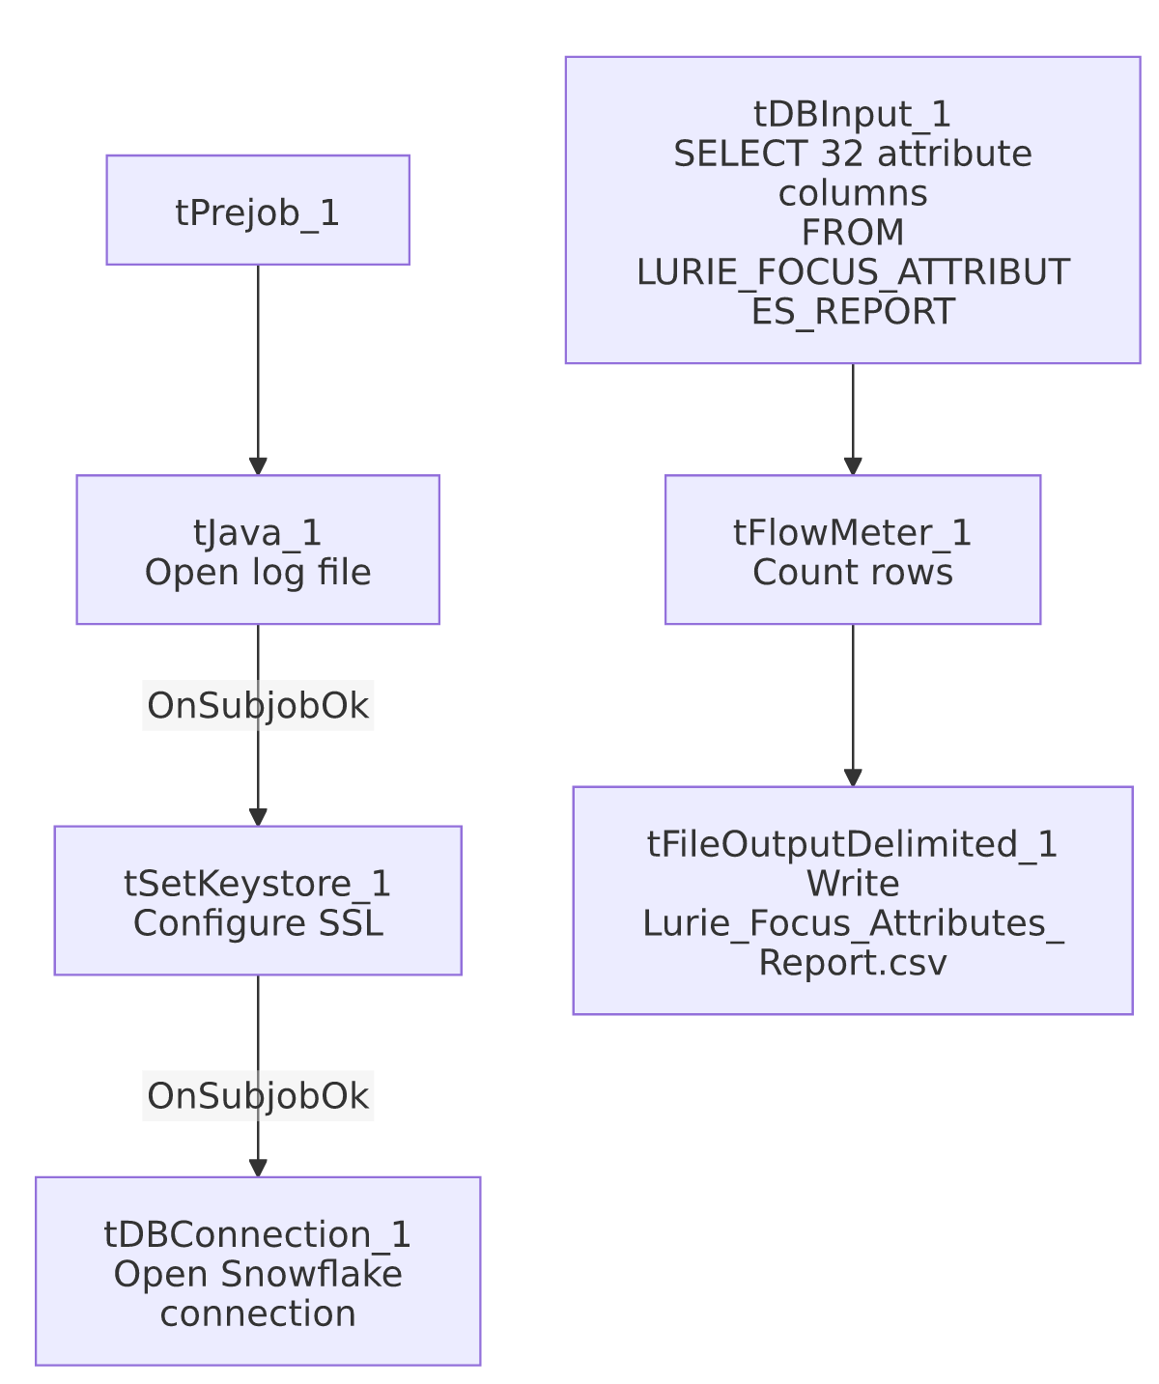

Settings tables

Source: `tDBInput_1` (`tSnowflakeInput`)
Setting | Value | What it means
Query | SELECT SECOND_IDENTIFIER, IDENTIFY_SELF, COMPLIANCE_STATEMENT, ... ACTION_CODE, ACC_DOCUMENTATION FROM PUB_LWASHINGTON.LURIE_FOCUS_ATTRIBUTES_REPORT; (same 32-column list as the Delaware/HPS siblings) | Note the source view name here follows a _REPORT suffix convention (LURIE_FOCUS_ATTRIBUTES_REPORT) unlike Delaware's (DELAWARE_FOCUS_ATTRIBUTE, singular, no suffix) and HPS's (HPS_FOCUS_ATTRIBUTE, singular) — a naming inconsistency across otherwise-identical sibling views.

Target: `tFileOutputDelimited_1`
Setting | Value | What it means
FILENAME | context.outputDir+"Lurie_Focus_Attributes_Report.csv"
APPEND / INCLUDEHEADER | false / true

Dependencies & configuration
- Triggers/depends on other jobs: none.
- Context variables used: keystorePath, logDir, outputDir.
- Hardcoded paths: tSetKeystore_1.SSL_TRUSTSERVER_TRUSTSTORE.
- Sibling comparison: Identical structure to LW_Delaware_Focus_Attributes and LW_HPS_Focus_Attributes. The Lurie source view name (LURIE_FOCUS_ATTRIBUTES_REPORT) is pluralized/suffixed differently from its siblings' singular view names — see Issues observed. LW_Lurie_Focus_Attributes_Granular is the related 2-column name/value variant.

Glossary
Component type | Plain-English meaning
tSnowflakeConnection / tSnowflakeInput | Open a Snowflake connection and run a query against it.
tFlowMeter | Counts rows passing a point in the flow.
tFileOutputDelimited | Writes rows to a CSV file.
tSetKeystore | Configures SSL trust store/keystore for the Snowflake JDBC connection.

Issues observed
- Source view naming is inconsistent across the three Focus Attributes siblings: DELAWARE_FOCUS_ATTRIBUTE (singular, no suffix), HPS_FOCUS_ATTRIBUTE (singular, no suffix), LURIE_FOCUS_ATTRIBUTES_REPORT (plural, _REPORT suffix). This is purely a naming-convention observation (the columns and job structure are otherwise identical) but could confuse anyone searching the Snowflake catalog for a consistent naming pattern across these three views.
- Same missing explicit trigger link between the connection-setup subjob and the query subjob as its siblings.
- No client/debtor identifying columns and no email/notification component, same as the Delaware and HPS siblings.

