Talend Job: LW_Lurie_Focus_Attributes_Granular

Overview
This job extracts a narrow, long-format (name/value pair) view of Lurie focus-attribute scores from a Snowflake view (PUB_LWASHINGTON.LURIE_FOCUS_ATTRIBUTES_GRANULAR) and writes them to Lurie_Focus_Attributes_Granular_View.csv. It is the Lurie counterpart to LW_Delaware_Focus_Attributes_Granular and LW_HPS_Focus_Attributes_Granular, structurally identical apart from the source view name and output filename.

Detail table
Field | Value
Job name | LW_Lurie_Focus_Attributes_Granular
Version | 0.1
Project | EDW2SF
Author | jmach@harriscollect.com
Created | 2024-07-09T11:46:25.132-0700
Last Modified | 2025-11-16T20:12:45.323-0800

Step-by-step data flow
Setup subjob: tPrejob_1 → tJava_1 opens a per-run log file → on subjob-ok, tSetKeystore_1 configures SSL → on subjob-ok, tDBConnection_1 opens the Snowflake connection.
Main flow (no explicit trigger link into it): tDBInput_1 runs SELECT SCORE_NAME, SCORE_VALUE FROM PUB_LWASHINGTON.LURIE_FOCUS_ATTRIBUTES_GRANULAR; → tFlowMeter_1 counts rows → tFileOutputDelimited_1 writes the result (with header, file recreated each run) to context.outputDir+"Lurie_Focus_Attributes_Granular_View.csv".
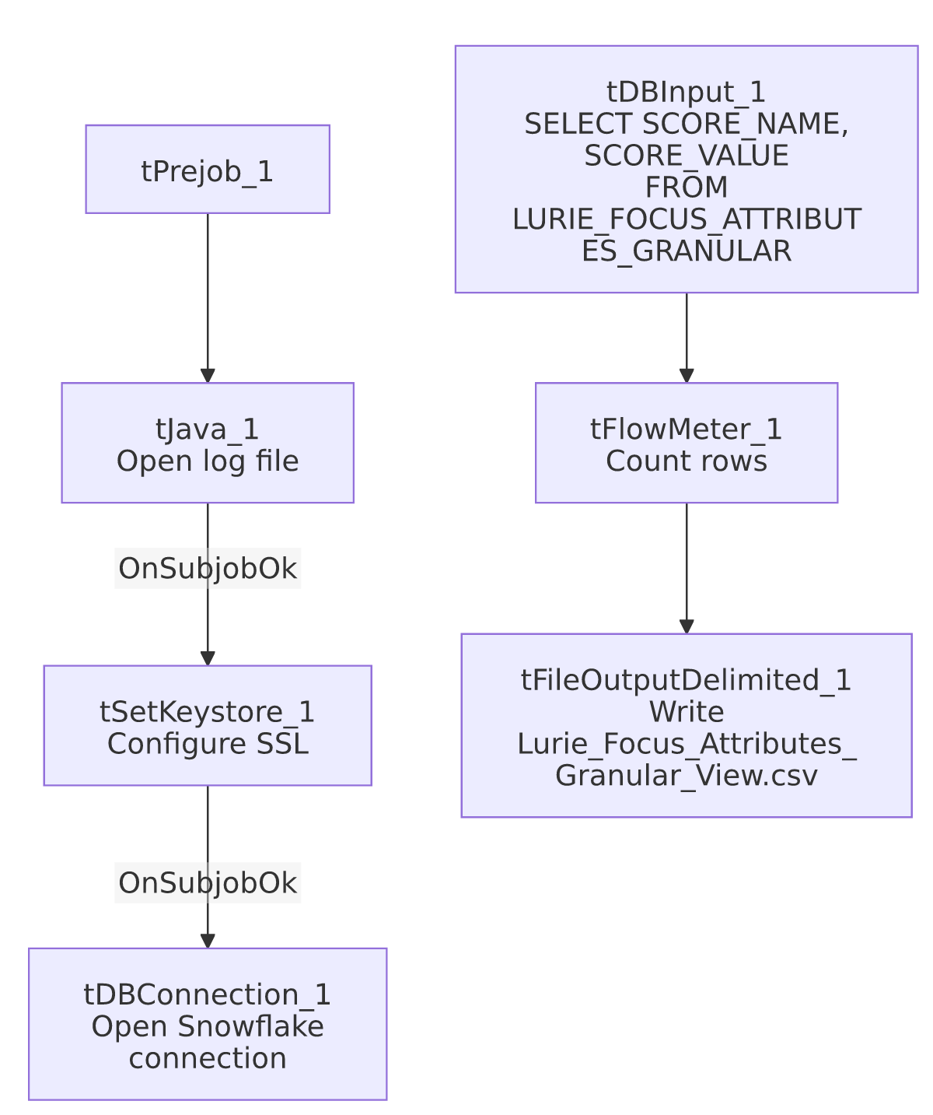

Settings tables

Source: `tDBInput_1` (`tSnowflakeInput`)
Setting | Value | What it means
Query | SELECT SCORE_NAME, SCORE_VALUE FROM PUB_LWASHINGTON.LURIE_FOCUS_ATTRIBUTES_GRANULAR; | Same 2-column long-format shape as the Delaware/HPS siblings.

Target: `tFileOutputDelimited_1`
Setting | Value | What it means
FILENAME | context.outputDir+"Lurie_Focus_Attributes_Granular_View.csv"
APPEND / INCLUDEHEADER | false / true

Dependencies & configuration
- Triggers/depends on other jobs: none.
- Context variables used: keystorePath, logDir, outputDir.
- Hardcoded paths: tSetKeystore_1.SSL_TRUSTSERVER_TRUSTSTORE.
- Sibling comparison: Identical structure to LW_Delaware_Focus_Attributes_Granular and LW_HPS_Focus_Attributes_Granular. This is the granular counterpart to LW_Lurie_Focus_Attributes and LW_Lurie_Audit_Scorecard.

Glossary
Component type | Plain-English meaning
tSnowflakeConnection / tSnowflakeInput | Open a Snowflake connection and run a query against it.
tFlowMeter | Counts rows passing a point in the flow.
tFileOutputDelimited | Writes rows to a CSV file.
tSetKeystore | Configures SSL trust store/keystore for the Snowflake JDBC connection.

Issues observed
- Same missing explicit trigger link between the connection-setup subjob and the query subjob as the other Granular jobs in this batch.
- No client/debtor/audit identifying columns, same limitation as the Delaware and HPS siblings — see LW_HPS_Focus_Attributes_Granular's doc for the cross-sibling source-view naming inconsistency this job is part of (LURIE_FOCUS_ATTRIBUTES_GRANULAR, no _VIEW suffix, unlike HPS's ..._GRANULAR_VIEW).

