Talend Job: LW_Manual_Audit_Scorecard

Overview
This job extracts a general, client-agnostic manual-audit scorecard — auditor name, audit/call dates, acknowledgement status, call duration/direction/ID, a letter grade, and the same category-and-attribute structure seen in the Delaware/HPS/Lurie audit scorecards (Opening, Bridging, Get the Facts, Negotiation Flow, Customer Service, Call Closing, Documentation, each with its underlying yes/no checklist items) — from a Snowflake view (PUB_LWASHINGTON.MANUAL_AUDIT_SCORECARD) and writes the full result to manual_audit_scorecard.csv. Unlike the Delaware/HPS/Lurie variants, this job is not tied to one specific client: its schema includes a Latitude Id and Phone Number column, and its category-breakdown columns are typed as id_Boolean (true/false) rather than id_BigDecimal — suggesting this is a more general/manual audit process feeding into (or alongside) the client-specific automated scorecards.

Detail table
Field | Value
Job name | LW_Manual_Audit_Scorecard
Version | 0.1
Project | EDW2SF
Author | jmach@harriscollect.com
Created | 2024-11-25T10:53:35.104-0800
Last Modified | 2025-11-16T20:23:31.487-0800

Step-by-step data flow
Setup subjob: tPrejob_1 → tJava_1 opens a per-run log file → on subjob-ok, tSetKeystore_1 configures SSL → on subjob-ok, tDBConnection_1 opens the Snowflake connection.
Main flow (no explicit trigger link into it): tDBInput_1 runs the 61-column query below → tFlowMeter_1 counts rows → tFileOutputDelimited_1 writes the result (with header, file recreated each run) to context.outputDir+"manual_audit_scorecard.csv".
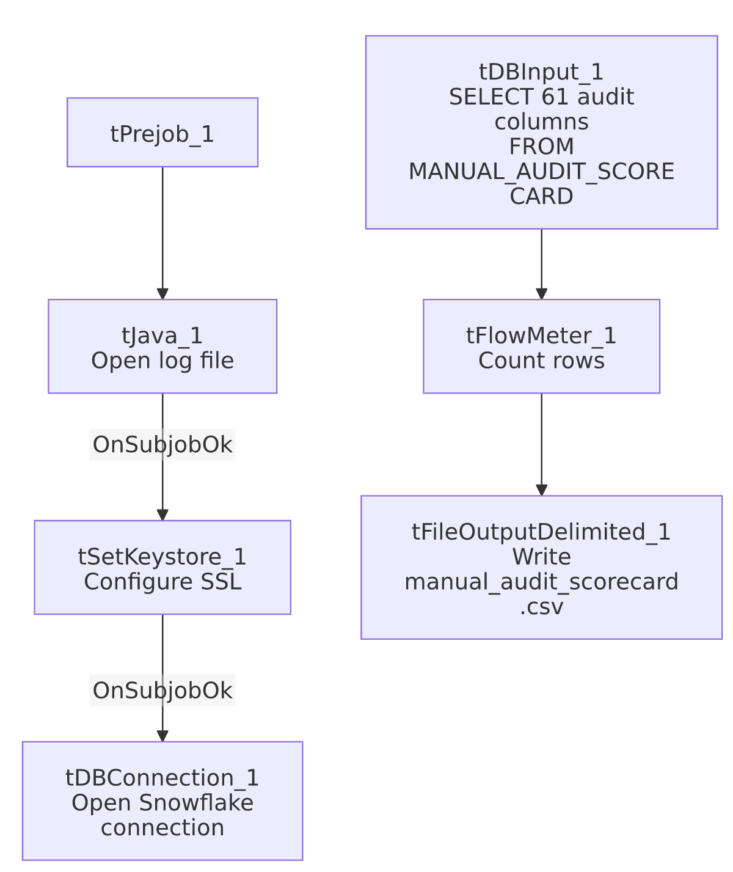

Settings tables

Source: `tDBInput_1` (`tSnowflakeInput`)
Setting | Value | What it means
Query | SELECT "Scorecard Link", "Auditor Name", "Audit Date", "Edited By", "Edited At", "Collector Name", "call Date", "Acknowledged", "Acknowledged By", "Call Duration", "Call Direction", "Call ID", "File", "Auto-Fail?", "Score", "Latitude Id", "Phone Number", "Grade", "Opening", ...category checklist items..., "Documentation", "1. Action Code", "2. Acc Documentation" FROM PUB_LWASHINGTON.MANUAL_AUDIT_SCORECARD; | 61 columns total: audit metadata (scorecard link, auditor, edit trail, acknowledgement), call metadata (duration, direction, ID, phone number), an overall Score/Grade, a Latitude Id (suggesting this table also aggregates data originating from a separate "Latitude" system — see Latitude project context if available), and the full category-checklist structure as id_Boolean flags rather than the numeric flags used in the Delaware/HPS/Lurie audit scorecards.

Target: `tFileOutputDelimited_1`
Setting | Value | What it means
FILENAME | context.outputDir+"manual_audit_scorecard.csv" | Lowercase filename, unlike the Title_Case convention used by the Delaware/HPS/Lurie scorecard jobs.
APPEND / INCLUDEHEADER | false / true

Dependencies & configuration
- Triggers/depends on other jobs: none.
- Context variables used: keystorePath, logDir, outputDir.
- Hardcoded paths: tSetKeystore_1.SSL_TRUSTSERVER_TRUSTSTORE.
- Relationship to sibling jobs: Not a client-specific sibling of the Delaware/HPS/Lurie audit-scorecard family — it has a different, broader column set (auditor/edit-trail/acknowledgement fields not present in those jobs) and represents manually-conducted audits rather than an automated per-call scoring pipeline. The Latitude Id column is a notable cross-system reference not otherwise explained in this job's own metadata.

Glossary
Component type | Plain-English meaning
tSnowflakeConnection / tSnowflakeInput | Open a Snowflake connection and run a query against it.
tFlowMeter | Counts rows passing a point in the flow.
tFileOutputDelimited | Writes rows to a CSV file.
tSetKeystore | Configures SSL trust store/keystore for the Snowflake JDBC connection.

Issues observed
- The presence of a `Latitude Id` column suggests this manual-audit data set spans or references the separate "LATITUDE" Talend project/system documented elsewhere in this reverse-engineering effort. Unable to determine from this job's own metadata what that cross-system relationship actually is (e.g., whether MANUAL_AUDIT_SCORECARD is populated by a process that also touches LATITUDE data, or whether Latitude Id is simply a legacy column name carried over) — worth confirming with the team, especially since it implies a cross-project data dependency not visible anywhere else in this batch.
- Column naming in the query mixes numbered prefixes with descriptive names (e.g., "1. 2nd identifier", "2. Identify self"), and the extracted schema_columns shows several truncated/collided auto-generated column names (___Transition_back_to_c and ___Transition_back_to_c1 both derived from what are presumably two different underlying "Transition back to..." questions, and a generic Column50 with no descriptive name) — a sign the source view's column headers are long free-text questions that Talend's schema import truncated and, in at least one case, could not fully disambiguate. This is a data-quality/schema-hygiene observation rather than a job-logic defect, but it means anyone mapping this CSV's columns back to the original audit questions should verify column meaning directly against the Snowflake view rather than relying solely on the truncated names in this extract.
- Same missing explicit trigger link between the connection-setup subjob and the query subjob as the rest of this batch.

