Talend Job: LW_ProMedica_Scrub

Overview
This job produces a monthly "ProMedica" asset scrub report for a health-system client: it queries a curated Snowflake view (PUB_LWASHINGTON.PROMEDICA_ASSET_SCRUB) for debtor/account/employment/denial-reason details, decrypts protected debtor fields, writes the result to a CSV file, and emails it to a distribution list. It follows the same query→decrypt→write→mail template as LW_Carle_Asset_Scrub, differing in the source table, target client, and column list — this job includes a denial/approval reason and transaction date not present in the Carle variant, while omitting Carle's last-payment-date column.

Detail table
Field | Value
Job name | LW_ProMedica_Scrub
Version | 0.1
Project | EDW2SF
Author | jmach@harriscollect.com
Created | 2024-03-20T09:36:44.437-0700
Last Modified | 2025-11-16T20:24:14.545-0800

Step-by-step data flow
Setup subjob: tPrejob_1 → tJava_1 opens a per-run log file → on subjob-ok, tSetKeystore_1 configures SSL from context.keystorePath → on subjob-ok, tDBConnection_1 opens the Snowflake connection.
Main flow: tDBInput_1 runs the query below → tDataDecrypt_1 decrypts protected debtor fields using context.cryptoPath+"dimdbtr.crypt" → tFlowMeter_1 counts rows → tFileOutputDelimited_1 writes the full result (with header, file recreated each run) to context.outputDir+"query_promedica_asset_scrub.csv". Separately, on subjob-ok from tDBInput_1, tSendMail_1 emails the finished report.
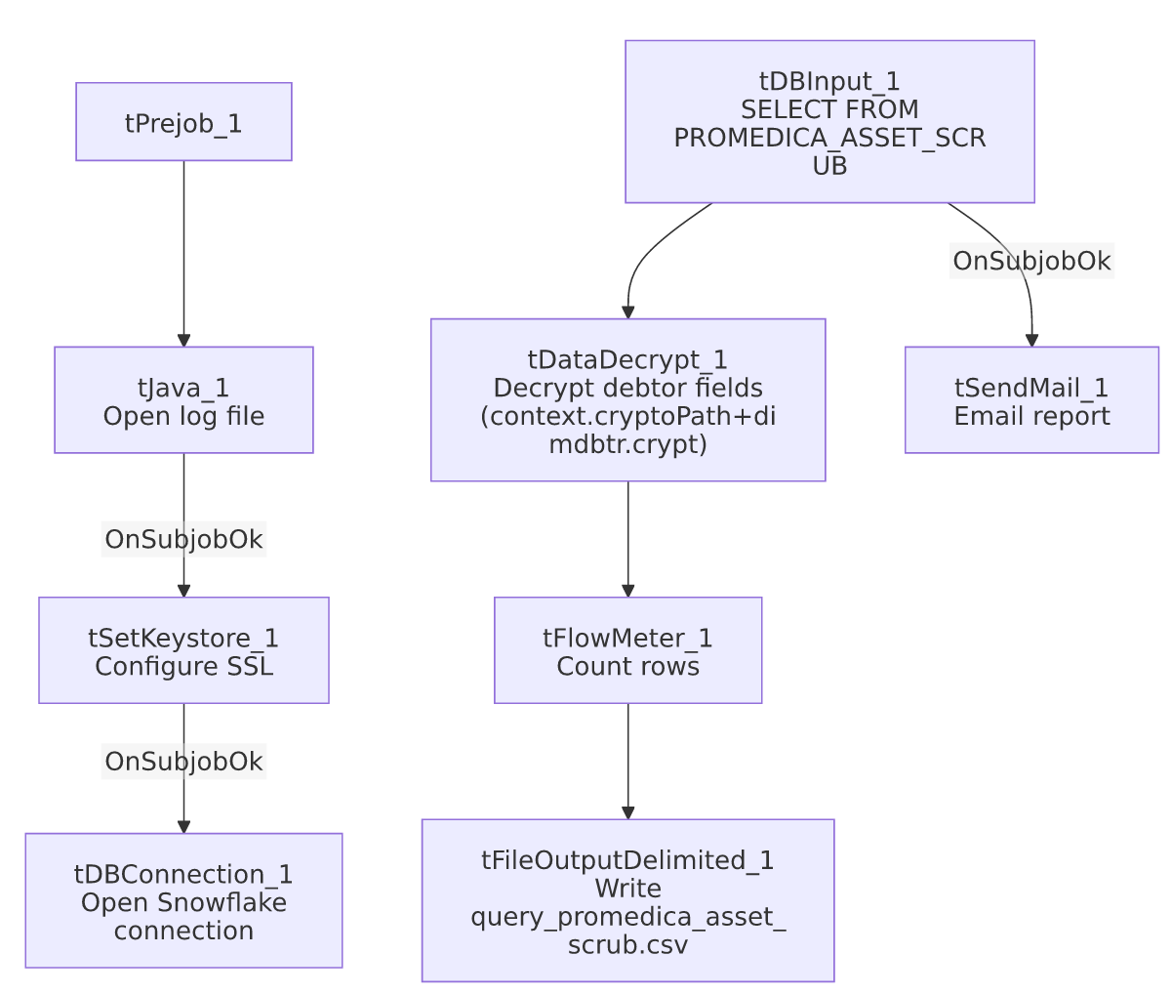

Settings tables

Source: `tDBInput_1` (`tSnowflakeInput`)
Setting | Value | What it means
Query | SELECT DEBTORNUMBER, CLIENT, NAME1, "DENIAL/APPROVAL REASON", ADD1, CITY, ST, ZIP, PACKET, PHONE, DOB, "C.D.#", SSNUM, STATUS, ASGN_AMT, ASGN_COLL, TOTAL_BAL, BALANCE_DIMDEBTOR_PACKET, EMP1_NAME, EMP1_ADDR, EMP1_CSZ, EMP1_PHN, ADMIT_DATE, DISCHARGE_DATE, NAME, TRANS_DATE, DT_ASSIGNED FROM PUB_LWASHINGTON.PROMEDICA_ASSET_SCRUB; | 26-column pull, insurance-denial-focused: includes a "DENIAL/APPROVAL REASON" column not present in LW_Carle_Asset_Scrub's equivalent query, plus a duplicate-looking NAME column alongside NAME1.

Transform: `tDataDecrypt_1`
Setting | Value | What it means
CRYPTO_FILE_PATH | context.cryptoPath+"dimdbtr.crypt" | Same context-driven key path convention as LW_Carle_Asset_Scrub/LW_Property_Scrub.
DIE_ON_ERROR | true | Decryption failure fails the job.
SECRET_TYPE / SECRET_KEY / PASSWORD_M1 | ***REDACTED*** | Preserved as redacted.

Target: `tFileOutputDelimited_1`
Setting | Value | What it means
FILENAME | context.outputDir+"query_promedica_asset_scrub.csv"
APPEND / INCLUDEHEADER | false / true | File recreated fresh each run with a header.

Mail: `tSendMail_1`
Setting | Value | What it means
SUBJECT / MESSAGE | "ProMedica Asset Scrub Report" / "The monthly ProMedica asset scrub report is attached."
DIE_ON_ERROR | true | Unconditional on-success mail (SUBJOB_OK), unlike LW_Insurance_Pmt_Tracking's conditional RUN_IF wiring.

Dependencies & configuration
- Triggers/depends on other jobs: none.
- Context variables used: cryptoPath, keystorePath, logDir, mailRecipients, outputDir.
- Hardcoded paths: tSetKeystore_1.SSL_TRUSTSERVER_TRUSTSTORE.
- Per 05_operational_runbook.md, this is one of the jobs that sends email on completion, consistent with its role as a partner-facing monthly report.

Glossary
Component type | Plain-English meaning
tSnowflakeConnection / tSnowflakeInput | Open a Snowflake connection and run a query against it.
tDataDecrypt | Decrypts protected debtor fields (SSN, etc.) using a local key file before the data is written out.
tFlowMeter | Counts rows passing a point in the flow.
tFileOutputDelimited | Writes rows to a CSV file.
tSendMail | Emails the finished report to a distribution list.
tSetKeystore | Configures SSL trust store/keystore for the Snowflake JDBC connection.

Issues observed
- The query selects both `NAME1` and a separate `NAME` column — it's not clear from this job's own metadata whether these represent genuinely different fields (e.g., a formatted vs. raw name) or a redundant/leftover column; unable to determine intent from metadata alone.
- No reject-row handling or row-count-based warning/failure path — same observation as LW_Carle_Asset_Scrub: tFlowMeter_1 counts rows but nothing branches on the count, so an empty upstream view would still produce and email a header-only report with no in-job indication that something may be off.
- No other job-specific issues beyond the project-wide hardcoded truststore path already covered in 05_operational_runbook.md.

