Talend Job: LW_Property_Scrub

Overview
This job produces a "Property Scrub" report: it queries a Snowflake view (PUB_LWASHINGTON.PROPERTY_SCRUB) for customer identity/address fields and SSN, decrypts the protected fields, and appends the result to a date-stamped CSV file (query_property_scrub_<CCYYMMDD>.csv) in the output directory. Unlike the Carle/ProMedica scrub jobs, this one has no email step — its output is presumably picked up by a separate downstream process — and follows the same file-reset/header-build/sleep template seen in LW_COC_Water_Scrub and the LW_Dashboard_* jobs rather than the simple query→decrypt→write→mail pattern used by its LW_*_Scrub siblings.

Detail table
Field | Value
Job name | LW_Property_Scrub
Version | 0.1
Project | EDW2SF
Author | jmach@harriscollect.com
Created | 2024-12-18T09:24:35.959-0800
Last Modified | 2025-11-16T20:24:55.516-0800

Step-by-step data flow
Setup subjob: tPrejob_1 → tJava_1 opens a per-run log file → on subjob-ok, tSetKeystore_1 configures SSL → on subjob-ok, tDBConnection_1 opens the Snowflake connection.
File-reset subjob (separate chain): tFileExist_1 checks whether today's dated output file (context.outputDir+"query_property_scrub_"+<CCYYMMDD>+".csv") already exists → if so (RUN_IF), tFileDelete_1 deletes it → on subjob-ok, tSleep_1 (30s) → tJava_2 builds a header-record string (truncated in the captured metadata, same pattern as LW_COC_Water_Scrub — see Issues observed) → on subjob-ok, tSleep_2 (30s) → tDBInput_1 runs the query below.
Query, decrypt, and output: tDBInput_1 → tDataDecrypt_1 decrypts protected fields using context.cryptoPath+"dimdbtr.crypt" → tFlowMeter_1 counts rows → tFileOutputDelimited_1 appends the rows (APPEND=true, INCLUDEHEADER=false) to context.outputDir+"query_property_scrub_"+<CCYYMMDD>+".csv".
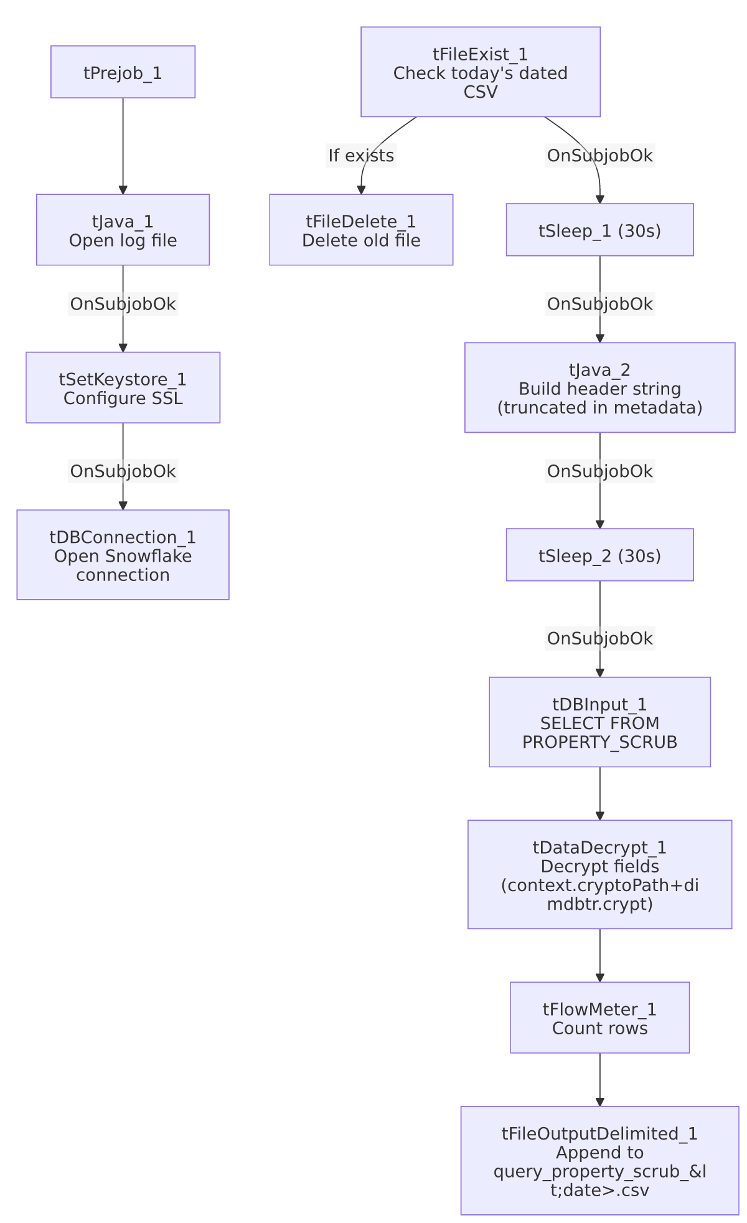

Settings tables

Source: `tDBInput_1` (`tSnowflakeInput`)
Setting | Value | What it means
Query | SELECT "Customer's Unique Record ID" AS CUSTOMER_ID, "First Name" AS FIRST_NAME, "Middle Name" AS MIDDLE_NAME, "Last Name" AS LAST_NAME, "Address Line 1" AS ADDRESS_1, "Address Line 2" AS ADDRESS_2, "City" AS CITY, "State" AS STATE, "Zip" AS ZIP, SSN FROM PUB_LWASHINGTON.PROPERTY_SCRUB; | 10-column customer identity/address extract with SSN — no client/desk/balance columns, unlike the other LW_*_Scrub jobs, suggesting this feeds a property/skip-tracing match process rather than an account-status report.

Transform: `tDataDecrypt_1`
Setting | Value | What it means
CRYPTO_FILE_PATH | context.cryptoPath+"dimdbtr.crypt"
DIE_ON_ERROR | true
SECRET_TYPE / SECRET_KEY / PASSWORD_M1 | ***REDACTED*** | Preserved as redacted.

Target: `tFileOutputDelimited_1`
Setting | Value | What it means
FILENAME | context.outputDir+"query_property_scrub_"+TalendDate.getDate("CCYYMMDD")+".csv" | Date-stamped filename — a new file per calendar day, unlike the other LW_* jobs' fixed filenames.
APPEND / INCLUDEHEADER | true / false | Header expected from the (truncated) tJava_2 step, same pattern as LW_COC_Water_Scrub.

Dependencies & configuration
- Triggers/depends on other jobs: none.
- Context variables used: cryptoPath, keystorePath, logDir, outputDir.
- Hardcoded paths: tFileDelete_1.DIRECTORY/PATH (generic Talend-Studio-workspace placeholder path), tSetKeystore_1.SSL_TRUSTSERVER_TRUSTSTORE.
- No email step — unlike LW_Carle_Asset_Scrub/LW_ProMedica_Scrub, this job is not listed in 05_operational_runbook.md's email-sending jobs, and indeed has no tSendMail component in its own metadata.

Glossary
Component type | Plain-English meaning
tFileExist / tFileDelete | Check for and conditionally delete the current day's output file before rebuilding it.
tSleep | Pauses the job for a fixed duration around the delete/header-build steps.
tSnowflakeConnection / tSnowflakeInput | Open a Snowflake connection and run a query against it.
tDataDecrypt | Decrypts protected fields (SSN) using a local key file.
tFlowMeter | Counts rows passing a point in the flow.
tFileOutputDelimited | Writes rows to a CSV file.
tSetKeystore | Configures SSL trust store/keystore for the Snowflake JDBC connection.

Issues observed
- Same truncated header-write pattern as `LW_COC_Water_Scrub`/`LW_Dashboard_By_Agent`/`LW_Dashboard_By_Metric` — tJava_2's headerRecord string cuts off mid-literal ("...Cit...") with no visible file-write call, and tFileOutputDelimited_1 relies on INCLUDEHEADER=false. If the code genuinely stops short of writing the header, each day's new dated CSV could end up without a header row. This is now the fourth job in this batch showing the identical truncation pattern, reinforcing that it's likely either a genuine shared template gap or a consistent metadata-extraction limit on inline Java code length — worth resolving which by checking one job directly in Talend Studio, since the answer applies to all four at once.
- No email or downstream-notification step, despite decrypting SSNs — worth confirming with the team how/whether the daily dated CSV output is picked up (e.g., a scheduled file transfer, a separate consuming job not present in this project's metadata) since nothing in this job's own logic signals completion externally.
- Same missing explicit trigger link between the connection-setup subjob and the file-reset/query subjob as the rest of this batch — tSetKeystore_1 → tDBConnection_1 and tFileExist_1 → ... → tDBInput_1 are two separate chains in the connections array, with nothing explicitly linking the Snowflake connection's completion to the start of the file-reset/query chain. Within the file-reset/query chain itself, however, the internal sequencing (tFileExist_1 → tSleep_1 → tJava_2 → tSleep_2 → tDBInput_1) is fully and explicitly wired.

