Talend Job: LW_REPORTS_2

Overview
This job is a second multi-report batch extractor, structurally similar to LW_REPORTS but pulling a different set of four (well, effectively three run in parallel plus one run outside the parallel block) Snowflake reports: agent utilization (call-type breakdowns, idle/break time), a month-over-month fee report, and a Kansas Department of Revenue ("KDOR") collections report. Each writes straight to its own CSV file in context.outputDir. It shares the "several independent queries bundled into one job" pattern with LW_REPORTS, but is not identical to it — different source views, and only 3 of its 4 report branches actually run inside the tParallelize_1 block (see Issues observed).

Detail table
Field | Value
Job name | LW_REPORTS_2
Version | 0.1
Project | EDW2SF
Author | jmach@harriscollect.com
Created | 2023-12-20T12:39:13.782-0800
Last Modified | 2025-11-16T20:25:39.458-0800

Step-by-step data flow
Setup subjob: tPrejob_1 → tJava_1 opens a per-run log file → on subjob-ok, tSetKeystore_1 configures SSL → on subjob-ok, tDBConnection_1 opens the Snowflake connection.
Main flow: tParallelize_1 (a separate, unconnected chain from the setup subjob — see Issues observed) fans out to three query→write pairs, run concurrently (order 1–3 in the metadata):
- tDBInput_4 (KDOR Collection Report) → tFlowMeter_5 → tFileOutputDelimited_4 → query_kdor_collections_report.csv
- tDBInput_3 (MOM Fee Report) → tFlowMeter_8 → tFileOutputDelimited_3 → query_mom_fee_report.csv
- tDBInput_1 (Agent Utilization Report) → tFlowMeter_14 → tFileOutputDelimited_1 → query_agent_utilization_report.csv
Note the component numbering (tDBInput_1, _3, _4 — no _2; tFlowMeter_5, _8, _14 — no lower numbers; tFileOutputDelimited_1, _3, _4 — no _2) has gaps, suggesting components were added/removed during development and never renumbered — see Issues observed.
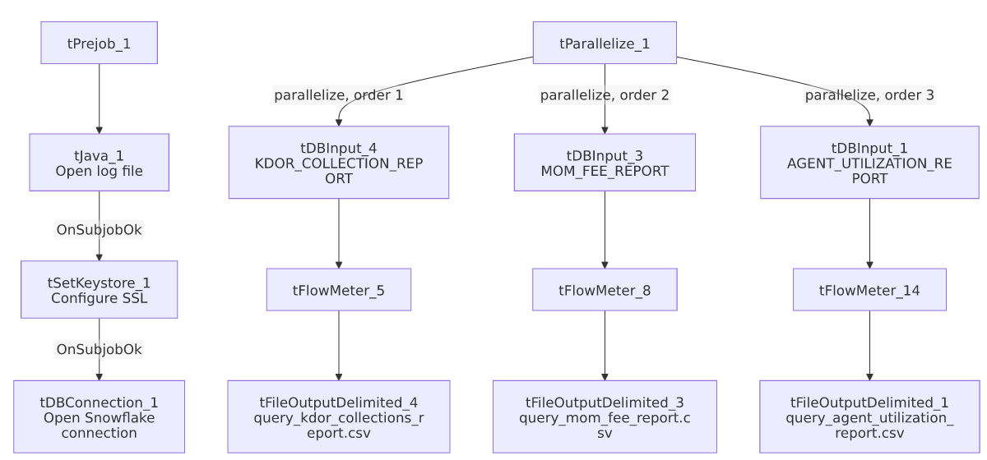

Settings tables

Sources (all `tSnowflakeInput`)
Component | Table/view | Notable columns
tDBInput_1 | EDWPRODHH.PUB_LWASHINGTON.AGENT_UTILIZATION_REPORT | Per-agent call-type breakdown (dialer/preview/inbound/manual calls, counts and averages), idle and break time totals and percentages — an agent time-utilization report.
tDBInput_3 | EDWPRODHH.PUB_LWASHINGTON.MOM_FEE_REPORT | Department, PL group, industry, client, director, fee total, and revenue growth by transaction date — a month-over-month fee/revenue tracking report.
tDBInput_4 | PUB_LWASHINGTON.KDOR_COLLECTION_REPORT | Posted month/year, payment type, place flag, collections, fees posted — appears specific to Kansas Department of Revenue collections (unqualified by EDWPRODHH., unlike the other two queries in this job).

Targets (all `tFileOutputDelimited`)
Setting | Value | What it means
APPEND / INCLUDEHEADER | false / true (all three) | Each output file is recreated fresh each run with a header row.

Dependencies & configuration
- Triggers/depends on other jobs: none.
- Context variables used: keystorePath, logDir, outputDir.
- Hardcoded paths: tSetKeystore_1.SSL_TRUSTSERVER_TRUSTSTORE.
- Relationship to `LW_REPORTS`: Same "bundle multiple independent Snowflake report queries into one job with a shared tParallelize_1" pattern, but a different, non-overlapping set of source views. Not orchestrated together via tRunJob.

Glossary
Component type | Plain-English meaning
tParallelize | Runs its downstream branches at the same time rather than one after another.
tSnowflakeConnection / tSnowflakeInput | Open a Snowflake connection and run a query against it.
tFlowMeter | Counts rows passing a point in the flow.
tFileOutputDelimited | Writes rows to a CSV file.
tSetKeystore | Configures SSL trust store/keystore for the Snowflake JDBC connection.

Issues observed
- Component numbering has gaps (tDBInput_1, _3, _4 with no _2; tFlowMeter_5, _8, _14 with no lower-numbered siblings; tFileOutputDelimited_1, _3, _4 with no _2) — a strong indicator that this job previously had at least one more report branch (e.g., a tDBInput_2/tFileOutputDelimited_2 pair) that was later deleted without renumbering the survivors, and/or that components were copy-pasted from a larger template job and partially pruned. This doesn't affect current functionality but is worth flagging as a signal that this job's history may have removed a report that once existed — verify with the team whether a fourth report was intentionally retired or is missing by mistake.
- `tParallelize_1` has no incoming trigger link from the connection-setup chain — same gap as LW_REPORTS: tPrejob_1 → tJava_1 → tSetKeystore_1 → tDBConnection_1 and tParallelize_1 → {tDBInput_1,3,4} are separate, unconnected chains in the extracted connections array. Verify ordering directly in Talend Studio.
- No `DIE_ON_ERROR`/`WAIT_FOR` values were captured for this job's `tParallelize_1` in the way LW_REPORTS's were (tParallelize_1 here has the same parameter keys — WAIT_FOR=All, SLEEPTIME=100, DIE_ON_ERROR=false — so behavior is the same: a failure in one of the three report branches won't fail the job or stop the others, and there's no branch-level success/failure check beyond the row-count tFlowMeters).
- The KDOR report's table reference is not database-qualified (PUB_LWASHINGTON.KDOR_COLLECTION_REPORT) while the other two in this same job are (EDWPRODHH.PUB_LWASHINGTON....) — likely just relying on the connection's default database matching EDWPRODHH, but worth confirming rather than assuming, since an inconsistency here could indicate the KDOR view actually lives in a different database.

