Talend Job: LW_TPL_PMT_REPORT

Overview
This is a single-query reporting extract: it reads a pre-built "Legal TPL Payment Report" view/table (EDWPRODHH.PUB_LWASHINGTON.LEGAL_TPL_PAYMENT_REPORT) from Snowflake — CUBS account number, client number, current/previous status, payment and commission amounts posted, payment date, current CUBS desk, client name, and two grouping/bank codes (PL_GROUP, KDOR_BANK) — and writes the result straight to a CSV file in context.outputDir. It moves no data anywhere else; its only purpose is to hand a flat file of this report to whoever consumes it downstream (name and "TPL" suggest a Third-Party Liability legal payment report). The PUB_LWASHINGTON schema name (compare PUB_JCHANG documented project-wide in 01_system_architecture.md) suggests this reads from an individually-owned publish schema rather than shared platform infrastructure.

Detail table
Field | Value
Job name | LW_TPL_PMT_REPORT
Version | 0.1
Project | EDW2SF
Author | jmach@harriscollect.com
Created | 2024-06-26T14:37:42.488-0700
Last Modified | 2025-11-16T20:26:57.689-0800

Step-by-step data flow
Setup subjob: tPrejob_1 → tJava_1 opens a per-run log file at context.logDir + jobName + "_" + <timestamp> + ".log" and redirects System.out/System.err to it → on subjob-ok, tSetKeystore_1 configures SSL trust/keystore from context.keystorePath (passwords redacted) → on subjob-ok, tDBConnection_1 opens the Snowflake connection.
Main subjob (no explicit trigger connection from the setup subjob or from tDBConnection_1 — it runs independently and relies on Talend's implicit shared-connection behavior, same pattern seen in other jobs in this project):
- tDBInput_2 runs a fixed SELECT of 11 columns from EDWPRODHH.PUB_LWASHINGTON.LEGAL_TPL_PAYMENT_REPORT (CUBS#, Client Number, Current Status, Payment Posted, Commission Posted, Date of Payment Posted, Current CUBS Desk, Previous Status, Client Name, PL_GROUP, KDOR_BANK).
- tFlowMeter_11 counts rows passing through (labeled "MyLabel", not renamed for this job).
- tFileOutputDelimited_2 writes the rows to context.outputDir + "query_legal_tpl_payment_report.csv" — comma-delimited, header included, ISO-8859-15 encoding, CREATE=true, APPEND=false (overwrites on each run).
Teardown: none — there is no tPostjob/tDBClose component in this job at all; the Snowflake connection opened by tDBConnection_1 is never explicitly closed (see Issues observed).
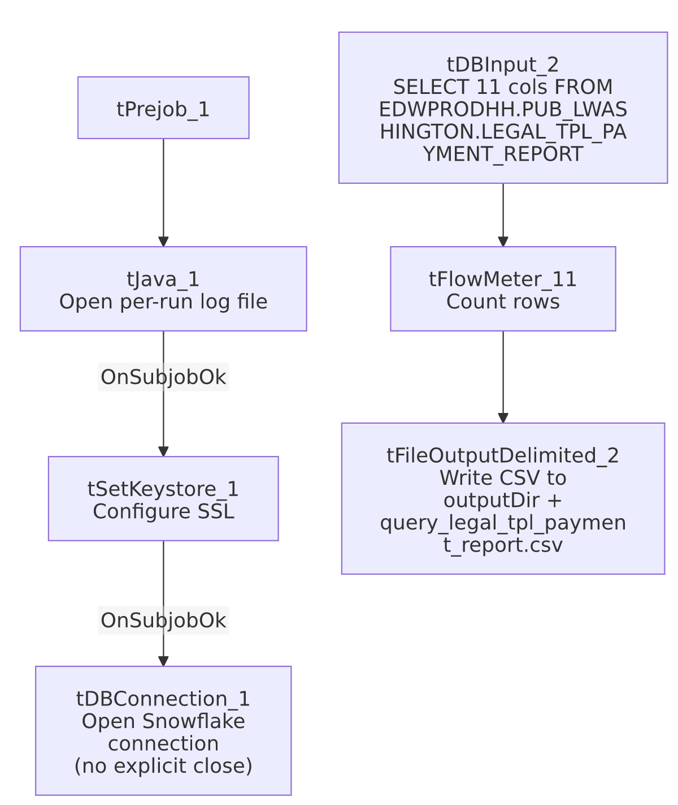

Settings tables

Source: `tDBInput_2` (`tSnowflakeInput`)
Setting | Value | What it means
Query | SELECT "CUBS#" AS CUBS_Number, "Client Number", "Current Status", "Payment Posted", "Commission Posted", "Date of Payment Posted", "Current CUBS Desk", "Previous Status", "Client Name", PL_GROUP, KDOR_BANK FROM EDWPRODHH.PUB_LWASHINGTON.LEGAL_TPL_PAYMENT_REPORT; | Reads a pre-existing report table/view fully qualified across database (EDWPRODHH) and an individually-named schema (PUB_LWASHINGTON) — no filtering or date-scoping visible in the query text.

Target: `tFileOutputDelimited_2`
Setting | Value | What it means
FILENAME | context.outputDir + "query_legal_tpl_payment_report.csv" | Destination CSV path, driven entirely by the outputDir context variable.
FIELDSEPARATOR / INCLUDEHEADER | , / true | Standard comma-delimited CSV with a header row.
APPEND | false | Each run overwrites the previous file rather than accumulating rows.
ENCODING | ISO-8859-15 | Non-default encoding choice (most other file-output jobs in this project use US-ASCII per the shared context groups) — worth confirming this is intentional for whatever consumes the file.

Dependencies & configuration
- Triggers/depends on other jobs: none — no tRunJob links found (runjob_targets is empty), and not listed as a target in 06_dependency_matrix.md.
- Context variables used: keystorePath, logDir, outputDir.
- 1 hardcoded path finding: tSetKeystore_1.SSL_TRUSTSERVER_TRUSTSTORE = "C:/clientTrustStore.trustStore" — a Windows-workstation-style path, consistent with the project-wide hardcoded-path pattern noted in 05_operational_runbook.md (though this specific path isn't the C:/Talend-Studio-... one called out there).

Glossary
Component type | Plain-English meaning
tPrejob / tPostjob | Marks the start/end of a job's setup/teardown subjob; this job has no tPostjob.
tJava | Runs custom Java code once — here, only to open a per-run log file.
tSetKeystore | Configures SSL trust/keystore settings for the job's outbound connections.
tSnowflakeConnection / tSnowflakeInput | Open a Snowflake connection / run a query against Snowflake and return result rows.
tFlowMeter | Counts rows passing a point in the flow, for logging/monitoring.
tFileOutputDelimited | Writes rows to a delimited (CSV-style) text file.

Issues observed
- No `tPostjob`/`tDBClose` component exists in this job at all — the Snowflake connection opened by tDBConnection_1 is never explicitly closed within the job. Every other reviewed job in this project pairs its tDBConnection/tPrejob with a tPostjob/tDBClose teardown; this job's absence of one is a deviation from that pattern. Whether Talend's runtime closes the connection implicitly on job exit is unable to determine from metadata — worth confirming this isn't leaking a connection on a long-running server.
- No explicit wiring connects the setup subjob (`tDBConnection_1`) to the main query subjob (`tDBInput_2`) — the two subjobs appear to run independently in the component graph, relying on Talend's shared-connection-by-name behavior rather than a SUBJOB_OK/COMPONENT_OK link. This is common in Talend but means the query's success is not gated on the connection setup subjob completing first from this metadata's perspective alone.
- No error handling of any kind (no tWarn, tDie, tLogRow, reject flow) — a query failure or file-write failure here would only show up as a generic Talend execution error.
- `PUB_LWASHINGTON` looks like an individually-owned schema (compare PUB_JCHANG, flagged project-wide in 01_system_architecture.md and 06_dependency_matrix.md as a likely one-off/personal connection rather than shared infrastructure) — if the underlying person/relationship behind this schema changes, this report could silently break with no one else aware of the dependency.

