Talend Job: Last4SSN_Extract

Overview
Extracts and decrypts debtor Social Security Numbers from the Snowflake DIMDEBTOR table, derives just the last 4 digits of each SSN, and writes the result into a Snowflake LAST4SSN table (truncate-and-reload) — then immediately uses that table to back-fill a LAST4SSN column directly on DIMDEBTOR wherever it's currently null. This is a data-privacy-minimization pattern: rather than exposing full SSNs elsewhere in the warehouse, downstream consumers can join to (or read the column added to) DIMDEBTOR for just the last 4 digits, which is enough for identity verification without keeping the fully decrypted SSN in view.

Detail table
Field | Value
Job name | Last4SSN_Extract
Version | 0.1
Project | EDW2SF
Author | jmach@harriscollect.com
Created | 2026-05-22T10:08:48.767-0700
Last Modified | 2026-05-22T11:22:58.998-0700

Step-by-step data flow
Setup subjob: tPrejob_1 → tSetKeystore_1 configures SSL trust/keystore from context.keystorePath (passwords redacted) → on subjob-ok, tDBConnection_1 opens the Snowflake connection.
Main subjob (runs independently of the setup chain in the component graph, same implicit shared-connection pattern seen elsewhere in this project):
- tDBInput_1 runs SELECT DEBTOR_IDX, SSN FROM DIMDEBTOR; against Snowflake, pulling every debtor's (presumably encrypted) SSN value.
- tDataDecrypt_1 decrypts the SSN column using AES (algorithm version 2), reading its crypto key material from context.cryptoPath + "dimdbtr.crypt" (secret type, secret key, and password all redacted); DIE_ON_ERROR=true, so a decryption failure fails the job outright.
- tJavaRow_1 trims the decrypted SSN value (passing DEBTOR_IDX through unchanged), guarding against a null SSN by leaving it null rather than trimming.
- tFilterRow_2 applies a row filter — its condition text is left as unmodified template boilerplate (input_row.columnName1.equals(input_row.columnNam..., truncated in this metadata) rather than a real business condition; see Issues observed. Rows passing the FILTER branch continue; there's no visible handling of the "else" branch.
- tJavaRow_2 derives LAST4SSN as the last 4 characters of the trimmed SSN (input_row.SSN.trim().substring(...length() - 4)), dropping the full SSN from the output row entirely (only DEBTOR_IDX and LAST4SSN remain).
- tDBOutput_1 writes to Snowflake table LAST4SSN with outputAction=INSERT and tableAction=TRUNCATE — the table is fully cleared and reloaded every run.
- Separately, tDBInput_1 also connects on SUBJOB_OK directly to tDBRow_1, which runs UPDATE DIMDEBTOR dd SET LAST4SSN = l4.LAST4SSN FROM LAST4SSN l4 WHERE dd.DEBTOR_IDX = l4.DEBTOR_IDX AND dd.LAST4SSN IS NULL; — this only back-fills debtors that don't already have a LAST4SSN value, and it fires once the SELECT from tDBInput_1 completes (not once the full extract/decrypt/load chain into LAST4SSN finishes) — see Issues observed.
Teardown: none — there is no tPostjob/tDBClose component in this job.
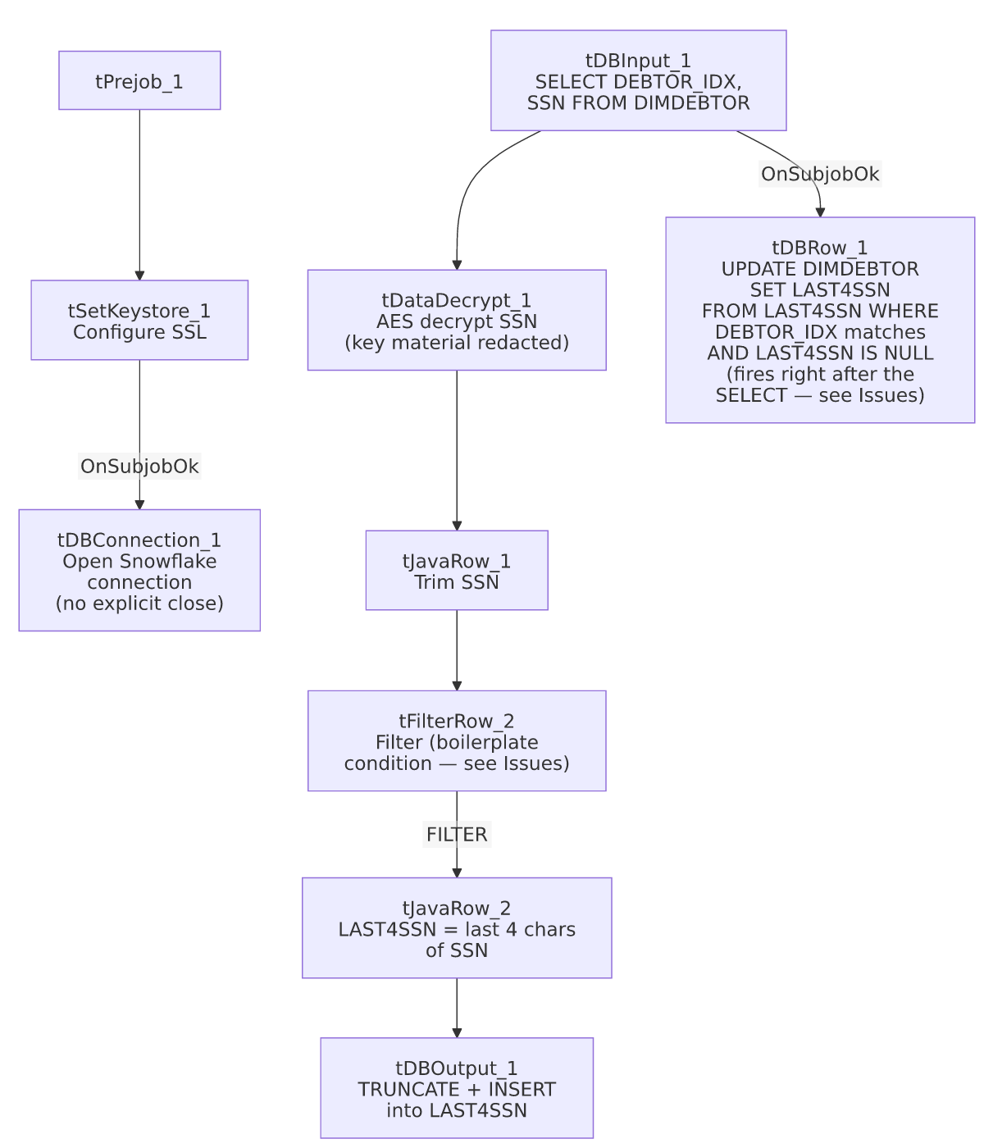

Settings tables

Source: `tDBInput_1` (`tSnowflakeInput`)
Setting | Value | What it means
Query | SELECT DEBTOR_IDX, SSN FROM DIMDEBTOR; | Pulls every debtor row's (presumably still-encrypted) SSN — no filtering by null/existing LAST4SSN, so every run re-decrypts the full table.

Transform: `tDataDecrypt_1`
Setting | Value | What it means
CRYPTO_METHOD / ALGO_VERSION | AES / 2 | Symmetric decryption of the SSN column.
SECRET_TYPE / SECRET_KEY / PASSWORD_M1 | ***REDACTED*** / ***REDACTED*** / ***REDACTED*** | Key material for decryption — preserved as redacted, not guessable from this metadata.
CRYPTO_FILE_PATH | context.cryptoPath + "dimdbtr.crypt" | Points at a per-table crypto key file.
DIE_ON_ERROR | true | A decryption failure (e.g. bad key, corrupted value) fails the job outright rather than skipping the row.

Target: `tDBOutput_1` (`tSnowflakeOutput`)
Setting | Value | What it means
Table | LAST4SSN | Destination table for the derived last-4-digit values.
Output action / Table action | INSERT / TRUNCATE | Table is cleared and reloaded every run — standard staging-table pattern.

Back-fill: `tDBRow_1` (`tSnowflakeRow`)
Setting | Value | What it means
Query | UPDATE DIMDEBTOR dd SET LAST4SSN = l4.LAST4SSN FROM LAST4SSN l4 WHERE dd.DEBTOR_IDX = l4.DEBTOR_IDX AND dd.LAST4SSN IS NULL; | Only touches DIMDEBTOR rows that don't already have a LAST4SSN value — an incremental back-fill, not a full overwrite, of the dimension table itself.

Dependencies & configuration
- Triggers/depends on other jobs: none — no tRunJob links found (runjob_targets is empty), and not listed as a target in 06_dependency_matrix.md.
- Context variables used: cryptoPath, keystorePath.
- 1 hardcoded path finding: tSetKeystore_1.SSL_TRUSTSERVER_TRUSTSTORE = "C:/clientTrustStore.trustStore".

Glossary
Component type | Plain-English meaning
tDataDecrypt | Decrypts a column's value using a stored key/algorithm — the reverse of however the SSN was originally encrypted at rest.
tJavaRow | Runs custom Java code once per input row — here used to trim a string and to derive a substring.
tFilterRow | Passes rows through only if they meet a configured condition.
tSnowflakeInput / tSnowflakeOutput / tSnowflakeRow / tSnowflakeConnection | Read from / write to / run arbitrary SQL against Snowflake, and open the shared connection.

Issues observed
- `tFilterRow_2`'s condition is left as unmodified Talend template boilerplate — the captured text is input_row.columnName1.equals(input_row.columnNam... (truncated), which is the literal placeholder Talend inserts into a new tFilterRow's advanced-condition editor before a developer customizes it. Column names columnName1/columnName2 don't exist in this job's DEBTOR_IDX/SSN schema at all. This strongly suggests the filter was never actually configured and may pass all rows through unconditionally (if USE_ADVANCED=false and no basic-mode conditions were captured either) or may throw a runtime error referencing nonexistent columns. Unable to determine the actual runtime behavior from this metadata — verify directly in Talend Studio, since as written this looks like a job that was never fully finished before being put into use (consistent with its very recent creation/modification dates, both in May 2026).
- The `DIMDEBTOR` back-fill (`tDBRow_1`) is wired to fire on `tDBInput_1`'s `SUBJOB_OK`, not after the full extract-decrypt-load chain into `LAST4SSN` completes. Both tDBRow_1 and the tDataDecrypt_1→...→tDBOutput_1 chain branch off the same tDBInput_1 component. Depending on Talend's execution-order guarantees for parallel branches off one source, the UPDATE ... FROM LAST4SSN back-fill could run before this run's fresh TRUNCATE+INSERT into LAST4SSN has completed, in which case it would either back-fill from a stale/empty LAST4SSN table or race with the truncate. Unable to determine execution ordering from this metadata alone — verify with the team, since this affects whether the back-fill uses this run's data or last run's.
- No reject-row or error-count logging on tDataDecrypt_1, tJavaRow_1, or tJavaRow_2 beyond the blanket DIE_ON_ERROR=true on the decrypt step — a single bad/corrupt SSN value fails the entire job rather than being skipped and logged.
- No `tPostjob`/`tDBClose` — same pattern as LW_TPL_PMT_REPORT in this batch; the Snowflake connection is never explicitly closed within the job.
- This job handles decrypted SSNs in-memory and briefly in a Snowflake staging table (`LAST4SSN`) — per this organization's data-handling guidance, confirm LAST4SSN's access controls are at least as restrictive as DIMDEBTOR's, since the table transiently holds derived SSN fragments tied to DEBTOR_IDX.

