Talend Job: LegalMatch_Extract

Overview
For each value in a configured list of "PL Group" codes (client/portfolio groupings — the list itself isn't visible in this metadata), this job finds currently-active "CO" (site code) debtors in that group and cross-references them against a separate, fixed list of debtors whose accounts were previously closed as paid ("LPF"/"PIF" status) under one of eleven specific county/state legal-referral portfolios (Illinois counties Kane, DuPage, McHenry, Kankakee, Kendall, Winnebago, Champaign, Will, Lake, LaSalle, plus "STATE OF KS - DOR"). Both sides' SSNs are decrypted, and matched pairs are written to a per-group TSV file (LegalMatch_<plGroup>.tsv) containing both the active debtor's and the matched historical debtor's full details side by side. This looks like a legal-referral/skip-eligibility check: finding debtors currently being worked who have a history of being legally pursued (e.g., a lien, garnishment, or county/state legal collection) elsewhere.

Detail table
Field | Value
Job name | LegalMatch_Extract
Version | 0.1
Project | EDW2SF
Author | jmach@harriscollect.com
Created | 2023-08-28T09:38:17.322-0700
Last Modified | 2025-09-24T11:00:17.280-0700

Step-by-step data flow
Setup subjob: tPrejob_1 → tDBConnection_1 opens the Snowflake connection — no `tSetKeystore` SSL configuration and no per-run log file exist anywhere in this job, unlike most other Legal_* extract jobs in this project; see Issues observed.
Main subjob has two independent starting branches feeding into a join:
Branch A — currently-active debtors, looped per PL Group (this is the main/driving flow):
- tForeach_1 iterates over a fixed list of values (not captured in this metadata, same limitation as Semaphore_Check's tForeach_1) → tJava_1 sets context.plGroup to the current value.
- tDBInput_1 runs (per iteration) a query joining DIMDEBTOR, DIMCLIENT, and (left join) DIMFISCAL_CO_A/DIMFISCAL_CO_C for employer name/address and a second encrypted SSN field (TEC_SSN), filtered to logon = 'CO', status IN ('ACT','PPD','LNA') (active-family statuses), non-null name/SSN, name length > 3, and `dc.pl_group = '<context.plGroup>'` — i.e., scoped to whichever group the current loop iteration is processing.
- tDataDecrypt_1 decrypts the row (AES, algorithm version 2, hardcoded key path "C:/Data/dimdbtr.crypt"; DIE_ON_ERROR=true).
- tFilterRow_14 applies a genuinely configured condition, input_row.SSN.trim().length() > 0 — unlike the unmodified-boilerplate tFilterRow instances found elsewhere in this project (Last4SSN_Extract, Load_Evergreen_Hours, LoadLegalRpt20231130), this one actually filters out rows whose decrypted SSN came back blank.
- tSortRow_1 sorts the filtered rows, feeding the main side of tJoin_1.
Branch B — historical closed legal-referral debtors, fixed list of groups (independent starting point, no incoming trigger — same pattern as the unconnected branches in `Livevox_Daily_Load`):
- tDBInput_2 runs a similarly-shaped query, but filtered to status IN ('LPF','PIF') (closed/paid statuses) and a hardcoded list of 11 specific `pl_group` values (the Illinois counties and Kansas DOR named above) — this query is not parameterized by `context.plGroup` and does not change across tForeach_1's iterations; see Issues observed.
- tDataDecrypt_2 decrypts this row the same way (same hardcoded crypto key path).
- tFilterRow_17 applies the same genuine SSN-not-blank condition.
- tSortRow_2 sorts, feeding the lookup side of tJoin_1.
Join and output:
- tJoin_1 (USE_INNER_JOIN=true, USE_LOOKUP_COLS=true) inner-joins Branch A's active debtors against Branch B's historical closed-legal debtors — the actual match key column(s) aren't captured in this metadata (USE_LOOKUP_COLS=true only confirms specific columns were selected in the Studio UI, not which ones); see Issues observed. The joined output carries every column from both sides, with Branch B's columns prefixed M_ (e.g. M_NAME1, M_SSN, M_TEC_SSN).
- tFileOutputDelimited_1 writes matched rows to "C:/Data/LegalMatch_" + context.plGroup + ".tsv" (tab-delimited, header included, ISO-8859-15 encoding) — one output file per PL Group processed by the outer loop.
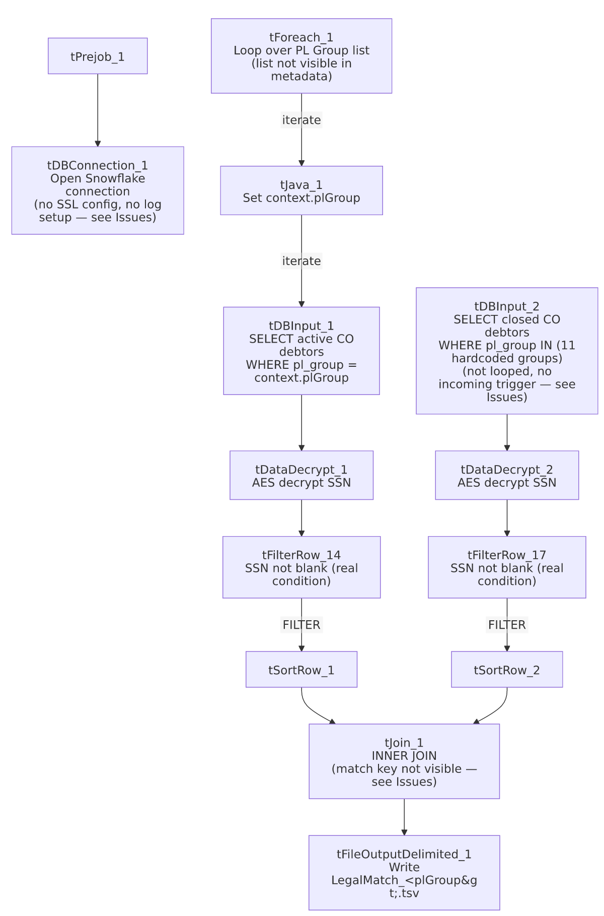

Settings tables

Source A: `tDBInput_1` (`tSnowflakeInput`, looped per PL Group)
Setting | Value | What it means
Query filter | logon = 'CO', status IN ('ACT','PPD','LNA'), dc.pl_group = '<context.plGroup>', non-null name/SSN, len(name1) > 3 | Currently-active-family debtors for the CO site, scoped to whichever group the loop is currently processing.
Joins | DIMDEBTOR inner-joined to DIMCLIENT; left-joined to DIMFISCAL_CO_A (employer info) and DIMFISCAL_CO_C (TEC_SSN, a second encrypted SSN-like field) | Employer/second-SSN fields are optional (left join) — a debtor without a fiscal-CO record still appears with those fields null.

Source B: `tDBInput_2` (`tSnowflakeInput`, fixed, not looped)
Setting | Value | What it means
Query filter | logon = 'CO', status IN ('LPF','PIF'), dc.pl_group IN ('COUNTY OF KANE IL - 3P', 'COUNTY OF DUPAGE IL - 3P', 'COUNTY OF MCHENRY IL - 3P', 'COUNTY OF KANKAKEE IL - 3P', 'COUNTY OF KENDALL IL - 3P', 'COUNTY OF WINNEBAGO IL - 3P', 'COUNTY OF CHAMPAIGN IL - 3P', 'COUNTY OF WILL IL - 3P', 'COUNTY OF LAKE IL - 3P', 'COUNTY OF LASALLE IL - 3P', 'STATE OF KS - DOR - 3P') | A fixed, hardcoded reference set of closed/paid legal-referral accounts across 10 Illinois counties and Kansas's Department of Revenue — independent of which group tForeach_1 is currently processing.

Transform: `tDataDecrypt_1` / `tDataDecrypt_2`
Setting | Value | What it means
CRYPTO_FILE_PATH | "C:/Data/dimdbtr.crypt" (hardcoded literal, both instances) | Same hardcoded key path pattern seen in LoadLegalRpt20231130 and Legal_Asset_Scrub_Illinois_Counties_Extract (v1).
DIE_ON_ERROR | true (both) | A decryption failure fails the job outright.

Join: `tJoin_1`
Setting | Value | What it means
USE_INNER_JOIN | true | Only debtors matching on both sides appear in the output — non-matches from either branch are dropped, not carried through with nulls.
USE_LOOKUP_COLS | true | Match key columns were explicitly selected in the Studio UI, but the specific column(s) used are not captured in this metadata — see Issues observed.

Target: `tFileOutputDelimited_1`
Setting | Value | What it means
FILENAME | "C:/Data/LegalMatch_" + context.plGroup + ".tsv" | One output file per group processed, tab-delimited.
Columns | Full column set from both sides (unprefixed for the active debtor, M_-prefixed for the matched historical debtor), including both decrypted SSN/TEC_SSN and M_SSN/M_TEC_SSN | Writes two people's decrypted SSNs per output row into an unencrypted flat file — see Issues observed.

Dependencies & configuration
- Triggers/depends on other jobs: none — no tRunJob links found (runjob_targets is empty).
- Context variables used: plGroup (set internally by tJava_1 from the tForeach_1 loop).
- 2 hardcoded path findings: tSortRow_1.TEMPFILE and tSortRow_2.TEMPFILE (both C:/Talend-Studio-20211109_1610-V8.0.1/workspace/temp) — plus the crypto key path and output filename base, both also hardcoded literals not captured in the hardcoded_path_findings array.

Glossary
Component type | Plain-English meaning
tForeach | Loops over a fixed list of values (defined in the component's own configuration), running the same downstream steps once per value.
tSnowflakeInput | Runs a query against Snowflake and returns its result rows.
tDataDecrypt | Decrypts a column's value using a stored key/algorithm.
tFilterRow | Passes rows through only if they meet a configured condition.
tSortRow | Sorts rows by one or more configured columns.
tJoin | Joins two input flows together by matching column(s), similar to a SQL join but performed in-memory within the Talend job.
tFileOutputDelimited | Writes rows to a delimited (here, tab-separated) text file.

Issues observed
- The exact column(s) `tJoin_1` matches on are not captured in this metadata. For a job explicitly built to find "legal matches" between two debtor populations, the match key is the single most consequential design decision (e.g., matching on SSN alone is high-precision but would miss name/DOB-based matches for people whose SSN wasn't captured on one side; matching on name+address is higher-recall but risks false positives between different people). Verify directly in Talend Studio which columns tJoin_1 actually uses before relying on this job's output for any legal or compliance decision.
- `tDBInput_2`'s lookup query is a fixed, hardcoded list of 11 `pl_group` values and does not vary with `context.plGroup` — it has no incoming trigger connection at all, making it an independent starting point (same pattern flagged in Livevox_Daily_Load's unconnected archive branch) that presumably runs once per job execution rather than once per loop iteration. This is very likely the intended design (Branch B is meant to be a fixed reference set for every group processed by Branch A, not itself parameterized), but it does mean: (a) any group value that tForeach_1 iterates over which is *not* meaningfully related to these 11 counties/Kansas would only produce matches for debtors who happen to also have a historical closed record in exactly one of those 11 groups, and (b) this query and its downstream decrypt/filter/sort chain are unable to be confirmed, from this metadata, to execute only once rather than being re-triggered per iteration — verify actual runtime behavior in Talend Studio.
- This job writes two people's decrypted SSNs per matched row into an unencrypted flat TSV file (SSN/TEC_SSN for the active debtor and M_SSN/M_TEC_SSN for the matched historical debtor), one file per PL Group, with no visible file-level protection (no password, no encryption option configured on tFileOutputDelimited_1). Given the apparent legal/compliance purpose of this data, confirm the output location (C:/Data/) and downstream handling meet this organization's requirements for sensitive PII in a legal-discovery-adjacent context.
- No `tSetKeystore`/SSL configuration and no per-run log file exist anywhere in this job, unlike most other file/report-extract jobs reviewed in this project — a decryption or connection failure here would produce a generic Talend error with no job-specific log trail.
- No `tPostjob`/`tDBClose` — the Snowflake connection opened by tDBConnection_1 is never explicitly closed, the same gap found in LW_TPL_PMT_REPORT and Last4SSN_Extract elsewhere in this batch.
- The list of PL Group values `tForeach_1` iterates over is not captured in this metadata — unable to determine how many output files this job produces per run or which groups are actually processed; verify directly in Talend Studio.
- Positive note: unlike several other jobs reviewed in this project, tFilterRow_14 and tFilterRow_17 in this job both have genuinely configured, working conditions (input_row.SSN.trim().length() > 0), not the unmodified Talend template boilerplate found in Last4SSN_Extract, Load_Evergreen_Hours, and LoadLegalRpt20231130 — this job is not part of that recurring project-wide pattern.

