Talend Job: Legal_Asset_Scrub_Champaign_County_Extract

Overview
Extracts a legal "asset scrub" file for Champaign County from a Snowflake publish view (PUB_MBOICH.CHAMPAIGN_COUNTY_ASSET_SCRUB_FILE) — debtor identity, address, DOB, packet/CDN references, assigned/interest/misc dollar amounts, payment, total balance, status, and employer name/address — decrypts the debtor's SSN column, and writes the combined result to a dated CSV file for a legal/asset-verification partner ("work number" in the filename suggests an employment/income-verification service, e.g. The Work Number). This is one of three closely related "Legal_Asset_Scrub" jobs in this batch; see Issues observed for exactly how it differs from Legal_Asset_Scrub_Illinois_Counties_Extract and _2.

Detail table
Field | Value
Job name | Legal_Asset_Scrub_Champaign_County_Extract
Version | 0.2
Project | EDW2SF
Author | jmach@harriscollect.com
Created | 2024-12-05T15:41:16.634-0800
Last Modified | 2025-11-12T06:18:43.547-0800

Step-by-step data flow
Setup subjob: tPrejob_1 → tJava_1 opens a per-run log file at context.logDir + jobName + "_" + <timestamp> + ".log" → on subjob-ok, tSetKeystore_1 configures SSL trust/keystore from context.keystorePath (passwords redacted) → on subjob-ok, tDBConnection_1 opens the Snowflake connection.
Main subjob (runs independently of the setup chain, relying on the shared connection):
- tDBInput_1 runs a fixed SELECT of 19 columns from PUB_MBOICH.CHAMPAIGN_COUNTY_ASSET_SCRUB_FILE — county is hardcoded in the table name, not parameterized.
- tDataDecrypt_1 decrypts the TEC_SSN column (AES, algorithm version 2) using key material from context.cryptoPath + "dimdbtr.crypt" (all secret fields redacted); DIE_ON_ERROR=true.
- tFileOutputDelimited_1 writes the decrypted rows to context.outputDir + "CHAMPAIGN_work_number_" + <CCYYMMDD> + ".csv" — comma-delimited, header included, ISO-8859-15 encoding, overwrite-on-run (APPEND=false).
Teardown subjob: tPostjob_1 → tDBClose_1 closes the Snowflake connection.
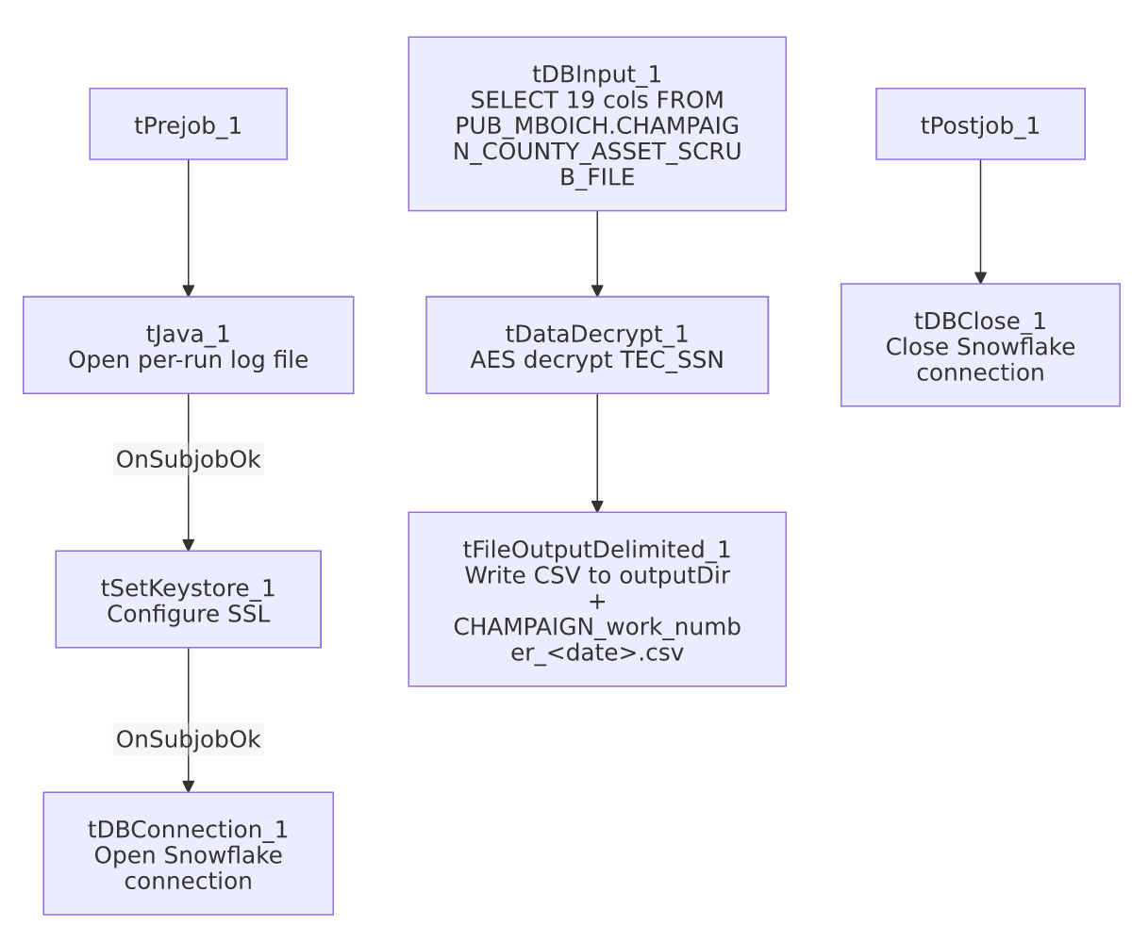

Settings tables

Source: `tDBInput_1` (`tSnowflakeInput`)
Setting | Value | What it means
Query | SELECT DEBTOR_IDX, CLIENT_IDX, NAME1, ADDRESS_1, CITY, STATE, ZIP_CODE, PACKET_IDX, DOB, CDN, ASSIGNED_AMOUNT, INT_AMT, MISC_AMT, PAYMENT, TTL_BAL, STATUS, EMP1_NAME, EMP1_ADDR, TEC_SSN FROM PUB_MBOICH.CHAMPAIGN_COUNTY_ASSET_SCRUB_FILE; | Fixed to Champaign County only — includes employer name/address (EMP1_NAME, EMP1_ADDR), which the sibling Illinois_Counties_Extract (v1) job's column set does not.

Transform: `tDataDecrypt_1`
Setting | Value | What it means
CRYPTO_FILE_PATH | context.cryptoPath + "dimdbtr.crypt" | Key file location driven by context variable (unlike sibling Illinois_Counties_Extract v1, which hardcodes this path — see that job's doc).
SECRET_TYPE / SECRET_KEY / PASSWORD_M1 | ***REDACTED*** | Preserved as redacted.
DIE_ON_ERROR | true | A decryption failure fails the job outright.

Target: `tFileOutputDelimited_1`
Setting | Value | What it means
FILENAME | context.outputDir + "CHAMPAIGN_work_number_" + TalendDate.getDate("CCYYMMDD") + ".csv" | County name is hardcoded into the filename as well as the source table.
Format | CSV, comma-delimited, header included, ISO-8859-15 | Same output shape as Legal_Asset_Scrub_Illinois_Counties_Extract_2, but that job writes a per-county filename via context.countyName rather than a literal "CHAMPAIGN".

Dependencies & configuration
- Triggers/depends on other jobs: none — no tRunJob links found (runjob_targets is empty).
- Context variables used: cryptoPath, keystorePath, logDir, outputDir.
- 1 hardcoded path finding: tSetKeystore_1.SSL_TRUSTSERVER_TRUSTSTORE = "C:/clientTrustStore.trustStore".

Glossary
Component type | Plain-English meaning
tDataDecrypt | Decrypts a column's value using a stored key/algorithm.
tFileOutputDelimited | Writes rows to a delimited (CSV-style) text file.
tSetKeystore | Configures SSL trust/keystore settings for the job's outbound connections.
tSnowflakeConnection / tSnowflakeInput / tSnowflakeClose | Open a Snowflake connection, run a query against it, and close it.

Issues observed
- This job hardcodes "Champaign" into both the source table name and the output filename, rather than using the context.countyName parameterization pattern that Legal_Asset_Scrub_Illinois_Counties_Extract and _2 both use. Since those two sibling jobs already generalize this exact pattern (query PUB_MBOICH."+context.countyName+"_COUNTY_ASSET_SCRUB_FILE), it's unclear why Champaign has its own dedicated, non-parameterized copy rather than being run as one more value passed to the generalized job — possibly Champaign's asset-scrub table has a genuinely different column layout (it does: this job's query includes EMP1_NAME/EMP1_ADDR, which the Illinois_Counties_Extract v1 job's query does not) that made a one-off copy easier than reconciling schemas. Unable to determine from metadata which came first; verify with the team whether Champaign could be folded into the generalized job's per-county schema instead.
- No reject-row or error-count logging beyond DIE_ON_ERROR=true on the decrypt step — a single bad/corrupt SSN value fails the entire job.
- This job's output file carries decrypted SSNs (via the derived data) to a partner-facing flat file — confirm the "work number" recipient's data-sharing agreement covers full SSN transmission (unlike Last4SSN_Extract in this same batch, which deliberately truncates to the last 4 digits before persisting anywhere).

