Talend Job: Legal_Asset_Scrub_Illinois_Counties_Extract

Overview
Extracts a legal "asset scrub" file for a parameterized Illinois county (the table name is built dynamically as PUB_MBOICH."+context.countyName+"_COUNTY_ASSET_SCRUB_FILE) — debtor identity, address, DOB, packet/CDN references, dollar amounts, misc collections, status, and assignment date — decrypts the debtor's SSN column, and writes the combined result to a dated Excel workbook. This is the original, generalized version of the county-parameterized asset scrub; a near-identical _2 version exists with a different output format and a materially different setup subjob (see Issues observed for the specific differences).

Detail table
Field | Value
Job name | Legal_Asset_Scrub_Illinois_Counties_Extract
Version | 0.1
Project | EDW2SF
Author | jmach@harriscollect.com
Created | 2023-09-13T10:10:15.911-0700
Last Modified | 2023-10-04T16:22:49.835-0700

Step-by-step data flow
Setup subjob: tPrejob_1 → tDBConnection_1 opens the Snowflake connection directly — there is no `tJava` log-file setup and no `tSetKeystore` SSL configuration in this job (both present in the sibling jobs; see Issues observed).
Main subjob (runs independently of the setup chain, relying on the shared connection):
- tDBInput_1 runs SELECT DEBTOR_IDX, CLIENT_IDX, NAME1, ADDRESS_1, CITY, STATE, ZIP_CODE, PACKET_IDX, DOB, CDN, ASSIGNED_AMOUNT, PAYMENT, TOTAL_BAL, MISC_AMT, MISC_COLL, STATUS, TEC_SSN, MD_MISC_3, DT_ASSIGNED FROM PUB_MBOICH."+context.countyName+"_COUNTY_ASSET_SCRUB_FILE; — 19 columns, dynamically scoped to whatever county the run is configured for.
- tDataDecrypt_1 decrypts TEC_SSN (AES, algorithm version 2) using key material from a hardcoded path, "C:/Data/dimdbtr.crypt" (not a context variable — see Issues observed); DIE_ON_ERROR=true.
- tFileOutputExcel_1 writes the decrypted rows to context.outputDir + context.countyName + "_work_number_" + <CCYYMMDD> + ".xlsx" (Excel 2007+ format, single sheet "Sheet1", header included, DELETE_EMPTYFILE=true so a zero-row run produces no file at all). PROTECT_FILE=false, but a PASSWORD field is present and redacted anyway — see Issues observed.
Teardown subjob: tPostjob_1 → tDBClose_1 closes the Snowflake connection.
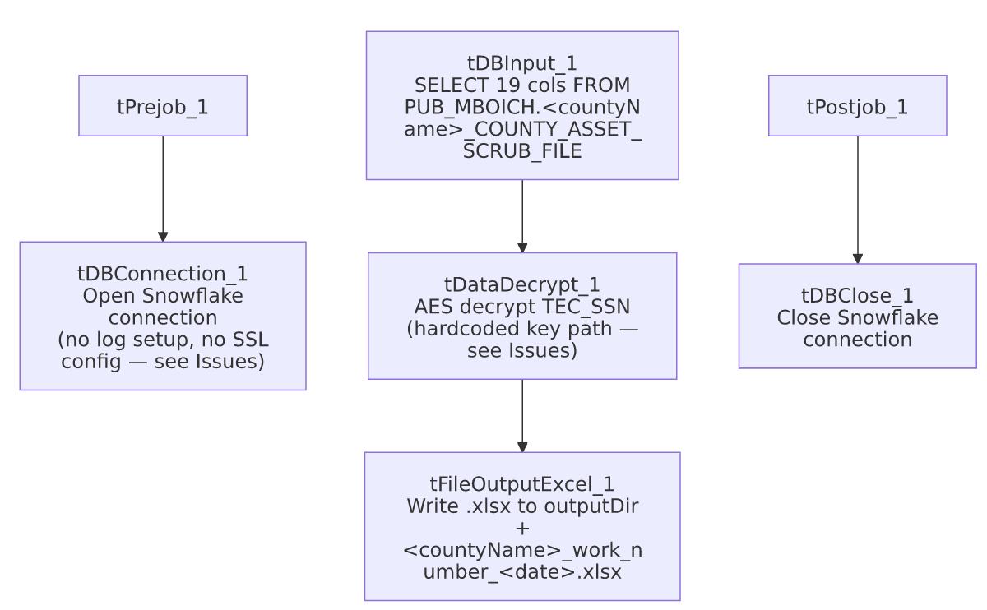

Settings tables

Source: `tDBInput_1` (`tSnowflakeInput`)
Setting | Value | What it means
Query | SELECT ... FROM PUB_MBOICH."+context.countyName+"_COUNTY_ASSET_SCRUB_FILE; | County-parameterized via string concatenation with context.countyName — which value(s) this runs with per-invocation isn't captured in this job's own metadata (no tRunJob/context override visible).
Column set | TOTAL_BAL, MISC_COLL, MD_MISC_3, DT_ASSIGNED (no EMP1_NAME/EMP1_ADDR, no INT_AMT, no TTL_BAL) | Different column set from both Legal_Asset_Scrub_Champaign_County_Extract and _2 — see Issues observed.

Transform: `tDataDecrypt_1`
Setting | Value | What it means
CRYPTO_FILE_PATH | "C:/Data/dimdbtr.crypt" (hardcoded string literal) | Unlike Champaign_County_Extract and _2, which both use context.cryptoPath + "dimdbtr.crypt", this job hardcodes the full Windows path — a portability risk consistent with the project-wide hardcoded-path pattern in 05_operational_runbook.md, though this specific path wasn't captured in hardcoded_path_findings for this job (empty array) since it's inside the CRYPTO_FILE_PATH parameter rather than a recognized path-bearing field.
DIE_ON_ERROR | true | A decryption failure fails the job outright.

Target: `tFileOutputExcel_1`
Setting | Value | What it means
FILENAME | context.outputDir + context.countyName + "_work_number_" + <date> + ".xlsx" | Output format is Excel, not CSV (contrast both sibling jobs, which write CSV).
PROTECT_FILE / PASSWORD | false / ***REDACTED*** | Password protection is disabled, but a password value is still configured and redacted in this metadata — dead configuration, or a remnant from when protection was enabled; see Issues observed.
DELETE_EMPTYFILE | true | If the query returns zero rows for a given county, no file is produced at all (rather than an empty workbook) — worth knowing if a downstream process expects a file to always exist.

Dependencies & configuration
- Triggers/depends on other jobs: none — no tRunJob links found (runjob_targets is empty).
- Context variables used: countyName, outputDir — notably no cryptoPath, keystorePath, or logDir, unlike both sibling jobs (see Issues observed).
- `hardcoded_path_findings` is empty for this job, but tDataDecrypt_1.CRYPTO_FILE_PATH is in fact a hardcoded literal ("C:/Data/dimdbtr.crypt") not caught by the extraction's path-detection — see the settings table above.

Glossary
Component type | Plain-English meaning
tDataDecrypt | Decrypts a column's value using a stored key/algorithm.
tFileOutputExcel | Writes rows to an Excel workbook (.xlsx), as opposed to a plain delimited text file.
tSnowflakeConnection / tSnowflakeInput / tSnowflakeClose | Open a Snowflake connection, run a query against it, and close it.

Issues observed
- No `tSetKeystore` and no dedicated `tJava` log-file setup exist in this job at all — both Legal_Asset_Scrub_Champaign_County_Extract and Legal_Asset_Scrub_Illinois_Counties_Extract_2 open a per-run log file and configure SSL trust/keystore settings before connecting to Snowflake; this job connects directly from tPrejob_1 with neither step. Since keystorePath and logDir also don't appear in this job's context_vars_referenced at all, this looks like an earlier, less-mature version of the pattern that _2 later added — consistent with this job's older creation date (2023-09) versus _2's (2023-12) and _2's more recent last-modified date (2025-11, vs. this job's 2023-10). Confirm with the team whether this v1 job is still actively scheduled or has been superseded by _2.
- The decryption key file path is hardcoded ("C:/Data/dimdbtr.crypt") rather than built from a context.cryptoPath variable, unlike both sibling jobs. This is a portability/maintainability risk on its own (same class of issue as the project-wide C:/Talend-Studio-... hardcoded paths in 05_operational_runbook.md), and it did not surface in this job's hardcoded_path_findings array, so anyone scanning that field alone would miss it.
- This job's column set differs from both sibling jobs: it includes TOTAL_BAL, MISC_COLL, MD_MISC_3, and DT_ASSIGNED, none of which appear in Champaign_County_Extract or _2's queries; conversely it lacks EMP1_NAME, EMP1_ADDR, INT_AMT, and uses TOTAL_BAL where the other two jobs use TTL_BAL. Since all three query the same PUB_MBOICH.<county>_COUNTY_ASSET_SCRUB_FILE naming pattern, this suggests either the underlying per-county publish tables/views genuinely have different column layouts, or this job's column list is simply out of date relative to _2. Unable to determine which from metadata; verify against the actual PUB_MBOICH tables before assuming both jobs can be safely consolidated.
- A `PASSWORD` value is configured (and redacted) on `tFileOutputExcel_1` even though `PROTECT_FILE=false`. The password has no effect while protection is off, but its presence suggests file-level password protection may have been intended or previously enabled — verify whether this workbook should in fact be password-protected before being sent externally, given it carries decrypted SSNs.
- Output file is silently skipped when the query returns zero rows (DELETE_EMPTYFILE=true) — if a downstream process expects a file (even an empty one) to confirm the job ran, a zero-row county could look like the job never executed.

