Talend Job: Legal_Asset_Scrub_Illinois_Counties_Extract_2

Overview
Extracts a legal "asset scrub" file for a parameterized Illinois county (PUB_MBOICH."+context.countyName+"_COUNTY_ASSET_SCRUB_FILE) — debtor identity, address, DOB, packet/CDN references, assigned/interest/misc dollar amounts, payment, total balance, status, and employer name/address — decrypts the debtor's SSN column, and writes the combined result to a dated CSV file. This is a revised version of Legal_Asset_Scrub_Illinois_Counties_Extract (no suffix): it keeps the same county-parameterization approach but adds the SSL/logging setup subjob and switches output format from Excel back to CSV, while also switching to the same column set used by Legal_Asset_Scrub_Champaign_County_Extract. See Issues observed for the full comparison.

Detail table
Field | Value
Job name | Legal_Asset_Scrub_Illinois_Counties_Extract_2
Version | 0.2
Project | EDW2SF
Author | jmach@harriscollect.com
Created | 2023-12-21T10:39:02.722-0800
Last Modified | 2025-11-12T06:22:57.817-0800

Step-by-step data flow
Setup subjob: tPrejob_1 → tJava_1 opens a per-run log file at context.logDir + jobName + "_" + <timestamp> + ".log" → on subjob-ok, tSetKeystore_1 configures SSL trust/keystore from context.keystorePath (passwords redacted) → on subjob-ok, tDBConnection_1 opens the Snowflake connection. (This setup chain is absent in the sibling v1 job — see Issues observed.)
Main subjob (runs independently of the setup chain, relying on the shared connection):
- tDBInput_1 runs SELECT DEBTOR_IDX, CLIENT_IDX, NAME1, ADDRESS_1, CITY, STATE, ZIP_CODE, PACKET_IDX, DOB, CDN, ASSIGNED_AMOUNT, INT_AMT, MISC_AMT, PAYMENT, TTL_BAL, STATUS, EMP1_NAME, EMP1_ADDR, TEC_SSN FROM PUB_MBOICH."+context.countyName+"_COUNTY_ASSET_SCRUB_FILE; — 18 columns, dynamically scoped by county, and (unlike the v1 sibling) matching Champaign_County_Extract's exact column set (including EMP1_NAME/EMP1_ADDR, INT_AMT, TTL_BAL) rather than v1's (TOTAL_BAL, MISC_COLL, MD_MISC_3, DT_ASSIGNED).
- tDataDecrypt_1 decrypts TEC_SSN (AES, algorithm version 2) using key material from context.cryptoPath + "dimdbtr.crypt" (a context variable, not the hardcoded path v1 uses); DIE_ON_ERROR=true.
- tFileOutputDelimited_1 writes the decrypted rows to context.outputDir + context.countyName + "_work_number_" + <CCYYMMDD> + ".csv" — comma-delimited CSV (not the Excel format v1 produces), header included, ISO-8859-15 encoding, overwrite-on-run.
Teardown subjob: tPostjob_1 → tDBClose_1 closes the Snowflake connection.
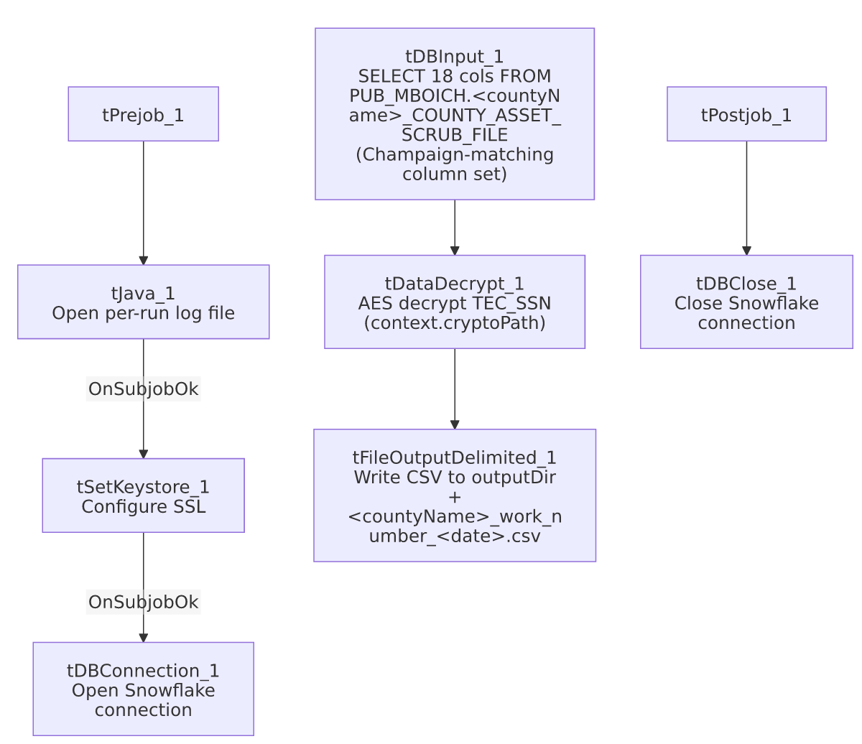

Settings tables

Source: `tDBInput_1` (`tSnowflakeInput`)
Setting | Value | What it means
Query | SELECT DEBTOR_IDX, CLIENT_IDX, NAME1, ADDRESS_1, CITY, STATE, ZIP_CODE, PACKET_IDX, DOB, CDN, ASSIGNED_AMOUNT, INT_AMT, MISC_AMT, PAYMENT, TTL_BAL, STATUS, EMP1_NAME, EMP1_ADDR, TEC_SSN FROM PUB_MBOICH."+context.countyName+"_COUNTY_ASSET_SCRUB_FILE; | County-parameterized, and column-for-column identical to Legal_Asset_Scrub_Champaign_County_Extract's query (differing only in that this job's table name is dynamic, Champaign's is a literal).

Transform: `tDataDecrypt_1`
Setting | Value | What it means
CRYPTO_FILE_PATH | context.cryptoPath + "dimdbtr.crypt" | Context-driven, matching Champaign_County_Extract; the v1 sibling hardcodes this instead.
DIE_ON_ERROR | true | A decryption failure fails the job outright.

Target: `tFileOutputDelimited_1`
Setting | Value | What it means
FILENAME | context.outputDir + context.countyName + "_work_number_" + <date> + ".csv" | CSV output with the county name interpolated into the filename — combines v1's dynamic-filename approach with Champaign's CSV format.
Format | Comma-delimited, header included, ISO-8859-15, APPEND=false | Identical output shape to Champaign_County_Extract.

Dependencies & configuration
- Triggers/depends on other jobs: none — no tRunJob links found (runjob_targets is empty).
- Context variables used: countyName, cryptoPath, keystorePath, logDir, outputDir — the full set used by Champaign_County_Extract, unlike the v1 sibling which only references countyName and outputDir.
- 1 hardcoded path finding: tSetKeystore_1.SSL_TRUSTSERVER_TRUSTSTORE = "C:/clientTrustStore.trustStore".

Glossary
Component type | Plain-English meaning
tDataDecrypt | Decrypts a column's value using a stored key/algorithm.
tFileOutputDelimited | Writes rows to a delimited (CSV-style) text file.
tSetKeystore | Configures SSL trust/keystore settings for the job's outbound connections.
tSnowflakeConnection / tSnowflakeInput / tSnowflakeClose | Open a Snowflake connection, run a query against it, and close it.

Issues observed
- This job appears to be a consolidation/rewrite of `Legal_Asset_Scrub_Illinois_Counties_Extract` (v1) that copies `Legal_Asset_Scrub_Champaign_County_Extract`'s setup subjob, column set, and CSV output format onto v1's county-parameterization. Concretely: it adds the tJava_1/tSetKeystore_1 setup chain v1 lacks; it switches tDataDecrypt_1's key path from v1's hardcoded literal to context.cryptoPath (matching Champaign); it switches output from v1's Excel format to CSV (matching Champaign); and its query's column list is identical to Champaign's rather than v1's. Given this job's later creation date (2023-12 vs. v1's 2023-09) and both this job and Champaign sharing a near-identical last-modified timestamp (2025-11-12, ~4 minutes apart), it's plausible this job and Champaign were edited together as part of the same later maintenance pass. Whether v1 (Excel-based) or this job (CSV-based) is the one actually scheduled today for the parameterized counties is unable to determine from metadata — verify with the team before assuming either is dead code, since running both against the same counties would produce duplicate output files in different formats.
- Its column set no longer matches what `PUB_MBOICH.<county>_COUNTY_ASSET_SCRUB_FILE` apparently contains per the v1 job's query (TOTAL_BAL, MISC_COLL, MD_MISC_3, DT_ASSIGNED are dropped; INT_AMT, TTL_BAL, EMP1_NAME, EMP1_ADDR are added instead). If the underlying per-county publish views genuinely differ in shape from Champaign's, this job could fail at runtime for counties whose view doesn't have EMP1_NAME/EMP1_ADDR/INT_AMT/TTL_BAL columns — unable to confirm from metadata; verify against the actual Snowflake views for at least one non-Champaign county before relying on this job.
- No reject-row or error-count logging beyond DIE_ON_ERROR=true on the decrypt step.
- Carries decrypted SSNs into a partner-facing flat file, same consideration as Legal_Asset_Scrub_Champaign_County_Extract — confirm the receiving party's data-sharing agreement covers full SSN transmission.

