Talend Job: Legal_Asset_Scrub_KDOR_Extract

Overview
Extracts a legal "asset scrub" file for KDOR (Kansas Department of Revenue, based on the KDOR_BANK/WARRANT_SRV_DT columns and job name) from EDWPRODHH.PUB_MBOICH.KDOR_ASSET_SCRUB_FILE — debtor identity, address, desk, DOB, status, transaction/assignment dates, dollar amounts, employer name/address, and KDOR-specific bank/warrant fields — decrypts the debtor's SSN column, and writes the combined result to a dated CSV file. It's the fourth "Legal_Asset_Scrub" job in this batch, sharing the same overall shape as the three county-based siblings but with its own distinct column set and source-table qualification (see Issues observed).

Detail table
Field | Value
Job name | Legal_Asset_Scrub_KDOR_Extract
Version | 0.2
Project | EDW2SF
Author | jmach@harriscollect.com
Created | 2023-10-04T17:38:03.351-0700
Last Modified | 2025-11-12T06:36:20.174-0800

Step-by-step data flow
Setup subjob: tPrejob_1 → tSetKeystore_1 configures SSL trust/keystore from context.keystorePath (passwords redacted) — no per-run log file is opened in this job (no tJava/log-setup component, unlike Champaign_County_Extract and Illinois_Counties_Extract_2; see Issues observed) → on subjob-ok, tDBConnection_1 opens the Snowflake connection.
Main subjob (runs independently of the setup chain, relying on the shared connection):
- tDBInput_1 runs a fixed SELECT of 22 columns from EDWPRODHH.PUB_MBOICH.KDOR_ASSET_SCRUB_FILE — note the fully database-qualified table reference (`EDWPRODHH.PUB_MBOICH...`), whereas all three sibling jobs reference PUB_MBOICH.<table> without the leading EDWPRODHH. database name; see Issues observed.
- tDataDecrypt_1 decrypts the SSN column (AES, algorithm version 2) using key material from context.cryptoPath + "dimdbtr.crypt" (all secret fields redacted); DIE_ON_ERROR=true.
- tFileOutputDelimited_1 writes the decrypted rows to context.outputDir + "KDOR_work_number_" + <CCYYMMDD> + ".csv" — comma-delimited, header included, ISO-8859-15 encoding, overwrite-on-run.
Teardown subjob: tPostjob_1 → tDBClose_1 closes the Snowflake connection.
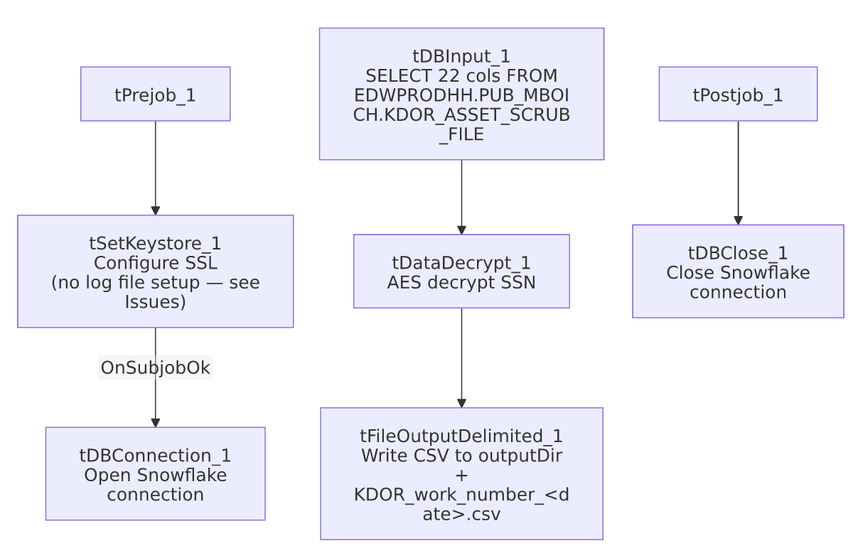

Settings tables

Source: `tDBInput_1` (`tSnowflakeInput`)
Setting | Value | What it means
Query | SELECT DEBTOR_IDX, CLIENT_IDX, NAME1, ADDRESS_1, CITY, STATE, ZIP_CODE, DESK, SSN, DOB, STATUS, TRANS_DATE, DT_ASSIGNED, ASSIGNED_AMOUNT, PAYMENT, TOTAL_BAL, BALANCE_DIMDEBTOR_PACKET, MD_MISC_2, MD_MISC_3, EMP1_NAME, EMP1_ADDR, KDOR_BANK, WARRANT_SRV_DT FROM EDWPRODHH.PUB_MBOICH.KDOR_ASSET_SCRUB_FILE; | KDOR-specific columns (DESK, TRANS_DATE, BALANCE_DIMDEBTOR_PACKET, MD_MISC_2, KDOR_BANK, WARRANT_SRV_DT) not present in any of the three county-based sibling jobs; conversely it lacks PACKET_IDX, CDN, INT_AMT/MISC_AMT, MISC_COLL. The plain (unprefixed) SSN column name is also unique to this job — the others use TEC_SSN.

Transform: `tDataDecrypt_1`
Setting | Value | What it means
CRYPTO_FILE_PATH | context.cryptoPath + "dimdbtr.crypt" | Context-driven, matching Champaign_County_Extract and Illinois_Counties_Extract_2.
DIE_ON_ERROR | true | A decryption failure fails the job outright.

Target: `tFileOutputDelimited_1`
Setting | Value | What it means
FILENAME | context.outputDir + "KDOR_work_number_" + <date> + ".csv" | "KDOR" is hardcoded into the filename (same pattern as Champaign_County_Extract hardcoding "CHAMPAIGN" — this job is not county-parameterized).
Format | Comma-delimited, header included, ISO-8859-15, APPEND=false | Same output shape as the other three jobs in this batch.

Dependencies & configuration
- Triggers/depends on other jobs: none — no tRunJob links found (runjob_targets is empty).
- Context variables used: cryptoPath, keystorePath, outputDir — notably no `logDir`, consistent with this job having no log-file-setup component.
- 1 hardcoded path finding: tSetKeystore_1.SSL_TRUSTSERVER_TRUSTSTORE = "C:/clientTrustStore.trustStore".

Glossary
Component type | Plain-English meaning
tDataDecrypt | Decrypts a column's value using a stored key/algorithm.
tFileOutputDelimited | Writes rows to a delimited (CSV-style) text file.
tSetKeystore | Configures SSL trust/keystore settings for the job's outbound connections.
tSnowflakeConnection / tSnowflakeInput / tSnowflakeClose | Open a Snowflake connection, run a query against it, and close it.

Issues observed
- No per-run log file is opened in this job (no tJava component writing to context.logDir), unlike Legal_Asset_Scrub_Champaign_County_Extract and Legal_Asset_Scrub_Illinois_Counties_Extract_2, both of which redirect System.out/System.err to a dated log file before connecting. This job does, however, have the tSetKeystore_1 SSL step those two also have — so it sits between the more mature Champaign/_2 pattern and the less mature Illinois_Counties_Extract (v1), which has neither log setup nor SSL config. Confirm whether this project has a preferred/required setup-subjob template all extract jobs should follow.
- The source table reference is fully database-qualified (EDWPRODHH.PUB_MBOICH.KDOR_ASSET_SCRUB_FILE) while all three sibling Legal_Asset_Scrub jobs reference PUB_MBOICH.<table> without the leading database name. Since the job connects via a single Snowflake connection component either way, this likely resolves to the same effective database either through a default-database setting on the connection or because both forms point at the same place — but it's inconsistent, and if the connection's default database ever changed, this job and its siblings could start pointing at different data without anyone noticing from the job definitions alone. Unable to confirm from metadata; verify the Snowflake connection's default database/schema configuration.
- No reject-row or error-count logging beyond DIE_ON_ERROR=true on the decrypt step.
- Carries decrypted SSNs into a partner-facing flat file, same consideration as the sibling Legal_Asset_Scrub jobs — confirm KDOR's data-sharing agreement covers full SSN transmission.

