Talend Job: Livevox_Daily_Load

Overview
Loads daily call-result files from the Livevox outbound dialer platform (tab-delimited "calls" files — call direction, phone dialed, result code, agent, campaign, talk/hold/wrapup times, etc.) into a Snowflake staging table, then calls two stored procedures to merge the newly loaded calls into the downstream warehouse — once matching by phone number and once by an internal reference number. It separately archives the source files to context.archiveDir. The staging table and merge procedures are all named LATITUDE_STAGING.* even though this job lives in the EDW2SF project — see Issues observed for why that's notable.

Detail table
Field | Value
Job name | Livevox_Daily_Load
Version | 0.1
Project | EDW2SF
Author | jmach@harriscollect.com
Created | 2025-02-10T09:57:45.302-0800
Last Modified | 2025-09-24T11:00:14.413-0700

Step-by-step data flow
Setup subjob: tPrejob_1 → tDBConnection_1 opens the Snowflake connection → on SUBJOB_OK, tJava_3 opens a per-run log file at context.logDir + jobName + "_" + <timestamp> + ".log" — note the log file is opened after the DB connection here, the reverse order from most other jobs in this project.
Main subjob has three separate starting points with no wiring between them, meaning their relative execution order is not guaranteed by this job's own component graph (see Issues observed):
- Load chain: tDBRow_2 runs TRUNCATE TABLE LATITUDE_STAGING.LIVEVOX_CALLS; (no incoming trigger — an independent starting point) → on SUBJOB_OK, tFileList_1 lists files in context.sourceRoot (the usual unapplied *.txt exclusion mask is present here too) → for each file (ITERATE), tJava_1 sets context.filePath → tFileInputDelimited_1 reads the tab-delimited "calls" file (DIE_ON_ERROR=false, TRIMALL=true) → tFlowMeter_3 counts rows → tDBOutput_1 inserts into Snowflake LIVEVOX_CALLS (INSERT, tableAction=NONE — relies on the earlier truncate, not a per-file truncate).
- Merge chain: once tFileList_1's entire file loop completes (SUBJOB_OK), tDBRow_3 runs CALL LATITUDE_STAGING.MERGE_INTO_LIVEVOX_BY_REFNUM(); first, then on SUBJOB_OK, tDBRow_1 runs CALL LATITUDE_STAGING.MERGE_INTO_LIVEVOX_BY_PHONE();. Each procedure's RETVALUE is captured (tDBRow_3→tMap_1→tWarn_1 logs "Return Code from merge by refnum: ..."; tDBRow_1→tMap_2→tWarn_2 logs "Return Code from merge by phone: ...") — both are warnings, not tDie, so a bad merge result doesn't fail the job.
- Archive chain (unconnected to the above): tFileList_2 independently lists files in context.sourceRoot (no incoming trigger) → for each file (ITERATE), tFileCopy_1 moves it to context.archiveDir (REMOVE_FILE=true). This branch has no dependency on the load or merge chain completing — see Issues observed.
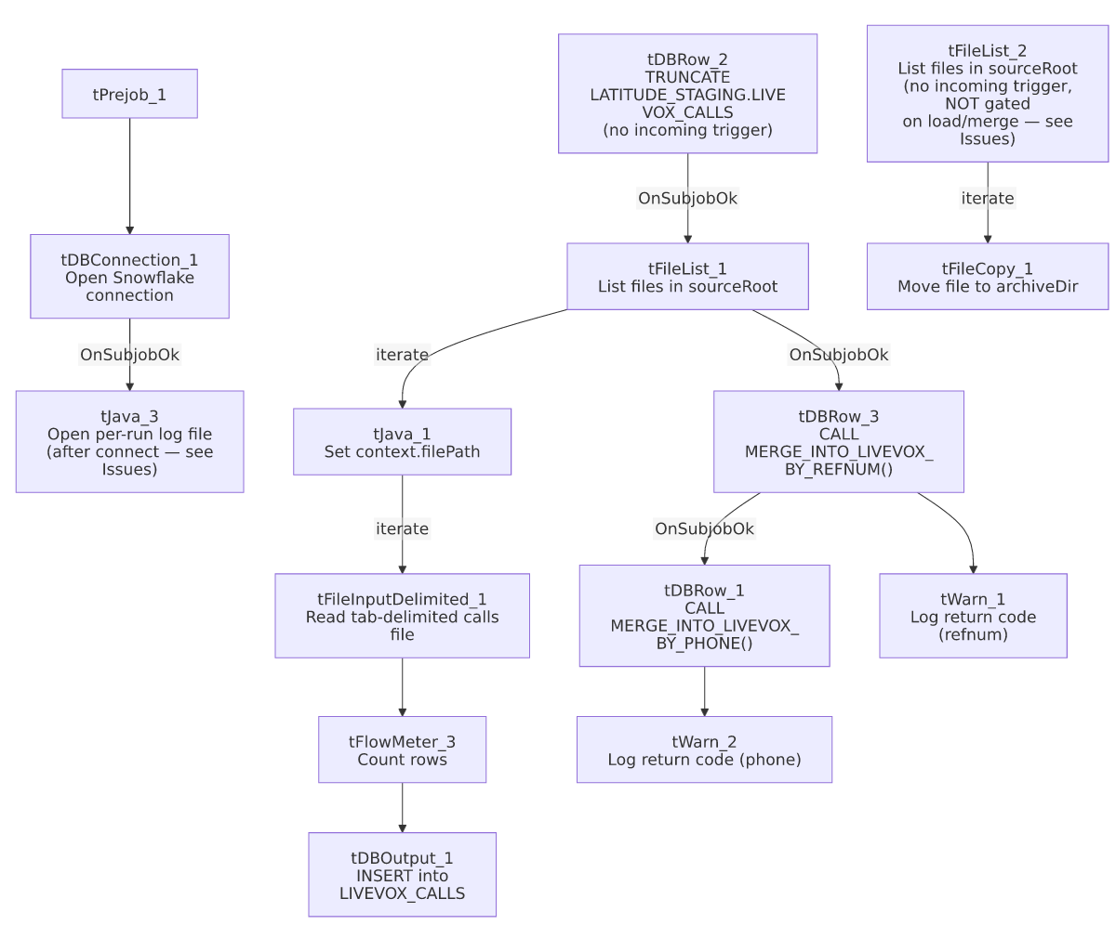

Settings tables

Staging reset: `tDBRow_2`
Setting | Value | What it means
Query | TRUNCATE TABLE LATITUDE_STAGING.LIVEVOX_CALLS; | Clears the staging table before this run's files are loaded.

Source: `tFileInputDelimited_1`
Setting | Value | What it means
FILENAME | context.filePath | Current file from tFileList_1's iteration over context.sourceRoot.
FIELDSEPARATOR / HEADER | \t (tab) / 1 header row | Tab-delimited Livevox export format.
DIE_ON_ERROR | false | Malformed rows don't fail the job...
Reject flow | Not wired | ...but (same as ADP_Payroll_Load) no connection carries rejected rows anywhere — silently dropped. Contrast Livevox_Sample_Load, which does wire (though disable) a reject output.

Target: `tDBOutput_1` (`tSnowflakeOutput`)
Setting | Value | What it means
Table | LIVEVOX_CALLS | Destination staging table, relies on the earlier tDBRow_2 truncate rather than truncating itself.
Output action / Table action | INSERT / NONE | Appends; safe because the whole table was truncated once before the file loop began.

Merge steps: `tDBRow_3` / `tDBRow_1` (`tSnowflakeRow`)
Setting | Value | What it means
Query (refnum, runs first) | CALL LATITUDE_STAGING.MERGE_INTO_LIVEVOX_BY_REFNUM(); | Merges staged calls into the warehouse by matching on an internal reference number.
Query (phone, runs second) | CALL LATITUDE_STAGING.MERGE_INTO_LIVEVOX_BY_PHONE(); | Merges staged calls into the warehouse by matching on phone number — presumably a fallback/secondary match strategy for calls without a usable reference number.
Result handling | RETVALUE → tMap → tWarn | Logged as a warning only; a bad merge result does not fail the job.

Archive: `tFileCopy_1`
Setting | Value | What it means
FILENAME / DESTINATION | current file from tFileList_2 / context.archiveDir | Moves (not copies — REMOVE_FILE=true) each source file to the archive directory.

Dependencies & configuration
- Triggers/depends on other jobs: none — no tRunJob links found (runjob_targets is empty).
- Context variables used: archiveDir, filePath, logDir, sourceRoot.
- 1 hardcoded path finding: tFileInputDelimited_1.TEMP_DIR = "C:/Talend-Studio-20211109_1610-V8.0.1/workspace".

Glossary
Component type | Plain-English meaning
tFileList | Lists files in a directory for the job to iterate over one at a time.
tFileInputDelimited | Reads a delimited (here, tab-separated) text file according to a schema.
tSnowflakeRow | Runs an arbitrary SQL statement or stored-procedure call against Snowflake.
tWarn | Logs a warning without failing the job.
tFileCopy | Copies (or, with REMOVE_FILE=true, moves) a file from one location to another.
tFlowMeter | Counts rows passing a point in the flow, for logging/monitoring.

Issues observed
- This job's staging table and merge procedures are all namespaced `LATITUDE_STAGING.*`, despite living in the EDW2SF project. Per 01_system_architecture.md, LATITUDE is documented as a separate, distinct Talend project from EDW2SF. This strongly suggests either (a) LATITUDE_STAGING is a genuinely shared Snowflake schema used by both projects, or (b) this job (and its sibling Livevox_Sample_Load) was copied from the LATITUDE project's job set and the schema reference was never updated to an EDW2SF-appropriate name — the same class of copy-paste-and-not-fully-updated issue documented in ADP_Payroll_Load (which copies from ADP_Roster_Load). Verify with the team which is the case; if it's (b) and LATITUDE_STAGING doesn't actually exist in this project's Snowflake environment, this job would fail entirely.
- The archive step (`tFileList_2` → `tFileCopy_1`) has no wiring connecting it to the load-and-merge chain at all — it's an entirely separate, unconnected component graph within the same job, with its own independent tFileList_2 (no incoming trigger). In Talend, subjobs with no explicit ordering between them do not have a guaranteed relative execution order. This means the archive/move-to-`archiveDir` step could run before, during, or after the load-and-merge chain, with no guarantee the files being archived have actually been loaded and merged successfully yet. This is a genuine data-integrity risk: a file could be moved out of sourceRoot (and thus out of tFileList_1's view, if the two tFileList components happen to run concurrently) before or without it ever being loaded. Verify with the team whether Talend Studio's actual subjob execution order (not captured in this metadata) enforces the load to run first, or whether this is an unaddressed race condition.
- `tDBRow_2` (the truncate) and `tFileList_2` (the archive list) both have no incoming trigger connection, making them independent starting points in the same job — same root cause as the above finding.
- No reject-row handling on tFileInputDelimited_1 — unlike Livevox_Sample_Load, which at least wires (if inactive) a reject-file output.
- Both merge procedures only warn on failure, never `tDie` — consistent with the truncate-load-merge-warn pattern flagged project-wide for merge-result handling in 05_operational_runbook.md, but worth knowing that a persistently failing MERGE_INTO_LIVEVOX_BY_PHONE/_BY_REFNUM would not stop this job from reporting success.

