Talend Job: Livevox_Sample_Load

Overview
Loads Livevox call-result files (the same tab-delimited "calls" format as Livevox_Daily_Load) from multiple subdirectories under context.sourceRoot — one per value in a tForeach loop — into the same Snowflake staging table used by the daily job, then merges by phone number and reference number. This looks like a bulk/backfill or per-client "sample" loader that processes a set of directories in one run rather than a single daily inbox, sharing target tables with Livevox_Daily_Load but differing in several structural details (see Issues observed).

Detail table
Field | Value
Job name | Livevox_Sample_Load
Version | 0.1
Project | EDW2SF
Author | jmach@harriscollect.com
Created | 2024-12-23T09:49:28.214-0800
Last Modified | 2025-09-24T11:00:27.048-0700

Step-by-step data flow
Setup subjob: tPrejob_1 → tDBConnection_1 opens the Snowflake connection → on SUBJOB_OK, tJava_3 opens a per-run log file (same after-connect ordering as Livevox_Daily_Load).
Main subjob (starts independently — tDBRow_2 has no incoming trigger, same pattern as Livevox_Daily_Load):
- tDBRow_2 runs TRUNCATE TABLE LATITUDE_STAGING.LIVEVOX_CALLS; → on SUBJOB_OK, tForeach_1 iterates over a fixed list of values (the list itself isn't captured in this metadata, same limitation documented in Semaphore_Check).
- For each value (ITERATE), tJava_2 sets context.subDir to the current value → tFileList_1 lists files in context.sourceRoot + context.subDir (a per-iteration subdirectory, unlike Livevox_Daily_Load's single fixed sourceRoot) → for each file (ITERATE), tJava_1 sets context.filePath → tFileInputDelimited_1 reads the tab-delimited "calls" file → the flow splits:
- FLOW → tDBOutput_1 inserts into Snowflake LIVEVOX_CALLS (INSERT, tableAction=NONE).
- REJECT → tFileOutputDelimited_1 would write rejected rows to context.logDir + "livevox_error.tsv" — but this component is deactivated (`ACTIVATE=false`), so despite being wired, it does not actually run; see Issues observed.
- Once the entire tForeach_1 loop (all subdirectories) completes (SUBJOB_OK), tDBRow_1 runs CALL EDWPRODHH.LATITUDE_STAGING.MERGE_INTO_LIVEVOX_BY_PHONE(); first, then on SUBJOB_OK, tDBRow_3 runs CALL EDWPRODHH.LATITUDE_STAGING.MERGE_INTO_LIVEVOX_BY_REFNUM(); — note the merge order (phone, then refnum) is reversed from `Livevox_Daily_Load` (refnum, then phone), and both queries here are fully database-qualified (EDWPRODHH.LATITUDE_STAGING....) whereas Livevox_Daily_Load's equivalents are not — see Issues observed. Neither merge's return code is captured or logged in this job (no tWarn/tMap following these tDBRow components, unlike Livevox_Daily_Load's RETVALUE-to-tWarn pattern).
No archive step exists in this job — files are read and loaded but never moved or deleted from their source subdirectories, unlike Livevox_Daily_Load.
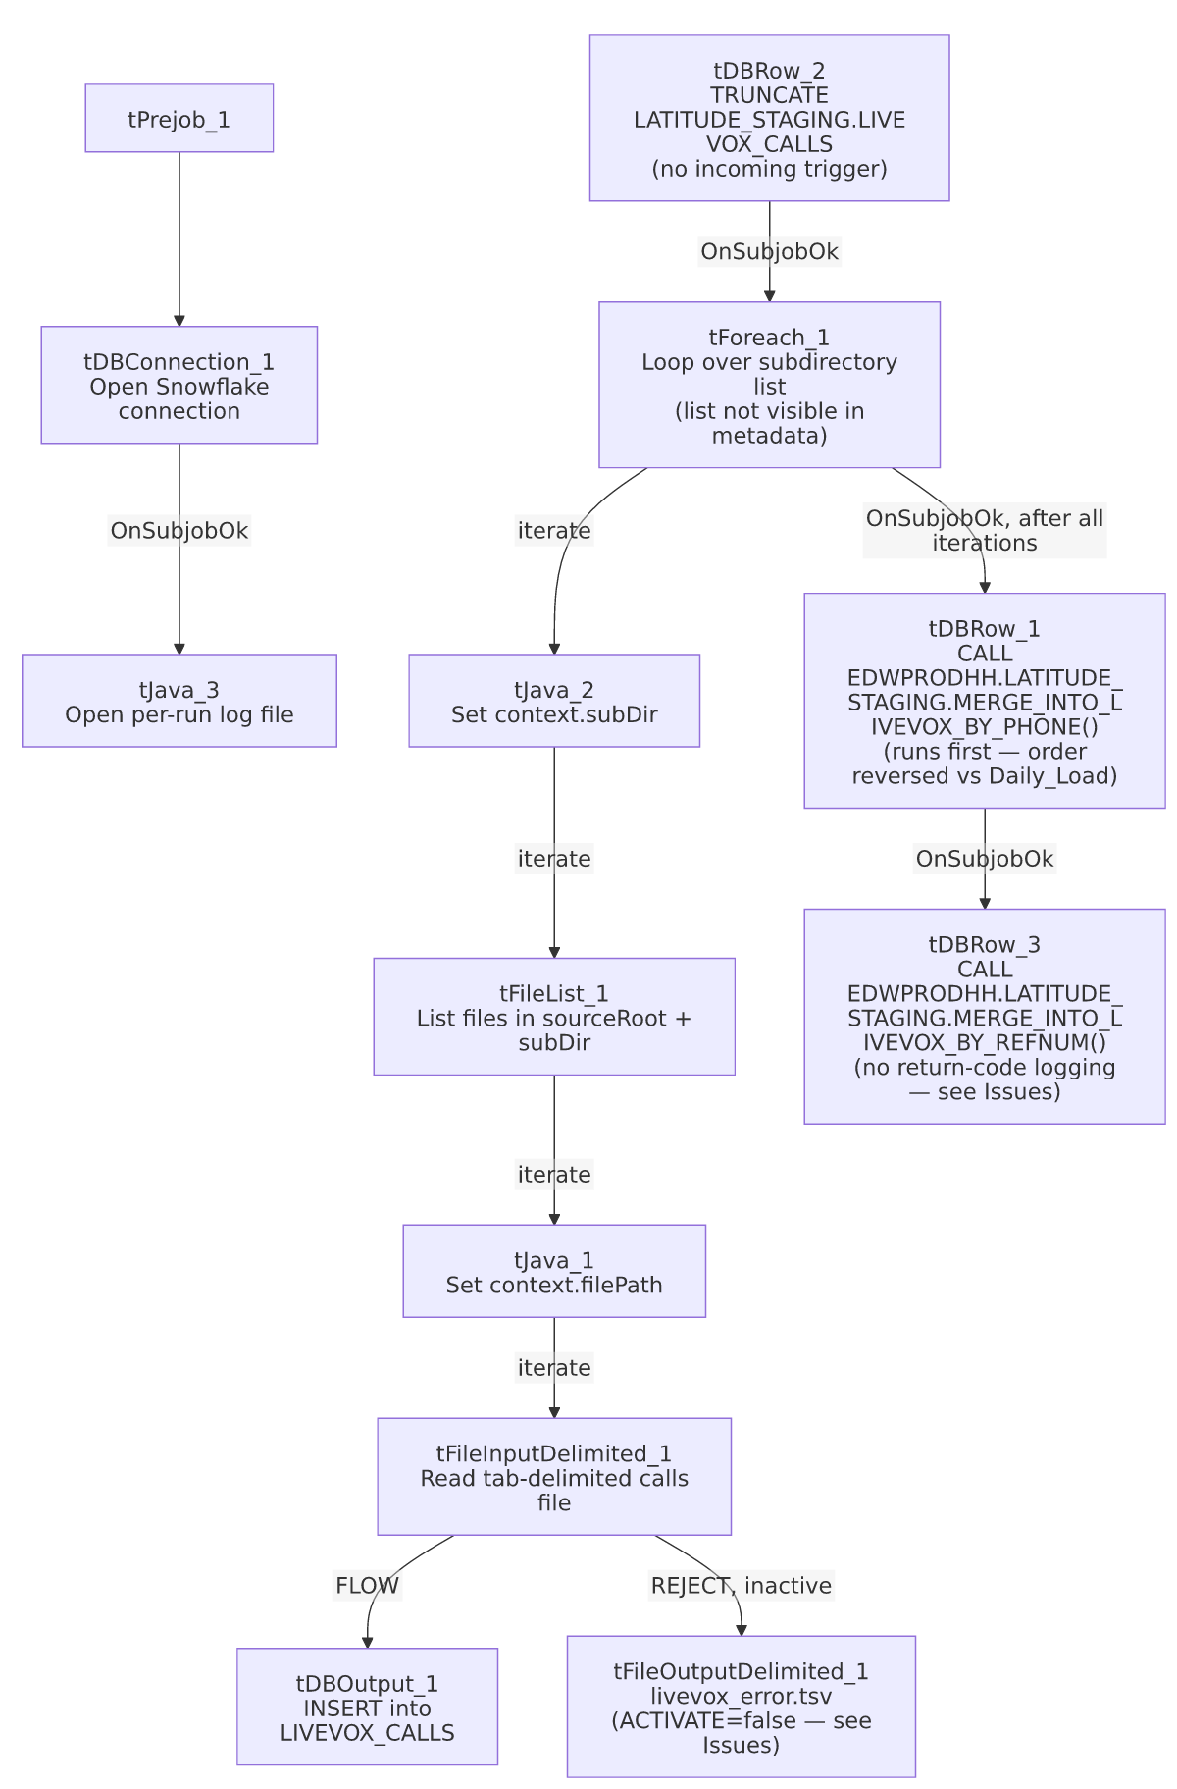

Settings tables

Loop: `tForeach_1` / `tJava_2`
Setting | Value | What it means
Value list | Not captured in this metadata | Same limitation as Semaphore_Check's tForeach_1 — unable to determine how many subdirectories/values this job processes per run.
tJava_2 | context.subDir = ((String)globalMap.get("tForeach_1_CURRENT_VALUE")); | Each loop iteration points tFileList_1 at a different subdirectory.

Source: `tFileInputDelimited_1`
Setting | Value | What it means
FILENAME | context.filePath | Current file from tFileList_1's iteration over context.sourceRoot + context.subDir.
REJECT wiring | Wired to tFileOutputDelimited_1, but that component has ACTIVATE=false | The job's design includes reject-row logging to a TSV file, but it's switched off — rejected rows are effectively silently dropped despite the pipeline looking, at a glance, like it handles them.

Target: `tDBOutput_1` (`tSnowflakeOutput`)
Setting | Value | What it means
Table | LIVEVOX_CALLS | Same destination table as Livevox_Daily_Load — both jobs load into the same staging table, so running them close together could interleave their inserts (the truncate only happens once per job run, at the start of each job).
Output action / Table action | INSERT / NONE | Appends across all subdirectories processed by the tForeach_1 loop.

Merge steps: `tDBRow_1` / `tDBRow_3`
Setting | Value | What it means
Query 1 (runs first) | CALL EDWPRODHH.LATITUDE_STAGING.MERGE_INTO_LIVEVOX_BY_PHONE(); | Fully database-qualified, unlike Livevox_Daily_Load's unqualified LATITUDE_STAGING.MERGE_INTO_LIVEVOX_BY_PHONE().
Query 2 (runs second) | CALL EDWPRODHH.LATITUDE_STAGING.MERGE_INTO_LIVEVOX_BY_REFNUM(); | Same procedure as Livevox_Daily_Load calls, but no return-code capture/logging follows it here.

Dependencies & configuration
- Triggers/depends on other jobs: none — no tRunJob links found (runjob_targets is empty).
- Context variables used: filePath, logDir, sourceRoot, subDir.
- 1 hardcoded path finding: tFileInputDelimited_1.TEMP_DIR = "C:/Talend-Studio-20211109_1610-V8.0.1/workspace".

Glossary
Component type | Plain-English meaning
tForeach | Loops over a fixed list of values (defined in the component's own configuration), running the same downstream steps once per value.
tFileList | Lists files in a directory for the job to iterate over one at a time.
tFileInputDelimited | Reads a delimited (here, tab-separated) text file according to a schema.
tSnowflakeRow | Runs an arbitrary SQL statement or stored-procedure call against Snowflake.
tFileOutputDelimited | Writes rows to a delimited text file — here, present but deactivated.

Issues observed
- The reject-row output (`tFileOutputDelimited_1`) is wired but deactivated (`ACTIVATE=false`). This is a more advanced (if unfinished) error-handling design than Livevox_Daily_Load's complete absence of a reject flow — someone built the reject-logging path here and then switched it off, or built it as a template for future activation. Either way, rejected rows are currently dropped with no record, same practical outcome as Livevox_Daily_Load despite the more complete-looking wiring. Verify with the team whether this should be turned on.
- Neither merge procedure's return code is captured or logged in this job, unlike Livevox_Daily_Load's RETVALUE→tWarn pattern for the same two procedures. A failed merge here produces no job-specific signal at all — only a generic Talend execution error if the CALL statement itself throws, and no warning if the procedure runs but reports an internal failure via its return value.
- This job shares its destination table (`LIVEVOX_CALLS`) and both merge procedures with `Livevox_Daily_Load`, but differs in merge call order (phone-then-refnum here vs. refnum-then-phone in Daily_Load) and in database-qualification (`EDWPRODHH.LATITUDE_STAGING....` here vs. unqualified in Daily_Load). Since both jobs truncate the same staging table at the start of their own run, running them concurrently (or close together) against the same environment would cause one job's truncate to wipe out the other's just-loaded rows before its merge runs — verify with the team that these two jobs are never scheduled to overlap.
- Same cross-project `LATITUDE_STAGING` naming question as `Livevox_Daily_Load` — this job lives in EDW2SF but references a schema/procedure set literally named for the separate LATITUDE project (see that job's Issues observed for the full explanation).
- No archive or cleanup step exists in this job at all — source files in each processed subdirectory are read and loaded but never moved, renamed, or deleted. If this job is re-run against the same subdirectories (e.g., for a genuine "sample" reload), it would simply re-insert the same files' rows again (no truncate-per-subdirectory, only one truncate at the very start of the whole run) — worth confirming this is the intended re-run behavior.

