Talend Job: LoadLegalRpt20231130

Overview
This is a one-time, dated legal report job (built and named for a specific run on November 30, 2023): it reads a hardcoded "Legal Report" CSV export (debtor/patient identity, address, packet/case numbers, balances, admit/discharge/last-payment dates), enriches it with a decrypted patient SSN looked up from the warehouse (scoped specifically to clients named "COLUMBIA D%" — likely Columbia Doctors, a hospital/health-system client referenced elsewhere in this project's runbook), sorts and aggregates the result, then draws a random 350-row sample and writes it to a second hardcoded CSV file. This looks like a one-off legal discovery/audit sample rather than a recurring pipeline — see Issues observed.

Detail table
Field | Value
Job name | LoadLegalRpt20231130
Version | 0.1
Project | EDW2SF
Author | jmach@harriscollect.com
Created | 2023-12-04T09:55:07.105-0800
Last Modified | 2025-09-24T10:59:24.718-0700

Step-by-step data flow
This job has no tPrejob/tPostjob and no explicit tDBConnection/tDBClose — it is a single linear chain with one lookup input:
- tFileInputDelimited_1 reads "C:/Data/Legal Report 20231130.csv" (hardcoded literal, comma-delimited, header row, DIE_ON_ERROR=false) — 20 columns spanning department, patient/debtor identity, address, packet/case references, balances, and key dates.
- tDBInput_1 (tSnowflakeInput) runs SELECT fisc.DEBTOR_NUMBER, COALESCE(fisc.PATIENT_SSN, dd.SSN) AS PATIENT_SSN FROM DIMFISCAL_HH_B fisc INNER JOIN DIMDEBTOR dd ON fisc.DEBTOR_IDX = dd.DEBTOR_IDX INNER JOIN DIMCLIENT dc ON dd.CLIENT = dc.CLIENT WHERE COALESCE(TRIM(fisc.PATIENT_SSN), TRIM(dd.SSN), '') <> '' AND dc.NAME LIKE 'COLUMBIA D%'; — an (encrypted) SSN lookup scoped only to debtors whose client name matches "COLUMBIA D%", even though the main input file's DEPARTMENT column suggests it may span multiple departments/clients; see Issues observed.
- tMap_1 combines the file rows (main) with the SSN lookup (tDBInput_1, presumably joined on DEBTORNUMBER/DEBTOR_NUMBER) and adds PATIENT_SSN to the row shape — the join type (inner vs. left outer) isn't captured in this metadata, so it's unable to determine from metadata whether non-Columbia-Doctors rows are dropped or simply left with a null PATIENT_SSN.
- tDataDecrypt_1 decrypts the (presumably) PATIENT_SSN column using AES (algorithm version 2) with key material from a hardcoded path, "C:/Data/dimdbtr.crypt" (same crypto file used elsewhere in this project, e.g. Legal_Asset_Scrub_Illinois_Counties_Extract's v1); DIE_ON_ERROR=true.
- tFilterRow_5 applies a row filter — its condition is left as unmodified Talend template boilerplate (input_row.columnName1.equals(input_row.columnNam...), the same recurring pattern documented in Last4SSN_Extract and Load_Evergreen_Hours elsewhere in this project; see Issues observed.
- tSortRow_1 sorts the filtered rows (the actual sort key(s) aren't captured in this metadata).
- tAggregateRow_1 is configured with only generic settings visible (LIST_DELIMITER, USE_FINANCIAL_PRECISION) — no group-by key or aggregation operation is captured in this metadata, and its output schema is identical, column-for-column, to its input schema (no summed/counted columns added). Unable to determine what this component actually aggregates, or whether it functions as a de-duplication step; see Issues observed.
- tReservoirSampling_1 draws a random sample of exactly 350 rows (SAMPLE_SIZE=350, fixed RANDOM_SEED=12345678 for reproducibility).
- tFileOutputDelimited_1 writes the sampled rows to "C:/Data/LegalReport20231130_1.csv" (hardcoded literal, comma-delimited, header included, ISO-8859-15 encoding).
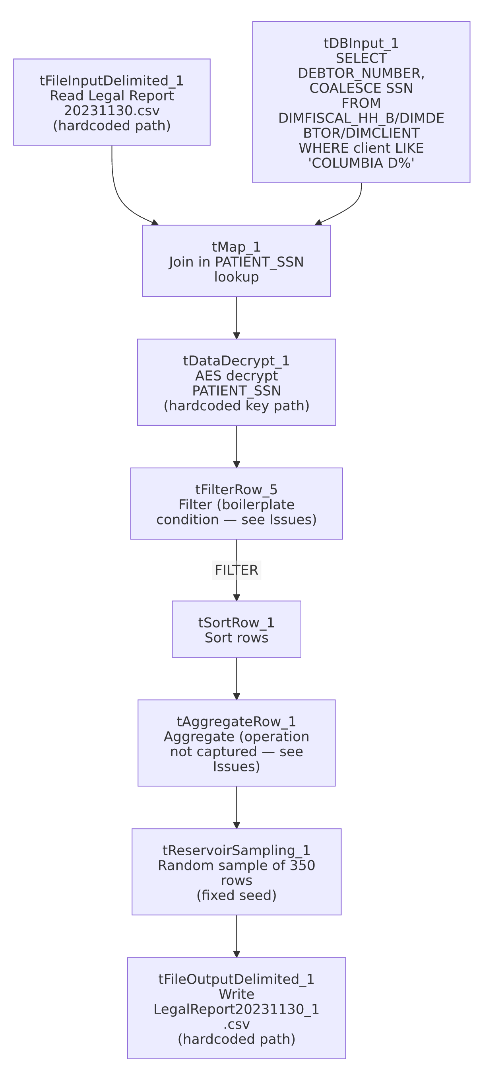

Settings tables

Source: `tFileInputDelimited_1`
Setting | Value | What it means
FILENAME | "C:/Data/Legal Report 20231130.csv" | Hardcoded literal, dated filename — no context-variable indirection at all in this job.
DIE_ON_ERROR | false | Malformed rows don't fail the job...
Reject flow | Not wired | ...but no connection carries rejected rows anywhere — silently dropped.

Lookup: `tDBInput_1` (`tSnowflakeInput`)
Setting | Value | What it means
Query | SELECT fisc.DEBTOR_NUMBER, COALESCE(fisc.PATIENT_SSN, dd.SSN) AS PATIENT_SSN FROM DIMFISCAL_HH_B fisc INNER JOIN DIMDEBTOR dd ON fisc.DEBTOR_IDX = dd.DEBTOR_IDX INNER JOIN DIMCLIENT dc ON dd.CLIENT = dc.CLIENT WHERE COALESCE(TRIM(fisc.PATIENT_SSN), TRIM(dd.SSN), '') <> '' AND dc.NAME LIKE 'COLUMBIA D%'; | Restricts the SSN source data to one client family (name pattern "COLUMBIA D%") — see Issues observed for the scope mismatch against the main file's apparent multi-department content.

Transform: `tDataDecrypt_1`
Setting | Value | What it means
CRYPTO_FILE_PATH | "C:/Data/dimdbtr.crypt" (hardcoded literal) | Same hardcoded-path pattern flagged in Legal_Asset_Scrub_Illinois_Counties_Extract (v1) elsewhere in this project.
DIE_ON_ERROR | true | A decryption failure fails the job outright.

Sampling: `tReservoirSampling_1`
Setting | Value | What it means
SAMPLE_SIZE | 350 | Draws exactly 350 rows at random from whatever reaches this point in the pipeline (post-filter, post-sort, post-aggregate).
RANDOM_SEED | 12345678 | A fixed seed makes the "random" sample reproducible across re-runs — useful for a legal/audit context where the same sample needs to be regenerable.

Target: `tFileOutputDelimited_1`
Setting | Value | What it means
FILENAME | "C:/Data/LegalReport20231130_1.csv" | Hardcoded literal output path — the _1 suffix suggests this may be one of possibly multiple output variants for this report date.

Dependencies & configuration
- Triggers/depends on other jobs: none — no tRunJob links found (runjob_targets is empty), and this job is not listed as a caller or target in 06_dependency_matrix.md. Note 05_operational_runbook.md separately documents a job named Columbia_Doctors_Legal_Rpt (in its email-on-failure list) — this job (LoadLegalRpt20231130) is a different job and does not call or get called by it per this job's own metadata; the relationship between the two (if any) is unable to determine from metadata.
- Context variables used: none — context_vars_referenced is empty.
- 2 hardcoded path findings: tFileInputDelimited_1.TEMP_DIR and tSortRow_1.TEMPFILE (both C:/Talend-Studio-20211109_1610-V8.0.1/workspace/...) — plus the source FILENAME, the crypto key path, and the output FILENAME, all also hardcoded literals not captured in the hardcoded_path_findings array.

Glossary
Component type | Plain-English meaning
tFileInputDelimited / tFileOutputDelimited | Read/write a delimited (CSV-style) text file.
tSnowflakeInput | Runs a query against Snowflake and returns its result rows.
tMap | Maps/transforms columns from one schema to another, and can join multiple input flows (here, joining the file with a database lookup).
tDataDecrypt | Decrypts a column's value using a stored key/algorithm.
tFilterRow | Passes rows through only if they meet a configured condition.
tSortRow | Sorts rows by one or more configured columns.
tAggregateRow | Groups rows and computes aggregate values (sums, counts, etc.) per group — configuration not fully captured for this instance; see Issues observed.
tReservoirSampling | Selects a fixed-size random sample from a stream of rows, useful when the total row count isn't known in advance.

Issues observed
- The SSN lookup query is scoped only to clients named "COLUMBIA D%" (`dc.NAME LIKE 'COLUMBIA D%'`), while the main input file includes a `DEPARTMENT` column suggesting it spans more than one department/client. If the source CSV contains legal-report rows for clients other than Columbia Doctors, those rows would either be dropped (if tMap_1's join is an inner join) or pass through with a null PATIENT_SSN (if it's a left outer join) — the join type isn't captured in this metadata. Verify in Talend Studio which join type tMap_1 uses, since it materially changes whether this job silently narrows the report to one client or produces a report with missing SSNs for everyone else.
- `tAggregateRow_1`'s actual grouping key and aggregation operation(s) are not captured in this metadata, and its output schema is identical to its input — no summed, counted, or otherwise aggregated column is visible anywhere downstream. This makes it unable to determine from metadata whether this component is doing meaningful aggregation (e.g., collapsing duplicate debtor rows) or is effectively a no-op / mis-configured pass-through. Verify directly in Talend Studio.
- `tFilterRow_5`'s condition is unmodified Talend template boilerplate (input_row.columnName1.equals(input_row.columnNam...) — the same class of finding now documented in at least three jobs in this project (Last4SSN_Extract, Load_Evergreen_Hours, and this job). This continues to support treating it as a project-wide pattern worth auditing across all tFilterRow components, not a one-off oversight.
- Every path in this job (source file, crypto key, output file) is a hardcoded literal embedding a specific date, and there are zero context variables in use. Combined with the job name itself (LoadLegalRpt20231130) and the very specific "Legal Report 20231130.csv" / "LegalReport20231130_1.csv" filenames, this strongly indicates a one-time job built for a single historical legal request rather than a recurring pipeline. If it's still present and runnable in the active job repository, verify with the team whether it should be archived/disabled to avoid confusion with any current, similarly-purposed recurring job (e.g., Columbia_Doctors_Legal_Rpt).
- This job decrypts and writes patient SSNs to a flat file intended for a legal proceeding — confirm the file's handling (storage location, retention, access) meets this organization's data-handling requirements for sensitive PII used in litigation contexts, especially given the file paths point to a local C:/Data/ directory rather than a managed/audited location.
- No error/row-count logging beyond DIE_ON_ERROR=true on the decrypt step, and no reject-row handling on the file input.

