Talend Job: Load_837_Files

Overview
Loads raw healthcare claim files (the "837" name is the standard ANSI X12 837 electronic health-care-claim transaction format) from a network drop-zone directory into Snowflake as bulk raw content, then separately lists and archives files out of a year-scoped source directory. This looks like an ingestion pipeline for an external healthcare partner's claim files (IUHC in the hardcoded path — likely a partner/payer name) rather than a structured column-by-column load: files are read as raw byte streams and bulk-loaded, not parsed into business columns.

Detail table
Field | Value
Job name | Load_837_Files
Version | 0.1
Project | EDW2SF
Author | jmach@harriscollect.com
Created | 2025-08-06T10:29:52.135-0700
Last Modified | 2026-02-26T10:24:54.183-0800

Step-by-step data flow
Setup subjob: tPrejob_1 → tJava_3 opens a per-run log file at context.logDir + jobName + "_" + <timestamp> + ".log" → on subjob-ok, tJava_2 computes context.fileYear as the current calendar year, then rebuilds context.sourceDir as Paths.get(context.sourceDir, context.fileYear) and recomputes context.archiveDir similarly (the archive-dir expression is truncated in this metadata) → on subjob-ok, tSetKeystore_1 configures SSL trust/keystore from context.keystorePath (passwords redacted) → on subjob-ok, tDBConnection_1 opens the Snowflake connection.
Main subjob, phase 1 — bulk-load raw file content (runs independently of the setup chain in the component graph):
- tFileList_1 lists files (non-recursive) in the hardcoded directory "G:/Analytics_Team/Drop_zone/IUHC/837_FILES_IN/2025" — note the year "2025" is a literal string here, not derived from context.fileYear the way the setup subjob computes it; see Issues observed. An EXCLUDEFILEMASK of *.txt is configured but IFEXCLUDE=false, so (same pattern as ADP_Payroll_Load in this project) the exclusion is not actually applied.
- For each file (ITERATE), tJava_1 sets context.filePath from tFileList_1's current file path.
- tFileInputRaw_1 reads the file's entire content as a raw InputStream (schema: a single content column of type id_Object) — DIE_ON_ERROR=false, so a file that can't be read is skipped rather than failing the job.
- tFlowMeter_2 counts files/rows passing through (labeled "MyLabel").
- tDBOutputBulk_1 (tSnowflakeOutputBulk) bulk-loads the raw content into Snowflake — the destination table name is not captured in this job's metadata (its db block is empty); see Issues observed.
Main subjob, phase 2 — archive source files (triggered by tFileList_1's SUBJOB_OK, i.e. after the entire phase-1 loop completes):
- tFileList_2 lists files (non-recursive, glob expressions enabled) in context.sourceDir — this is the dynamically year-scoped directory computed by tJava_2 in the setup subjob, which may or may not be the same physical directory tFileList_1 hardcoded in step 1; see Issues observed. The same unapplied *.txt exclusion mask appears here too.
- For each file (ITERATE), tJava_4 sets context.filePath from tFileList_2's current file path.
- tFileCopy_1 moves the file to context.archiveDir (REMOVE_FILE=true, REPLACE_FILE=true, CREATE_DIRECTORY=true) — effectively an archive-and-delete-from-source operation, not a plain copy.
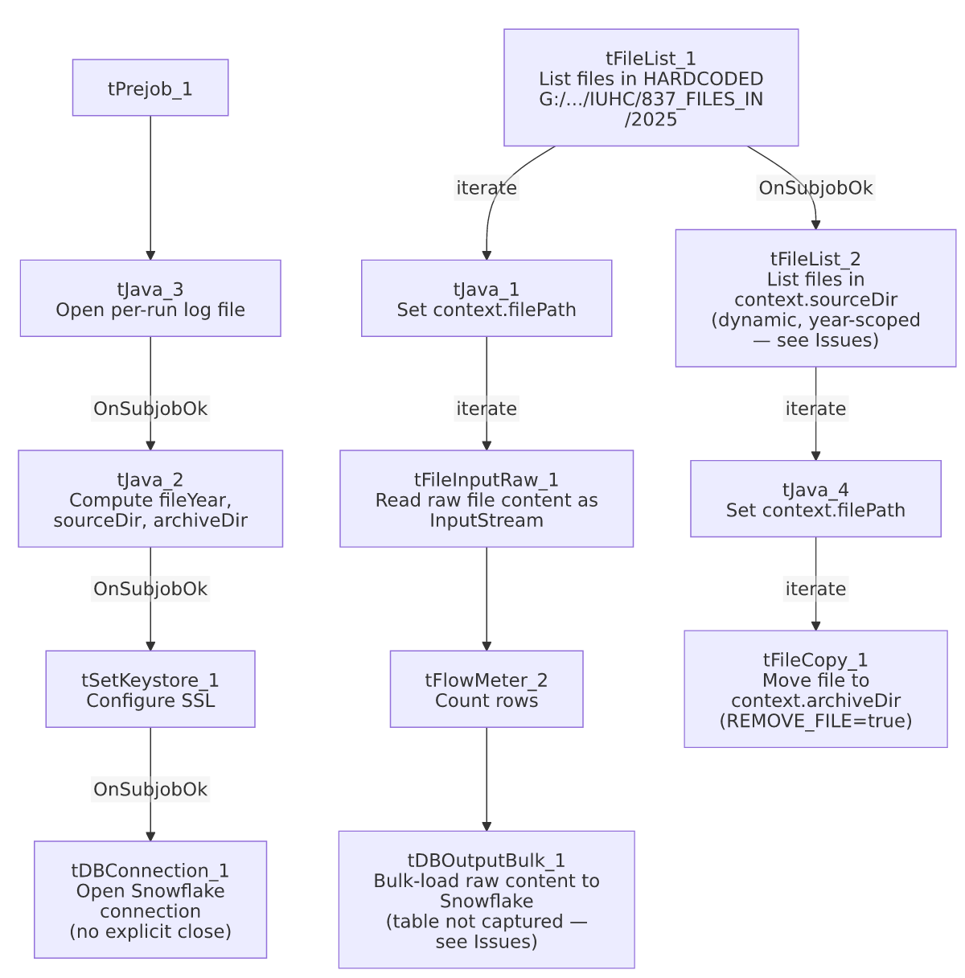

Settings tables

Source: `tFileList_1`
Setting | Value | What it means
DIRECTORY | "G:/Analytics_Team/Drop_zone/IUHC/837_FILES_IN/2025" | Hardcoded network-share path with a literal year — the drop zone where the partner ("IUHC") lands incoming 837 claim files.
EXCLUDEFILEMASK / IFEXCLUDE | "*.txt" / false | Exclusion mask configured but not applied — every file in the directory is picked up regardless of extension, same unused-exclusion pattern seen in ADP_Payroll_Load.

Read: `tFileInputRaw_1`
Setting | Value | What it means
FILENAME | context.filePath | Current file from tFileList_1's iteration.
AS_INPUTSTREAM | true | Reads the file as a raw byte stream rather than parsing it as delimited/structured text — appropriate for an EDI-format file that isn't meant to be column-split here.
DIE_ON_ERROR | false | A file that fails to read is skipped, not fatal to the job.

Target: `tDBOutputBulk_1` (`tSnowflakeOutputBulk`)
Setting | Value | What it means
Table | Not captured in this job's metadata (db block is empty) | Unable to determine from metadata which Snowflake table receives the bulk-loaded raw file content — verify directly in Talend Studio.

Archive: `tFileCopy_1`
Setting | Value | What it means
FILENAME / DESTINATION | context.filePath / context.archiveDir | Moves the current file (from tFileList_2's iteration) into the archive directory.
REMOVE_FILE / REPLACE_FILE | true / true | Deletes the original after copying (a move, not a copy) and overwrites if a same-named file already exists at the destination.
SOURCE_DERECTORY (hardcoded, unused in this mode) | "C:/Talend-Studio-20211109_1610-V8.0.1/workspace" | A directory-copy-mode setting left at its default Talend-Studio-workspace value; since ENABLE_COPY_DIRECTORY=false, this field is not actually used for the single-file copy this job performs — but it's still a hardcoded developer-workstation path sitting in the job's configuration.

Dependencies & configuration
- Triggers/depends on other jobs: none — no tRunJob links found (runjob_targets is empty).
- Context variables used: archiveDir, filePath, fileYear, keystorePath, logDir, sourceDir.
- 2 hardcoded path findings: tFileCopy_1.SOURCE_DERECTORY = "C:/Talend-Studio-20211109_1610-V8.0.1/workspace" (the project-wide developer-workstation path pattern from 05_operational_runbook.md, though inactive here per above) and tSetKeystore_1.SSL_TRUSTSERVER_TRUSTSTORE = "C:/clientTrustStore.trustStore". The drop-zone directory itself ("G:/Analytics_Team/Drop_zone/IUHC/837_FILES_IN/2025") is also a hardcoded, year-literal path, though it wasn't flagged in the hardcoded_path_findings array (likely because the extraction's path-detection targets specific known parameter names).

Glossary
Component type | Plain-English meaning
tFileList | Lists files in a directory for the job to iterate over one at a time.
tFileInputRaw | Reads a file's entire content as raw bytes/an input stream, without parsing it into columns.
tSnowflakeOutputBulk | Bulk-loads data into a Snowflake table, typically faster than row-by-row insert for large volumes.
tFileCopy | Copies (or, with REMOVE_FILE=true, moves) a file from one location to another.
tFlowMeter | Counts rows/files passing a point in the flow, for logging/monitoring.
tSetKeystore | Configures SSL trust/keystore settings for the job's outbound connections.

Issues observed
- `tFileList_1`'s source directory hardcodes the year "2025" as a literal string (.../837_FILES_IN/2025), while the setup subjob's tJava_2 computes context.fileYear dynamically from the current date and uses it to build a year-scoped context.sourceDir for the *separate* tFileList_2 archive step. This means the job's load phase (phase 1, reading from the hardcoded 2025 path) and its archive phase (phase 2, reading from the dynamically computed context.sourceDir) are not guaranteed to be looking at the same directory — in fact, from 2026 onward, tFileList_2 would look at a "2026" subdirectory while tFileList_1 would still be pointed at "2025." This is a likely functional bug: either the job will stop loading new files once the drop zone rolls over to a new year's folder (if the drop zone itself is year-partitioned to match), or the archive step will find nothing to move (if context.sourceDir's base differs from the drop-zone path) while phase 1 keeps loading from the same static 2025 folder indefinitely. Unable to determine the intended directory structure from metadata alone — verify with the team before this job runs past 2025, or confirm it was already caught and is scheduled for correction.
- `tDBOutputBulk_1`'s destination table is not captured in this metadata — its db configuration block is empty. Which Snowflake table receives this partner's raw 837 file content is unable to determine from metadata; verify directly in Talend Studio.
- `tJava_2`'s archive-directory computation is truncated in this metadata (context.archiveDir = Paths.get(... cuts off) — the exact archive path structure isn't fully visible; verify the full expression in Talend Studio before assuming where archived files land.
- No `tPostjob`/`tDBClose` component exists in this job — the Snowflake connection opened by tDBConnection_1 is never explicitly closed, same gap as LW_TPL_PMT_REPORT and Last4SSN_Extract elsewhere in this batch.
- No error/row-count logging specific to the bulk-load outcome (no tWarn/tDie) — if the bulk load silently fails or loads zero rows, nothing in this job's own components would flag it beyond a generic Talend execution error.
- The unapplied `EXCLUDEFILEMASK`/`IFEXCLUDE=false` pattern appears on both `tFileList_1` and `tFileList_2` — same as ADP_Payroll_Load's documented issue: the *.txt exclusion is configured but never actually takes effect, so any stray .txt file dropped in either directory would be picked up and processed like any other file.

