Talend Job: Load_Debtor_New_Columns

Overview
Loads a small set of newly-added debtor fields — cancellation reason, department ID, a "Spring Four" flag (likely referencing the SpringFour financial-hardship assistance program), and an offer-status code — from the legacy EDWProdHH MSSQL table dbo.DimDebtor_A into a Snowflake staging table (SPRING_FOUR), but only for debtors where at least one of those fields is actually populated. It then merges those values into the main DW.DIMDEBTOR dimension table. This looks like a narrowly scoped job built to backfill/sync a handful of specific columns rather than a full debtor reload.

Detail table
Field | Value
Job name | Load_Debtor_New_Columns
Version | 0.1
Project | EDW2SF
Author | jmach@harriscollect.com
Created | 2022-09-06T12:55:22.502-0700
Last Modified | 2025-09-24T11:08:33.697-0700

Step-by-step data flow
Setup subjob: tPrejob_1 → tDBConnection_1 opens the Snowflake connection → on COMPONENT_OK, tDBConnection_2 opens the MSSQL connection to context.EDWProdHH_Server/Port/Schema/Database/Login (password redacted, JTDS driver). No `tSetKeystore` and no per-run log file are configured in this job, unlike most file/report-extract jobs in this project — see Issues observed.
Main subjob (runs independently of the setup chain, relying on shared connections):
- tDBInput_1 runs a query (using the shared tDBConnection_2 MSSQL connection) against dbo.DimDebtor_A, selecting DEBTOR_IDX, CANCEL_REASON, DEPARTMENT_ID, SPRING_FOUR, SF_OFFER_ST filtered to only rows where at least one of those four columns is non-blank (WHERE RTRIM(COALESCE(CANCEL_REASON,'')) <> '' OR ... OR ... — the query text is truncated in this metadata after the third OR, so the exact condition on SF_OFFER_ST isn't fully visible).
- tMap_1 passes the rows through unchanged in shape (DIE_ON_ERROR=true).
- tDBOutput_1 writes to Snowflake table SPRING_FOUR with outputAction=INSERT and tableAction=TRUNCATE — the staging table is cleared and reloaded every run.
- Separately, tDBInput_1 also connects on SUBJOB_OK directly to tDBRow_1, which runs UPDATE DW.DIMDEBTOR db FROM STAGING.SPRING_FOUR sf SET CANCEL_REASON = sf.CANCEL_REASON, DEPARTMENT_ID = sf.DEPARTMENT_ID, SPRING_FOUR = sf.SPRING_FOUR, SF_OFFER_ST = sf.SF_OFFER_ST WHERE db.DEBTOR_IDX = sf.DEBTOR_IDX; — this fires once the MSSQL SELECT completes, not once the full extract→map→load chain into SPRING_FOUR finishes; see Issues observed (same pattern flagged in Last4SSN_Extract in this batch).
Teardown subjob: tPostjob_1 → tDBClose_1 closes the Snowflake connection → on COMPONENT_OK, tDBClose_2 closes the MSSQL connection.
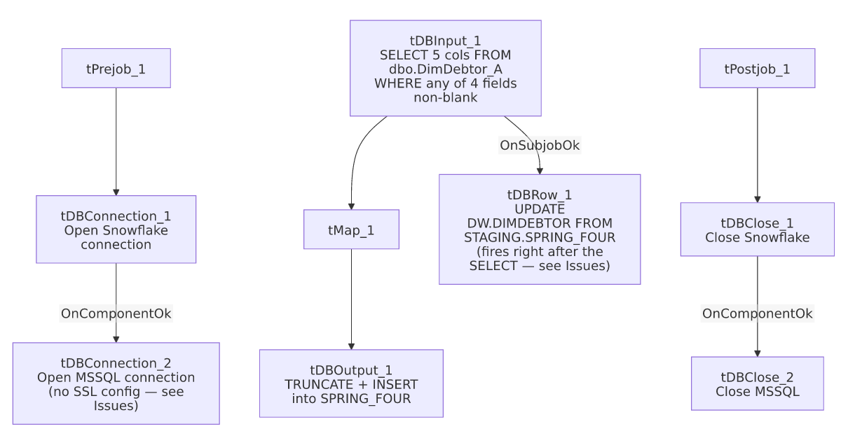

Settings tables

Source: `tDBInput_1` (`tMSSqlInput`)
Setting | Value | What it means
Query | SELECT DEBTOR_IDX, CANCEL_REASON, DEPARTMENT_ID, SPRING_FOUR, SF_OFFER_ST FROM dbo.DimDebtor_A WHERE RTRIM(COALESCE(CANCEL_REASON,'')) <> '' OR RTRIM(COALESCE(DEPARTMENT_ID,'')) <> '' OR RTRIM(COALESCE(SPRING_FOUR,'')) <> '' OR RTRIM(COA... (truncated) | Pulls only debtors with at least one of the four target fields populated — an incremental/delta-style filter, not a full-table pull.

Target: `tDBOutput_1` (`tSnowflakeOutput`)
Setting | Value | What it means
Table | SPRING_FOUR | Staging table for the four fields — shares its name with one of its own columns (SPRING_FOUR), which is a potential source of confusion when reading logs/queries referencing it.
Output action / Table action | INSERT / TRUNCATE | Cleared and reloaded every run.

Merge step: `tDBRow_1` (`tSnowflakeRow`)
Setting | Value | What it means
Query | UPDATE DW.DIMDEBTOR db FROM STAGING.SPRING_FOUR sf SET CANCEL_REASON = sf.CANCEL_REASON, DEPARTMENT_ID = sf.DEPARTMENT_ID, SPRING_FOUR = sf.SPRING_FOUR, SF_OFFER_ST = sf.SF_OFFER_ST WHERE db.DEBTOR_IDX = sf.DEBTOR_IDX; | Overwrites these four columns on DW.DIMDEBTOR for every debtor present in the staging table — note this always overwrites (no IS NULL guard, unlike Last4SSN_Extract's back-fill pattern), so a stale/incomplete SPRING_FOUR reload could blank out or revert previously-set values on DIMDEBTOR.

Dependencies & configuration
- Triggers/depends on other jobs: none — no tRunJob links found (runjob_targets is empty).
- Context variables used: EDWProdHH_Database, EDWProdHH_Login, EDWProdHH_Port, EDWProdHH_Schema, EDWProdHH_Server — the standard EDWProdHH MSSQL connection group (see 01_system_architecture.md).
- No hardcoded path findings in this job.

Glossary
Component type | Plain-English meaning
tMSSqlConnection / tMSSqlInput / tMSSqlClose | Open a Microsoft SQL Server connection, run a query against it, and close it.
tSnowflakeConnection / tSnowflakeOutput / tSnowflakeRow / tSnowflakeClose | Open a Snowflake connection, write rows to a table, run an arbitrary SQL statement, and close the connection.
tMap | Maps/transforms columns from one schema to another.

Issues observed
- The `DIMDEBTOR` merge (`tDBRow_1`) is wired to fire on `tDBInput_1`'s `SUBJOB_OK`, not after the full extract→map→load chain into `SPRING_FOUR` finishes. Both tDBRow_1 and the tMap_1→tDBOutput_1 chain branch off the same tDBInput_1 component. As with Last4SSN_Extract in this same batch, it's unable to determine from this metadata whether Talend's execution ordering guarantees the TRUNCATE+INSERT into SPRING_FOUR completes before the UPDATE ... FROM STAGING.SPRING_FOUR runs — if it doesn't, the merge could read a stale or momentarily-empty SPRING_FOUR table. Verify execution ordering with the team.
- The merge always overwrites `DIMDEBTOR`'s four target columns for every debtor in `SPRING_FOUR`, with no `IS NULL`/change-guard condition (contrast Last4SSN_Extract's AND dd.LAST4SSN IS NULL back-fill guard). Combined with the source query's non-blank filter, this should be safe in the common case, but if SPRING_FOUR ever contained a stale row from a previous, differently-filtered run, this job would blindly re-apply it.
- No `tSetKeystore`/SSL configuration and no per-run log file exist in this job, unlike most other jobs reviewed in this batch that connect to Snowflake — whether that's because this job predates the SSL-setup convention (created 2022-09, one of the earliest jobs in this batch) or because MSSQL-primary jobs in this project don't need it is unable to determine from metadata.
- The query text captured in this metadata is truncated after the third OR condition — the exact filter on SF_OFFER_ST isn't fully visible; verify the complete WHERE clause in Talend Studio before assuming which debtors are included.

