Talend Job: Load_Employee_Collector_History

Overview
Loads periodic employee/collector roster snapshot files (Excel workbooks — name, initials, desk, team, CUBS logon, payroll ID, start/end dates, manager/supervisor/director, title, department, agent type, subgroup) into the Snowflake EMPLOYEE_COLLECTOR_HISTORY table, tagging each loaded row with the file's month/year (parsed from an 8-digit date embedded in the filename itself) so the table accumulates a dated history of roster snapshots over time, rather than reflecting only the current staffing. After each file's rows are loaded, the source file is deleted (with no archive copy — see Issues observed), and once all files for the run are processed, a follow-up SQL statement back-fills a FILE_DATE column for any newly-loaded rows still missing one.

Detail table
Field | Value
Job name | Load_Employee_Collector_History
Version | 0.1
Project | EDW2SF
Author | jmach@harriscollect.com
Created | 2022-10-28T09:41:29.886-0700
Last Modified | 2025-11-04T11:08:13.666-0800

Step-by-step data flow
Setup subjob: tPrejob_1 → tJava_2 opens a per-run log file → on subjob-ok, tSetKeystore_1 configures SSL trust/keystore from context.keystorePath (passwords redacted) → on subjob-ok, tDBConnection_1 opens the Snowflake connection.
Main subjob (runs independently of the setup chain):
- tFileList_1 lists files in context.sourceDir, ordered by modified date, oldest first (ORDER_BY_MODIFIEDDATE=true, ORDER_ACTION_ASC=true) — unlike most other file-iterating jobs in this project, which don't specify an order. The usual unapplied *.txt exclusion mask is present here too.
- For each file (ITERATE), tJava_1 sets context.filePath/context.fileName, then uses a regex (\d{8}) to extract an 8-digit date string embedded in the filename and parses it into a date, presumably populating context.fileDate, context.fileMonth, and context.fileYear (the code is truncated in this metadata after the date-parsing setup, so the exact assignment logic isn't fully visible).
- tFileInputExcel_1 reads the workbook (all sheets, ALL_SHEETS=true, DIE_ON_ERROR=false, password field present and redacted — suggesting these workbooks may be password-protected) using a repository schema labeled "employee," with filemonth/fileyear columns appended to carry the parsed context values alongside each row.
- tJavaRow_1 passes the 17 roster columns plus filemonth/fileyear straight through (code truncated but appears to be a direct field-by-field copy).
- tMap_1 maps to an uppercase target schema and also computes a `FILE_DATE` column (not present in the upstream schema) — but see Issues observed, this computed value is not actually carried through to the database write.
- tFlowMeter_4 counts rows passing through (labeled "ech").
- tDBOutput_1 inserts into Snowflake EMPLOYEE_COLLECTOR_HISTORY (INSERT, tableAction=NONE — append-only, appropriate for a historical/dated table) — its own schema excludes the `FILE_DATE` column that tMap_1/tFlowMeter_4 computed and carried, so FILE_DATE is not populated at insert time; see Issues observed.
- On COMPONENT_OK, tFileDelete_1 deletes the just-loaded source file (context.filePath) — no archive/zip step precedes this deletion, unlike ADP_Payroll_Load's archive-then-delete pattern; see Issues observed.
- Separately, once tFileList_1's entire loop completes (SUBJOB_OK), tDBRow_1 runs UPDATE EMPLOYEE_COLLECTOR_HISTORY SET FILE_DATE = LAST_DAY(DATE_FROM_PARTS(FILE_YEAR::INTEGER, FILE_MONTH, 1)) WHERE FILE_DATE IS NULL; — this is how FILE_DATE actually gets populated: as the last calendar day of the row's file month/year, computed in SQL after all files are loaded, not from tMap_1's per-row computation.
Teardown subjob: tPostjob_1 → tDBClose_1 closes the Snowflake connection.
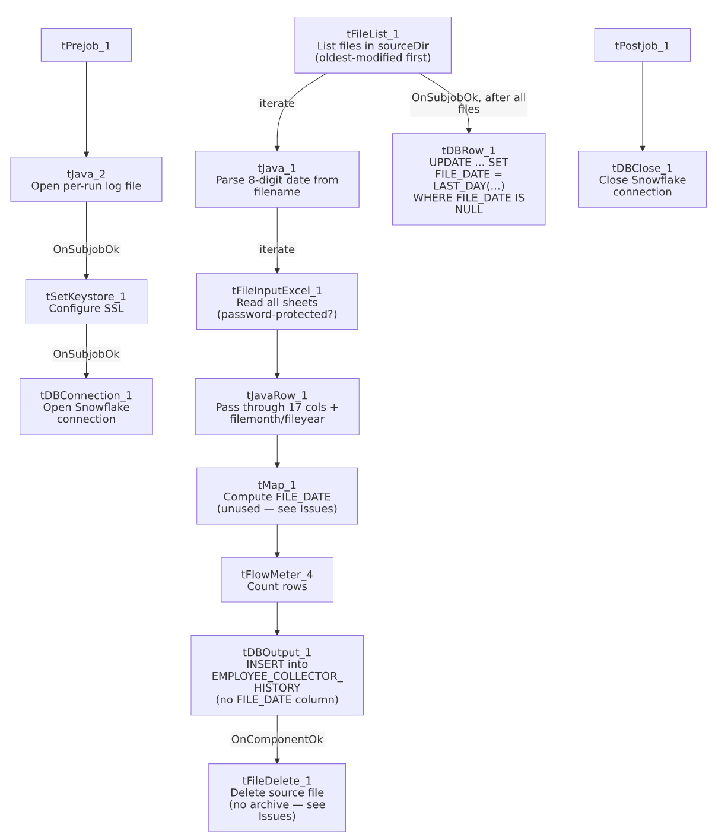

Settings tables

Source: `tFileInputExcel_1`
Setting | Value | What it means
FILENAME | context.filePath | Current file from tFileList_1's iteration.
ALL_SHEETS / AFFECT_EACH_SHEET | true / false | Reads every sheet in the workbook into the same flow, without treating each sheet as a separately-schemaed input.
PASSWORD | ***REDACTED*** | Suggests the source workbooks may be password-protected.
DIE_ON_ERROR | false | Malformed rows don't fail the job...
Reject flow | Not wired | ...but no connection carries rejected rows anywhere (same pattern as several other jobs in this batch) — silently dropped.

Filename parsing: `tJava_1`
Setting | Value | What it means
Regex | \d{8} against context.fileName | Extracts an 8-digit date embedded in the filename (e.g., a YYYYMMDD or MMDDYYYY pattern) to derive the file's reporting month/year. The exact date-format assumption and null/no-match handling are truncated in this metadata — see Issues observed.

Target: `tDBOutput_1` (`tSnowflakeOutput`)
Setting | Value | What it means
Table | EMPLOYEE_COLLECTOR_HISTORY | Append-only historical roster table.
Output action / Table action | INSERT / NONE | No truncate — every file's rows accumulate, consistent with a dated-history design.
Columns | Excludes FILE_DATE (present in tMap_1's output but not here) | FILE_DATE is populated later via tDBRow_1's UPDATE, not at insert time — see Issues observed.

Post-load back-fill: `tDBRow_1`
Setting | Value | What it means
Query | UPDATE EMPLOYEE_COLLECTOR_HISTORY SET FILE_DATE = LAST_DAY(DATE_FROM_PARTS(FILE_YEAR::INTEGER, FILE_MONTH, 1)) WHERE FILE_DATE IS NULL; | Sets FILE_DATE to the last calendar day of the row's file month/year, for any row that doesn't already have one — runs once per job, after the full file loop.

Cleanup: `tFileDelete_1`
Setting | Value | What it means
FILENAME | context.filePath | Deletes the just-processed source file immediately after a successful load of that file.
DIRECTORY / PATH (hardcoded, unused) | "C:/Talend-Studio-20211109_1610-V8.0.1/workspace/delete_folder" / ".../delete_folder or delete_file" | Default template values; FOLDER=false/FOLDER_FILE=false mean actual deletion is single-file via FILENAME.

Dependencies & configuration
- Triggers/depends on other jobs: none — no tRunJob links found (runjob_targets is empty).
- Context variables used: fileDate, fileMonth, fileName, filePath, fileYear, keystorePath, logDir, sourceDir.
- 3 hardcoded path findings: tFileDelete_1.DIRECTORY, tFileDelete_1.PATH (both C:/Talend-Studio-20211109_1610-V8.0.1/workspace/...), and tSetKeystore_1.SSL_TRUSTSERVER_TRUSTSTORE = "C:/clientTrustStore.trustStore".

Glossary
Component type | Plain-English meaning
tFileList | Lists files in a directory for the job to iterate over one at a time.
tFileInputExcel | Reads an Excel workbook, optionally across all sheets, according to a schema.
tJavaRow | Runs custom Java code once per input row.
tMap | Maps/transforms columns from one schema to another.
tFlowMeter | Counts rows passing a point in the flow, for logging/monitoring.
tSnowflakeOutput / tSnowflakeRow / tSnowflakeConnection / tSnowflakeClose | Write rows to a Snowflake table / run arbitrary SQL against Snowflake / open and close the shared connection.
tFileDelete | Deletes a file from disk.
tSetKeystore | Configures SSL trust/keystore settings for the job's outbound connections.

Issues observed
- Source files are deleted immediately after loading, with no archive/backup step first — unlike ADP_Payroll_Load and Load_Evergreen_Hours elsewhere in this project, which zip the source file to an archive directory before (or, in Load_Evergreen_Hours's case, regardless of) deleting it, this job has no tFileArchive component at all. If a load needs to be re-run, corrected, or audited after the fact, the original source workbook is gone — the only surviving record is whatever made it into EMPLOYEE_COLLECTOR_HISTORY. Given these files apparently contain employee personal/organizational data (and may be password-protected), losing the only copy without a retention/archive policy is worth flagging for review.
- `tMap_1` computes a `FILE_DATE` column that is never actually written to the database — it's present in tMap_1's and tFlowMeter_4's schemas but absent from tDBOutput_1's. The real population of FILE_DATE happens via the separate tDBRow_1 UPDATE ... WHERE FILE_DATE IS NULL statement after the load. This isn't necessarily a bug (the end result is the same, and computing it in SQL avoids potential precision differences with a Java-side calculation), but the unused tMap_1 computation is dead work that could confuse future maintainers into thinking FILE_DATE is set at load time — worth cleaning up or documenting.
- The filename date-parsing logic in `tJava_1` is truncated in this metadata, so the exact assumed date format and the behavior when a file's name doesn't contain a matching 8-digit sequence (e.g., an unrelated file dropped in sourceDir) is unable to determine — a Pattern/Matcher failing to find a match and then being dereferenced would typically throw a NullPointerException, which could fail the whole file-processing loop rather than just skipping that one file. Verify the full code in Talend Studio.
- No reject-row handling on tFileInputExcel_1 despite DIE_ON_ERROR=false — malformed rows are silently dropped with no count or record.
- This table accumulates historical rows from every workbook ever processed with no de-duplication logic visible in this job — if the same file were accidentally reprocessed (e.g., a backup copy with a different filename but the same embedded date and same roster data), EMPLOYEE_COLLECTOR_HISTORY would gain duplicate rows for that month with no unique-key constraint enforcement visible in this job's own components.

