Talend Job: Load_Evergreen_Hours

Overview
Loads a daily agent-hours timekeeping export ("Evergreen" — likely a workforce-management or timekeeping system name) from a CSV file into the Snowflake EVERGREEN_AGENT_HOURS table, keyed by work date and agent ID, with regular and overtime hours. Unlike most file-load jobs in this project, it uses a genuine UPSERT rather than a truncate-and-reload, so it can be re-run without wiping prior days' data — but see Issues observed for a file-handling risk that could still cause silent data loss.

Detail table
Field | Value
Job name | Load_Evergreen_Hours
Version | 0.1
Project | EDW2SF
Author | jmach@harriscollect.com
Created | 2022-11-01T14:53:05.758-0700
Last Modified | 2025-11-04T11:08:06.208-0800

Step-by-step data flow
Setup subjob: tPrejob_1 → tJava_1 opens a per-run log file at context.logDir + jobName + "_" + <timestamp> + ".log" → on subjob-ok, tSetKeystore_1 configures SSL trust/keystore from context.keystorePath (passwords redacted) → on subjob-ok, tDBConnection_1 opens the Snowflake connection.
Main subjob (runs independently of the setup chain, relying on the shared connection):
- tFileExist_1 checks whether context.sourceDir + "evergreen_hours.csv" exists; only if it does does tFileInputDelimited_1 proceed (SUBJOB_OK) — this job gates on file presence before attempting to read it, unlike several other file-load jobs in this project that attempt the read unconditionally.
- tFileInputDelimited_1 reads the CSV (comma-delimited, header row present, DIE_ON_ERROR=false) using a repository schema labeled "evergreen_hours" for both main and reject rows.
- tFilterRow_2 applies a row filter — its condition is left as unmodified Talend template boilerplate (input_row.columnName1.equals(input_row.columnNam..., truncated), the same placeholder text found in Last4SSN_Extract elsewhere in this project; see Issues observed. Only rows passing the FILTER branch continue.
- tMap_1 maps the filtered rows to a 5-column target schema (WORKDATE, AGENT_ID, AGENT_NAME, REGULAR_HOURS, OVERTIME_HOURS); DIE_ON_ERROR=true.
- tFlowMeter_4 counts rows passing through (labeled "MyLabel").
- tDBOutput_1 upserts the rows into Snowflake table EVERGREEN_AGENT_HOURS (outputAction=UPSERT, tableAction=NONE) — no truncate; this genuinely merges by key rather than replacing the whole table.
- Separately, tFileInputDelimited_1 also connects on SUBJOB_OK directly to tFileArchive_1, which zips the source file to context.sourceDir + "evergreen_hours_" + <CCYYMMDD> + ".zip" (note: archived into the same `sourceDir`, not a separate archiveDir, unlike most other file-archiving jobs in this project) — this fires as soon as the file read completes, not after the load into Snowflake succeeds; see Issues observed. On SUBJOB_OK, tFileDelete_1 then deletes the original source file (context.sourceDir + "evergreen_hours.csv").
Teardown subjob: tPostjob_1 → tDBClose_1 closes the Snowflake connection.
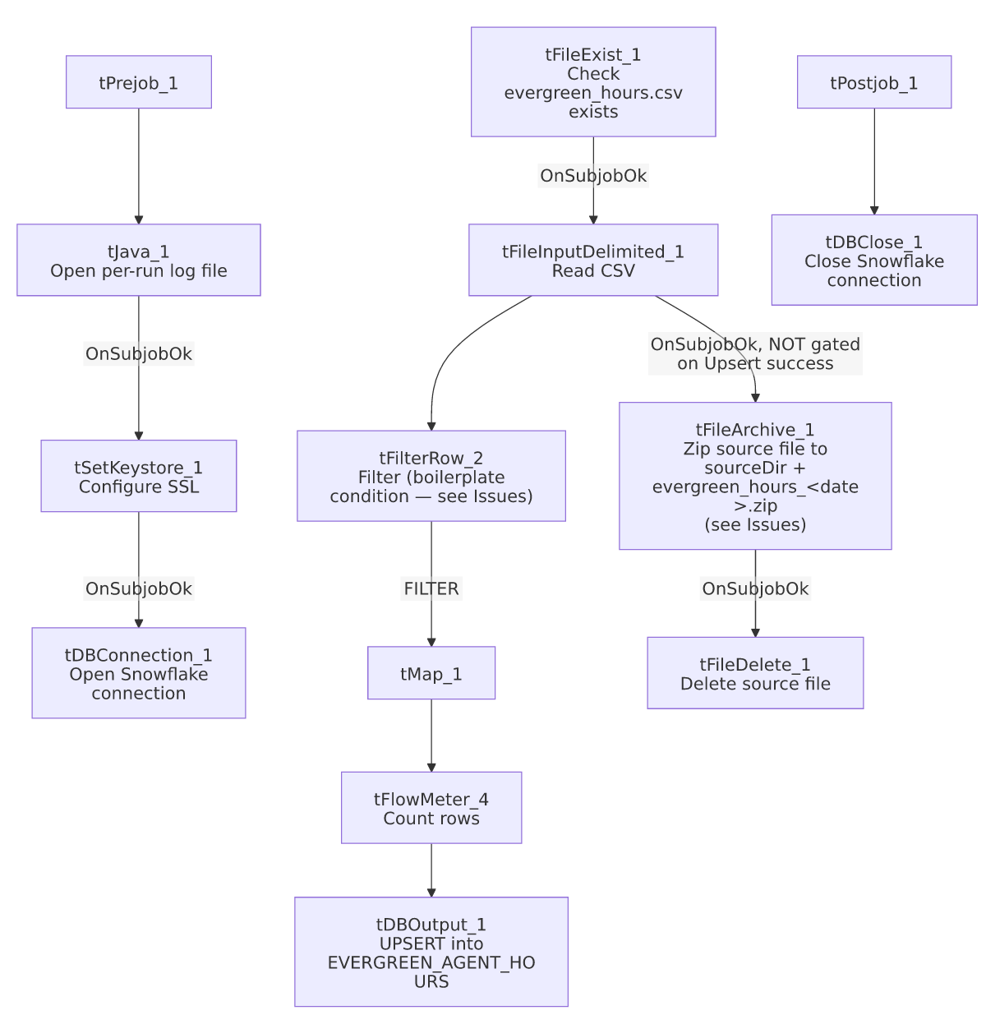

Settings tables

Source: `tFileInputDelimited_1`
Setting | Value | What it means
FILENAME | context.sourceDir + "evergreen_hours.csv" | Fixed filename, no date/pattern matching — expects the same file to be dropped and overwritten each run.
Gate | tFileExist_1 must succeed first | Prevents a "file not found" error from surfacing as a generic Talend failure; the job simply won't proceed to read if the file isn't there yet.
SCHEMA / SCHEMA_REJECT | Both repository schema "evergreen_hours" | Reject rows use the same schema as the main flow.
DIE_ON_ERROR | false | Malformed rows don't fail the job...
Reject flow | Not wired | ...but (same as ADP_Payroll_Load) no connection carries rejected rows anywhere — they're silently dropped.

Filter: `tFilterRow_2`
Setting | Value | What it means
ADVANCED_COND | input_row.columnName1.equals(input_row.columnNam... (truncated placeholder) | Unmodified Talend template boilerplate — columnName1/columnName2 don't exist in this job's schema. Unable to determine actual filtering behavior; see Issues observed.
LOGICAL_OP | `\ | \

Target: `tDBOutput_1` (`tSnowflakeOutput`)
Setting | Value | What it means
Table | EVERGREEN_AGENT_HOURS | Destination table, keyed presumably by WORKDATE + AGENT_ID for the upsert to work correctly (the actual key column(s) used for matching aren't captured in this metadata).
Output action / Table action | UPSERT / NONE | Genuinely merges by key rather than truncating — a better fit for a daily incremental timekeeping load than the truncate-reload pattern used elsewhere in this project.

Archive/cleanup: `tFileArchive_1` / `tFileDelete_1`
Setting | Value | What it means
TARGET (archive) | context.sourceDir + "evergreen_hours_" + <date> + ".zip" | Archives into the same source directory rather than a separate context.archiveDir, unlike other archiving jobs (e.g. ADP_Payroll_Load archives to context.archiveDir).
SOURCE_FILE (hardcoded, likely unused) | "C:/Talend-Studio-20211109_1610-V8.0.1/workspace/source.csv" | Leftover default value from the component template — the actual archived file is driven by SOURCE=context.sourceDir, not this field.
tFileDelete_1 FILENAME | context.sourceDir + "evergreen_hours.csv" | Deletes the original source file after archiving.
tFileDelete_1 DIRECTORY / PATH (hardcoded, unused) | "C:/Talend-Studio-20211109_1610-V8.0.1/workspace/delete_folder" / ".../delete_folder or delete_file" | Default template values; FOLDER=false/FOLDER_FILE=false mean the component is actually doing single-file deletion via FILENAME, not folder deletion via these fields.

Dependencies & configuration
- Triggers/depends on other jobs: none — no tRunJob links found (runjob_targets is empty).
- Context variables used: keystorePath, logDir, sourceDir.
- 5 hardcoded path findings: tFileInputDelimited_1.TEMP_DIR, tFileArchive_1.SOURCE_FILE, tFileDelete_1.DIRECTORY, tFileDelete_1.PATH (all C:/Talend-Studio-20211109_1610-V8.0.1/workspace/..., the project-wide developer-workstation pattern from 05_operational_runbook.md), and tSetKeystore_1.SSL_TRUSTSERVER_TRUSTSTORE = "C:/clientTrustStore.trustStore".

Glossary
Component type | Plain-English meaning
tFileExist | Checks whether a specific file exists on disk before proceeding.
tFileInputDelimited | Reads a delimited (CSV-style) text file according to a schema.
tFilterRow | Passes rows through only if they meet a configured condition.
tMap | Maps/transforms columns from one schema to another.
tFlowMeter | Counts rows passing a point in the flow, for logging/monitoring.
tSnowflakeOutput | Writes rows to a Snowflake table — here using UPSERT rather than INSERT after TRUNCATE.
tFileArchive / tFileDelete | Zip a processed file to an archive location, then delete the original from the source directory.

Issues observed
- The file archive-and-delete steps are not gated on the Snowflake upsert succeeding. tFileArchive_1 and tFileDelete_1 are wired off tFileInputDelimited_1's SUBJOB_OK (i.e., the file was successfully *read*), which is a separate branch from the tFilterRow_2 → tMap_1 → tDBOutput_1 chain that actually loads the data. If the filter, map, or upsert step fails or dies partway through (tMap_1 has DIE_ON_ERROR=true), the source file would still be archived and deleted, because that branch only depends on the file having been read, not on the load having succeeded. This is a genuine data-loss risk: a failed run could leave EVERGREEN_AGENT_HOURS unchanged (or partially updated) while the only copy of that day's source file is gone, with just a zip archive (which may itself only be checked for after the fact) as a recovery path. Verify with the team whether this is an accepted risk (archive is one form of preservation) or should be re-wired to depend on load success.
- `tFilterRow_2`'s condition is unmodified Talend template boilerplate (input_row.columnName1.equals(input_row.columnNam...) — the same class of finding documented in Last4SSN_Extract. Since columnName1/columnName2 don't exist in this job's Date/Agent_ID/etc. schema, this filter's actual runtime behavior (pass everything, pass nothing, or error) is unable to determine from metadata — verify directly in Talend Studio. This is now a recurring pattern across multiple jobs in this project (at least this job and Last4SSN_Extract), suggesting it may be worth a project-wide audit of tFilterRow components for unconfigured template text, not just a per-job fix.
- No reject-row handling on tFileInputDelimited_1 despite DIE_ON_ERROR=false — malformed rows are silently dropped with no count or record.
- Archived files land in the same `sourceDir` as the incoming file, not a dedicated archiveDir — over time this could accumulate zip files in what's meant to be a drop-zone/inbox directory, unlike the archiveDir-based pattern used elsewhere in this project.

