Talend Job: Load_HH_Debtor_Special_20251222

Overview
This is a one-off, ad hoc load job: its name embeds a specific date (December 22, 2025) and it was both created and last modified on that same day. It reads a single tab-delimited file (X:/HH_EDW_DEBTOR_SPECIAL_12222025, no file extension) containing debtor logon/client/case identifiers plus up to five document references with their dates and a "previous agency" field, and loads it as-is into a brand-new Snowflake table named after the job itself (HH_DEBTOR_SPECIAL_20251222), dropping and recreating that table every run. This has the shape of a special one-time data drop for the "HH" site rather than a recurring pipeline component.

Detail table
Field | Value
Job name | Load_HH_Debtor_Special_20251222
Version | 0.1
Project | EDW2SF
Author | jmach@harriscollect.com
Created | 2025-12-22T16:22:14.820-0800
Last Modified | 2025-12-22T16:31:30.328-0800

Step-by-step data flow
This job has no tPrejob/tPostjob and no explicit tDBConnection/tDBClose pair — the Snowflake connection details live inline on tDBOutput_1 itself rather than as a separate shared connection component (see Issues observed).
- tSetKeystore_1 configures SSL trust/keystore, but with hardcoded literal paths rather than context variables: SSL_KEYSTORE = "C:/Users/jmach/.ssl/keystore.p12" (note this embeds the developer's own Windows username, jmach) and SSL_TRUSTSERVER_TRUSTSTORE = "C:/clientTrustStore.trustStore" (passwords redacted).
- On SUBJOB_OK, tFileInputDelimited_1 reads "X:/HH_EDW_DEBTOR_SPECIAL_12222025" — also a hardcoded literal path, not built from any context variable — tab-delimited, 1 header row, DIE_ON_ERROR=false (malformed rows are skipped, not fatal).
- tDBOutput_1 writes the 16 columns (LOGON, CLIENT, CLIENT_IDX, CASE_NO, LIENED, DOCUMENT1–DOCUMENT5, DOC1_DATE–DOC5_DATE, PREV_AGENCY) into Snowflake table HH_DEBTOR_SPECIAL_20251222, with tableAction=DROP_IF_EXISTS_AND_CREATE — the table is fully rebuilt from scratch each run, not just truncated.
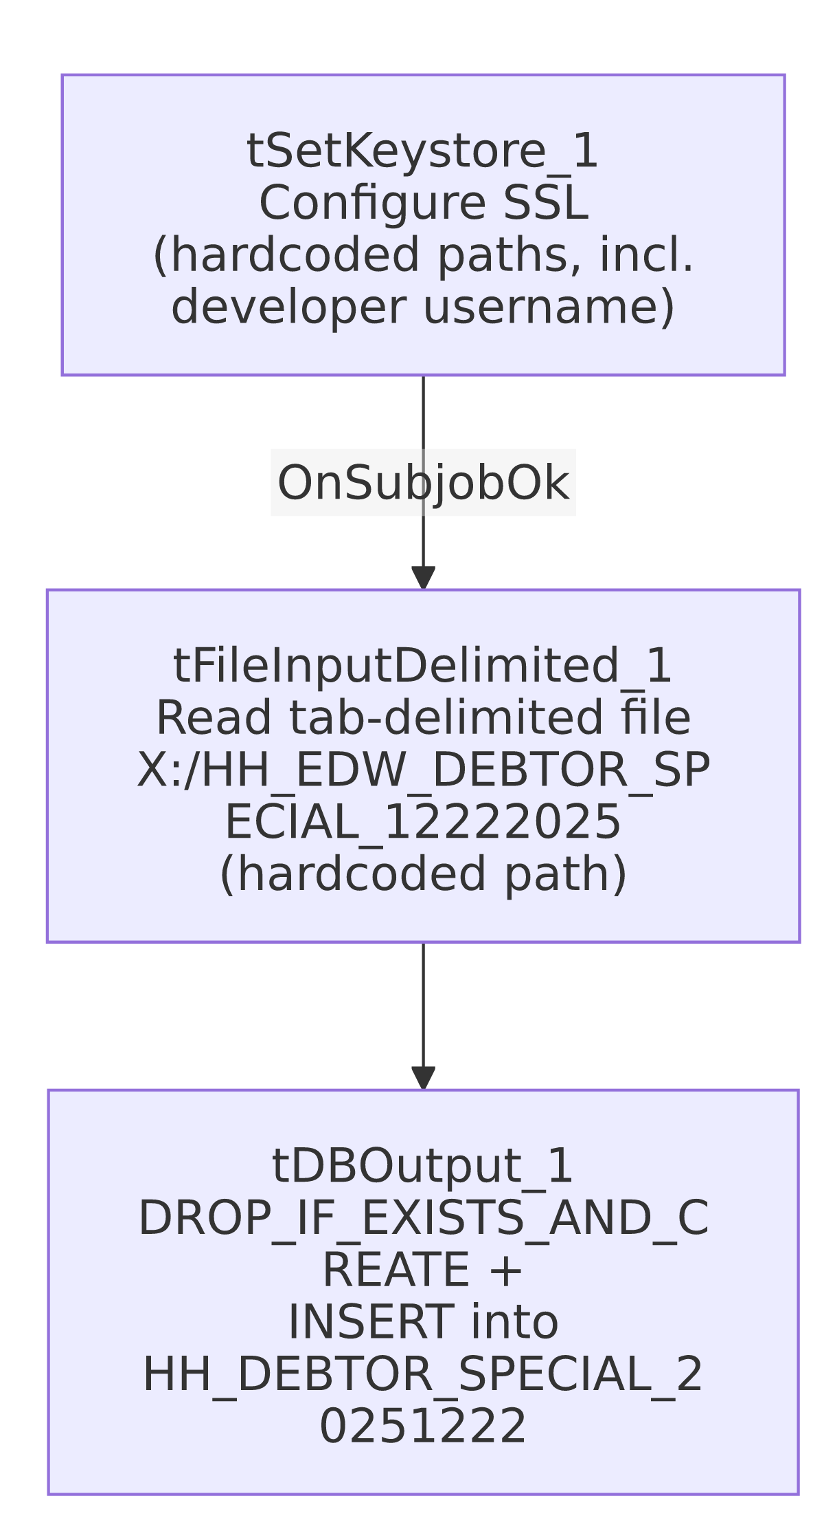

Settings tables

Source: `tFileInputDelimited_1`
Setting | Value | What it means
FILENAME | "X:/HH_EDW_DEBTOR_SPECIAL_12222025" | Hardcoded literal path with no context-variable indirection and no file extension — a one-time, manually-placed source file.
FIELDSEPARATOR / HEADER | \t (tab) / 1 header row | Tab-delimited rather than comma-delimited, unlike most other file-based jobs in this project.
DIE_ON_ERROR | false | Malformed rows are skipped rather than failing the job — and, as with ADP_Payroll_Load, there's no reject flow wired, so skipped rows are silently dropped with no record.
TEMP_DIR (hardcoded) | "C:/Talend-Studio-20211109_1610-V8.0.1/workspace" | The project-wide developer-workstation hardcoded path documented in 05_operational_runbook.md.

Target: `tDBOutput_1` (`tSnowflakeOutput`)
Setting | Value | What it means
Table | HH_DEBTOR_SPECIAL_20251222 | Table name is literally the job name — this table exists solely for this one-time load, not as an ongoing staging table for a recurring pipeline.
Table action | DROP_IF_EXISTS_AND_CREATE | Fully rebuilds the table structure each run — different from the truncate-and-reload pattern used by most other load jobs in this project (a DROP/CREATE also resets any downstream grants or dependent views on this table).

Dependencies & configuration
- Triggers/depends on other jobs: none — no tRunJob links found (runjob_targets is empty), and this job is not listed as a caller or target in 06_dependency_matrix.md.
- Context variables used: none — context_vars_referenced is empty. Every path in this job is a hardcoded literal (see Issues observed).
- 2 hardcoded path findings: tFileInputDelimited_1.TEMP_DIR = "C:/Talend-Studio-20211109_1610-V8.0.1/workspace" and tSetKeystore_1.SSL_TRUSTSERVER_TRUSTSTORE = "C:/clientTrustStore.trustStore" — plus the source FILENAME and SSL_KEYSTORE paths, which are also hardcoded literals but weren't captured in the hardcoded_path_findings array.

Glossary
Component type | Plain-English meaning
tFileInputDelimited | Reads a delimited (here, tab-separated) text file according to a schema.
tSnowflakeOutput | Writes rows to a Snowflake table.
tSetKeystore | Configures SSL trust/keystore settings for the job's outbound connections.

Issues observed
- Every path in this job is a hardcoded literal, with zero context-variable use — a clear departure from the pattern used across the rest of this project (where sourceDir, outputDir, keystorePath, etc. are consistently parameterized via context groups like StandardFolders_0.1). This is consistent with the job's evident purpose as a one-time, throwaway data load rather than a maintained pipeline component — but it also means this job cannot be safely reused or re-pointed at a different file/environment without editing the job definition directly.
- `tSetKeystore_1.SSL_KEYSTORE` hardcodes a specific developer's personal keystore path ("C:/Users/jmach/.ssl/keystore.p12"), tying this job's SSL trust configuration to one individual's workstation. If that keystore file is unavailable (e.g., the developer's machine is reimaged, or the job runs on a different execution host), this job would fail to establish its Snowflake connection. Since this job has no context-variable-driven keystore path (contrast every other job in this batch, which uses context.keystorePath), it cannot simply be redirected via configuration.
- No explicit `tDBConnection`/`tDBClose` pair and no `tPrejob`/`tPostjob` — this job's Snowflake connection details are configured inline on tDBOutput_1 rather than through a separate, shared connection component. This is a simpler but less consistent pattern than the rest of the project's jobs (all of which open/close a named connection explicitly).
- `DROP_IF_EXISTS_AND_CREATE` rebuilds the destination table from scratch every run — any downstream view, grant, or dependency on HH_DEBTOR_SPECIAL_20251222 would need to be re-established after each run, and re-running this job is not simply idempotent in the way a TRUNCATE+INSERT job would be.
- No reject-row handling on tFileInputDelimited_1 despite DIE_ON_ERROR=false — malformed rows are silently dropped with no count or record.
- Given the very narrow, single-run purpose of this job (a specific dated filename, no context parameterization, and same-day creation/modification), verify with the team whether it should be disabled/archived after its one-time use rather than left active in the shared job repository, where it could confuse anyone browsing for "the" HH debtor-load job.

