Talend Job: Load_Misc_Dims

Overview
Loads three small reference/dimension tables from the legacy EDWProdHH MSSQL database into Snowflake in parallel: logon codes (DimLogOn → DIMLOGON), collector desk/team assignments (DIMDESKINFO → DIMDESKINFO), and employee login/account info (DimEmployeeInfo → DIMEMPLOYEEINFO). All three are simple one-for-one column copies with a type cast on the shared DIMLOGON key column. Despite doing the same kind of load for all three, one of the three (DIMEMPLOYEEINFO) is configured without the truncate-before-insert step the other two use — see Issues observed for the consequence.

Detail table
Field | Value
Job name | Load_Misc_Dims
Version | 0.1
Project | EDW2SF
Author | jmach@harriscollect.com
Created | 2022-01-05T16:17:26.375-0800
Last Modified | 2022-05-24T09:48:37.480-0700

Step-by-step data flow
Setup subjob: tPrejob_1 → tDBConnection_1 opens the Snowflake connection → on COMPONENT_OK, tDBConnection_2 opens the MSSQL connection to context.EDWProdHH_Server/Port/Schema/Database/Login (password redacted, JTDS driver).
Main subjob: tParallelize_1 (WAIT_FOR=All, DIE_ON_ERROR=false) fans out into three independent branches that run concurrently, each reading from MSSQL via the shared tDBConnection_2 and writing to Snowflake via the shared tDBConnection_1:
- DimLogOn branch: tDBInput_1 runs SELECT CAST(DimLogOn AS numeric(38,0)) AS DimLogOn, LogOn, Description FROM DimLogOn → tMap_1 (pass-through, DIE_ON_ERROR=true) → tFlowMeter_7 counts rows (labeled "DimLogon") → tDBOutput_1 writes to Snowflake table DIMLOGON (INSERT, tableAction=TRUNCATE).
- DimDeskInfo branch: tDBInput_2 runs SELECT DESK_IDX, CAST(DIMLOGON AS NUMERIC(38,0)) AS DIMLOGON, DESK, NAME, PSEUDONYM, BRANCH_NAME, TEAM_NAME FROM DIMDESKINFO → tMap_2 (pass-through, DIE_ON_ERROR=true) → tFlowMeter_10 counts rows (labeled "DimDesk") → tDBOutput_2 writes to Snowflake table DIMDESKINFO (INSERT, tableAction=TRUNCATE).
- DimEmployeeInfo branch: tDBInput_3 runs SELECT EMP_IDX, CAST(DimLogon AS NUMERIC(38,0)) AS DIMLOGON, EMPPWD, EMP_NAME, EMP_INIT, LST_LOGIN, DISABLED FROM dbo.DimEmployeeInfo → tMap_3 (pass-through, DIE_ON_ERROR=true) → tFlowMeter_13 counts rows (labeled "DimEmp") → tDBOutput_3 writes to Snowflake table DIMEMPLOYEEINFO (INSERT, `tableAction=NONE` — no truncate; see Issues observed).
Teardown subjob: tPostjob_1 → tDBClose_1 closes the Snowflake connection → on COMPONENT_OK, tDBClose_2 closes the MSSQL connection.
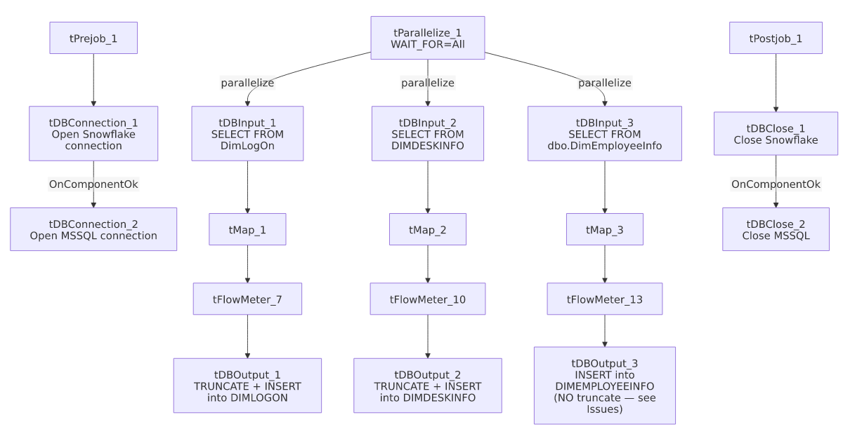

Settings tables

Sources: `tDBInput_1` / `tDBInput_2` / `tDBInput_3` (`tMSSqlInput`)
Setting | Value | What it means
Query 1 | SELECT CAST(DimLogOn AS numeric(38,0)) AS DimLogOn, LogOn, Description FROM DimLogOn | Full-table pull of the logon code lookup, no filtering.
Query 2 | SELECT DESK_IDX, CAST(DIMLOGON AS NUMERIC(38,0)) AS DIMLOGON, DESK, NAME, PSEUDONYM, BRANCH_NAME, TEAM_NAME FROM DIMDESKINFO | Full-table pull of desk/team assignment reference data.
Query 3 | SELECT EMP_IDX, CAST(DimLogon AS NUMERIC(38,0)) AS DIMLOGON, EMPPWD, EMP_NAME, EMP_INIT, LST_LOGIN, DISABLED FROM dbo.DimEmployeeInfo | Full-table pull of employee login records — includes an EMPPWD column (see Issues observed for the data-sensitivity implication).

Targets: `tDBOutput_1` / `tDBOutput_2` / `tDBOutput_3` (`tSnowflakeOutput`)
Setting | Value | What it means
DIMLOGON table action | TRUNCATE | Cleared and reloaded every run.
DIMDESKINFO table action | TRUNCATE | Cleared and reloaded every run.
DIMEMPLOYEEINFO table action | `NONE` | Not cleared before the insert — every run appends the full source table's rows on top of whatever is already there. See Issues observed.

Fan-out: `tParallelize_1`
Setting | Value | What it means
WAIT_FOR | All | The job doesn't consider the parallel section complete until all three branches finish.
DIE_ON_ERROR | false | A failure in one branch doesn't automatically fail the tParallelize_1 step itself — combined with WAIT_FOR=All, this means a broken branch might not visibly block the others, though the job's overall success/failure signaling from this component alone is unable to determine from metadata.

Dependencies & configuration
- Triggers/depends on other jobs: none — no tRunJob links found (runjob_targets is empty). Not listed as a target of any tRunJob calls in 06_dependency_matrix.md either — unlike DimDeskInfo_Load and DimEmployeeInfo_Load, which per that matrix each call CUBS_Raw_File_Load, this job appears to be its own independent, non-orchestrated dimension loader with overlapping table names/purpose to those two — worth confirming with the team whether Load_Misc_Dims and DimDeskInfo_Load/DimEmployeeInfo_Load are redundant, sequential, or serve different environments.
- Context variables used: EDWProdHH_Database, EDWProdHH_Login, EDWProdHH_Port, EDWProdHH_Schema, EDWProdHH_Server.
- No hardcoded path findings in this job.

Glossary
Component type | Plain-English meaning
tParallelize | Runs its downstream branches at the same time instead of one after another.
tMSSqlConnection / tMSSqlInput / tMSSqlClose | Open a Microsoft SQL Server connection, run a query against it, and close it.
tMap | Maps/transforms columns from one schema to another (used here as a straight pass-through with a type cast already done in the source query).
tFlowMeter | Counts rows passing a point in the flow, for logging/monitoring.
tSnowflakeOutput | Writes rows to a Snowflake table.

Issues observed
- `DIMEMPLOYEEINFO`'s load has no truncate step (`tableAction=NONE`), unlike its two sibling branches in the same job (`DIMLOGON` and `DIMDESKINFO`, both `TRUNCATE`). Since the output action is a plain INSERT (not UPSERT/MERGE), every run of this job appends the entire `dbo.DimEmployeeInfo` source table on top of whatever rows are already in `DIMEMPLOYEEINFO`, rather than replacing them. If this job runs on any kind of recurring schedule, DIMEMPLOYEEINFO would accumulate duplicate rows indefinitely — a likely data-quality bug given the other two branches in the same job clearly intend a fresh-reload pattern. Verify with the team whether this was an intentional exception (e.g., DIMEMPLOYEEINFO is meant to be append-only for historical login tracking) or a configuration oversight.
- The `dbo.DimEmployeeInfo` source table includes an `EMPPWD` column, and this job loads it into Snowflake `DIMEMPLOYEEINFO` unmodified — no masking, hashing, or exclusion of the password field is visible anywhere in this job's mapping. Per this organization's data-handling guidance, storing employee passwords (even legacy/hashed ones — the actual format of EMPPWD is unable to determine from metadata) in a reporting warehouse table warrants review; confirm whether EMPPWD should be excluded from this load or whether it's already a non-sensitive placeholder/hash in the source system.
- No reject-row or error-count logging in any of the three branches — a bad row or connection issue in one branch would only surface as a generic Talend execution error, and per-branch failure isolation (since tParallelize_1.DIE_ON_ERROR=false) makes it unclear from this metadata alone whether one branch's failure is reported distinctly from the others'.
- No per-run log file setup and no SSL/keystore configuration in this job, consistent with Load_Debtor_New_Columns elsewhere in this batch (both are MSSQL-to-Snowflake dimension loaders from a similar era, 2022) — a different, less-elaborate setup pattern than the file-extract jobs in this project.

