Talend Job: Load_PCI_Letter_Disp_Desc

Overview
Copies mail-disposition tracking data for PCI (likely a mail-fulfillment vendor or letter-processing system) letters — customer key, raw letter code, mail disposition code and description, and file date — from the legacy EDWProdHH MSSQL table [dbo].[PCI_Letters] straight into a new Snowflake table PCI_Letter_Disp, with no filtering, transformation, or intermediate staging. This is one of the simplest and most direct MSSQL-to-Snowflake copies in this batch, but its table-creation setting looks likely to break on a second run — see Issues observed.

Detail table
Field | Value
Job name | Load_PCI_Letter_Disp_Desc
Version | 0.1
Project | EDW2SF
Author | jmach@harriscollect.com
Created | 2022-04-15T13:39:17.862-0700
Last Modified | 2025-09-24T11:08:01.278-0700

Step-by-step data flow
Setup subjob: tPrejob_1 → tDBConnection_1 opens the MSSQL connection to context.EDWProdHH_Server/Port/Schema/Database/Login (password redacted, JTDS driver) → on COMPONENT_OK, tDBConnection_2 opens the Snowflake connection. No per-run log file and no SSL/keystore configuration exist in this job.
Main subjob (runs independently of the setup chain, relying on the shared MSSQL connection):
- tDBInput_1 runs SELECT [Customer_Key], [Raw_Letter_Code], [Mail_DispositionCode], [Mail_Disposition], [File_Date] FROM [EDWProdHH].[dbo].[PCI_Letters] — a full, unfiltered table pull with no date-scoping or incremental logic.
- tDBOutput_1 writes the rows directly into Snowflake table PCI_Letter_Disp, with outputAction=INSERT and `tableAction=CREATE` (not TRUNCATE, not DROP_IF_EXISTS_AND_CREATE, not CREATE_IF_NOT_EXISTS) — see Issues observed for why this setting is likely to cause a failure or unbounded duplication on any run after the first.
Teardown subjob: tPostjob_1 → tDBClose_2 closes the MSSQL connection → on COMPONENT_OK, tDBClose_1 closes the Snowflake connection.
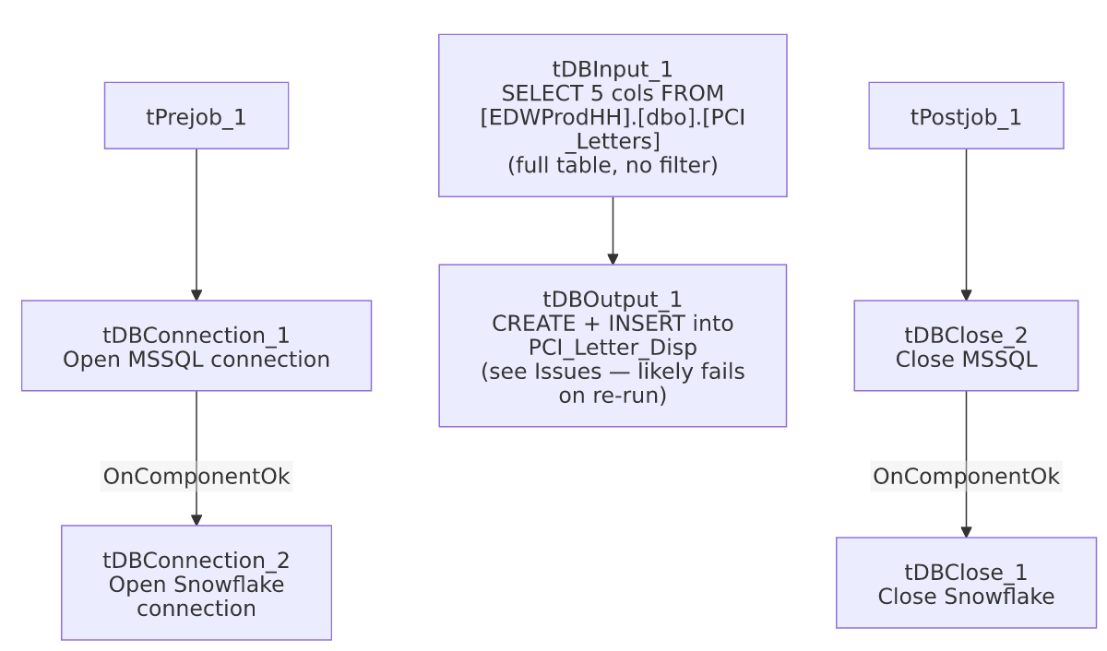

Settings tables

Source: `tDBInput_1` (`tMSSqlInput`)
Setting | Value | What it means
Query | SELECT [Customer_Key], [Raw_Letter_Code], [Mail_DispositionCode], [Mail_Disposition], [File_Date] FROM [EDWProdHH].[dbo].[PCI_Letters] | Pulls the entire source table every run — no WHERE clause of any kind.

Target: `tDBOutput_1` (`tSnowflakeOutput`)
Setting | Value | What it means
Table | PCI_Letter_Disp | Destination table.
Output action | INSERT | Appends rows; nothing clears the table between runs.
Table action | CREATE | Attempts to create the table fresh — this is a different setting from every other job reviewed in this batch, which use TRUNCATE, NONE, CREATE_IF_NOT_EXISTS-style semantics, or DROP_IF_EXISTS_AND_CREATE. See Issues observed.

Dependencies & configuration
- Triggers/depends on other jobs: none — no tRunJob links found (runjob_targets is empty).
- Context variables used: EDWProdHH_Database, EDWProdHH_Login, EDWProdHH_Port, EDWProdHH_Schema, EDWProdHH_Server.
- No hardcoded path findings in this job.

Glossary
Component type | Plain-English meaning
tMSSqlConnection / tMSSqlInput / tMSSqlClose | Open a Microsoft SQL Server connection, run a query against it, and close it.
tSnowflakeConnection / tSnowflakeOutput / tSnowflakeClose | Open a Snowflake connection, write rows to a table, and close the connection.

Issues observed
- `tDBOutput_1`'s table action is set to `CREATE` rather than `TRUNCATE`, `NONE`, or `DROP_IF_EXISTS_AND_CREATE`. A plain CREATE table action in Talend's Snowflake output component typically issues a CREATE TABLE statement that fails if the table already exists (unlike CREATE_IF_NOT_EXISTS or DROP_IF_EXISTS_AND_CREATE, which this project's other jobs use when they need repeatable table creation — e.g. Load_HH_Debtor_Special_20251222 uses DROP_IF_EXISTS_AND_CREATE). This strongly suggests the job would only succeed on its very first run against a fresh Snowflake environment, then fail on every subsequent run once `PCI_Letter_Disp` already exists — unless Talend's specific implementation of this CREATE option is more permissive than a literal CREATE TABLE (unable to confirm the exact runtime semantics from this metadata alone). Given the job has clearly been run and re-modified over a long period (created 2022, last modified 2025), either this setting has never actually caused a failure in practice (worth understanding why — perhaps the job hasn't been re-run since its table was first created, or the table is manually dropped before each run), or it's failing silently/being caught elsewhere. Verify directly with the team how this job is actually operated.
- No incremental filtering on the source query — every run pulls the entire PCI_Letters table. Combined with the CREATE/INSERT (no truncate) table action, if this job ever does run successfully more than once against an existing table, it would duplicate every previously-loaded row on top of itself with no de-duplication.
- No error/row-count logging — a load failure would only surface as a generic Talend execution error, with the ambiguous CREATE-on-existing-table failure mode described above being especially opaque to diagnose without direct access to the job's run history.
- No SSL/keystore configuration or per-run log file, consistent with Load_Debtor_New_Columns and Load_Misc_Dims elsewhere in this batch (all MSSQL-to-Snowflake dimension/reference loaders using a similar, simpler setup pattern than the file-extract jobs in this project).

