Talend Job: Mail_Merge_Load

Overview
Loads a wide, mostly-anonymous-column delimited extract file (one row per debtor/letter, with debtor number, logon, letter form/ID, ZIP, a RevSpring mail-vendor ID, and roughly 180 additional pipe-delimited positional columns most of which were never given business names) into the Snowflake MAIL_MERGE staging table, then calls a delta-load stored procedure to merge the new rows into a downstream table. The source data appears to be a mail-merge/letter-vendor export (the presence of LETTER_FORM, LETTER_ID, and REVSPRING_ID columns — RevSpring is a mail-fulfillment/print vendor — supports this), but most of the file's actual business content is not documented in the schema itself.

Detail table
Field | Value
Job name | Mail_Merge_Load
Version | 0.1
Project | EDW2SF
Author | jmach@harriscollect.com
Created | 2022-04-19T13:55:59.321-0700
Last Modified | 2022-06-10T10:39:07.578-0700

Step-by-step data flow
Setup subjob: tPrejob_1 → tJava_3 opens a per-run log file at context.logDir + jobName + "_" + <timestamp> + ".log" and redirects System.out/System.err to it → on subjob-ok, tDBConnection_1 opens the Snowflake connection → on subjob-ok, tJava_2 computes context.currentYear, then derives context.dataDir and context.archiveDir as subfolders of context.rootDir (<rootDir>/<currentYear> and <rootDir>/<currentYear>/archive).
Main subjob:
- tDBRow_1 runs TRUNCATE TABLE STAGING.MAIL_MERGE; (note the explicit STAGING. schema prefix, unlike some other jobs in this project).
- On success, tFileList_1 lists files in context.dataDir (EXCLUDEFILEMASK of *.txt is configured but IFEXCLUDE=false, so the exclusion is not actually applied).
- For each file, tJava_1 sets context.fileName from the current file path and prints a "Processing file" message.
- tFileInputDelimited_1 reads the file (pipe-delimited |, header row present, DIE_ON_ERROR=true) against a repository schema with ~185 columns, most positionally named (Column2, Column6, _0, _1, _3, _9, _01..._98, etc.) rather than business names — only DEBTORNUMBER, LOGON, LETTER_FORM, LETTER_ID, ZIP, REVSPRING_ID, DATE_TEXT, PL_GROUP, CDN, and CLIENT have meaningful names.
- tMap_1 maps down to an 11-column output schema (DEBTORNUMBER, LOGON, LETTER_FORM, LETTER_ID, ZIP, REVSPRING_ID, DATE_TEXT, PL_GROUP, CDN, CLIENT, FILENAME) — i.e., only the meaningfully-named columns (plus a FILENAME audit column) survive into the target; the ~175 unnamed positional columns are dropped at this step. DIE_ON_ERROR=true.
- tFlowMeter_3 counts rows passing through (labeled "MyLabel", not renamed for this job).
- tDBOutput_1 inserts the rows into Snowflake table MAIL_MERGE (INSERT, no table-recreate action).
- On component-ok, tFileCopy_1 copies the source file to context.archiveDir (REMOVE_FILE=true, i.e. moves rather than copies-and-keeps; REPLACE_FILE=true, CREATE_DIRECTORY=true).
- Separately, once tFileList_1's whole loop finishes (OnSubjobOk, not per-file), tDBRow_2 runs CALL DELTA_LOAD_MAIL_MERGE(); — this merge call runs once after all files are processed, not once per file.
Teardown subjob: tPostjob_1 → tDBClose_1 closes the Snowflake connection.
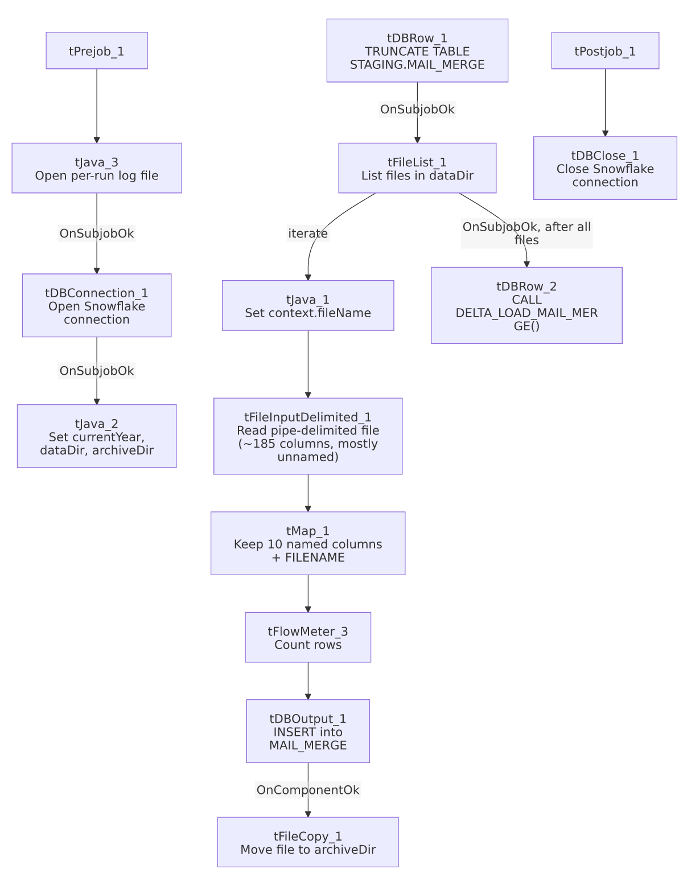

Settings tables

Source: `tFileInputDelimited_1`
Setting | Value | What it means
FILENAME | context.fileName | The current file from tFileList_1's iteration.
FIELDSEPARATOR / HEADER |  | ` / 1 header row
SCHEMA | Repository schema (~185 columns, mostly Column2/_NN positional placeholders) | Only 10 columns have business names; the rest were never mapped to meaningful labels in the Talend repository — see Issues observed.
TEMP_DIR | "C:/Talend-Studio-20211109_1610-V8.0.1/workspace" | Hardcoded developer-workstation path — same project-wide risk documented in 05_operational_runbook.md.
DIE_ON_ERROR | true | A malformed row fails the job outright.
Reject flow | Not wired | No tDie_ON_ERROR=false/reject-schema pattern is used here; a bad row simply fails the whole job rather than being isolated.

Target: `tDBOutput_1` (`tSnowflakeOutput`)
Setting | Value | What it means
Table | MAIL_MERGE | Destination staging table.
Output action | INSERT | Appends rows; relies on the earlier TRUNCATE TABLE STAGING.MAIL_MERGE; to prevent duplicate accumulation across runs.
Table action | NONE | Table is not recreated/altered by this job.

Merge step: `tDBRow_2` (`tSnowflakeRow`)
Setting | Value | What it means
Query | CALL DELTA_LOAD_MAIL_MERGE(); | Calls a stored procedure (not shown in this metadata) presumably merging the freshly loaded MAIL_MERGE staging rows into a final table — note this naming convention (DELTA_LOAD_<table>) differs from the MERGE_INTO_<table> convention seen in ADP_Payroll_Load and other jobs in this project.
Result handling | Not captured | Unlike ADP_Payroll_Load or CO_Master_Load, this job does not capture the procedure's return value or branch on success/failure — a failed merge produces no job-specific message.

Dependencies & configuration
- Triggers/depends on other jobs: none — no tRunJob links found.
- Context variables used: rootDir, currentYear (derived internally), dataDir (derived internally, rootDir/currentYear), archiveDir (derived internally, rootDir/currentYear/archive), fileName, logDir.
- 2 hardcoded developer-workstation paths: tFileInputDelimited_1.TEMP_DIR and tFileCopy_1.SOURCE_DERECTORY (both C:/Talend-Studio-20211109_1610-V8.0.1/workspace) — same portability risk documented project-wide in 05_operational_runbook.md.

Glossary
Component type | Plain-English meaning
tFileList | Lists files in a directory for the job to iterate over one at a time.
tFileInputDelimited | Reads a delimited (CSV/pipe-style) text file according to a schema.
tMap | Maps/transforms columns from one schema to another — here used to drop ~175 unnamed columns from the source.
tFlowMeter | Counts rows passing through a point in the flow, for logging/monitoring.
tSnowflakeOutput / tSnowflakeRow / tSnowflakeConnection / tSnowflakeClose | Write rows to a Snowflake table / run an arbitrary SQL statement or stored-procedure call against Snowflake / open and close the Snowflake connection used throughout the job.
tFileCopy | Moves or copies a processed file to another location (here, to the year-based archive folder, removing the original).
tJava | Runs custom Java code — used here to derive folder paths, set the current filename, and redirect log output.

Issues observed
- ~175 of the ~185 source columns have no business name (Column2, Column6, Column7, Column8, _0 through _98, _01/_001/_011 variants, etc.) — this repository schema appears to have been reverse-engineered from a fixed-width or highly repetitive positional file format without anyone assigning meaningful names to most fields. Since tMap_1 only carries forward the 10 named columns (plus FILENAME) into MAIL_MERGE, whatever business data lives in those ~175 unnamed columns is read from the file but never loaded anywhere — permanently discarded on each run unless the source file itself is archived (which it is, via tFileCopy_1). Unable to determine from metadata whether this is intentional (only 10 fields are actually needed downstream) or a case where useful data is being silently dropped; verify with the team what the full column layout represents.
- The merge stored procedure `DELTA_LOAD_MAIL_MERGE()` is called once after the entire file loop completes (`OnSubjobOk` from `tFileList_1`), not per file, and its result is not captured or checked. If the procedure fails, this job would show no job-specific failure indicator — only a generic Talend execution error, if the Talend engine even surfaces one for an uncaptured CALL failure. This is a materially different failure-handling posture than ADP_Payroll_Load or CO_Master_Load, both of which check the merge result and branch to tWarn/tDie.
- `TEMP_DIR` and `SOURCE_DERECTORY` are hardcoded to a specific developer's Talend Studio install path (C:/Talend-Studio-20211109_1610-V8.0.1/workspace), the same project-wide risk noted in 05_operational_runbook.md — moving this job to a different install path or a non-Windows runner would very likely break it.
- No reject flow or row-count-based alerting: a malformed row in the source file fails the whole job (DIE_ON_ERROR=true on both tFileInputDelimited_1 and tMap_1) rather than being isolated and logged, and there is no tWarn/tDie/tSendMail reacting to tFlowMeter_3's count — a silent drop in expected row volume would not be flagged.

