Talend Job: Migrating_Clients_20260424

Overview
A small, one-off-looking job that reads a hardcoded local file listing client codes and inserts them into the Snowflake UTILITY_CLIENT_EXCLUDE_LIST table. Based on the job name and the target table name, this appears to be a point-in-time load of clients that are migrating (away from, or between, systems) and should be excluded from some other utility/process while the migration is in progress.

Detail table
Field | Value
Job name | Migrating_Clients_20260424
Version | 0.1
Project | EDW2SF
Author | jmach@harriscollect.com
Created | 2026-04-23T22:01:22.076-0700
Last Modified | 2026-04-23T22:12:16.488-0700

Step-by-step data flow
Two subjobs run independently with no visible connection between them:
- Connection setup: tSetKeystore_1 configures SSL trust/keystore (SSL_TRUSTSERVER_TRUSTSTORE hardcoded to "C:/clientTrustStore.trustStore", SSL_KEYSTORE from context.keystorePath, passwords ***REDACTED***) → on subjob-ok, tDBConnection_1 opens the Snowflake connection. This subjob does not visibly feed into the load subjob below (see Issues observed).
- Load: tFileInputDelimited_1 reads the hardcoded file "C:/Data/HC_Clients_20260424.txt" (semicolon-delimited, no header row, DIE_ON_ERROR=false) into a schema with a single business column, CLIENT (the schema lists CLIENT twice — likely a main/reject-schema artifact captured as one field, plus errorCode/errorMessage reject columns) → tDBOutput_1 inserts the rows directly into Snowflake table UTILITY_CLIENT_EXCLUDE_LIST (INSERT, no table-recreate action, no intermediate transform component).
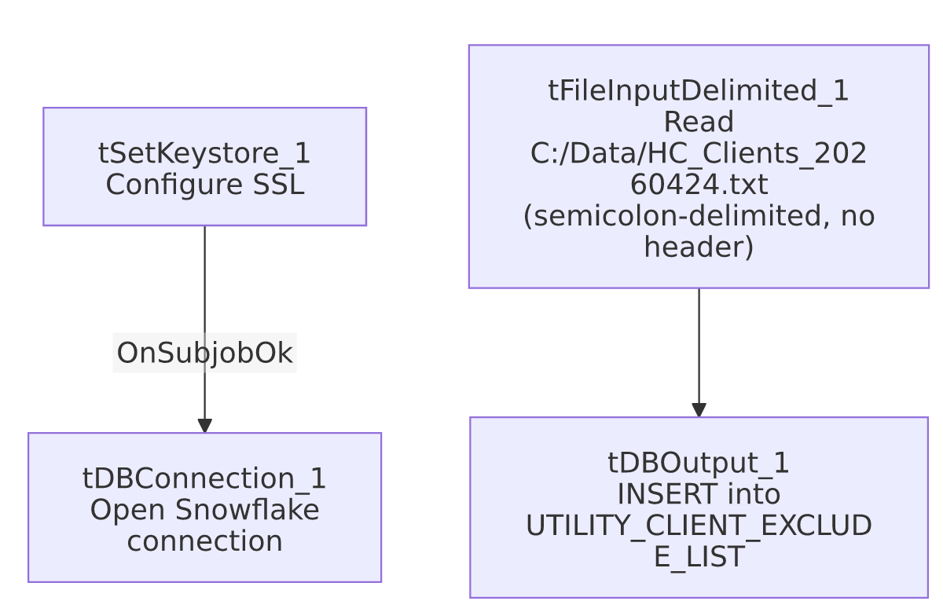

Settings tables

Source: `tFileInputDelimited_1`
Setting | Value | What it means
FILENAME | "C:/Data/HC_Clients_20260424.txt" (hardcoded) | A fixed local file path with the job's creation date baked into both the filename and the job name itself — strongly suggests a one-time, manually-prepared input file rather than a repeatable feed.
FIELDSEPARATOR / HEADER | ; / 0 (no header) | Semicolon-delimited, headerless — a simple list-style file, consistent with a short manually-curated list of client codes.
DIE_ON_ERROR | false | A malformed row doesn't fail the job, but (as with other jobs) no reject flow captures what was skipped.

Target: `tDBOutput_1` (`tSnowflakeOutput`)
Setting | Value | What it means
Table | UTILITY_CLIENT_EXCLUDE_LIST | Destination table — its name suggests other jobs/processes check this list to skip processing for these clients.
Output action | INSERT | Appends rows; there is no TRUNCATE step, so re-running this job would insert duplicate rows for the same clients — see Issues observed.
Table action | NONE | Table is not recreated/altered by this job.

Dependencies & configuration
- Triggers/depends on other jobs: none — no tRunJob links found. This job does not appear in 06_dependency_matrix.md's orchestration table either as a caller or a target.
- Context variables used: keystorePath (used only by the disconnected tSetKeystore_1/tDBConnection_1 pair — see Issues observed).
- 2 hardcoded path findings: tFileInputDelimited_1.FILENAME ("C:/Data/HC_Clients_20260424.txt", not flagged in the metadata's own hardcoded_path_findings list but hardcoded nonetheless — see Issues observed) and tSetKeystore_1.SSL_TRUSTSERVER_TRUSTSTORE ("C:/clientTrustStore.trustStore"), plus a TEMP_DIR hardcoded to C:/Talend-Studio-20211109_1610-V8.0.1/workspace per the job's own hardcoded_path_findings.

Glossary
Component type | Plain-English meaning
tFileInputDelimited | Reads a delimited (CSV-style) text file according to a schema.
tSnowflakeOutput | Writes rows to a Snowflake table.
tSetKeystore | Configures the SSL trust store/keystore used by other components for secure connections.
tSnowflakeConnection | Opens a Snowflake database connection.

Issues observed
- The `tSetKeystore_1`/`tDBConnection_1` subjob and the `tFileInputDelimited_1`/`tDBOutput_1` load subjob have no visible connection between them in this job's `connections` list. In every other Snowflake-writing job reviewed in this project, the connection-setup subjob feeds (directly or via a shared implicit connection) into the load subjob. Here, tDBOutput_1 presumably uses whatever default/shared Snowflake connection context it has, but the explicit tDBConnection_1 component appears to be disconnected/orphaned relative to the file-read-and-insert flow. Unable to determine from metadata whether this is a genuine wiring gap (the file load might actually run against a stale or default connection rather than the one just opened) or simply how Talend's implicit connection-reuse works when only one Snowflake connection exists in the job — verify directly in Talend Studio.
- `FILENAME` is hardcoded to a literal path with a specific date baked in (`C:/Data/HC_Clients_20260424.txt`), and this hardcoded value was not flagged in the job's own hardcoded_path_findings list (which only captured the TEMP_DIR and SSL_TRUSTSERVER_TRUSTSTORE settings) — a reminder that the automated hardcoded-path scan may not catch every hardcoded value; the FILENAME itself is just as much a fixed, non-portable, one-time input as those two flagged settings. Given the job name and modification timestamp are only 11 minutes apart from creation, this job reads very much like a single-use, manually-run load rather than a job intended for a recurring schedule.
- No `TRUNCATE` before the `INSERT`, and the target is named an "exclude list." If this job is ever run more than once (e.g., accidentally re-triggered, or reused as a template for a future migration batch without updating the file path), it would insert duplicate CLIENT rows into UTILITY_CLIENT_EXCLUDE_LIST rather than replacing the prior batch — worth confirming with the team whether downstream consumers of this exclude list are tolerant of duplicate entries.
- No `tPrejob`/`tPostjob`, no per-run log file, and no row-count logging (tFlowMeter, tWarn) — consistent with a quick, manually-supervised one-time load rather than an unattended scheduled job, but it also means there's no audit trail beyond Snowflake's own row count of what was loaded and when.

