Talend Job: Northwestern_Future_Appts

Overview
Loads an Excel-based partner extract from Northwestern (a hospital/health system, based on the column set and job name) into the Snowflake NORTHWESTERN_UPCOMING_APPTS table. Each row represents a discharged patient/account with a flagged future appointment (department, appointment date-proximity grouping, mobile phone), likely used to identify patients who have an upcoming visit while still carrying an outstanding balance from a prior discharge — useful for coordinating collections outreach around a patient's next visit. After loading, source files are archived to a separate archive folder via a second file-listing pass.

Detail table
Field | Value
Job name | Northwestern_Future_Appts
Version | 0.1
Project | EDW2SF
Author | jmach@harriscollect.com
Created | 2026-03-31T14:38:50.978-0700
Last Modified | 2026-04-23T09:54:13.593-0700

Step-by-step data flow
Setup subjob: tPrejob_1 → tJava_2 opens a per-run log file (named jobName + "_" + <timestamp> + ".log", written to the current working directory rather than context.logDir — see Issues observed) and also sets context.archiveDir (assignment expression truncated in this metadata) → on subjob-ok, tSetKeystore_1 configures SSL trust/keystore (hardcoded trust-store path, context.keystorePath for the keystore itself) → on subjob-ok, tDBConnection_2 opens the Snowflake connection.
Main subjob — load loop:
- tFileList_1 lists files in context.sourceDir.
- For each file, tJava_1 sets context.currentFile, context.fileName, and context.filePath from the current file.
- tFileInputExcel_1 reads the file as an Excel workbook (VERSION_2007=true, i.e. .xlsx; password ***REDACTED***; ALL_SHEETS=false, so only one sheet is read; header row present; columns 1–20; DIE_ON_ERROR=false) against a repository schema labeled "...- appts" with ~19 named columns (REPORT_DATE, LOCATION, BILLING_SYSTEM, PAT_ID, GUARANTOR_ID, CONCAT_PATGUAR, PAT_MRN, ACCOUNT_ID, ACCOUNT_NAME, DISCH_DEPT_ID, DISCHARGE_DEPARTMENT, MOBILE_PHONE, DISCH_DATE, AGENCY_ASSIGN_DATE_MAX, FUTURE_APPT, FUTURE_APPT_CSN, DAYS_BEFORE_APPT, FUTURE_APPT_GRP, FUTURE_APPT_DEPT_ID, FUTURE_APPT_DEPT_NAME).
- tMap_1 passes the row through, adding FILENAME and LOAD_DT audit columns (DIE_ON_ERROR=true).
- tFlowMeter_3 counts rows passing through (labeled "MyLabel").
- tDBOutput_1 inserts the rows into Snowflake table NORTHWESTERN_UPCOMING_APPTS (INSERT, no table-recreate action).
Main subjob — archive loop (separate `tFileList`, chained after the load loop):
- Once tFileList_1's loop finishes (OnSubjobOk), tFileList_2 independently lists files in context.sourceDir again.
- For each file, tJava_3 sets context.currentFile/fileName/filePath, then tFileCopy_1 copies/moves it to context.archiveDir (REMOVE_FILE=true, REPLACE_FILE=true, CREATE_DIRECTORY=true, and — unlike most other file-archive components reviewed in this project — FAILON=true, meaning a copy failure here does fail the job).
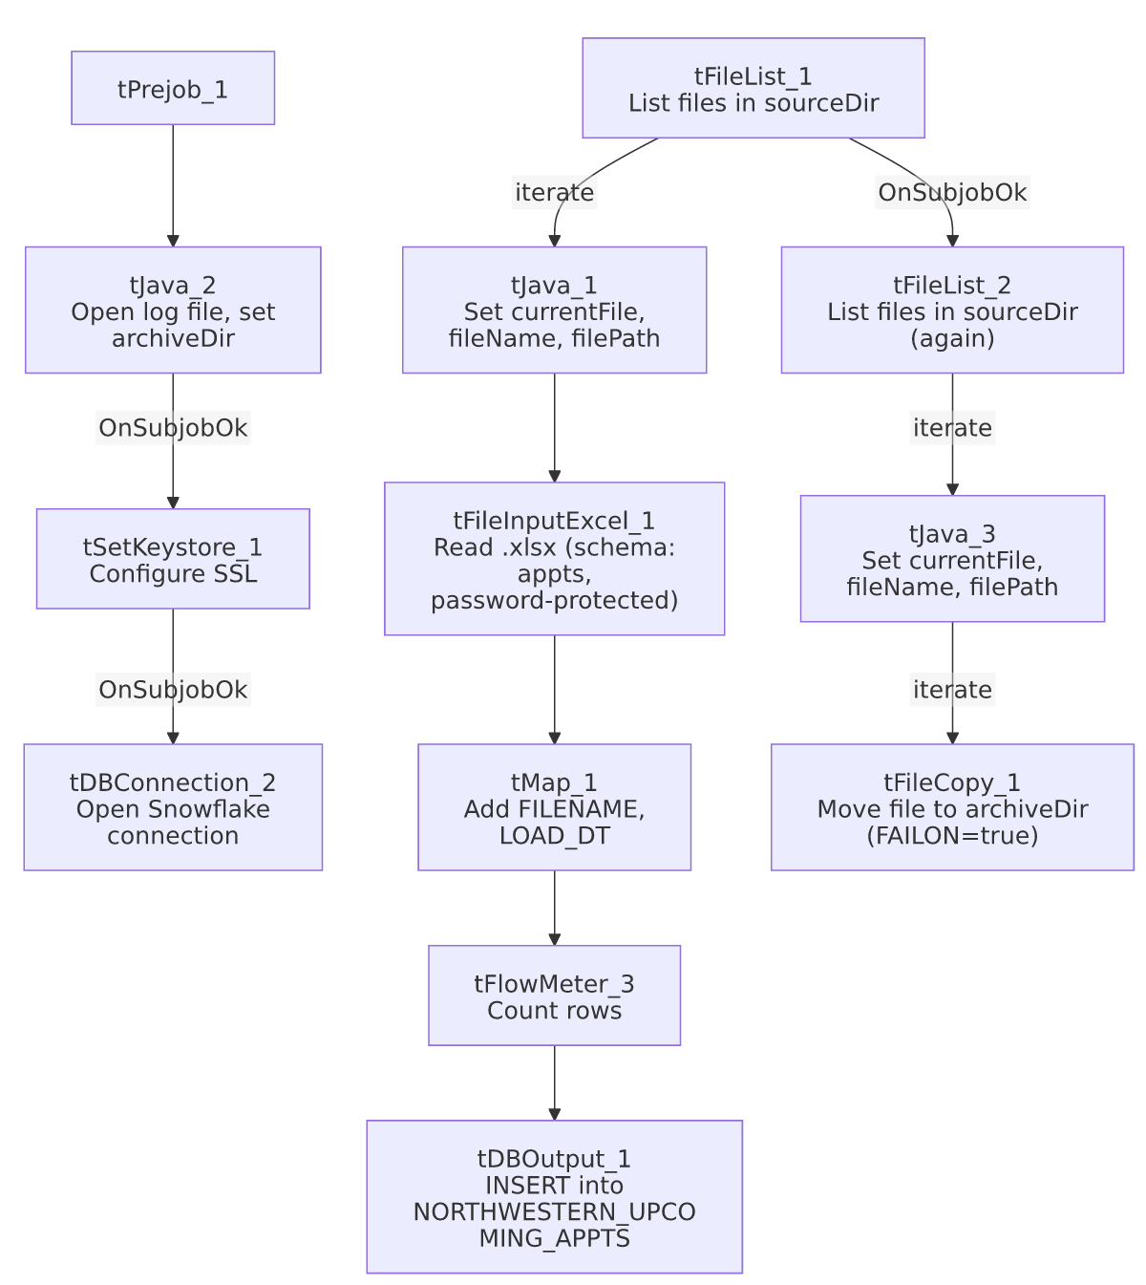

Settings tables

Source: `tFileInputExcel_1`
Setting | Value | What it means
FILENAME | context.currentFile | Current file from tFileList_1's iteration.
PASSWORD | ***REDACTED*** | The Excel workbook is password-protected; the password value is preserved as redacted.
ALL_SHEETS | false | Only the first/default sheet is read — if the partner ever sends a multi-sheet workbook with data on a later sheet, it would be silently ignored.
SCHEMA | Repository schema "...- appts", columns 1–20 | 19 named columns describing patient/account/discharge/future-appointment data.
DIE_ON_ERROR | false | Malformed rows don't fail the job, but (as elsewhere) no reject flow is wired to capture them.

Target: `tDBOutput_1` (`tSnowflakeOutput`)
Setting | Value | What it means
Table | NORTHWESTERN_UPCOMING_APPTS | Destination table for the loaded rows.
Output action | INSERT | Appends rows; there is no TRUNCATE step before it — see Issues observed regarding duplicate-load risk.

Archive: `tFileCopy_1`
Setting | Value | What it means
SOURCE_DERECTORY | "C:/Talend-Studio-20211109_1610-V8.0.1/workspace" (hardcoded) | Standard project-wide developer-workstation path risk.
DESTINATION | context.archiveDir | Set earlier in tJava_2 (exact expression truncated in this metadata).
FAILON | true | Unlike most archive steps reviewed elsewhere in this project, a copy failure here does fail the job — see Issues observed.

Dependencies & configuration
- Triggers/depends on other jobs: none — no tRunJob links found; this job doesn't appear in 06_dependency_matrix.md's orchestration table.
- Context variables used: archiveDir (set internally in tJava_2), currentFile, fileName, filePath, keystorePath, sourceDir.
- 2 hardcoded path findings: tSetKeystore_1.SSL_TRUSTSERVER_TRUSTSTORE ("C:/clientTrustStore.trustStore") and tFileCopy_1.SOURCE_DERECTORY ("C:/Talend-Studio-20211109_1610-V8.0.1/workspace").

Glossary
Component type | Plain-English meaning
tFileList | Lists files in a directory for the job to iterate over one at a time.
tFileInputExcel | Reads a Microsoft Excel workbook (here, a password-protected .xlsx file) according to a schema.
tMap | Maps/transforms columns from one schema to another.
tFlowMeter | Counts rows passing through a point in the flow, for logging/monitoring.
tSnowflakeOutput | Writes rows to a Snowflake table.
tFileCopy | Moves or copies a processed file to another location.
tSetKeystore | Configures the SSL trust store/keystore used by other components for secure connections.

Issues observed
- The per-run log file in `tJava_2` is written using a bare filename (`jobName + "_" + <timestamp> + ".log"`), with no `context.logDir` prefix, unlike the equivalent log-open code seen in most other jobs in this project (e.g. Notes_Load, MaxRTE_Request_Export, which all prefix with context.logDir). This means the log file lands wherever the job's working directory happens to be when it runs, rather than in a predictable, centralized log location — making it harder to find this job's logs alongside every other job's.
- `tFileCopy_1.FAILON=true` — a failure to archive the source file (e.g., a permissions issue, a locked file, or a full disk on the archive destination) will fail this job, even though the load itself may have already succeeded. This differs from the more common pattern elsewhere in this project (FAILON=false) where an archive-step failure is tolerated so the load's success isn't retroactively treated as a failure. Whether this stricter behavior is intentional (e.g., ensuring processed files are never left un-archived, which would risk reprocessing) is unable to determine from metadata — worth confirming with the team, since it means an archive-only problem could block visibility into an otherwise-successful data load.
- No `TRUNCATE` step before the `INSERT` into `NORTHWESTERN_UPCOMING_APPTS`. If a file is loaded twice (e.g., due to a failed archive step under FAILON=true leaving the file in sourceDir for the next run to pick up again — see above), its rows would be inserted twice with no deduplication visible in this job's own metadata.
- `ALL_SHEETS=false` means only the default sheet of the Excel file is read. If Northwestern's extract format ever changes to include multiple sheets (e.g., a summary tab plus a detail tab), this job would silently ignore any data beyond the first sheet with no error or warning.
- The load loop and archive loop are two independent `tFileList` passes over the same `context.sourceDir`, chained by `OnSubjobOk` — the same two-pass pattern seen in MaxRTE_Result_Load. See that job's Issues section for the general risk (a file arriving between the two passes, or a load failure not preventing archival of that same file) which applies equally here.

