Talend Job: Notes_Load

Overview
Loads free-text collector/agent notes ("memos") keyed by debtor and timestamp from a tab-delimited extract file into the Snowflake NOTES table. This is a simple, narrow file-load job with only three business columns — debtor identifier, memo timestamp, and memo text — and no merge/staging step visible in this metadata, suggesting NOTES is loaded as a straight append-only history table.

Detail table
Field | Value
Job name | Notes_Load
Version | 0.1
Project | EDW2SF
Author | jmach@harriscollect.com
Created | 2025-08-14T14:45:51.378-0700
Last Modified | 2025-09-24T11:00:22.361-0700

Step-by-step data flow
Setup subjob: tPrejob_1 → tJava_1 opens a per-run log file at context.logDir + jobName + "_" + <timestamp> + ".log" and redirects System.out/System.err to it → on subjob-ok, tDBConnection_1 opens the Snowflake connection. This setup subjob has no visible connection into the main load subjob below — see Issues observed (same pattern flagged in Migrating_Clients_20260424).
Main subjob:
- tFileList_1 lists files in context.sourceDir (ORDER_BY_NOTHING=true, i.e. files are processed in whatever order the filesystem returns them, unlike most other file-load jobs in this project which sort by modified date).
- For each file, tJava_2 sets context.filePath from the current file.
- tFileInputDelimited_1 reads the file (tab-delimited, header row present, DIE_ON_ERROR=false) against a repository schema labeled "...- metadata" with 3 business columns — DEBTOR_IDX, MEMO_TIMESTAMP, MEMO_TEXT (listed twice in the extracted schema, likely a main/reject-schema capture artifact, plus errorCode/errorMessage reject columns).
- tMap_1 passes the row through unchanged to the same 3-column schema (DIE_ON_ERROR=true).
- tFlowMeter_2 counts rows passing through (labeled "MyLabel").
- tDBOutput_1 inserts the rows into Snowflake table NOTES (INSERT, no table-recreate action).
No archive or file-cleanup step, no merge/stored-procedure call, and no tPostjob teardown are present in this job's metadata.
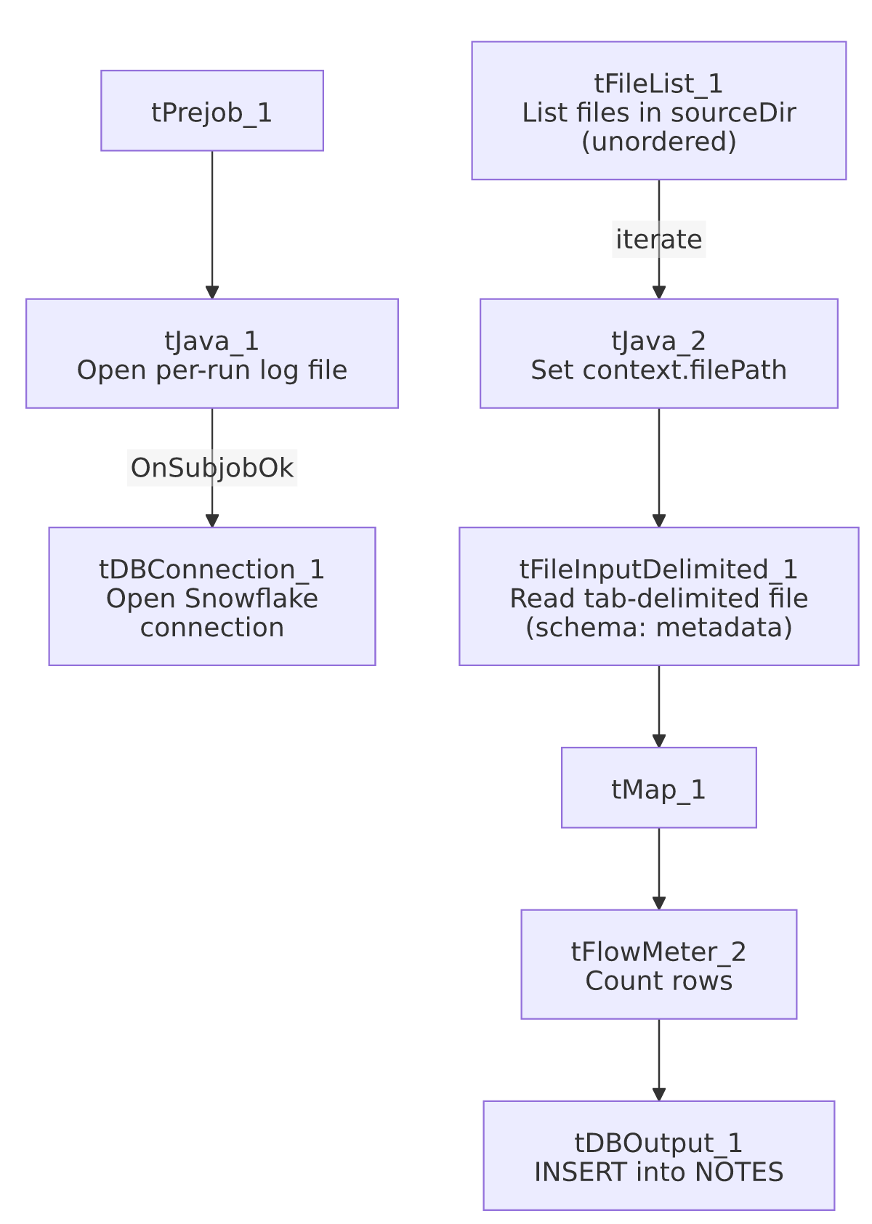

Settings tables

Source: `tFileInputDelimited_1`
Setting | Value | What it means
FILENAME | context.filePath | Current file from tFileList_1's iteration.
FIELDSEPARATOR / HEADER | \t (tab) / 1 header row | Tab-delimited with header — distinct from the comma/pipe/semicolon patterns seen in other jobs.
SCHEMA | Repository schema "...- metadata" | 3 named columns: DEBTOR_IDX, MEMO_TIMESTAMP, MEMO_TEXT.
TEMP_DIR | "C:/Talend-Studio-20211109_1610-V8.0.1/workspace" | Hardcoded developer-workstation path — same project-wide risk documented in 05_operational_runbook.md.
DIE_ON_ERROR | false | Malformed rows don't fail the job, but no reject flow captures them — see Issues observed.

Target: `tDBOutput_1` (`tSnowflakeOutput`)
Setting | Value | What it means
Table | NOTES | Destination table for collector/agent memo text.
Output action | INSERT | Appends rows; no TRUNCATE step precedes it, consistent with NOTES being an append-only history table rather than a truncate-and-reload staging table.
Table action | NONE | Table is not recreated/altered by this job.

Dependencies & configuration
- Triggers/depends on other jobs: none — no tRunJob links found; this job doesn't appear in 06_dependency_matrix.md's orchestration table.
- Context variables used: filePath (set internally per iteration), logDir, sourceDir.
- 1 hardcoded path finding: tFileInputDelimited_1.TEMP_DIR = "C:/Talend-Studio-20211109_1610-V8.0.1/workspace".

Glossary
Component type | Plain-English meaning
tFileList | Lists files in a directory for the job to iterate over one at a time.
tFileInputDelimited | Reads a delimited (CSV-style) text file according to a schema.
tMap | Maps/transforms columns from one schema to another.
tFlowMeter | Counts rows passing through a point in the flow, for logging/monitoring.
tSnowflakeOutput / tSnowflakeConnection | Write rows to a Snowflake table / open the Snowflake database connection used by other components in the job.

Issues observed
- The `tPrejob_1`/`tJava_1`/`tDBConnection_1` setup chain has no visible connection into the `tFileList_1` load subjob, the same disconnected-setup pattern flagged in Migrating_Clients_20260424. tDBOutput_1 presumably relies on an implicit/default Snowflake connection rather than the one explicitly opened in the setup subjob. Unable to determine from metadata whether this reflects an actual configuration gap or simply how a single-connection job's implicit wiring works in Talend Studio; verify directly if this job is ever modified to use more than one connection.
- No file archival or deletion step after a successful load — unlike most other file-load jobs reviewed in this project (ADP_Payroll_Load, Mail_Merge_Load, MaxRTE_Result_Load, Northwestern_Future_Appts), this job does not move, rename, or delete the source file once its rows are loaded. If tFileList_1 runs again before the source file is manually cleared out of context.sourceDir, the same memo rows would be reloaded and duplicated in NOTES (there is no TRUNCATE and no visible "already loaded" filter). Verify with the team whether file cleanup happens outside this job (e.g., by a separate process) or whether this is a gap.
- `ORDER_BY_NOTHING=true` on `tFileList_1` means files are processed in whatever order the underlying filesystem call returns them — not sorted by name, size, or modified date, unlike most other tFileList components reviewed in this project (which typically sort by modified date, ascending). If multiple note files can arrive in the same run and their processing order matters (e.g., for a given debtor's notes to be inserted in chronological file-arrival order), this is not guaranteed here.
- No reject flow wired from `tFileInputDelimited_1`, no row-count-based alerting (tWarn/tDie/tSendMail) — consistent with the general pattern noted project-wide in 05_operational_runbook.md, but worth flagging since MEMO_TEXT is free-form collector notes that could plausibly contain characters (tabs, embedded newlines) that break simple tab-delimited parsing; a silently-dropped or truncated memo would not be visible from this job's own logging.

