Talend Job: PA_Turnpike_Load

Overview
Loads a fixed, single-file CSV extract from the Pennsylvania Turnpike (a client, based on the job name and column set — debtor number, client, CDN, status, assigned/last-payment dates, two flag-like fields, and total balance) into the Snowflake PA_TURNPIKE table, replacing the table's contents entirely on each run via a bulk-load truncate-and-insert. This is a narrow, single-purpose reporting/reconciliation table for one client's account status snapshot rather than a general debtor load.

Detail table
Field | Value
Job name | PA_Turnpike_Load
Version | 0.1
Project | EDW2SF
Author | jmach@harriscollect.com
Created | 2022-08-30T13:36:19.891-0700
Last Modified | 2025-08-28T08:57:24.118-0700

Step-by-step data flow
This job has no tPrejob/tPostjob structure or explicit connection-open/close components in its metadata — it is a single straight-line flow:
- tFileInputDelimited_1 reads a fixed filename, context.sourcePath + "TP-Report_083022.csv" — note the literal date string 083022 (August 30, 2022, matching the job's creation date) baked into the filename itself, appended to a parameterized directory path (comma-delimited, header row present, DIE_ON_ERROR=false) into a schema of 9 named columns (DNUM, CLIENT, CDN, STATUS, ASSIGN, LAST_PAY, F853, F854, TOTAL_BAL).
- tMap_1 passes the row through unchanged to the same 9-column schema (DIE_ON_ERROR=true).
- tDBOutputBulkExec_1 bulk-loads the rows into Snowflake table PA_TURNPIKE with outputAction=INSERT and tableAction=TRUNCATE — the table is cleared and reloaded fresh on every run.
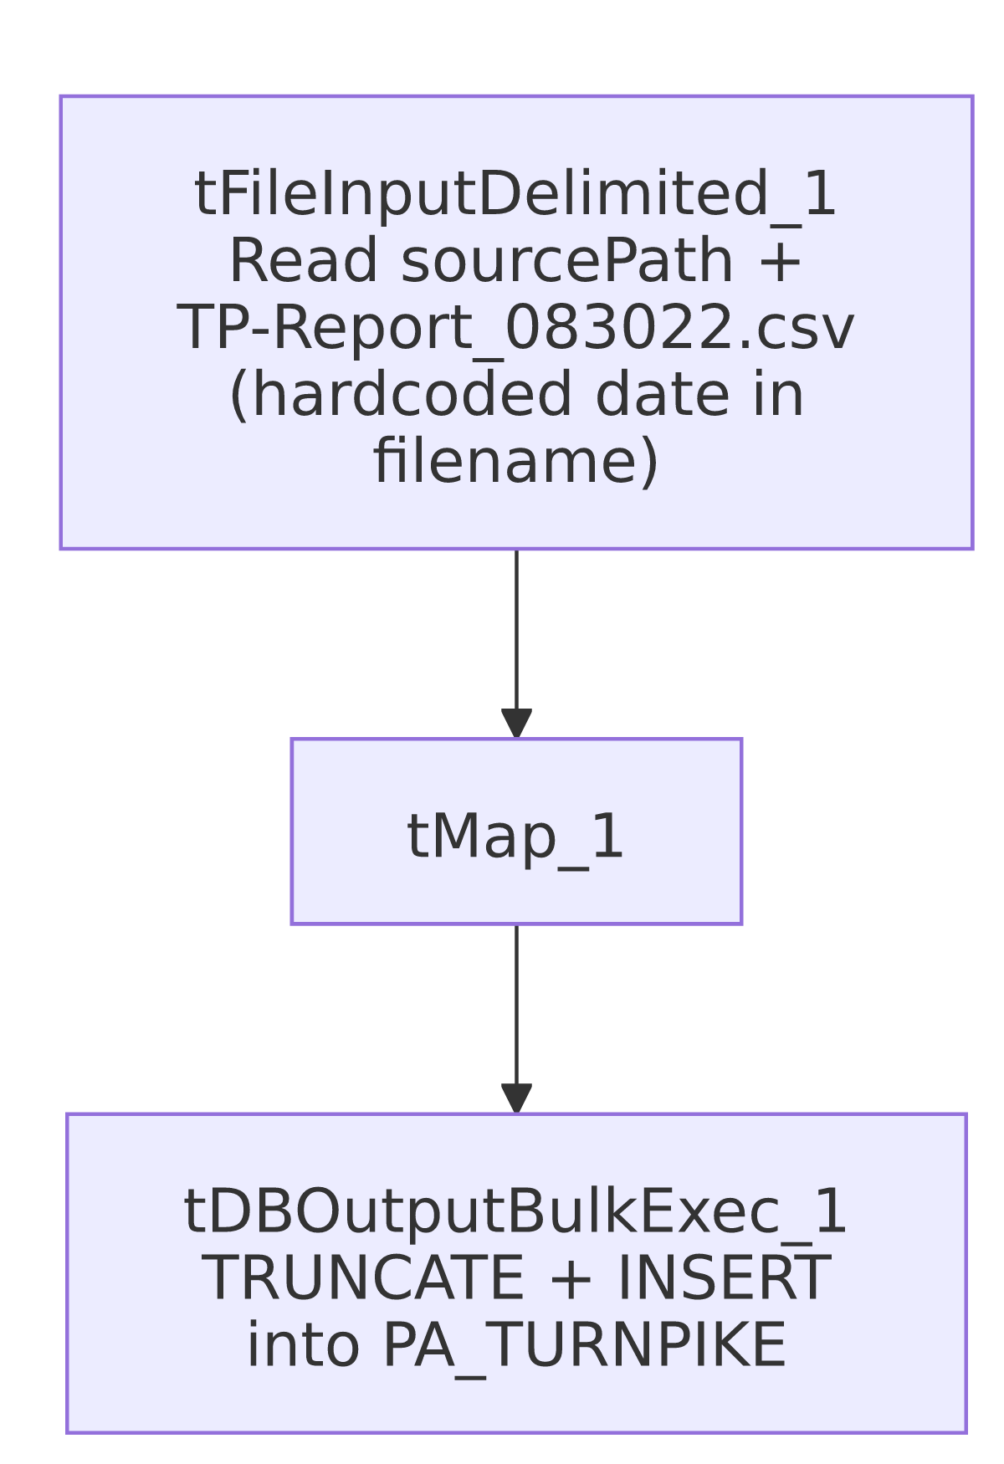

Settings tables

Source: `tFileInputDelimited_1`
Setting | Value | What it means
FILENAME | context.sourcePath+"TP-Report_083022.csv" | The directory is parameterized via context, but the filename itself is a fixed literal string with a specific date embedded — see Issues observed.
FIELDSEPARATOR / HEADER | , / 1 header row | Standard comma-delimited CSV with header.
TEMP_DIR | "C:/Talend-Studio-20211109_1610-V8.0.1/workspace" | Hardcoded developer-workstation path — same project-wide risk documented in 05_operational_runbook.md.
DIE_ON_ERROR | false | Malformed rows don't fail the job, but no reject flow is wired to capture them.

Target: `tDBOutputBulkExec_1` (`tSnowflakeOutputBulkExec`)
Setting | Value | What it means
Table | PA_TURNPIKE | Destination table for this client's account snapshot.
Output action | INSERT | Bulk-inserts rows.
Table action | TRUNCATE | The table is cleared before the new rows are loaded — a full-refresh, not an incremental, pattern; consistent with a small, periodically-refreshed reporting snapshot rather than an append-only history table.

Dependencies & configuration
- Triggers/depends on other jobs: none — no tRunJob links found; this job doesn't appear in 06_dependency_matrix.md's orchestration table.
- Context variables used: sourcePath (the directory portion of the hardcoded input filename).
- 1 hardcoded path finding: tFileInputDelimited_1.TEMP_DIR = "C:/Talend-Studio-20211109_1610-V8.0.1/workspace". The FILENAME itself is also effectively hardcoded (fixed literal filename with a baked-in date) even though it was not separately flagged in this job's own hardcoded_path_findings list — see Issues observed.

Glossary
Component type | Plain-English meaning
tFileInputDelimited | Reads a delimited (CSV-style) text file according to a schema.
tMap | Maps/transforms columns from one schema to another.
tSnowflakeOutputBulkExec | Bulk-loads rows into a Snowflake table (typically faster than a row-by-row tSnowflakeOutput insert for large volumes), with a configurable table-recreate action.

Issues observed
- The input filename is a fixed literal string, `TP-Report_083022.csv`, with the date of the job's creation baked directly into it — not derived from the current run date. Combined with tableAction=TRUNCATE, this means every time this job actually runs, it looks for the exact same file (TP-Report_083022.csv) inside context.sourcePath, regardless of when it runs — it will never pick up a newer report unless someone renames each new file to that exact literal name, or edits this job's FILENAME parameter every time a new extract needs to be loaded. Given the very long gap between creation (2022-08-30) and last modification (2025-08-28) — almost exactly 3 years apart — it's plausible this job is manually re-pointed at a renamed file before each run, or that it was run once and left unscheduled since; unable to determine from metadata which. This should be verified directly with the team, since as written, a scheduled/automated re-run of this job would either silently fail to find the file (if it was moved/archived) or repeatedly reload the exact same stale August 2022 data (if the file was left in place) — either way, the table's contents would not reflect a "PA_TURNPIKE" table that anyone expects to be current.
- No archive or file-cleanup step after the load — unlike most other file-load jobs in this project, the source file is neither moved nor deleted after being loaded, consistent with a possibly manually-managed, occasionally-run job rather than a fully automated recurring one.
- No row-count logging, `tWarn`/`tDie`, or reject-flow handling — a load producing zero rows (e.g., if the hardcoded filename can no longer be found, or the file is empty) would still let tDBOutputBulkExec_1's TRUNCATE clear the table, potentially leaving PA_TURNPIKE empty with no error raised. This is a materially higher-impact version of the general "no explicit tDie/tWarn" pattern documented project-wide in 05_operational_runbook.md, because the destructive TRUNCATE happens unconditionally regardless of whether the subsequent load actually produced any rows.

