Talend Job: PCI_Letter_Load

Overview
Loads letter-generation/mail-disposition audit records (one row per debtor letter attempt, with the raw letter code, any rejection reason/value, and the resulting mail disposition — e.g. suppressed, printed, returned) from the MSSQL EDWProdHH database's PCI_Letters table into the Snowflake PCI_LETTERS table. Uses an incremental-load pattern keyed on INSERT_KEY, following the same "check max key in Snowflake, then pull from source" shape used in i3_CallDetail_40_Load. As with that job, the "PCI" naming and the letter-suppression/disposition columns suggest this feeds compliance tracking of which letters were withheld from mailing due to PCI (cardholder-data) content.

Detail table
Field | Value
Job name | PCI_Letter_Load
Version | 0.1
Project | EDW2SF
Author | jmach@harriscollect.com
Created | 2022-01-10T15:54:03.317-0800
Last Modified | 2022-02-28T10:05:17.477-0800

Step-by-step data flow
Setup subjob: tPrejob_1 → tDBConnection_1 opens the Snowflake connection → on component-ok, tDBConnection_2 opens the MSSQL connection to context.EDWProdHH_Server/Port/Schema/Database/Login (password redacted; JTDS driver) — the same EDWProdHH_* context-variable naming convention flagged as potentially mismatched in i3_CallDetail_40_Load's doc.
Main subjob:
- tDBInput_2 runs SELECT COALESCE(CAST(MAX(INSERT_KEY) AS VARCHAR(10)),'0') AS MAX_INSERT_KEY FROM DW.PCI_LETTERS; against Snowflake to find the highest INSERT_KEY already loaded.
- tJavaRow_1 captures that value into context.maxInsertKey.
- On success (SUBJOB_OK), tDBInput_1 runs a fixed SELECT (against the shared MSSQL connection, table PCI_Letters) pulling Customer_Key, Logon, Debtor_Number, Raw_Letter_Code, Reject_Type, Reject_Reason, Reject_Value, Mail_DispositionCode, Mail_Disposition, File_Date, File_Name, AuditInsertKey, InsertedBy — the captured query text is truncated in this metadata after the column list, so it is not visible whether the query filters on `context.maxInsertKey` (same caveat as i3_CallDetail_40_Load — see Issues observed).
- tMap_1 maps the ~13 source columns to an uppercase-named 12-column target schema (CUSTOMER_KEY, LOGON, DEBTOR_NUMBER, RAW_LETTER_CODE, REJECT_TYPE, REJECT_REASON, REJECT_VALUE, MAIL_DISPOSITIONCODE, MAIL_DISPOSITION, FILE_DATE, FILE_NAME, INSERT_KEY — note the source's AuditInsertKey becomes the target's INSERT_KEY).
- tFlowMeter_4 counts rows passing through (labeled "MyLabel").
- tDBOutput_1 inserts the rows into Snowflake table PCI_LETTERS (INSERT, no table-recreate action).
Teardown subjob: tPostjob_1 → tDBClose_1 (close Snowflake) → tDBClose_2 (close MSSQL).
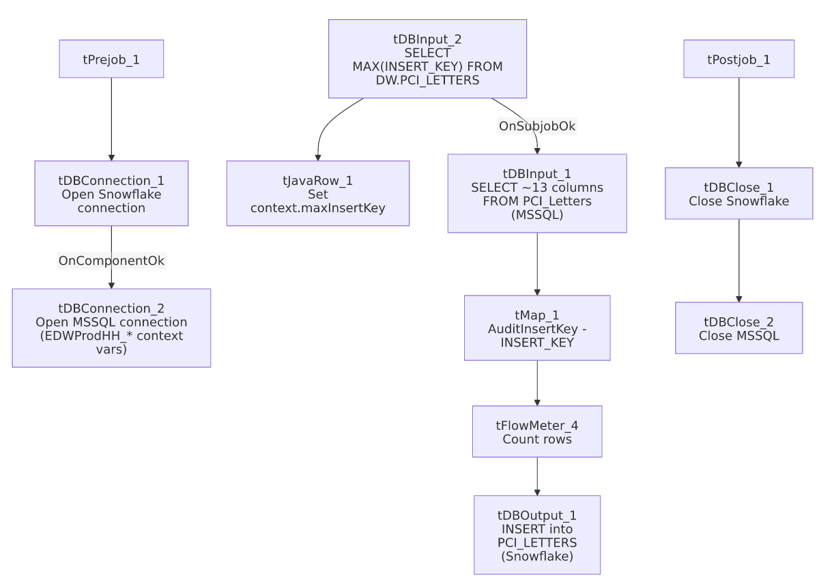

Settings tables

Source: `tDBInput_1` (`tMSSqlInput`)
Setting | Value | What it means
Connection | Shared tDBConnection_2 | Reuses the job's single MSSQL connection.
Table | PCI_Letters | Source letter-disposition audit table in the EDWProdHH MSSQL database.
Query | Fixed SELECT of 13 named columns | The visible portion of the query does not show a WHERE clause referencing context.maxInsertKey — see Issues observed.

Target: `tDBOutput_1` (`tSnowflakeOutput`)
Setting | Value | What it means
Table | PCI_LETTERS | Destination table in Snowflake.
Output action | INSERT | Appends rows — no TRUNCATE/staging step, consistent with an incremental-append design assuming the max-key check is actually applied upstream.

Dependencies & configuration
- Triggers/depends on other jobs: none — no tRunJob links found; this job doesn't appear in 06_dependency_matrix.md's orchestration table. Note it produces the PCI_LETTERS table, which is a plausible (but not confirmed by any metadata link) reference point for the separate PCI_LETTERS_TO_DELETE job's compliance-remediation purpose — the two are not connected via tRunJob or any other visible mechanism.
- Context variables used: EDWProdHH_Server, EDWProdHH_Port, EDWProdHH_Schema, EDWProdHH_Database, EDWProdHH_Login (MSSQL connection details), maxInsertKey (computed internally from the Snowflake max-key query).
- No hardcoded developer-workstation paths found in this job.

Glossary
Component type | Plain-English meaning
tSnowflakeConnection / tSnowflakeClose | Open/close a Snowflake database connection shared by other components in the job.
tMSSqlConnection / tMSSqlInput / tMSSqlClose | Open a Microsoft SQL Server connection, run a query against it, and close it.
tSnowflakeInput | Runs a query against Snowflake and returns its result rows (here, used just once for a single aggregate value).
tJavaRow | Runs custom Java code once per input row — here used to unpack a single query result into a context variable.
tMap | Maps/transforms columns from one schema to another.
tFlowMeter | Counts rows passing a point in the flow for logging/monitoring.
tSnowflakeOutput | Writes rows to a Snowflake table.

Issues observed
- The incremental-load logic may not actually be applied — the same caveat documented for `i3_CallDetail_40_Load`. The job computes context.maxInsertKey from Snowflake before reading the MSSQL source, strongly suggesting an intent to pull only rows with a higher key than what's already loaded, but the tDBInput_1.QUERY text captured in this metadata is truncated after the column list and does not show a WHERE clause referencing context.maxInsertKey in the visible portion. Unable to determine from this metadata whether the query is actually filtered — if it isn't, every run re-reads and re-inserts the entire PCI_Letters source table, duplicating all previously loaded rows in Snowflake (there is no TRUNCATE step before the INSERT). This should be verified directly in Talend Studio before assuming the incremental design works as intended — this is the second job in this batch (after i3_CallDetail_40_Load, documented separately) with the identical unverifiable pattern, suggesting it may be worth a one-time check across all tDBInput_2/maxInsertKey-style jobs in the project rather than job-by-job.
- The MSSQL connection uses `context.EDWProdHH_*` variables, the same naming convention flagged as ambiguous in i3_CallDetail_40_Load — here it is at least plausible the PCI_Letters table genuinely lives in the EDWProdHH database (unlike the I3 telephony case), but this still can't be confirmed from metadata alone; verify which physical database context.EDWProdHH_Database actually points to for this job specifically.
- The source column `AuditInsertKey` is renamed to `INSERT_KEY` in the target schema, while the source also has its own distinct Reject_Type/Reject_Value fields not otherwise cross-referenced to any lookup table visible in this metadata — unable to determine from metadata what the valid Reject_Type/Mail_DispositionCode value sets are, or what business process consumes them downstream.
- No error/row-count logging specific to this job's business outcome (no tWarn/tDie/tSendMail) — a load failure here would only surface as a generic Talend execution error, with no job-specific message to distinguish it in a shared log.

