Talend Job: PRE_E_Media_Load

Overview
Loads electronic-media/letter-disposition tracking records (one row per generated letter or communication, with status codes/text, waterfall series, and update timestamps) for the "PRE" site from the MSSQL EDWProdHH database's DC-ElectronicsMedia table into Snowflake, staging into PRE_ELECTRONICSMEDIA and then merging into the DW.PRE_ELECTRONICSMEDIA warehouse table. Uses the same incremental max-key pattern seen in i3_CallDetail_40_Load and PCI_Letter_Load, but — unlike those two — this job's merge step is fully visible and does contain an explicit MERGE statement with matched/not-matched logic, giving a clearer picture of the incremental design's intent even though the upstream source query's filter clause is still truncated.

Detail table
Field | Value
Job name | PRE_E_Media_Load
Version | 0.1
Project | EDW2SF
Author | jmach@harriscollect.com
Created | 2022-05-17T09:44:40.025-0700
Last Modified | 2025-09-24T11:06:53.976-0700

Step-by-step data flow
Setup subjob: tPrejob_1 → tDBConnection_1 opens the MSSQL connection to context.EDWProdHH_Server/Port/Schema/Database/Login (password redacted, JTDS driver) → on component-ok, tDBConnection_2 opens a Snowflake connection → on component-ok, tDBConnection_3 opens a second, separate Snowflake connection (see Issues observed).
Main subjob:
- tDBInput_2 runs SELECT CAST(COALESCE(MAX(UPDATEKEY),0) AS VARCHAR(10)) AS MAXUPDATEKEY FROM DW.PRE_ELECTRONICSMEDIA; against Snowflake to find the highest UPDATEKEY already merged into the warehouse table.
- tJavaRow_1 captures that value into context.maxUpdateKey.
- On success (SUBJOB_OK), tDBInput_1 runs a query (against the shared MSSQL connection, table DC-ElectronicsMedia) pulling LOGON, EMID, EMID_IDX, LETTER_NAME, STATUS_DATE, STATUS_TIME, STATUS, STATUS_TEXT, STATUS_TYPE, WATERFALL, UPDATE_DT, UPDATE_TIME, CURR_SERIES, NEW_SERIES, CONTENT, ORIG_STATUS, SOURCE, SRC_NAME, UpdateKey — the captured query text is truncated after the column list, so it is not visible whether the query filters on `context.maxUpdateKey` (same caveat as i3_CallDetail_40_Load/PCI_Letter_Load).
- tMap_1 renames UpdateKey to UPDATEKEY (uppercase) and passes the rest of the columns through unchanged.
- tFlowMeter_2 counts rows passing through (labeled "MyLabel").
- tDBOutput_1 loads the rows into Snowflake table PRE_ELECTRONICSMEDIA with outputAction=INSERT and `tableAction=TRUNCATE` — this table is cleared and reloaded fresh each run (this is the staging landing table, per the merge query's FROM STAGING.PRE_ELECTRONICSMEDIA reference below).
- Once tDBInput_1's whole subjob (including the staging load above) succeeds (SUBJOB_OK), tDBRow_1 runs a MERGE INTO DW.PRE_ELECTRONICSMEDIA statement, sourcing from STAGING.PRE_ELECTRONICSMEDIA, matching on EMID_IDX: matched rows get all their other columns updated; unmatched rows are inserted as new.
Teardown subjob: tPostjob_1 → tDBClose_2 (close MSSQL) → tDBClose_1 (close first Snowflake connection) → tDBClose_3 (close second Snowflake connection).
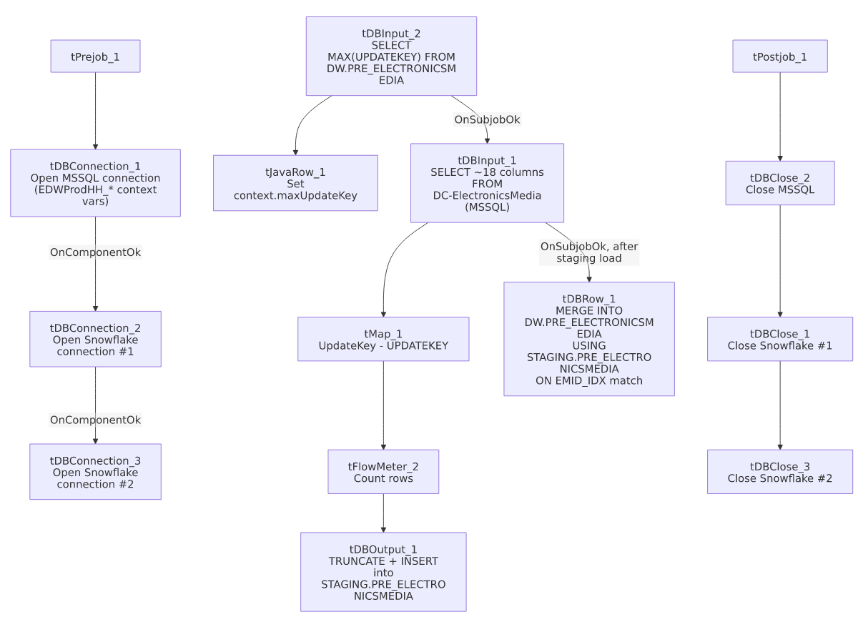

Settings tables

Source: `tDBInput_1` (`tMSSqlInput`)
Setting | Value | What it means
Connection | Shared tDBConnection_1 | Reuses the job's single MSSQL connection.
Table | DC-ElectronicsMedia | Source letter/media-disposition table — note the table name itself is prefixed DC-, even though this job is named PRE_E_Media_Load — see Issues observed.
Query | Fixed SELECT of 18 named columns | The visible portion of the query does not show a WHERE clause referencing context.maxUpdateKey — see Issues observed.

Staging load: `tDBOutput_1` (`tSnowflakeOutput`)
Setting | Value | What it means
Table | PRE_ELECTRONICSMEDIA | Destination staging table (in the STAGING schema, per the merge query's FROM STAGING.PRE_ELECTRONICSMEDIA reference).
Output action | INSERT | Loads the freshly-read rows.
Table action | TRUNCATE | The staging table is cleared before each load — standard truncate-then-load staging pattern.

Merge: `tDBRow_1` (`tSnowflakeRow`)
Setting | Value | What it means
Query | MERGE INTO DW.PRE_ELECTRONICSMEDIA AS tgt USING (SELECT ... FROM STAGING.PRE_ELECTRONICSMEDIA) AS src ON (tgt.EMID_IDX = src.EMID_IDX) WHEN MATCHED THEN UPDATE ... WHEN NOT MATCHED THEN INSERT ... | A full upsert: existing rows (matched by EMID_IDX) get all their tracked columns updated in place; new rows are inserted. The SELECT inside USING also applies LEFT(...) length-truncation to several string columns and TRY_TO_NUMBER(WATERFALL,10,0) to safely coerce WATERFALL to a number, defaulting to 0 on a non-numeric value.
Result handling | Not captured | Unlike ADP_Payroll_Load or CO_Master_Load, this job does not capture the merge's result/row count or branch on success/failure.

Dependencies & configuration
- Triggers/depends on other jobs: none — no tRunJob links found; this job doesn't appear in 06_dependency_matrix.md's orchestration table.
- Context variables used: EDWProdHH_Server, EDWProdHH_Port, EDWProdHH_Schema, EDWProdHH_Database, EDWProdHH_Login (MSSQL connection details), maxUpdateKey (computed internally from the Snowflake max-key query).
- No hardcoded developer-workstation paths found in this job.

Glossary
Component type | Plain-English meaning
tMSSqlConnection / tMSSqlInput / tMSSqlClose | Open a Microsoft SQL Server connection, run a query against it, and close it.
tSnowflakeConnection / tSnowflakeClose | Open/close a Snowflake database connection.
tSnowflakeInput | Runs a query against Snowflake and returns its result rows.
tJavaRow | Runs custom Java code once per input row — here used to unpack a single query result into a context variable.
tMap | Maps/transforms columns from one schema to another.
tFlowMeter | Counts rows passing through a point in the flow, for logging/monitoring.
tSnowflakeOutput | Writes rows to a Snowflake table (here, a truncate-and-reload staging table).
tSnowflakeRow | Runs an arbitrary SQL statement — here, the MERGE upsert into the final warehouse table.

Issues observed
- The MSSQL source table is literally named `DC-ElectronicsMedia`, containing "DC" — a different site code than this job's own name (`PRE_E_Media_Load`). Given 01_system_architecture.md's documented site codes (CHI, CO, DC, HH, PRE, TOL), this is a genuine naming inconsistency: either the source table name is a holdover from when this table served the DC site (and was later repurposed/renamed at the target level for PRE without renaming the source), or this job is unintentionally reading DC's electronic-media data and loading it as if it were PRE's. Unable to determine from this metadata which is the case — this is worth confirming directly with the team, since if it's the latter, PRE_ELECTRONICSMEDIA/DW.PRE_ELECTRONICSMEDIA could be silently populated with the wrong site's data.
- The incremental-load logic may not actually be filtered — the same caveat documented for `i3_CallDetail_40_Load` and `PCI_Letter_Load`. The job computes context.maxUpdateKey from Snowflake before reading the MSSQL source, but tDBInput_1.QUERY's captured text is truncated after the column list and does not show a WHERE clause referencing context.maxUpdateKey. However, this job's tDBOutput_1 step does TRUNCATE the STAGING.PRE_ELECTRONICSMEDIA table before each load, and the subsequent MERGE's ON (tgt.EMID_IDX = src.EMID_IDX) match means even a full, unfiltered re-read of the source would only update/re-insert existing rows rather than duplicate them in the final DW.PRE_ELECTRONICSMEDIA table — so the practical impact of an unfiltered source query here is likely just wasted read/merge work each run (re-processing the entire source table every time), not duplicate data, unlike the two peer jobs. Still, the max-key computation would then be essentially unused; worth confirming with the team whether the source query is actually filtered.
- Two separate Snowflake connections (`tDBConnection_2` and `tDBConnection_3`) are opened in this single job, rather than one shared connection reused by both tDBOutput_1 (staging load) and tDBRow_1 (merge). Unable to determine from metadata whether this is necessary (e.g., different connection-level settings between the two) or simply an unnecessary duplicate connection — opening two connections where one would suffice adds unnecessary overhead and two more failure points to monitor.
- The merge's `MERGE INTO ... USING (SELECT ...)` source subquery applies `LEFT(...)` truncation to several string columns (e.g., LEFT(LOGON,50), LEFT(STATUS_TEXT,500)) — if any staged value is longer than these limits, it will be silently truncated during the merge with no warning, even though the earlier staging load (tDBOutput_1) may have accepted the full-length value without truncation. This could produce a staging table and a final warehouse table that briefly disagree in content for any row with an over-length field.
- No error/row-count logging specific to this job's business outcome (no tWarn/tDie/tSendMail) and the merge's result is not captured — a load or merge failure here would only surface as a generic Talend execution error.

