Talend Job: PV_PostDate_Export_Load

Overview
Despite its name, this job is a load, not an export: it reads post-dated-payment extract files (debtor, payment type/date/amount, an "Ignite" system key) from a source directory into a Snowflake staging table, then reconciles that staging data against the existing DW.PV_POSTDATE warehouse table using an active-flag pattern — deactivating (ACTIVE_FLAG='N') any previously-loaded post-dated payment that no longer appears (or has changed) in the new file, then merging/upserting the current file's rows in as active (ACTIVE_FLAG='Y'). "PV" is not one of the site codes documented in 01_system_architecture.md (CHI/CO/DC/HH/PRE/TOL) — its meaning is not defined anywhere in this job's own metadata.

Detail table
Field | Value
Job name | PV_PostDate_Export_Load
Version | 0.1
Project | EDW2SF
Author | jmach@harriscollect.com
Created | 2026-01-06T10:11:21.974-0800
Last Modified | 2026-05-28T14:57:37.840-0700

Step-by-step data flow
Setup subjob: tPrejob_1 → tJava_2 opens a per-run log file at context.logDir + jobName + "_" + <timestamp> + ".log" → on subjob-ok, tSetKeystore_1 configures SSL trust/keystore (hardcoded trust-store path, context.keystorePath for the keystore) → on subjob-ok, tDBConnection_1 opens the Snowflake connection.
Main subjob — staging load:
- tDBRow_3 runs TRUNCATE TABLE PV_POSTDATE; (the staging table).
- On success, tFileList_1 lists files in context.sourceDir.
- For each file, tJava_1 sets context.fileName/context.filePath, then uses a regex (\d{8}) to extract an 8-digit date string from the filename (captured into a local variable; the assignment to a context variable is not fully visible in this metadata's truncated code snippet).
- tFileInputDelimited_2 reads the file (comma-delimited, header row present, DIE_ON_ERROR=false) against a repository schema labeled "...- metadata" with 8 named columns (Logon, Account_Number, Debtor_Name, Payment_Type, Payment_Date, Payment_Amount, Ignite_Key, Created_Date).
- tMap_1 renames/reshapes into an 11-column target schema, adding FILE_DATE, FILE_NAME, and LOAD_TIMESTAMP audit columns and renaming e.g. Account_Number→DEBTOR_NUMBER, Debtor_Name→DEBTOR_NAME, Created_Date→CREATE_DATE.
- tFlowMeter_1 counts rows passing through (labeled "MyLabel").
- tDBOutput_1 inserts the rows into Snowflake table PV_POSTDATE (the staging table just truncated in step 1; INSERT, no table-recreate action here since the truncate already happened).
Main subjob — post-load reconciliation and archival (`tParallelize_1`, once the staging load's file loop finishes):
- Branch A — deactivate stale rows: tDBRow_1 runs an UPDATE DW.PV_POSTDATE ... SET ACTIVE_FLAG = 'N' for any (DEBTOR_NUMBER, LOGON) pair present in both DW.VW_PV_POSTDATE and STAGING.PV_POSTDATE where the staged row's IGNITE_KEY is now null, or its CREATE_DATE/PAYMENT_DATE no longer matches — i.e., flags previously-active post-dated payments as inactive if the new file's version of that record has changed or dropped its Ignite key. On success, tDBRow_2 runs a MERGE INTO DW.PV_POSTDATE from a de-duplicated (QUALIFY ROW_NUMBER() ... = 1) STAGING.PV_POSTDATE, matching on DEBTOR_NUMBER/PAYMENT_DATE/LOGON/CREATE_DATE: matched rows are updated (including TARGET.ACTIVE_FLAG = 'Y' and TRY_TO_NUMBER(...) coercion of PAYMENT_AMOUNT); unmatched rows are inserted as new, also with ACTIVE_FLAG='Y'.
- Branch B — archive: tFileList_2 independently re-lists context.sourceDir, and for each file, tJava_3 sets context.fileName/filePath, then tFileCopy_1 moves it to context.archiveDir (REMOVE_FILE=true, REPLACE_FILE=true, FAILON=false).
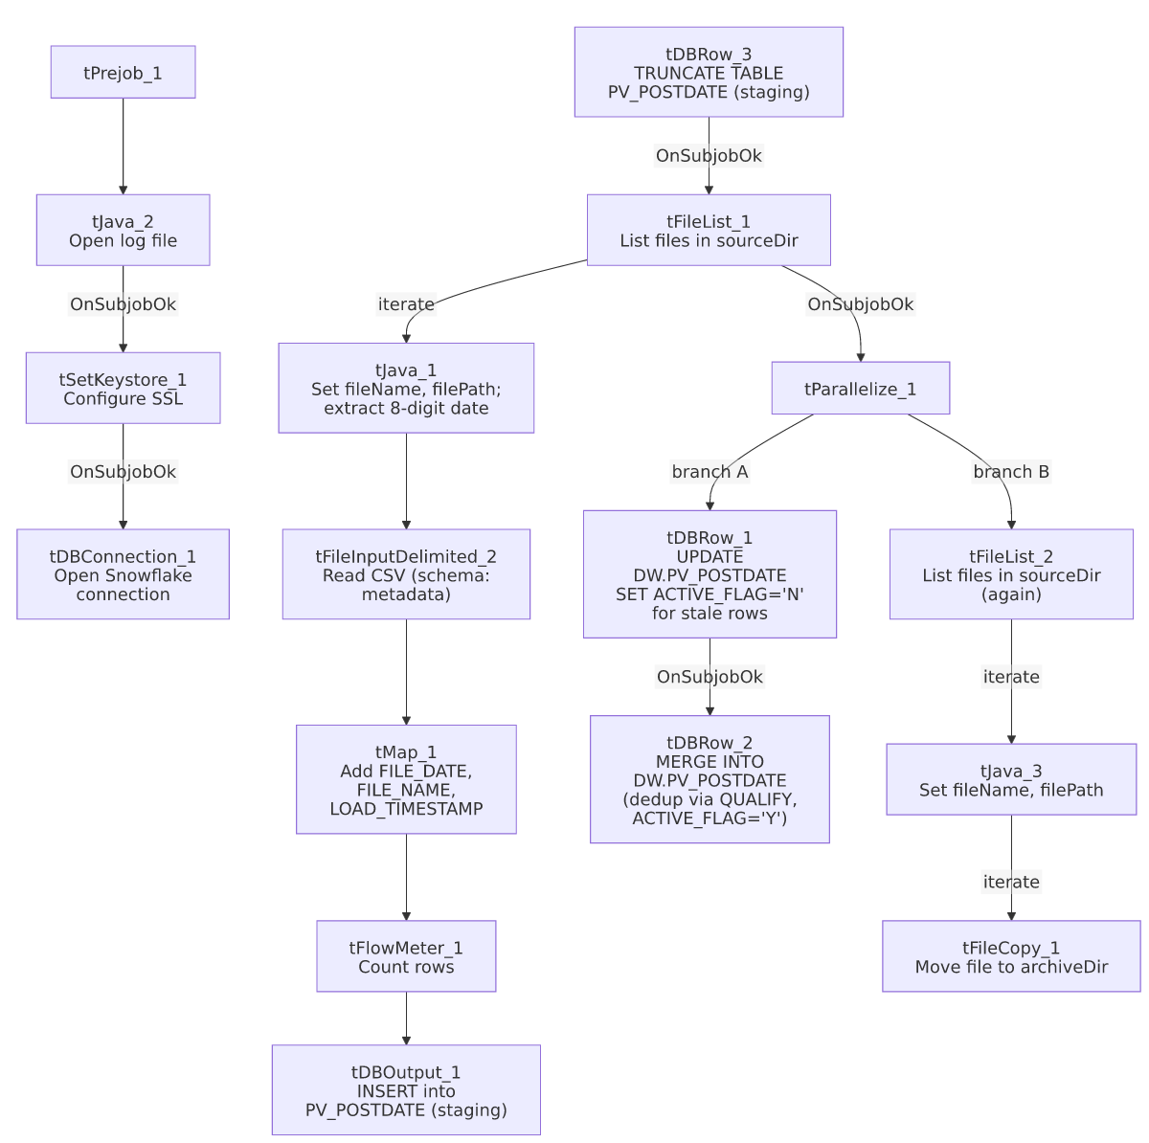

Settings tables

Source: `tFileInputDelimited_2`
Setting | Value | What it means
FILENAME | context.filePath | Current file from tFileList_1's iteration.
FIELDSEPARATOR / HEADER | , / 1 header row | Standard comma-delimited CSV.
SCHEMA | Repository schema "...- metadata" | 8 named columns — payment/debtor identifiers and an "Ignite" key (an external payment/collections system, based on the column name).
TEMP_DIR | "C:/Talend-Studio-20211109_1610-V8.0.1/workspace" | Hardcoded developer-workstation path — same project-wide risk documented in 05_operational_runbook.md.
DIE_ON_ERROR | false | Malformed rows don't fail the job; no reject flow is wired.

Staging load: `tDBOutput_1`
Setting | Value | What it means
Table | PV_POSTDATE | Staging table (default/current schema; the merge query's FROM STAGING.PV_POSTDATE confirms this is the STAGING schema copy).
Output action | INSERT | Loads the rows; relies on the earlier explicit tDBRow_3.TRUNCATE TABLE PV_POSTDATE; to clear it first.

Deactivate step: `tDBRow_1`
Setting | Value | What it means
Query | UPDATE DW.PV_POSTDATE pvp SET ACTIVE_FLAG = 'N' FROM (SELECT DISTINCT ... FROM DW.VW_PV_POSTDATE dp INNER JOIN STAGING.PV_POSTDATE sp ON ... WHERE sp.IGNITE_KEY IS NULL OR dp.CREATE_DATE <> sp.CREATE_DATE OR dp.PAYMENT_DATE <> sp.PAYMENT_DATE) AS tbd WHERE pvp.DEBTOR_NUMBER = tbd.DEBTOR_NUMBER AND pvp.LOGON = tbd.LOGON; | Flags a warehouse row inactive if the corresponding staged row's Ignite key is now missing or its create/payment date has changed — effectively a soft-delete/superseded marker rather than a hard delete. Note this reads from DW.VW_PV_POSTDATE (a view), not the base table directly.

Merge step: `tDBRow_2`
Setting | Value | What it means
Query | MERGE INTO DW.PV_POSTDATE ... USING (SELECT * FROM STAGING.PV_POSTDATE QUALIFY ROW_NUMBER() OVER (PARTITION BY DEBTOR_NUMBER,LOGON,PAYMENT_DATE,CREATE_DATE ORDER BY PAYMENT_DATE) = 1) ... WHEN MATCHED THEN UPDATE ... ACTIVE_FLAG='Y' ... WHEN NOT MATCHED THEN INSERT ... ACTIVE_FLAG='Y'; | De-duplicates the staged rows (keeping one per debtor/logon/payment-date/create-date combination) before merging, then marks every matched-or-inserted row active. PAYMENT_AMOUNT is coerced via TRY_TO_NUMBER(..., 18, 2), silently producing NULL (not an error) for any non-numeric value.

Dependencies & configuration
- Triggers/depends on other jobs: none — no tRunJob links found; this job doesn't appear in 06_dependency_matrix.md's orchestration table.
- Context variables used: archiveDir, fileDate (referenced per context_vars_referenced though the exact assignment in tJava_1's truncated code is not fully visible), fileName, filePath, keystorePath, logDir, sourceDir.
- 3 hardcoded path findings: tFileInputDelimited_2.TEMP_DIR, tFileCopy_1.SOURCE_DERECTORY (both C:/Talend-Studio-20211109_1610-V8.0.1/workspace), and tSetKeystore_1.SSL_TRUSTSERVER_TRUSTSTORE (C:/clientTrustStore.trustStore).

Glossary
Component type | Plain-English meaning
tFileList | Lists files in a directory for the job to iterate over one at a time.
tFileInputDelimited | Reads a delimited (CSV-style) text file according to a schema.
tMap | Maps/transforms columns from one schema to another.
tFlowMeter | Counts rows passing through a point in the flow, for logging/monitoring.
tSnowflakeOutput / tSnowflakeRow / tSnowflakeConnection | Write rows to a Snowflake table / run an arbitrary SQL statement (here, the deactivate UPDATE and the MERGE) / open the shared Snowflake connection.
tParallelize | Runs its downstream branches (here, the reconciliation SQL and the archive loop) at the same time.
tFileCopy | Moves or copies a processed file to another location.
tSetKeystore | Configures the SSL trust store/keystore used by other components for secure connections.

Issues observed
- The job name says "Export" but this job only loads data — nothing in this metadata writes an output file or sends data anywhere external. Either this job was renamed from an original export-then-load design without the "Export" being dropped from the name, or it's paired with a separate, unseen export job that isn't part of this metadata (e.g., something that reads DW.VW_PV_POSTDATE and writes a file for a downstream consumer). Unable to determine from metadata; worth confirming the job's actual role with the team so it isn't confused with an actual data-export process.
- "PV" is not one of the six site codes documented in `01_system_architecture.md` (CHI, CO, DC, HH, PRE, TOL). Unable to determine from this job's own metadata what "PV" stands for (a client name? a payment-vendor abbreviation? "post-void"?) — flag for team clarification, consistent with the general site-code ambiguity noted project-wide.
- The deactivate step (`tDBRow_1`) reads from `DW.VW_PV_POSTDATE` (a view) rather than the base `DW.PV_POSTDATE` table, while the UPDATE statement itself writes to the base table (pvp). If the view applies any filtering (e.g., only currently-active rows, or a date-range restriction) not visible in this job's own metadata, the deactivate logic's actual scope could be narrower or different than a plain read of the base table would suggest. Unable to determine from metadata what DW.VW_PV_POSTDATE actually filters; verify its definition before assuming this deactivate step covers all relevant rows.
- The `tJava_1` code that extracts an 8-digit date from the filename via regex is truncated in this metadata after the match is found — it's not clear from what's captured whether the extracted date string is ever assigned to a context variable used later (e.g., context.fileDate, which is listed in context_vars_referenced but whose assignment isn't fully visible). If the date parsing silently fails to produce a usable value, FILE_DATE in the loaded rows could be blank or default-valued with no error — verify directly in Talend Studio.
- No row-count-based alerting (tWarn/tDie/tSendMail) on either the deactivate UPDATE or the MERGE — a reconciliation that deactivates far more (or fewer) rows than expected, or a merge that silently NULLs out PAYMENT_AMOUNT via TRY_TO_NUMBER's default-on-failure behavior, would produce no job-specific warning.

