Talend Job: PaymentPlan_Load

Overview
An orchestrator-and-merge job for payment-plan data: it triggers the shared CUBS_Raw_File_Load job to actually read and stage a payment-plan extract file, then calls a Snowflake stored procedure to merge the staged rows into the final PAYMENTPLAN table, checking the merge's row-count result and either warning or failing the job depending on outcome. Unlike PaymentPlan_Legacy_Load (a direct MSSQL full-refresh into the same-named target table), this job represents the newer, incremental, file-based loading pattern used elsewhere in this project (e.g. CO_Master_Load's sub-jobs) — see that job's doc for the apparent overlap risk between the two.

Detail table
Field | Value
Job name | PaymentPlan_Load
Version | 0.1
Project | EDW2SF
Author | jmach@harriscollect.com
Created | 2022-08-17T11:18:12.425-0700
Last Modified | 2022-08-17T12:01:31.600-0700

Step-by-step data flow
Setup subjob: tPrejob_1 → tDBConnection_1 opens the Snowflake connection.
Main subjob:
- tRunJob_1 calls `CUBS_Raw_File_Load` (USE_INDEPENDENT_PROCESS=false, i.e. runs inside this job's own JVM rather than as a separate process; DIE_ON_CHILD_ERROR=true; TRANSMIT_ORIGINAL_CONTEXT=true) — this shared sub-job (also called by DimDeskInfo_Load, DimEmployeeInfo_Load, and Fact_Electronic_Media_Load per 06_dependency_matrix.md) presumably reads a payment-plan extract file and loads it into a staging table; its own internal logic is not part of this job's metadata.
- On success (SUBJOB_OK), tDBRow_1 runs CALL STAGING.MERGE_INTO_PAYMENTPLAN(); against Snowflake.
- tJavaRow_1 captures the procedure's RETVALUE into context.rowCount.
- The flow branches on two RUN_IF conditions off tJavaRow_1 (branch conditions not captured in this metadata, but component wiring and message content make the intent clear):
- Failure branch: tDie_1 fails the job with message context.rowCount.toString() + ": an error occurred during MERGE" and exit code = context.rowCount.intValue().
- Success branch: tWarn_1 logs context.rowCount.toString() + " rows added to FACT_ELECTRONIC_MEDIA" — note this message refers to the wrong table; see Issues observed.
Teardown subjob: tPostjob_1 → tDBClose_1 closes the Snowflake connection.
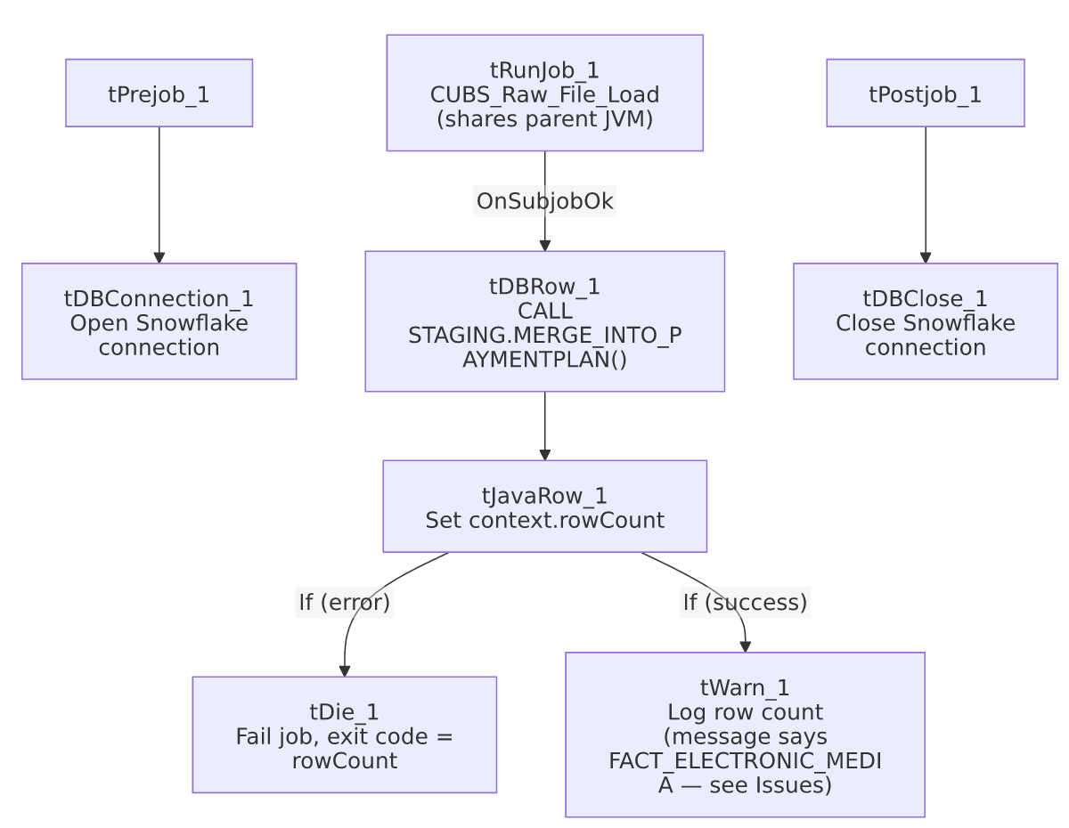

Settings tables

Orchestration: `tRunJob_1`
Setting | Value | What it means
PROCESS | CUBS_Raw_File_Load | A shared, generic file-loading sub-job reused across at least 4 jobs in this project (per 06_dependency_matrix.md: PaymentPlan_Load, DimCellphone_Load — actually DimCellphone_Load calls CUBS_Raw_Cellphone_Load, so the shared caller set specific to CUBS_Raw_File_Load is DimDeskInfo_Load, DimEmployeeInfo_Load, Fact_Electronic_Media_Load, PaymentPlan_Load).
USE_INDEPENDENT_PROCESS | false | Runs inside this job's own JVM rather than as a separate process — the same non-default setting flagged as notable for DimFiscal_CO_Load inside CO_Master_Load.
DIE_ON_CHILD_ERROR | true | If CUBS_Raw_File_Load fails, this job fails too.
TRANSMIT_ORIGINAL_CONTEXT | true | The sub-job receives this job's context values.

Merge step: `tDBRow_1`
Setting | Value | What it means
Query | CALL STAGING.MERGE_INTO_PAYMENTPLAN(); | Calls a stored procedure (not shown in this metadata) that merges the staged payment-plan rows (loaded by CUBS_Raw_File_Load) into the final PAYMENTPLAN table — following the MERGE_INTO_<table> naming convention also seen in ADP_Payroll_Load, with the STAGING. schema prefix used in CO_Master_Load.
Result handling | RETVALUE → context.rowCount → branch to tDie/tWarn | A negative or error-indicating return code fails the job with that code as the exit status; otherwise a row count is logged.

Dependencies & configuration
- Triggers/depends on other jobs: calls CUBS_Raw_File_Load via tRunJob (confirmed in 06_dependency_matrix.md's orchestration table, which also lists DimDeskInfo_Load, DimEmployeeInfo_Load, and Fact_Electronic_Media_Load as other callers of the same shared sub-job). Not called by any other job itself.
- Context variables used: rowCount (set internally from the merge procedure's return value).
- No hardcoded developer-workstation paths found in this job's own components (though CUBS_Raw_File_Load itself, being a separate job, may have its own — not covered by this job's metadata).

Glossary
Component type | Plain-English meaning
tRunJob | Runs another Talend job as a sub-process (or, since USE_INDEPENDENT_PROCESS=false here, inline in the same JVM), waiting for it to finish before continuing.
tSnowflakeRow | Runs an arbitrary SQL statement or stored-procedure call against Snowflake.
tJavaRow | Runs custom Java code once per input row — here used to unpack a stored procedure's single return value.
tDie / tWarn | tDie ends the job with a specific failure message and exit code; tWarn logs a warning without failing the job.
tSnowflakeConnection / tSnowflakeClose | Open/close the Snowflake database connection used by other components in the job.

Issues observed
- The success-branch `tWarn_1` message says `"<rowCount> rows added to FACT_ELECTRONIC_MEDIA"`, but this job merges into `PAYMENTPLAN`, not `FACT_ELECTRONIC_MEDIA`. This is a clear copy-paste artifact — almost certainly carried over from Fact_Electronic_Media_Load (a separate job in this project, also listed in 05_operational_runbook.md's 16-jobs-with-explicit-tDie/tWarn list, and which also calls CUBS_Raw_File_Load per 06_dependency_matrix.md) without updating the logged table name for this job's own context. This is a cosmetic/log-message bug only — the actual merge (CALL STAGING.MERGE_INTO_PAYMENTPLAN();) is correctly targeted — but it means anyone reading this job's run log to confirm what was loaded would see a misleading table name. This is the same class of issue documented for ADP_Payroll_Load's tJava_4 log messages (which said "roster" instead of "payroll").
- This job and `PaymentPlan_Legacy_Load` both target a table named `PAYMENTPLAN` via two entirely different mechanisms (this job: file-based staging + incremental MERGE_INTO_PAYMENTPLAN(); PaymentPlan_Legacy_Load: direct MSSQL query + TRUNCATE+INSERT full refresh). See PaymentPlan_Legacy_Load's own doc for the full discussion — if both jobs are actively scheduled against the same physical table, they would conflict with each other (one incrementally merging, the other periodically wiping and reloading from a completely different source). This should be verified as a priority.
- `CUBS_Raw_File_Load`'s own internal logic (what file it reads, from where, with what schema) is not part of this job's metadata — this job's documentation is necessarily incomplete regarding the actual source file and its location/format; refer to CUBS_Raw_File_Load's own job documentation (if produced in this documentation effort) for those details.
- No hardcoded hostnames or hardcoded hard-coded paths found here, but this job was last modified only about a month after creation (2022-08-17) and has not been touched since, unlike PaymentPlan_Legacy_Load (last modified 2025-09-24) — worth noting the two jobs have very different recent-maintenance histories, which may itself be a signal about which one is considered "live" today, though this is inference, not something confirmed by the metadata.

