Talend Job: PaymentVision_Activity_Load

Overview
Loads user-activity/login audit records (hostname, login ID, user token, event type, timestamp) exported from the third-party PaymentVision payment portal into the Snowflake table PAYMENTVISION_ACTIVITY, then calls a stored procedure to merge the newly loaded rows into a downstream warehouse table. In a second, independent pass over the same source directory, it also archives and deletes the source files. Business purpose appears to be an audit trail of who accessed/used the PaymentVision payment portal and when — likely for security or compliance review rather than financial reconciliation, since no dollar amounts appear in this job's schema.

Detail table
Field | Value
Job name | PaymentVision_Activity_Load
Version | 0.1
Project | EDW2SF
Author | jmach@harriscollect.com
Created | 2025-07-07T09:43:13.341-0700
Last Modified | 2025-11-16T21:08:14.416-0800

Step-by-step data flow
Setup subjob: tPrejob_1 → tJava_2 opens a per-run log file at context.logDir + jobName + "_" + <timestamp> + ".log" and redirects System.out/System.err to it → tSetKeystore_1 configures SSL trust/keystore from context.keystorePath (passwords redacted) → tDBConnection_1 opens the Snowflake connection. This setup subjob runs independently of the main load subjob below (Talend guarantees tPrejob runs first in the job, but there is no direct wiring from tDBConnection_1 into the load flow).
Main subjob:
- tFileList_1 lists files in context.sourceDir (an EXCLUDEFILEMASK of *.txt is configured but IFEXCLUDE is false, so the exclusion is not actually applied — every file in the directory is picked up, same non-functional-exclusion pattern seen in ADP_Payroll_Load).
- For each file, tJava_1 sets context.fileName/context.filePath to the current file.
- tFileInputDelimited_1 reads the CSV (comma-delimited, no header row — HEADER=0) using repository schema "...- pvact" for both the main and reject branches (correctly matched, unlike ADP_Payroll_Load's roster/payroll mismatch). DIE_ON_ERROR=false.
- tMap_1 passes the 5 source columns (HOSTNAME, LOGINID, USERTOKEN, EVENTTYPENAME, CREATEDDATE) into a 7-column output schema, adding LOAD_DT and FILENAME. DIE_ON_ERROR=true here, so a mapping failure fails the job outright.
- tFlowMeter_2 counts rows passing through (labeled "MyLabel", not renamed for this job).
- tDBOutput_1 inserts the rows into Snowflake table PAYMENTVISION_ACTIVITY (INSERT, no table-recreate action). There is no `TRUNCATE` step anywhere in this job before the insert — unlike ADP_Payroll_Load's explicit TRUNCATE TABLE step. See Issues observed.
- Once the entire tFileList_1 iteration subjob completes (OnSubjobOk), tParallelize_1 fires two branches at the same time:
- Branch 1 (merge): tDBRow_1 runs CALL STAGING.MERGE_INTO_PAYMENTVISION_ACTIVITY(); — with no result-checking afterward (no tJavaRow/tWarn/tDie), unlike ADP_Payroll_Load's merge-result branching logic.
- Branch 2 (archive): tFileList_2 performs a second, independent listing of the same `context.sourceDir` directory, iterating via tJava_3 (re-sets fileName/filePath) into tFileCopy_1, which copies each file to context.archiveDir with REMOVE_FILE=true and REPLACE_FILE=true — effectively moving (archiving) the file and deleting the original in one step, rather than ADP_Payroll_Load's separate zip-then-delete pattern.
No teardown subjob is present — there is no tPostjob/tDBClose component anywhere in this job's metadata, so the Snowflake connection opened by tDBConnection_1 is never explicitly closed. See Issues observed.
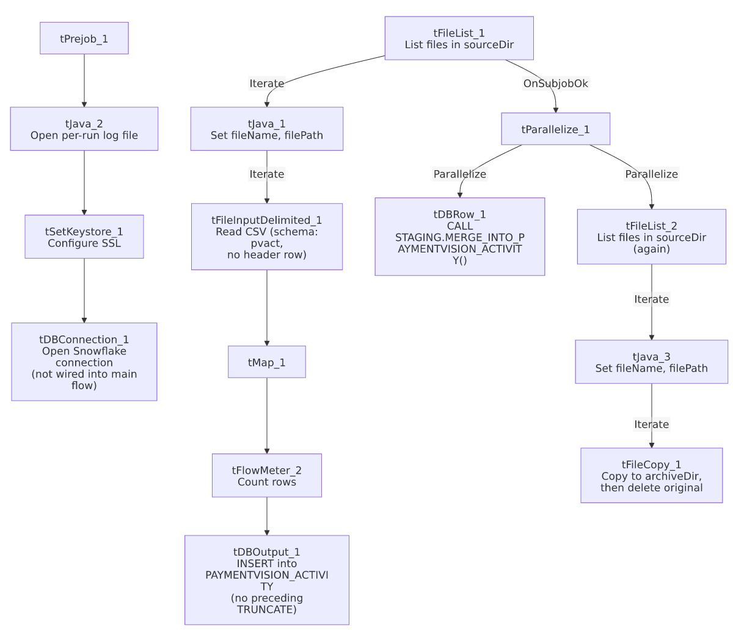

Settings tables

Source: `tFileInputDelimited_1`
Setting | Value | What it means
FILENAME | context.filePath | The current file from tFileList_1's iteration.
FIELDSEPARATOR / HEADER | , / 0 (no header row) | Every row, including the first, is treated as data — unlike most CSV loads in this project.
SCHEMA / SCHEMA_REJECT | Repository schema "...- pvact" (both) | Main and reject schemas are correctly matched to this job, unlike ADP_Payroll_Load's mismatch.
DIE_ON_ERROR | false | Malformed rows don't fail the job...
Reject flow | Not wired | ...but no connection carries rejected rows anywhere — they are silently dropped, same gap as ADP_Payroll_Load.
TEMP_DIR | "C:/Talend-Studio-20211109_1610-V8.0.1/workspace" | Hardcoded developer-workstation path — see Dependencies & configuration.

Target: `tDBOutput_1` (`tSnowflakeOutput`)
Setting | Value | What it means
Table | PAYMENTVISION_ACTIVITY | Destination table for the raw loaded rows.
Output action | INSERT | Appends rows — but with no `TRUNCATE` anywhere in this job, so every run adds to whatever is already in the table rather than replacing a staging load. See Issues observed.
Table action | NONE | Table is not recreated/altered by this job.

Merge step: `tDBRow_1` (`tSnowflakeRow`)
Setting | Value | What it means
Query | CALL STAGING.MERGE_INTO_PAYMENTVISION_ACTIVITY(); | Calls a stored procedure (not shown in this metadata) that presumably merges the freshly loaded rows into a final warehouse table.
Result handling | None | Unlike ADP_Payroll_Load, there is no tJavaRow/tWarn/tDie after this call — a merge failure here surfaces only as a generic Talend execution error.

Archive/cleanup: `tFileCopy_1`
Setting | Value | What it means
FILENAME | context.filePath | The current file from tFileList_2's separate iteration over the same directory.
DESTINATION | context.archiveDir | Where the file is copied to.
REMOVE_FILE / REPLACE_FILE | true / true | The original is deleted after the copy, and an existing file of the same name at the destination is overwritten — a move, in effect.
SOURCE_DERECTORY | "C:/Talend-Studio-20211109_1610-V8.0.1/workspace" (hardcoded) | A hardcoded developer-workstation path; since FILENAME is already the full path via context.filePath, it is unclear from this metadata whether this field is actually used at runtime.

Dependencies & configuration
- Triggers/depends on other jobs: none — no tRunJob links found in this job's metadata, and it does not appear as a caller or target in 06_dependency_matrix.md's orchestration table.
- Context variables used: archiveDir, fileName, filePath, keystorePath, logDir, sourceDir (likely from StandardFolders_0.1, the project's shared-paths context group — see 06_dependency_matrix.md).
- 3 hardcoded developer-workstation paths: tFileInputDelimited_1.TEMP_DIR and tFileCopy_1.SOURCE_DERECTORY (both C:/Talend-Studio-20211109_1610-V8.0.1/workspace), and tSetKeystore_1.SSL_TRUSTSERVER_TRUSTSTORE (C:/clientTrustStore.trustStore) — same portability risk documented project-wide in 05_operational_runbook.md.

Glossary
Component type | Plain-English meaning
tFileList | Lists files in a directory for the job to iterate over one at a time.
tFileInputDelimited | Reads a delimited (CSV-style) text file according to a schema.
tMap | Maps/transforms columns from one schema to another.
tFlowMeter | Counts rows passing through a point in the flow, for logging/monitoring.
tSnowflakeOutput / tSnowflakeRow / tSnowflakeConnection | Write rows to a Snowflake table / run an arbitrary SQL statement or stored-procedure call against Snowflake / open a Snowflake connection used elsewhere in the job.
tParallelize | Runs its downstream branches at the same time instead of one after another — here, the merge call and the archive pass run concurrently.
tFileCopy | Copies a file to a destination directory, optionally deleting the original (used here as an archive-and-delete step).
tSetKeystore | Configures SSL trust/keystore settings for secure connections used later in the job.

Issues observed
- No `TRUNCATE` step exists anywhere in this job before the `INSERT` into `PAYMENTVISION_ACTIVITY`. Every run appends the newly read files' rows to whatever is already in the table, unlike the truncate-then-load pattern used in ADP_Payroll_Load and documented project-wide in 05_operational_runbook.md. Whether PAYMENTVISION_ACTIVITY is a staging table that the downstream MERGE_INTO_PAYMENTVISION_ACTIVITY() procedure knows to deduplicate, or whether this causes accumulating duplicate rows over time, is unable to determine from this job's own metadata — verify with the team.
- The archive/delete pass (`tFileList_2` → `tFileCopy_1`) is a second, independent directory listing of `context.sourceDir`, run in parallel with the merge call rather than driven by which files tFileList_1 actually loaded. If a new file lands in sourceDir between the two listings, it could be archived and deleted without ever being loaded; conversely, if a file fails during the load (e.g., a tMap_1 mapping error, which is DIE_ON_ERROR=true), there is no guarantee it would be excluded from this second pass — unable to determine from metadata whether that scenario is actually possible in practice, but the two listings are not coupled to each other's results.
- No reject flow is wired from `tFileInputDelimited_1`. DIE_ON_ERROR is false, so malformed rows don't fail the job, but there is no connection carrying rejected rows anywhere — they are silently dropped with no record of how many, or which, rows failed to parse.
- No result-checking on the merge procedure call. Unlike ADP_Payroll_Load's tJavaRow/tWarn/tDie pattern, tDBRow_1's CALL STAGING.MERGE_INTO_PAYMENTVISION_ACTIVITY(); has no downstream logic to detect or report a failed merge — consistent with 05_operational_runbook.md's note that this job is not among the 16 project-wide jobs with explicit tDie/tWarn merge-result logic.
- No teardown subjob (`tPostjob`/`tDBClose`) exists in this job, unlike ADP_Payroll_Load and i3_CallDetail_40_Load, both of which explicitly close their Snowflake connection at the end. Whether this leaves the connection open until the JVM exits, or Talend closes it implicitly, is unable to determine from metadata alone.

