Talend Job: ProInsight_Analytics_Load

Overview
Loads AI/speech-analytics call-scoring export files from the "ProInsight" system into the Snowflake table PROINSIGHT_ANALYTICS via UPSERT. Each source row represents one recorded call, tagged with roughly 70 automatically-detected compliance/behavioral flags (profanity, hardship, bankruptcy mentions, promises to pay, disputes, silence duration, sentiment, etc.) alongside call metadata (agent, borrower, account, campaign, duration). Business purpose is call-quality/compliance analytics — very likely feeding QA dashboards or compliance review, distinct from ProInsight_CCU_Scorecard_Load's manual auditor scorecards (see that job's own doc).

Detail table
Field | Value
Job name | ProInsight_Analytics_Load
Version | 0.1
Project | EDW2SF
Author | jmach@harriscollect.com
Created | 2023-08-18T09:51:41.850-0700
Last Modified | 2025-11-16T21:12:18.568-0800

Step-by-step data flow
Setup subjob: tPrejob_1 → tJava_2 opens a per-run log file at context.logDir + jobName + "_" + <timestamp> + ".log" → tSetKeystore_1 configures SSL trust/keystore from context.keystorePath (passwords redacted). This setup subjob has no `tDBConnection` component and is not wired into the main load flow at all — see Issues observed.
Main subjob:
- tFileList_2 lists files in context.fileDir, ordered by filename ascending (EXCLUDEFILEMASK of *.txt is set but IFEXCLUDE is false, so it has no actual effect — the same non-functional-exclusion pattern seen elsewhere in this project).
- For each file, tJava_1 sets context.fileName/context.filePath, then runs a regex (\d{8}) against the filename to extract what is presumably an 8-digit date into context.fileDate — the code is truncated in this job's own extracted metadata after the `if (m.lookingAt() || m....` line, so the exact logic (and whether it always succeeds) can't be confirmed from this metadata.
- tFileInputDelimited_1 reads the CSV (CSV_OPTION=true, header row present) using repository schema "...- metadata" for both main and reject branches, covering roughly 90 columns: call identifiers/metadata (Call_Id, Called_At, Duration, Agent_ID, Client_Name, Account, Campaign, etc.) plus ~70 boolean compliance/behavioral flag columns (e.g. Hardship, Bankruptcy_Filed, Promise_to_Pay, Legal_Threat, Silence_over_50). DIE_ON_ERROR=false.
- tMap_1 renames/reshapes these into a same-sized uppercase-named Snowflake-ready schema (e.g. Duration__in_secs → DURATION, Account → ACCOUNT_NUMBER), adding FILENAME and FILE_DATE. DIE_ON_ERROR=true here, so a mapping failure fails the job outright.
- tFlowMeter_3 counts rows passing through (labeled "MyLabel", not renamed for this job).
- tDBOutput_1 upserts the rows into Snowflake table PROINSIGHT_ANALYTICS (UPSERT, no table-recreate action) — unlike the plain INSERT pattern used in PaymentVision_Activity_Load and ADP_Payroll_Load, so this job does not need a preceding TRUNCATE or a separate merge stored-procedure call to avoid duplicating rows across runs.
- On success (OnComponentOk), tFileDelete_1 deletes the source file (context.filePath) directly — there is no archive step (no tFileArchive/tFileCopy), unlike PaymentVision_Activity_Load and ADP_Payroll_Load, both of which preserve a copy of the processed file. See Issues observed.
No teardown subjob — no tPostjob/tDBClose/tDBConnection exists anywhere in this job's metadata.
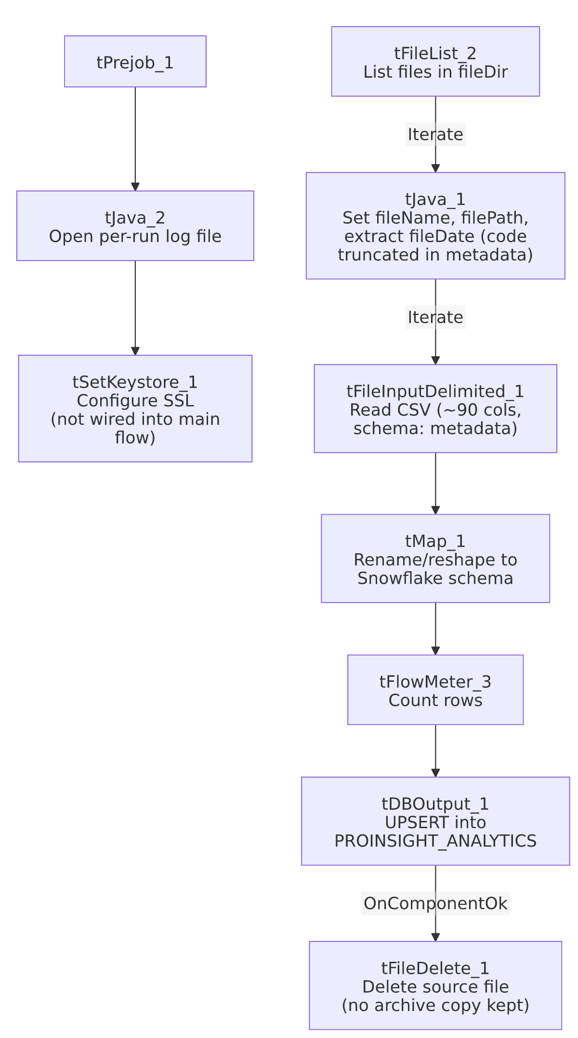

Settings tables

Source: `tFileInputDelimited_1`
Setting | Value | What it means
FILENAME | context.filePath | The current file from tFileList_2's iteration.
CSV_OPTION / HEADER | true / 1 header row | Standard CSV parsing with header row skipped.
SCHEMA / SCHEMA_REJECT | Repository schema "...- metadata" (both) | ~90 columns: call metadata plus ~70 boolean compliance/behavioral flags scored by the ProInsight analytics engine, plus errorCode/errorMessage reject columns.
DIE_ON_ERROR | false | Malformed rows don't fail the job...
Reject flow | Not wired | ...but no connection carries rejected rows anywhere — silently dropped, same gap seen across this project's file-load jobs.
TEMP_DIR | "C:/Talend-Studio-20211109_1610-V8.0.1/workspace" | Hardcoded developer-workstation path.

Target: `tDBOutput_1` (`tSnowflakeOutput`)
Setting | Value | What it means
Table | PROINSIGHT_ANALYTICS | Destination table for the scored call records.
Output action | UPSERT | Inserts new rows and updates existing ones (presumably keyed on CALL_ID, the one NOT NULL column in this schema) — no separate TRUNCATE/merge-procedure step is needed for this pattern.
Table action | NONE | Table is not recreated/altered by this job.

Cleanup: `tFileDelete_1`
Setting | Value | What it means
FILENAME | context.filePath | Deletes the just-loaded source file directly — no archive copy is made first.
DIRECTORY | "C:/Talend-Studio-20211109_1610-V8.0.1/workspace/delete_folder" (hardcoded) | Appears to be an unused/leftover default value, since FILENAME already supplies the full path — see Issues observed.
PATH | "C:/Talend-Studio-20211109_1610-V8.0.1/workspace/delete_folder or delete_file" (hardcoded) | The literal text " or delete_file" in this value strongly suggests it is placeholder/template text that was never replaced, not a real path.

Dependencies & configuration
- Triggers/depends on other jobs: none — no tRunJob links found, and this job does not appear in 06_dependency_matrix.md's orchestration table.
- Context variables used: fileDate, fileDir, fileName, filePath, keystorePath (set but never actually consumed by a connected component — see Issues observed), logDir.
- 4 hardcoded developer-workstation paths: tFileInputDelimited_1.TEMP_DIR, tFileDelete_1.DIRECTORY, tFileDelete_1.PATH (the latter two containing template-like placeholder text), and tSetKeystore_1.SSL_TRUSTSERVER_TRUSTSTORE — same portability risk documented project-wide in 05_operational_runbook.md.

Glossary
Component type | Plain-English meaning
tFileList | Lists files in a directory for the job to iterate over one at a time.
tFileInputDelimited | Reads a delimited (CSV-style) text file according to a schema.
tMap | Maps/transforms columns from one schema to another.
tFlowMeter | Counts rows passing through a point in the flow, for logging/monitoring.
tSnowflakeOutput | Writes rows to a Snowflake table — here configured as UPSERT, so it both inserts and updates in one step.
tFileDelete | Deletes a file from disk — used here with no preceding archive step.
tSetKeystore | Configures SSL trust/keystore settings for secure connections — present in this job but not wired to anything that uses it.

Issues observed
- The setup subjob (`tPrejob_1` → `tJava_2` → `tSetKeystore_1`) has no `tDBConnection` component and is not wired into the main data-load flow at all. Every other reference job in this project (e.g. ADP_Payroll_Load, PaymentVision_Activity_Load) opens a Snowflake connection via tDBConnection in its setup subjob; this job's tDBOutput_1 must therefore be using its own inline connection settings rather than a shared one — unable to confirm from this metadata, since tDBOutput_1's own parameters were not captured beyond table/action. It also means the SSL keystore setup performed by tSetKeystore_1 does not appear to affect the actual Snowflake write in tDBOutput_1, since there's no connection dependency linking them — worth confirming with the team whether this keystore step is doing anything at all in this job.
- `context.fileDate` is set from a truncated regex extraction whose full logic isn't visible in this metadata. The captured code cuts off mid-statement (if (m.lookingAt() || m....), so it's not possible to confirm from this metadata whether fileDate is reliably set for every filename pattern, or what happens if the regex doesn't match. Verify directly in Talend Studio.
- No reject flow is wired from `tFileInputDelimited_1`. Malformed rows are silently dropped, with no file, log, or table capturing what was rejected.
- The source file is deleted immediately after a successful load with no archive step, unlike PaymentVision_Activity_Load and ADP_Payroll_Load, which both preserve a copy before deleting. If the Snowflake UPSERT needs to be re-run for any reason (e.g. a downstream data issue discovered later), the original source file will not be available — verify whether ProInsight's own export system can regenerate historical files if needed.
- `tFileDelete_1`'s `DIRECTORY` and `PATH` parameters contain what look like unedited placeholder/template text ("...delete_folder or delete_file"), rather than a real path. Since FILENAME is set directly from context.filePath, these fields may simply be unused defaults left over from the component's initial drop onto the canvas — but this should be confirmed in Talend Studio rather than assumed harmless.

