Talend Job: ProInsight_CCU_Scorecard_Load

Overview
Loads manual QA-auditor call scorecards (auditor name, collector/agent, team, per-section scores such as Opening/Authentication/Bridging with earned-vs-available points, overall score/grade, acknowledgement status) exported from the ProInsight quality-management system into a Snowflake staging table, then merges them into a downstream table via a stored procedure. This is a companion job to ProInsight_Analytics_Load but a different data source: this one is a *manually completed* compliance/quality scorecard per audited call, not the automated speech-analytics flags loaded by ProInsight_Analytics_Load. ProInsight_CCU_Scorecard_V2_Load is a near-identical but not-identical sibling job — see that job's own doc for the specific differences.

Detail table
Field | Value
Job name | ProInsight_CCU_Scorecard_Load
Version | 0.1
Project | EDW2SF
Author | jmach@harriscollect.com
Created | 2024-01-16T10:48:28.606-0800
Last Modified | 2025-09-24T11:09:03.625-0700

Step-by-step data flow
Setup subjob: tPrejob_1 → tJava_2 opens a per-run log file → tDBConnection_1 opens the Snowflake connection directly. Unlike its `V2` sibling, this job has no `tSetKeystore` component at all — no SSL/keystore configuration step exists between the log-file setup and the Snowflake connection. See Issues observed.
Main subjob:
- tDBRow_1 runs TRUNCATE TABLE STAGING.PROINSIGHT_CCU_SCORECARD; to clear the staging table before the new load.
- On success (OnSubjobOk), tFileList_2 lists files in context.fileDir (EXCLUDEFILEMASK of *.txt set but IFEXCLUDE=false, so not actually applied).
- For each file, tJava_1 sets context.fileName/context.filePath, then runs a regex (\d{8}) against the filename intended to extract context.fileDate — the code is truncated in this job's own metadata (cuts off mid-statement), same gap as in ProInsight_Analytics_Load.
- tFileInputDelimited_1 reads the CSV (header row present, REMOVE_EMPTY_ROW=true) using repository schema ID __SCCcLSfEe6cGLqwyWLPVw (labeled "metadata") for the main schema — covering dozens of scorecard columns (Scorecard_Link, Scorecard_Name, Auditor_Name, Audit_Date, Collector_Name, Team, Client_Name, Call_Date, Score, Score_Earned, Score_Available, Grade, plus per-category earned/available/score triplets like Opening_Earned/Opening_Available/Opening_Score, Bridging_*, Avoiding_Early_Termination_*, etc.). The reject schema is a *different* repository schema ID (_0CMaMD0wEe6iz_4VDQBfZg, also labeled "metadata") — see Issues observed regarding whether these two "metadata" schemas actually match.
- tMap_1 passes the columns through to a matching Snowflake-ready schema, adding FILEDATE.
- tFlowMeter_3 counts rows passing through (labeled "ccu").
- tDBOutput_1 inserts the rows into Snowflake table PROINSIGHT_CCU_SCORECARD (INSERT, no table-recreate action).
- Once the tFileList_2 iteration subjob completes (OnSubjobOk), tDBRow_2 runs CALL UPDATE_PROINSIGHT_CCU_SCORECARD(); — with no result-checking downstream (no tJavaRow/tWarn/tDie), unlike the V2 sibling job.
- On success (OnSubjobOk), tFileList_1 performs a second, independent listing of the same `context.fileDir` directory, iterating via tJava_3 into tFileDelete_1, which deletes each file directly — no archive copy is kept, same pattern as ProInsight_Analytics_Load.
No teardown subjob — no tPostjob/tDBClose exists in this job's metadata.
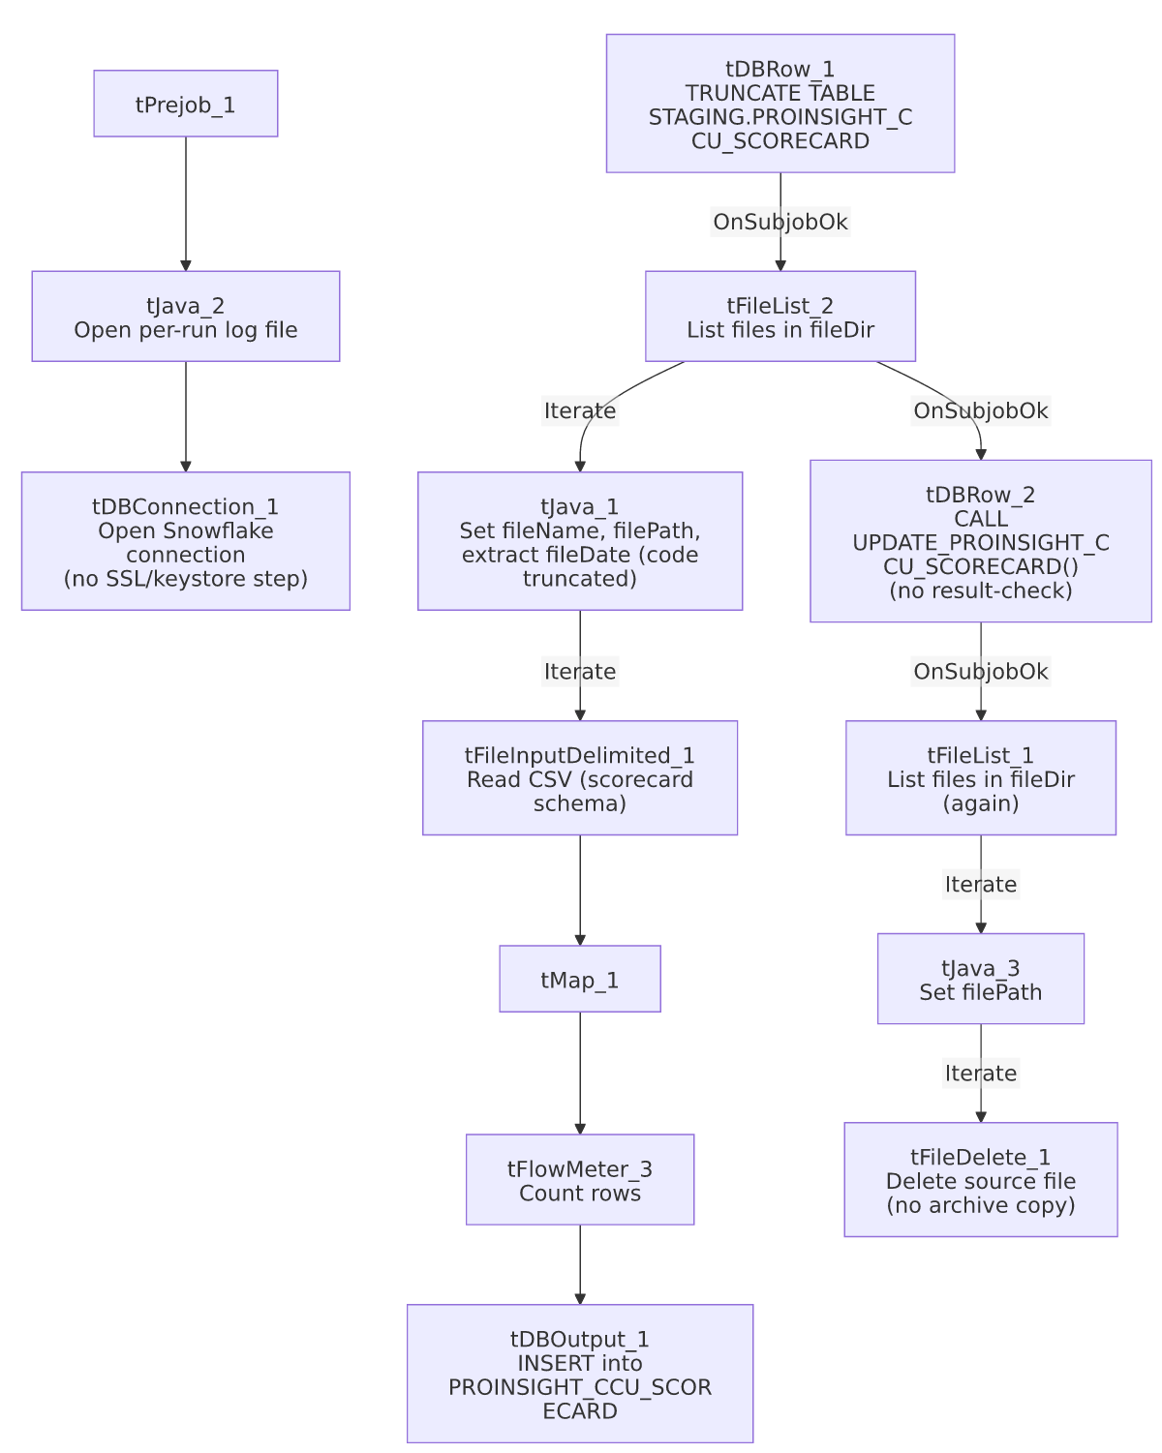

Settings tables

Source: `tFileInputDelimited_1`
Setting | Value | What it means
FILENAME | context.filePath | The current file from tFileList_2's iteration.
HEADER / REMOVE_EMPTY_ROW | 1 / true | Header row skipped; blank rows are dropped rather than loaded as empty records.
SCHEMA (main) | Repository schema ID __SCCcLSfEe6cGLqwyWLPVw (labeled "metadata") | Dozens of scorecard columns per audited call.
SCHEMA_REJECT | Repository schema ID _0CMaMD0wEe6iz_4VDQBfZg (also labeled "metadata") | A different repository schema ID than the main schema, despite the same label — see Issues observed.
DIE_ON_ERROR | false | Malformed rows don't fail the job...
Reject flow | Not wired | ...but no connection carries rejected rows anywhere — silently dropped.
TEMP_DIR | "C:/Talend-Studio-20211109_1610-V8.0.1/workspace" | Hardcoded developer-workstation path.

Staging clear & target: `tDBRow_1` / `tDBOutput_1`
Setting | Value | What it means
Query (tDBRow_1) | TRUNCATE TABLE STAGING.PROINSIGHT_CCU_SCORECARD; | Clears the staging table before every run — the truncate-then-load pattern used project-wide. Its own schema_columns reference an unrelated repository schema labeled LEGACY_DIMDEBTOR (debtor/client columns like DEBTOR, CLIENT, NAME1, ADD1) — almost certainly a copy-paste artifact from a different job template, since a TRUNCATE statement doesn't need an input schema at all. See Issues observed.
Table (tDBOutput_1) | PROINSIGHT_CCU_SCORECARD | Destination staging table for the raw scorecard rows.
Output action | INSERT | Appends rows; safe because of the preceding TRUNCATE.

Merge step: `tDBRow_2` (`tSnowflakeRow`)
Setting | Value | What it means
Query | CALL UPDATE_PROINSIGHT_CCU_SCORECARD(); | Calls a stored procedure (not shown in this metadata) that presumably applies the staged scorecards to a final warehouse table. Note the UPDATE_<table> naming, distinct from the MERGE_INTO_<table> convention used by ADP_Payroll_Load and this job's own V2 sibling — yet another inconsistent merge-procedure naming pattern in this project (see 05_operational_runbook.md).
Result handling | None | No tJavaRow/tWarn/tDie after this call — a failure here would only surface as a generic Talend execution error.

Dependencies & configuration
- Triggers/depends on other jobs: none — no tRunJob links found, and this job does not appear in 06_dependency_matrix.md's orchestration table.
- Context variables used: fileDate, fileDir, fileName, filePath, logDir. Notably, `keystorePath` is not referenced — consistent with there being no tSetKeystore component in this job (unlike V2).
- 3 hardcoded developer-workstation paths: tFileInputDelimited_1.TEMP_DIR, and tFileDelete_1.DIRECTORY/PATH (the latter two containing template-like placeholder text, e.g. "...delete_folder or delete_file").

Glossary
Component type | Plain-English meaning
tFileList | Lists files in a directory for the job to iterate over one at a time.
tFileInputDelimited | Reads a delimited (CSV-style) text file according to a schema.
tMap | Maps/transforms columns from one schema to another.
tFlowMeter | Counts rows passing through a point in the flow, for logging/monitoring.
tSnowflakeOutput / tSnowflakeRow / tSnowflakeConnection | Write rows to a Snowflake table / run an arbitrary SQL statement or stored-procedure call against Snowflake / open the Snowflake connection used elsewhere in the job.
tFileDelete | Deletes a file from disk — used here with no preceding archive step.

Issues observed
- `ProInsight_CCU_Scorecard_Load` has no `tSetKeystore` component and no `keystorePath` reference, while `ProInsight_CCU_Scorecard_V2_Load` has both. This is the clearest structural difference between the two "sibling" jobs beyond their target tables — see job_ProInsight_CCU_Scorecard_V2_Load.md for the full comparison. Whether the missing SSL/keystore step in this (V1) job is intentional (e.g. the V1 Snowflake connection doesn't require client-cert auth) or a gap fixed later in V2 is unable to determine from metadata; verify with the team.
- The main and reject schemas on `tFileInputDelimited_1` are two different repository schema IDs, both generically labeled "metadata" in this extraction, rather than the same schema used for both branches (contrast PaymentVision_Activity_Load, where main and reject correctly share one ID). Whether the two "metadata" schemas actually have compatible column layouts is unable to determine from this metadata — verify directly in the Talend repository before assuming a rejected row would parse cleanly against the reject schema.
- `tDBRow_1`'s (`TRUNCATE`) and `tDBRow_2`'s (`CALL UPDATE_...`) captured schemas both reference an unrelated `LEGACY_DIMDEBTOR` repository schema (debtor/client columns like DEBTOR, NAME1, ADD1) that has nothing to do with call scorecards. Since neither component's actual SQL text needs an input schema, this is very likely a leftover artifact from copying these components from an unrelated debtor-load job template, rather than a functional issue — but it's worth a cleanup pass so the repository metadata doesn't mislead someone reading it later.
- No reject flow is wired from `tFileInputDelimited_1`, and no result-checking exists on the `UPDATE_PROINSIGHT_CCU_SCORECARD()` merge call — both gaps match patterns seen elsewhere in this project (see 05_operational_runbook.md), meaning a bad row or a failed merge here produces no job-specific diagnostic, only a generic error if something downstream breaks loudly enough to fail the job at all.
- The archive/delete pass (`tFileList_1` → `tFileDelete_1`) is a second, independent directory listing run only after the merge call succeeds, and deletes files with no archive copy kept — same risk profile as ProInsight_Analytics_Load: if the merge needs to be re-run later, the original source files will already be gone.

