Talend Job: ProInsight_CCU_Scorecard_V2_Load

Overview
Loads the same kind of manual QA-auditor call scorecard data as ProInsight_CCU_Scorecard_Load (auditor, collector, team, per-category earned/available/score columns, overall grade) into a separate Snowflake staging table, STAGING.PROINSIGHT_CCU_V2_SCORECARD, then merges it into a downstream table via its own stored procedure. Despite the shared naming and near-identical component layout, this is not simply a copy of the V1 job run against a new table — it adds SSL/keystore setup and merge-result error handling that V1 lacks. See Issues observed for the full comparison.

Detail table
Field | Value
Job name | ProInsight_CCU_Scorecard_V2_Load
Version | 0.1
Project | EDW2SF
Author | jmach@harriscollect.com
Created | 2024-05-17T10:53:59.001-0700
Last Modified | 2025-11-16T21:13:27.184-0800

Step-by-step data flow
Setup subjob: tPrejob_1 → tJava_2 opens a per-run log file → tSetKeystore_1 configures SSL trust/keystore from context.keystorePath (passwords redacted) → tDBConnection_1 opens the Snowflake connection. This is a real difference from V1, which has no tSetKeystore step at all between the log file and the connection.
Main subjob:
- tDBRow_1 runs TRUNCATE TABLE STAGING.PROINSIGHT_CCU_V2_SCORECARD; — note the _V2_ infix in the table name, a genuinely separate staging table from V1's STAGING.PROINSIGHT_CCU_SCORECARD.
- On success (OnSubjobOk), tFileList_2 lists files in context.fileDir (same non-functional EXCLUDEFILEMASK/IFEXCLUDE=false pattern as V1).
- For each file, tJava_1 sets context.fileName/context.filePath and runs the same truncated-in-metadata regex to extract context.fileDate as V1 and ProInsight_Analytics_Load.
- tFileInputDelimited_1 reads the CSV (header row present, REMOVE_EMPTY_ROW=true). Unlike V1, this component's main schema has no `SCHEMA:SCHEMA_TYPE`/`SCHEMA:REPOSITORY_SCHEMA_TYPE` parameter set at all — the main schema appears to be defined locally (built-in) rather than pointing at a repository entry, even though the column layout itself (Scorecard_Link, Scorecard_Name, Auditor_Name, Score, Grade, per-category _Earned/_Available/_Score columns, etc.) is the same shape as V1's. The reject schema is still repository-based, using the same schema ID (_0CMaMD0wEe6iz_4VDQBfZg, labeled "metadata") that V1's reject schema and ProInsight_Analytics_Load's main/reject schema also use. See Issues observed.
- tMap_1 passes the columns through to a matching Snowflake-ready schema, adding FILEDATE.
- tFlowMeter_3 counts rows passing through (labeled "ccu", same label reused from V1).
- tDBOutput_1 inserts the rows into Snowflake table PROINSIGHT_CCU_V2_SCORECARD (INSERT, no table-recreate action).
- Once the tFileList_2 iteration subjob completes (OnSubjobOk), tDBRow_2 runs CALL MERGE_INTO_PROINSIGHT_CCU_V2_SCORECARD(); — note the MERGE_INTO_<table> naming convention here, different from V1's `UPDATE_PROINSIGHT_CCU_SCORECARD()`.
- Unlike V1, this merge call's result is captured and checked: tDBRow_2 also feeds (MAIN) into tJavaRow_1, which reads the procedure's MERGERESULT output column into context.mergeResult. Two ordered RUN_IF branches follow (branch conditions themselves aren't captured in this metadata, but component order and message content make the intent clear):
- tDie_1 (order 1): fails the job with message "Merge failed: " + context.mergeResult (exit code 4).
- tWarn_1 (order 2): logs "Rows inserted/updated: " + context.mergeResult (severity 42) on the apparent success path.
- On success (OnSubjobOk), tFileList_1 performs a second, independent listing of the same context.fileDir directory, iterating via tJava_3 into tFileDelete_1, which deletes each file directly — no archive copy is kept, same as V1.
No teardown subjob — no tPostjob/tDBClose exists in this job's metadata.
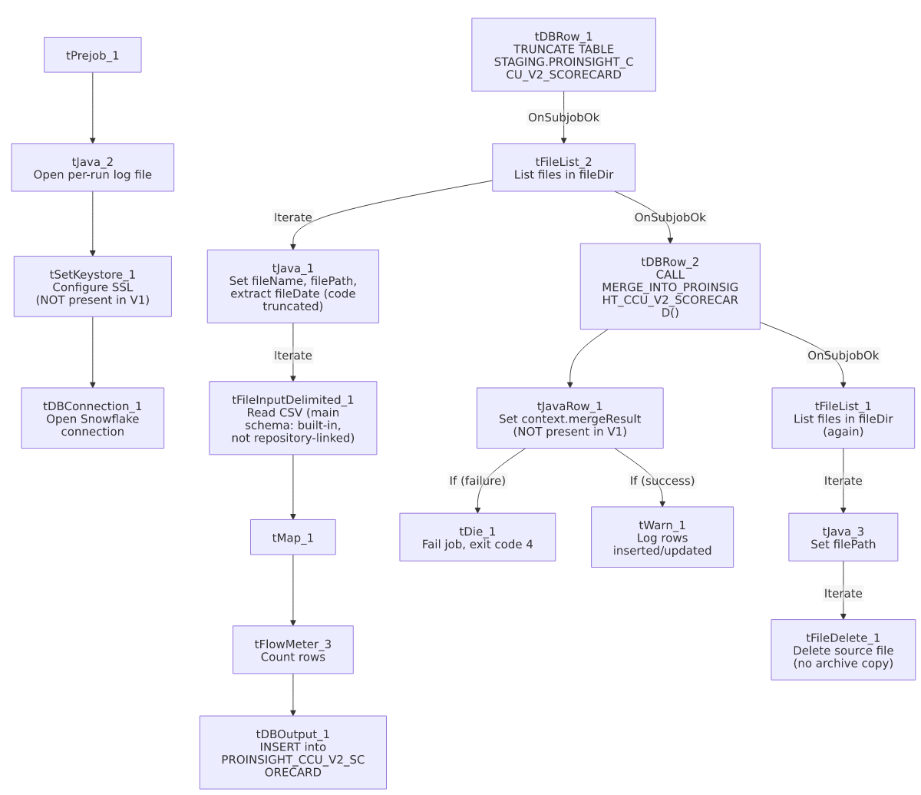

Settings tables

Source: `tFileInputDelimited_1`
Setting | Value | What it means
FILENAME | context.filePath | The current file from tFileList_2's iteration.
HEADER / REMOVE_EMPTY_ROW | 1 / true | Same as V1.
SCHEMA (main) | No repository schema parameter set | Unlike V1's explicit REPOSITORY schema reference, this job's main schema appears to be defined locally (built-in) directly via its column list rather than a shared repository entry. See Issues observed.
SCHEMA_REJECT | Repository schema ID _0CMaMD0wEe6iz_4VDQBfZg (labeled "metadata") | The same reject schema ID used by V1 and by ProInsight_Analytics_Load — appears to be a shared generic reject schema across the ProInsight job family.
DIE_ON_ERROR | false | Malformed rows don't fail the job...
Reject flow | Not wired | ...but no connection carries rejected rows anywhere — silently dropped, same as V1.
TEMP_DIR | "C:/Talend-Studio-20211109_1610-V8.0.1/workspace" | Hardcoded developer-workstation path.

Staging clear & target: `tDBRow_1` / `tDBOutput_1`
Setting | Value | What it means
Query (tDBRow_1) | TRUNCATE TABLE STAGING.PROINSIGHT_CCU_V2_SCORECARD; | A genuinely separate staging table from V1's, not a shared one. Same LEGACY_DIMDEBTOR-schema copy-paste artifact on this component as seen in V1 (see that job's Issues observed) — it recurs here too.
Table (tDBOutput_1) | PROINSIGHT_CCU_V2_SCORECARD | Destination staging table — distinct from V1's PROINSIGHT_CCU_SCORECARD.
Output action | INSERT | Appends rows; safe because of the preceding TRUNCATE.

Merge step: `tDBRow_2` (`tSnowflakeRow`) / `tJavaRow_1` / `tDie_1` / `tWarn_1`
Setting | Value | What it means
Query | CALL MERGE_INTO_PROINSIGHT_CCU_V2_SCORECARD(); | Follows the MERGE_INTO_<table> naming convention (matches ADP_Payroll_Load), unlike V1's UPDATE_PROINSIGHT_CCU_SCORECARD().
Result handling | MERGERESULT → context.mergeResult → branch to tDie_1/tWarn_1 | The clearest functional difference from V1: a failed merge here actually fails the job (exit code 4) with a specific message, rather than only surfacing as a generic Talend error.

Dependencies & configuration
- Triggers/depends on other jobs: none — no tRunJob links found, and this job does not appear in 06_dependency_matrix.md's orchestration table.
- Context variables used: fileDate, fileDir, fileName, filePath, keystorePath, logDir, mergeResult (set internally from the merge procedure's return value) — one more variable (keystorePath) than V1, reflecting the added tSetKeystore_1 step.
- 3 hardcoded developer-workstation paths: tFileInputDelimited_1.TEMP_DIR, and tFileDelete_1.DIRECTORY/PATH (the latter two containing the same template-like placeholder text seen in V1 and ProInsight_Analytics_Load).

Glossary
Component type | Plain-English meaning
tFileList | Lists files in a directory for the job to iterate over one at a time.
tFileInputDelimited | Reads a delimited (CSV-style) text file according to a schema.
tMap | Maps/transforms columns from one schema to another.
tFlowMeter | Counts rows passing through a point in the flow, for logging/monitoring.
tSnowflakeOutput / tSnowflakeRow / tSnowflakeConnection | Write rows to a Snowflake table / run an arbitrary SQL statement or stored-procedure call against Snowflake / open the Snowflake connection used elsewhere in the job.
tJavaRow | Runs custom Java code once per input row — here used to unpack a stored procedure's single return value.
tDie / tWarn | tDie ends the job with a specific failure message and exit code; tWarn logs a warning without stopping the job.
tSetKeystore | Configures SSL trust/keystore settings for secure connections used later in the job.
tFileDelete | Deletes a file from disk — used here with no preceding archive step.

Issues observed
- V2 adds a `tSetKeystore_1` SSL-configuration step that V1 lacks entirely, and correspondingly references context.keystorePath, which V1 never uses. Whether this means V1's Snowflake connection genuinely doesn't need SSL/keystore setup, or V1 simply predates this being added and should probably have the same step, is unable to determine from metadata — worth asking the team, since it's an unexplained inconsistency between two jobs that otherwise do the same kind of work.
- V2 adds real error handling on the merge call (`tJavaRow_1` → `tDie_1`/`tWarn_1`) that V1 lacks. In V1, a failed UPDATE_PROINSIGHT_CCU_SCORECARD() call would only show up as a generic Talend execution error; in V2, a failed MERGE_INTO_PROINSIGHT_CCU_V2_SCORECARD() call fails the job explicitly with a message identifying it as a merge failure. This is a genuine behavioral improvement in V2, not just a renamed copy — if V1 is still actively used, it inherits the weaker failure signal.
- The merge stored procedures follow two different naming conventions between the two jobs (UPDATE_PROINSIGHT_CCU_SCORECARD() in V1 vs. MERGE_INTO_PROINSIGHT_CCU_V2_SCORECARD() in V2), suggesting the underlying Snowflake procedures were also rewritten for V2, not just copied and renamed — consistent with the project-wide lack of a single merge-procedure naming standard (see 05_operational_runbook.md).
- V2's `tFileInputDelimited_1` main schema is not linked to a Talend repository schema at all (no SCHEMA:SCHEMA_TYPE parameter present), while V1's is. This could mean the V2 job's input schema was built locally/inline rather than migrated to the shared repository schema used by V1 — if the two column layouts drift apart over time, there would be no single repository definition keeping them in sync. Unable to confirm from metadata whether the two schemas are actually identical today; verify directly in Talend Studio.
- The `TRUNCATE`/merge `tDBRow` components carry the same unrelated `LEGACY_DIMDEBTOR` schema copy-paste artifact documented in V1's own doc — this appears to be inherited from whatever template both jobs were built from, rather than something introduced specifically in V2.
- No reject flow is wired from `tFileInputDelimited_1`, and the archive/delete pass is a second, independent directory listing with no archive copy kept — both the same gaps documented in V1's own doc, unresolved in this newer sibling.

