Talend Job: ProInsight_HPS_Scorecard_Load

Overview
Loads manual QA-auditor call scorecards from the "HPS" call-quality program (auditor name, collector/agent, team, client, call metadata, overall score/grade, acknowledgement status, and a distinct set of category checklist columns — HPS_CC_Technique, Appropriate_greeting, HIPAA_Verification, Empathy, Zendesk_Ticket, etc.) exported from the ProInsight quality-management system into a Snowflake staging table, then merges them into a downstream table via a stored procedure. This is a third sibling in the same family as ProInsight_CCU_Scorecard_Load/_V2_Load — same overall file-list → parse → map → insert → merge → delete shape — but scores a different checklist (HPS-specific compliance/greeting/HIPAA items rather than CCU's Opening/Bridging/Avoiding-Early-Termination categories) and, unlike either CCU sibling, actually checks its merge result and fails the job on error. See Issues observed for the full three-way comparison.

Detail table
Field | Value
Job name | ProInsight_HPS_Scorecard_Load
Version | 0.1
Project | EDW2SF
Author | jmach@harriscollect.com
Created | 2023-12-21T15:14:54.445-0800
Last Modified | 2025-11-16T21:14:17.296-0800

Step-by-step data flow
Setup subjob: tPrejob_1 → tJava_2 opens a per-run log file at context.logDir + jobName + "_" + <timestamp> + ".log" → on success (OnSubjobOk), tSetKeystore_1 configures SSL trust/keystore from context.keystorePath (passwords redacted) → on success, tDBConnection_1 opens the Snowflake connection. (This job does have the tSetKeystore step that ProInsight_CCU_Scorecard_Load (V1) lacks — matching V2's pattern instead.)
Main subjob:
- tDBRow_1 runs TRUNCATE TABLE STAGING.PROINSIGHT_HPS_SCORECARD;. Its own captured schema references an unrelated repository schema labeled LEGACY_DIMDEBTOR (debtor/client columns like DEBTOR, NAME1, ADD1, SSN) — the same copy-paste artifact documented in both ProInsight_CCU_Scorecard_Load and _V2_Load's own tDBRow_1/tDBRow_2 components, recurring here for a third time in the family (a TRUNCATE statement needs no input schema at all, so this is almost certainly harmless leftover metadata, not a functional bug).
- On success (OnSubjobOk), tFileList_2 lists files in context.fileDir (EXCLUDEFILEMASK of *.txt set but IFEXCLUDE=false, so not actually applied — the same non-functional exclusion seen in the CCU siblings).
- For each file (Iterate), tJava_1 sets context.fileName/context.filePath from the current file, then runs a regex (\d{8}) against the filename intended to extract context.fileDate — the code is truncated in this job's own metadata, the same gap documented in both CCU siblings and ProInsight_Analytics_Load.
- tFileInputDelimited_1 reads the CSV (header row present, REMOVE_EMPTY_ROW=true) using repository schema _sJomkKBZEe6nJKm53X2n5A - metadata for the main schema (Scorecard_Link, Scorecard_Name, Auditor_Name, Audit_Date, Collector_Name, Team, Client_Name, Call_Date/Duration/Direction/ID, Score/Score_Earned/Score_Available/Grade, Acknowledged/Acknowledged_By, and the HPS-specific checklist columns: HPS_CC_Technique [+ Earned/Available/Score], Appropriate_greeting, Identify_themselves, HIPAA_Verification, Identify_caller, Callback_Phone_Email, Use_system_fittingly, Listen_to_caller, Empathy, Provide_correct_Info, Use_appropriate_tone, Speak_clearly, Appropriate_closure, Zendesk_Ticket, Correct_doc_call, Follow_up_provided). The reject schema is a *different* repository schema ID (_0CMaMD0wEe6iz_4VDQBfZg - metadata) — the same shared generic reject schema ID used by both ProInsight_CCU_Scorecard_Load and _V2_Load, confirming it is a reused reject schema across the whole ProInsight job family, not something specific to this job.
- tMap_1 passes the columns through to a matching Snowflake-ready schema, uppercasing names and adding FILE_DATE.
- tDBOutput_1 inserts the rows into Snowflake table PROINSIGHT_HPS_SCORECARD (INSERT, tableAction: NONE).
- Once the tFileList_2 iteration subjob completes (OnSubjobOk), tDBRow_2 runs CALL UPDATE_PROINSIGHT_HPS_SCORECARD(); — following the UPDATE_<table> naming convention (matching ProInsight_CCU_Scorecard_Load's V1 convention, not V2's MERGE_INTO_<table>).
- Unlike V1 CCU, this merge call's result *is* captured and checked, matching V2 CCU's pattern instead: tDBRow_2 feeds (MAIN) into tJavaRow_1, which reads the procedure's MERGERESULT into context.mergeResult. Two ordered RUN_IF branches follow (branch conditions themselves aren't captured in this metadata, but component order and message content make the intent clear):
- tDie_1 (order 1): fails the job with message "Merge failed: " + context.mergeResult (exit code 4).
- tWarn_1 (order 2): logs "Rows inserted/updated: " + context.mergeResult (severity 42) on the apparent success path.
- On success (OnSubjobOk), tFileList_1 performs a second, independent listing of the same `context.fileDir` directory, iterating via tJava_3 into tFileDelete_2, which deletes each file directly — no archive copy is kept, same pattern as both CCU siblings.
No teardown subjob — no tPostjob/tDBClose exists in this job's metadata, same as both CCU siblings.
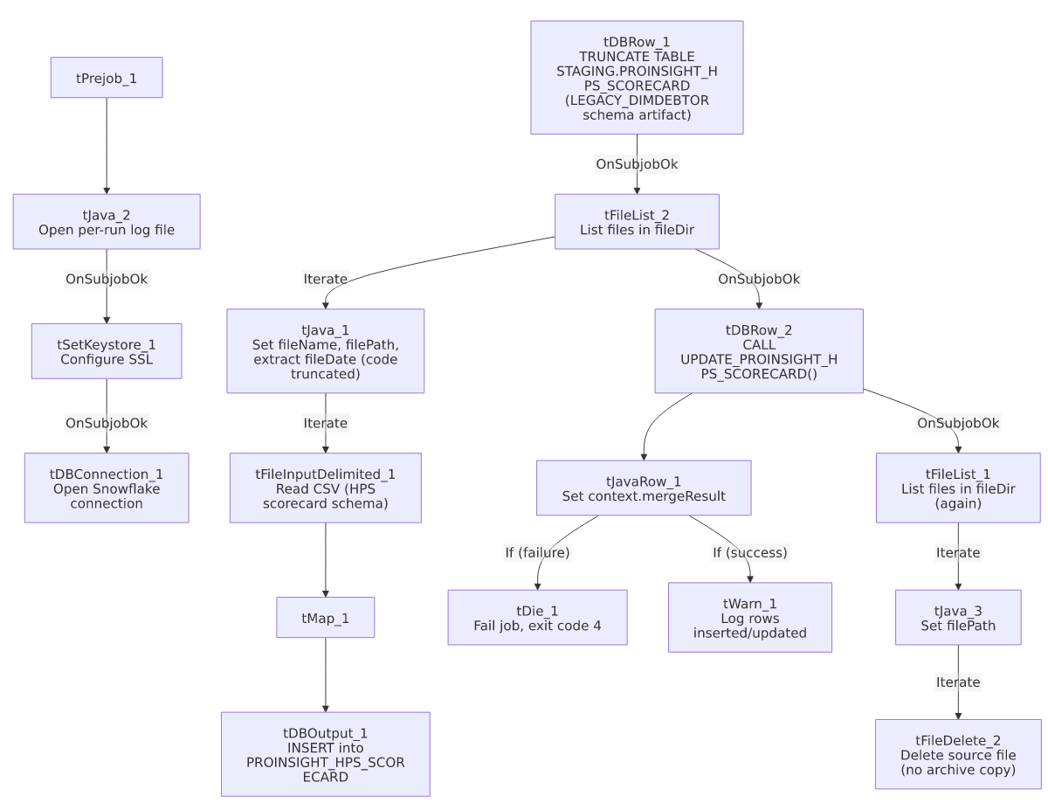

Settings tables

Source: `tFileInputDelimited_1`
Setting | Value | What it means
FILENAME | context.filePath | The current file from tFileList_2's iteration.
HEADER / REMOVE_EMPTY_ROW | 1 / true | Header row skipped; blank rows dropped rather than loaded as empty records.
SCHEMA (main) | Repository schema _sJomkKBZEe6nJKm53X2n5A - metadata | The HPS-specific scorecard column layout (auditor/call metadata plus the HPS checklist columns).
SCHEMA_REJECT | Repository schema _0CMaMD0wEe6iz_4VDQBfZg - metadata | The same shared reject schema ID used by ProInsight_CCU_Scorecard_Load and _V2_Load — a generic reject schema reused across the ProInsight family.
DIE_ON_ERROR | false | Malformed rows don't fail the job...
Reject flow | Not wired | ...but no connection carries rejected rows anywhere — silently dropped, same as both CCU siblings.
TEMP_DIR | "C:/Talend-Studio-20211109_1610-V8.0.1/workspace" | Hardcoded developer-workstation path.

Staging clear & target: `tDBRow_1` / `tDBOutput_1`
Setting | Value | What it means
Query (tDBRow_1) | TRUNCATE TABLE STAGING.PROINSIGHT_HPS_SCORECARD; | Clears the staging table before every run. Its own captured schema references the unrelated LEGACY_DIMDEBTOR repository schema — a copy-paste artifact, not a functional issue (a TRUNCATE needs no input schema).
Table (tDBOutput_1) | PROINSIGHT_HPS_SCORECARD | Destination staging table for the raw scorecard rows.
Output action | INSERT | Appends rows; safe because of the preceding TRUNCATE.

Merge step: `tDBRow_2` (`tSnowflakeRow`) / `tJavaRow_1` / `tDie_1` / `tWarn_1`
Setting | Value | What it means
Query | CALL UPDATE_PROINSIGHT_HPS_SCORECARD(); | Follows the UPDATE_<table> naming convention — matches V1 CCU's naming, not V2 CCU's MERGE_INTO_<table> convention. Yet another data point confirming this project has no single merge-procedure naming standard (see 05_operational_runbook.md).
Result handling | MERGERESULT → context.mergeResult → branch to tDie_1/tWarn_1 | A failed merge here fails the job explicitly (exit code 4, message identifying it as a merge failure) — matching V2 CCU's error-handling behavior, not V1 CCU's silent (no result-check) behavior.

Dependencies & configuration
- Triggers/depends on other jobs: none — no tRunJob links found, and this job does not appear in 06_dependency_matrix.md's orchestration table.
- Context variables used: fileDate, fileDir, fileName, filePath, keystorePath, logDir, mergeResult (set internally from the merge procedure's return value).
- 4 hardcoded developer-workstation paths: tFileInputDelimited_1.TEMP_DIR, tFileDelete_2.DIRECTORY/PATH (both containing template-like placeholder text, e.g. "...delete_folder or delete_file"), and tSetKeystore_1.SSL_TRUSTSERVER_TRUSTSTORE.

Glossary
Component type | Plain-English meaning
tFileList | Lists files in a directory for the job to iterate over one at a time.
tFileInputDelimited | Reads a delimited (CSV-style) text file according to a schema.
tMap | Maps/transforms columns from one schema to another.
tSnowflakeOutput / tSnowflakeRow / tSnowflakeConnection | Write rows to a Snowflake table / run an arbitrary SQL statement or stored-procedure call against Snowflake / open the Snowflake connection used elsewhere in the job.
tJavaRow | Runs custom Java code once per input row — here used to unpack a stored procedure's single return value.
tDie / tWarn | tDie ends the job with a specific failure message and exit code; tWarn logs a warning without stopping the job.
tSetKeystore | Configures SSL trust/keystore settings for secure connections used later in the job.
tFileDelete | Deletes a file from disk — used here with no preceding archive step.

Issues observed
- This job is a hybrid of its two documented siblings' behaviors. It uses V1 CCU's UPDATE_<table>() stored-procedure naming convention, but it uses V2 CCU's actual error-handling pattern (capturing MERGERESULT and failing the job with tDie on error) — a combination neither sibling doc alone would predict. This is a genuinely useful data point for anyone assuming the two CCU jobs represent "old vs. new" ProInsight patterns cleanly: HPS shows the naming and the error-handling conventions evolved independently of each other, not as a single package. Confirmed directly from this job's own metadata (CALL UPDATE_PROINSIGHT_HPS_SCORECARD() paired with a full tJavaRow_1/tDie_1/tWarn_1 result-check chain).
- `tDBRow_1`'s captured schema references the unrelated `LEGACY_DIMDEBTOR` repository schema (debtor/client columns like DEBTOR, NAME1, ADD1, SSN) — the same copy-paste artifact already documented in both ProInsight_CCU_Scorecard_Load and _V2_Load. Seeing it a third time in this family reinforces that all three ProInsight scorecard jobs were very likely built from the same original template, with this leftover schema reference never cleaned up in any of them. Not a functional issue (a TRUNCATE statement needs no input schema), but worth a cleanup pass across the whole family.
- No reject flow is wired from `tFileInputDelimited_1`, and the archive/delete pass (`tFileList_1` → `tJava_3` → `tFileDelete_2`) is a second, independent directory listing with no archive copy kept before deleting source files — both gaps match the same patterns documented in the CCU siblings' own docs and in 05_operational_runbook.md. If the merge procedure needs to be re-run later after a bad load, the original source files will already be gone.
- The `tJava_1` regex code for extracting `fileDate` from the filename is truncated in this job's own metadata, the same gap seen in both CCU siblings and ProInsight_Analytics_Load — the exact filename pattern expected cannot be confirmed from this extraction.

