Talend Job: ProInsight_Scorecard_Load

Overview
Loads manual QA-auditor call scorecards (scorecard link/name, auditor, edit history, collector/team, client, call details, and per-section earned/available/score fields) exported from the ProInsight quality-management system into a Snowflake staging table (PROINSIGHT_SCORECARD), then merges them into a downstream table via a stored procedure. This job is closely related to the already-documented ProInsight_CCU_Scorecard_Load/ProInsight_CCU_Scorecard_V2_Load (same manual-scorecard concept, same overall shape) but targets a differently-named staging table (PROINSIGHT_SCORECARD vs PROINSIGHT_CCU_SCORECARD) and has its own set of structural quirks documented below — it is not simply a renamed copy.

Detail table
Field | Value
Job name | ProInsight_Scorecard_Load
Version | 0.1
Project | EDW2SF
Author | jmach@harriscollect.com
Created | 2023-10-06T12:20:29.090-0700
Last Modified | 2025-11-16T21:15:10.294-0800

Step-by-step data flow
Setup subjob: tPrejob_1 → tJava_2 opens a per-run log file at context.logDir + jobName + "_" + <timestamp> + ".log" → on success (OnSubjobOk), tSetKeystore_1 configures SSL trust/keystore settings from context.keystorePath (all passwords redacted). No `tDBConnection` component exists anywhere in this job's metadata — see Issues observed; how the Snowflake components below actually obtain a connection is not visible in this extraction.
Main subjob — starts independently at tDBRow_1:
- tDBRow_1 runs TRUNCATE TABLE STAGING.PROINSIGHT_SCORECARD;. Its own captured schema is an unrelated repository schema (LEGACY_DIMDEBTOR: FILEDATE, LOGON, DEBTOR, DEBTOR_IDX, CLIENT, NAME1, NAME2, ADD1, ADD2, CITY, ST, ZIP, PACKET, PHONE, DOB, DESK, CDN, and more debtor/collections columns) that has nothing to do with call scorecards — the same kind of copy-paste artifact documented in ProInsight_CCU_Scorecard_Load's doc. Since a TRUNCATE statement doesn't need an input schema, this is very likely cosmetic only.
- On success (OnSubjobOk), tFileList_2 lists files in context.fileDir, ordered by filename ascending (EXCLUDEFILEMASK of *.txt set but IFEXCLUDE=false, so not actually applied).
- For each file, tJava_1 sets context.fileName/context.filePath, then runs a regex (\d{8}) against the filename intended to extract context.fileDate — the code is truncated in this job's own metadata (cuts off mid-statement if (m.lookingAt() || m....), the same kind of gap documented in ProInsight_Analytics_Load and ProInsight_CCU_Scorecard_Load.
- tFileInputDelimited_1 reads the CSV (comma-delimited, header row present, REMOVE_EMPTY_ROW=true, ENCODING="US-ASCII") using repository schema ID _syPuwGa-Ee6-B9n22oPWjQ (labeled "metadata") for the main schema — dozens of scorecard columns (Scorecard_Link, Scorecard_Name, Auditor_Name, Audit_Date, Edited_By, Edited_At, Collector_Name, Team, Client_Name, Client_Number, Call_Date, Call_Duration, Call_Direction, Call_ID, and further per-category score fields). The reject schema is a *different* repository schema ID (_0CMaMD0wEe6iz_4VDQBfZg, also labeled "metadata") — notably, this is the same reject-schema ID used by `ProInsight_CCU_Scorecard_Load`, suggesting a shared generic reject schema across the ProInsight family rather than a mismatch unique to this job (though whether its columns actually fit this job's main schema is still unconfirmed — see Issues observed).
- tMap_1 passes the columns through to a matching Snowflake-ready schema, adding FILE_NAME and FILE_DATE.
- tDBOutput_1 inserts the rows into Snowflake table PROINSIGHT_SCORECARD (INSERT, no table-recreate action).
- Once the tFileList_2 iteration subjob completes (OnSubjobOk), tDBRow_2 runs CALL UPDATE_PROINSIGHT_SCORECARD();.
- tDBRow_2's MERGERESULT output flows (MAIN) into tJavaRow_1, which captures it into context.mergeResult. This then branches via two RUN_IF conditions (the branch conditions themselves aren't captured in this metadata, but the message content and ordering make the intent clear): the failure branch routes to tDie_1 (message "Merge failed: " + context.mergeResult, exit code 4), the success branch routes to tWarn_1 (message "Rows inserted/updated: " + context.mergeResult). Unlike `ProInsight_CCU_Scorecard_Load`, this job does check and react to the merge result — matching its listing in 05_operational_runbook.md's "16 jobs have explicit tDie/tWarn logic" table.
- On success (OnSubjobOk), tFileList_1 performs a second, independent listing of the same `context.fileDir` directory, iterating (ITERATE) into tFileDelete_1, which deletes each file directly (FAILON=false, so a failed delete doesn't fail the job) — no archive copy is kept, same pattern as ProInsight_Analytics_Load/ProInsight_CCU_Scorecard_Load.
No teardown subjob — no tPostjob/tDBClose exists in this job's metadata, matching ProInsight_CCU_Scorecard_Load.
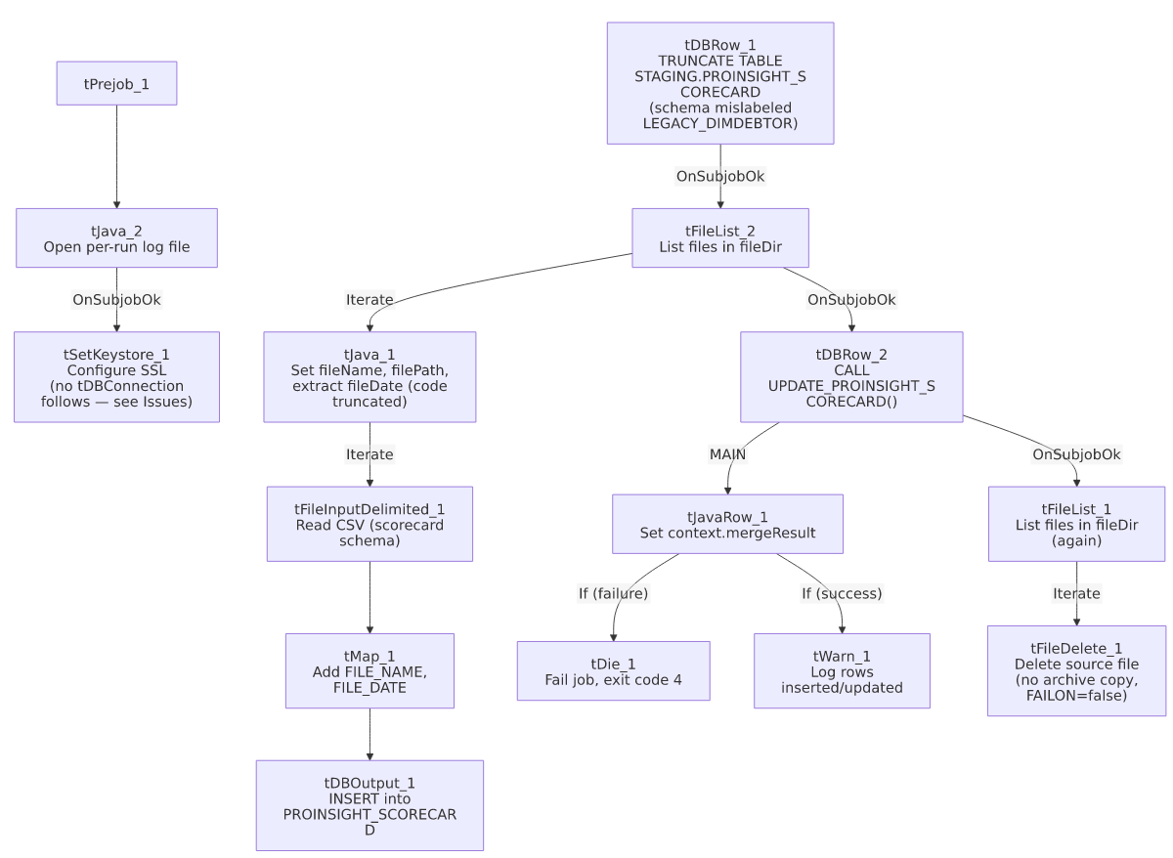

Settings tables

Source: `tFileInputDelimited_1`
Setting | Value | What it means
FILENAME | context.filePath | The current file from tFileList_2's iteration.
HEADER / REMOVE_EMPTY_ROW | 1 / true | Header row skipped; blank rows dropped rather than loaded as empty records.
ENCODING | US-ASCII (custom) | Non-standard encoding relative to the ISO-8859-15 used by most other file-reading jobs in this project.
SCHEMA (main) | Repository schema ID _syPuwGa-Ee6-B9n22oPWjQ (labeled "metadata") | Dozens of scorecard columns per audited call.
SCHEMA_REJECT | Repository schema ID _0CMaMD0wEe6iz_4VDQBfZg (also labeled "metadata") | Same reject-schema ID as ProInsight_CCU_Scorecard_Load — likely a shared generic reject schema, but see Issues observed.
DIE_ON_ERROR | false | Malformed rows don't fail the job...
Reject flow | Not wired | ...but no connection carries rejected rows anywhere — silently dropped.
TEMP_DIR | "C:/Talend-Studio-20211109_1610-V8.0.1/workspace" | Hardcoded developer-workstation path.

Staging clear & target: `tDBRow_1` / `tDBOutput_1`
Setting | Value | What it means
Query (tDBRow_1) | TRUNCATE TABLE STAGING.PROINSIGHT_SCORECARD; | Clears the staging table before every run. Its own captured schema references an unrelated LEGACY_DIMDEBTOR repository schema — a copy-paste artifact, since a TRUNCATE doesn't need an input schema (see Issues observed).
Table (tDBOutput_1) | PROINSIGHT_SCORECARD | Destination staging table for the raw scorecard rows.
Output action | INSERT | Appends rows; safe because of the preceding TRUNCATE.

Merge step: `tDBRow_2` (`tSnowflakeRow`)
Setting | Value | What it means
Query | CALL UPDATE_PROINSIGHT_SCORECARD(); | Calls a stored procedure (not shown in this metadata) that presumably applies the staged scorecards to a final warehouse table. Note the UPDATE_<table> naming convention, matching ProInsight_CCU_Scorecard_Load's merge call but differing from ADP_Payroll_Load's MERGE_INTO_<table> convention — yet another example of this project's inconsistent merge-procedure naming (see 05_operational_runbook.md).
Result handling | MERGERESULT → context.mergeResult → tDie_1/tWarn_1 | Unlike ProInsight_CCU_Scorecard_Load, this job *does* check the merge result and fails loudly (tDie, exit code 4) on failure — one of the project's 16 jobs with explicit tDie/tWarn merge-result logic.

Dependencies & configuration
- Triggers/depends on other jobs: none — no tRunJob links found, and this job does not appear in 06_dependency_matrix.md's orchestration table.
- Context variables used: fileDate, fileDir, fileName, filePath, keystorePath, logDir, mergeResult.
- 4 hardcoded developer-workstation paths: tFileInputDelimited_1.TEMP_DIR, tFileDelete_1.DIRECTORY/PATH (containing template-like placeholder text, e.g. "...delete_folder or delete_file"), and tSetKeystore_1.SSL_TRUSTSERVER_TRUSTSTORE (C:/clientTrustStore.trustStore).
- Relationship to sibling ProInsight jobs: shares its overall shape (truncate → file-list iterate → parse → load → merge with result-check → cleanup-delete) with ProInsight_CCU_Scorecard_Load/_V2_Load, but loads a differently-named table (PROINSIGHT_SCORECARD, not PROINSIGHT_CCU_SCORECARD) with a different, larger scorecard column set (including Edited_By/Edited_At/Client_Number/Call_Duration/Call_Direction/Call_ID, none of which appear in the CCU job's documented schema) — these are genuinely different scorecard exports, not a renamed duplicate.

Glossary
Component type | Plain-English meaning
tFileList | Lists files in a directory for the job to iterate over one at a time.
tFileInputDelimited | Reads a delimited (CSV-style) text file according to a schema.
tMap | Maps/transforms columns from one schema to another.
tSnowflakeOutput / tSnowflakeRow | Write rows to a Snowflake table / run an arbitrary SQL statement or stored-procedure call against Snowflake.
tJavaRow | Runs custom Java code once per input row — here used to unpack a stored procedure's single return value into a context variable.
tFileDelete | Deletes a file from disk — used here with no preceding archive step.
tWarn / tDie | Log a warning without failing the job, or end the job with a specific failure message and exit code, respectively.
tSetKeystore | Configures SSL trust/keystore settings used by subsequent secure connections.

Issues observed
- No `tDBConnection` component exists anywhere in this job's metadata, despite three Snowflake components (tDBRow_1, tDBOutput_1, tDBRow_2) actively reading/writing Snowflake. Every other Snowflake-using job reviewed in this project batch opens an explicit tSnowflakeConnection in its setup subjob. tSetKeystore_1 runs in the setup chain but nothing is wired after it. Unable to determine from this metadata whether each Snowflake component in this job is configured with its own embedded/implicit connection (not captured by this extraction, since their own parameters fields are empty), or whether a connection component was missed by the extraction — verify directly in Talend Studio before assuming this job's connection handling matches the rest of the project.
- No teardown subjob (tPostjob/tDBClose) exists — consistent with the missing tDBConnection above; there is no explicit connection-close step either.
- `tDBRow_1`'s (`TRUNCATE`) captured schema references an unrelated `LEGACY_DIMDEBTOR` repository schema (DEBTOR, NAME1, ADD1, DOB, DESK, etc.) that has nothing to do with call scorecards — the same copy-paste artifact documented in ProInsight_CCU_Scorecard_Load, strongly suggesting both jobs were built from the same debtor-load job template and never had this leftover schema cleaned up. Not a functional issue (the TRUNCATE statement doesn't use it), but worth a cleanup pass.
- The main and reject schemas on `tFileInputDelimited_1` are two different repository schema IDs, both generically labeled "metadata." The reject ID here is identical to the one used in ProInsight_CCU_Scorecard_Load, which may indicate a shared, intentionally generic reject schema across the ProInsight job family (in which case this is not an error) — but whether its columns are actually compatible with *this* job's larger main schema (more columns than the CCU job's) is unable to determine from metadata; verify directly in the Talend repository.
- `tJava_1`'s file-date extraction code is truncated in this metadata (cuts off mid-conditional), the same capture gap seen in ProInsight_Analytics_Load and ProInsight_CCU_Scorecard_Load — unable to confirm exactly how context.fileDate is derived from the filename beyond the initial \d{8} regex match attempt.
- No reject flow is wired from `tFileInputDelimited_1`, matching the project-wide pattern documented in 05_operational_runbook.md — malformed rows are silently dropped with no diagnostic trail.
- The archive/delete pass (`tFileList_1` → `tFileDelete_1`) is a second, independent directory listing run only after the merge call succeeds, and deletes files with no archive copy kept (FAILON=false, so even a failed delete doesn't stop the job) — same risk profile as ProInsight_Analytics_Load/ProInsight_CCU_Scorecard_Load: if the merge needs to be re-run later, the original source files will already be gone.

