Talend Job: Raw_PCI_Letter_Load

Overview
Loads post-processed mail/letter output files (address-standardization results from a CASS/NCOA mail-processing vendor, per the "pci_output" repository schema label) into two Snowflake tables — PCI_LETTERS (the full per-letter record, including original vs. standardized vs. NCOA-corrected address, reject/disposition codes) and DEBTOR_ADDRESSES (a narrower address-only subset) — then merges the PCI_LETTERS staging data into a downstream table via a stored procedure, and finally republishes a Tableau data-source extract counting letters and pushes it to a Tableau server. This is the most operationally varied job in this batch: it combines a file-load/merge pattern with an external Tableau-publishing step driven by Python scripts invoked from within the Talend job.

Detail table
Field | Value
Job name | Raw_PCI_Letter_Load
Version | 0.1
Project | EDW2SF
Author | jmach@harriscollect.com
Created | 2022-07-11T15:59:03.038-0700
Last Modified | 2022-07-14T13:26:36.504-0700

Step-by-step data flow
Setup subjob: tPrejob_1 → tJava_2 opens a per-run log file → on success (OnComponentOk), tDBConnection_1 opens the Snowflake connection.
Main subjob:
- tDBRow_2 runs TRUNCATE TABLE STAGING.PCI_LETTERS;.
- On success (OnSubjobOk), tFileList_1 lists files in context.fileDir (ERROR=true — unlike most other jobs' tFileList, a listing error here does fail the subjob).
- For each file (ITERATE), tJava_1 sets context.fileName/context.filePath and extracts a 6-digit pattern from the filename (via a compiled regex, presumably a date embedded in the file name).
- tFileInputDelimited_1 reads the file (comma-delimited, header row, DIE_ON_ERROR=false) using the repository schema "pci_output" for both its main and reject schema (~40 address/disposition columns: OriginalFileName, CustID, RawAddress1-3, StdAddress1-3, NcoaACSAddress1-2, MailAddress1-3, CASSErrorCode, NcoaCode, NixieCode, RejectType, RejectReason, MailDispositionCode, etc.).
- tMap_1 maps the source columns to a target schema, adding SOURCEFILE/FILEDATE (derived from the file-list/regex steps above), and splits the flow into two branches:
- Branch 1 (order 1): tFlowMeter_1 counts rows → tDBOutput_1 inserts the full ~40-column record into Snowflake PCI_LETTERS (INSERT, no table-recreate).
- Branch 2 (order 2): tDBOutput_2 inserts a narrower address-only subset (FILEDATE, CUSTOMERKEY, RAWADDRESS1-3, MAILADDRESS1-3, CASSERRORCODE, NCOACODE, NIXIECODE, REJECTTYPE/REASON, MAILDISPOSITIONCODE/DISPOSITION, NCOAMOVETYPE) directly into Snowflake DEBTOR_ADDRESSES (INSERT, no table-recreate, and no truncate step precedes this insert — see Issues observed).
- On success (OnComponentOk), tFileCopy_1 copies the source file to context.archiveDir and removes the original (REMOVE_FILE=true, REPLACE_FILE=true, FAILON=false).
- After the entire file-list loop completes (tFileList_1 → tDBRow_1, OnSubjobOk), tDBRow_1 calls CALL STAGING.MERGE_INTO_PCI_LETTERS();.
- tJavaRow_1 captures the procedure's PROCRESULT into context.procResult, which branches via two ordered RUN_IF conditions (the branch condition text itself is not captured in this metadata, but the wiring and message content make the intent clear): the success path logs tWarn_1 ("Rows affected: <n>"), the failure path fails the job with tDie_1 ("Error: <n>", exit code -1).
- On success (OnSubjobOk from tWarn_1), tJava_3 builds a Python command (tableau_letter_Count_sf.py --file <tabFile>) → tSystem_1 runs it → on success, tJava_4 builds a second Python command (publish_tableau_datasource.py --server ... --user ... --password ... --file ... --name ... --project ...) → tSystem_2 runs it, publishing the resulting Tableau extract to the configured Tableau server.
Teardown subjob: tPostjob_1 → tDBClose_1 (close Snowflake).
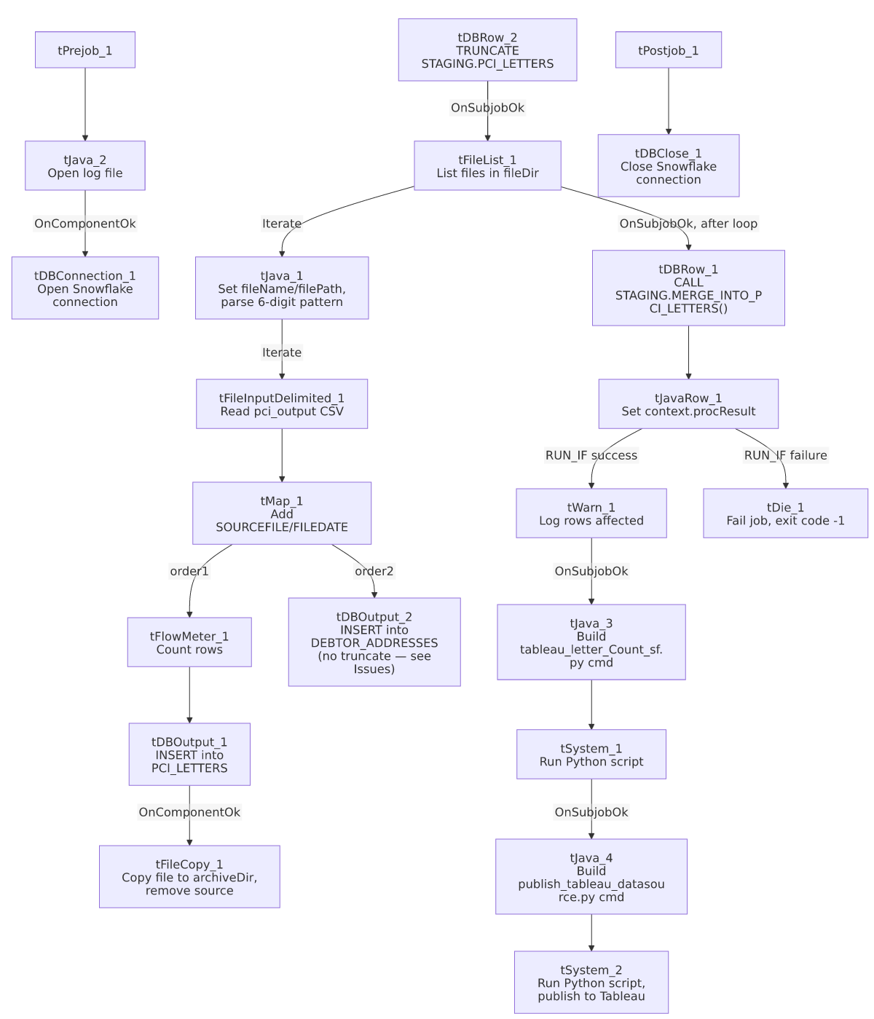

Settings tables

Source: `tFileInputDelimited_1`
Setting | Value | What it means
FILENAME | context.filePath | Current file from tFileList_1's iteration.
SCHEMA / SCHEMA_REJECT | Both repository schema "pci_output" | Main and reject schemas are consistently the same repository schema here (unlike the mismatch seen in ADP_Payroll_Load).
DIE_ON_ERROR | false | Malformed rows don't fail the job; no reject flow is wired downstream, so rejects are silently dropped.
ENCODING | US-ASCII (custom)
TEMP_DIR | "C:/Talend-Studio-20211109_1610-V8.0.1/workspace" | Developer-workstation path — see Issues observed.

Target 1: `tDBOutput_1` (`tSnowflakeOutput`)
Setting | Value | What it means
Table | PCI_LETTERS | Full per-letter record (address, standardization, disposition/reject codes).
Output action | INSERT | Relies on the prior TRUNCATE TABLE STAGING.PCI_LETTERS to prevent duplicate accumulation.

Target 2: `tDBOutput_2` (`tSnowflakeOutput`)
Setting | Value | What it means
Table | DEBTOR_ADDRESSES | Narrower address-only subset of the same source data.
Output action | INSERT | No corresponding truncate step precedes this insert anywhere in the job — see Issues observed; every run appends more rows to DEBTOR_ADDRESSES with no reset.

Merge step: `tDBRow_1` (`tSnowflakeRow`)
Setting | Value | What it means
Query | CALL STAGING.MERGE_INTO_PCI_LETTERS(); | Merges the freshly loaded STAGING.PCI_LETTERS rows into a downstream table (not shown in this metadata).
Result handling | PROCRESULT → context.procResult → branch to tWarn_1/tDie_1 | A failure here does fail the job outright (tDie_1, exit code -1), unlike some other merge-result patterns in this project that only warn.

Tableau publishing: `tJava_3`/`tSystem_1`, `tJava_4`/`tSystem_2`
Setting | Value | What it means
Script 1 | python3 <pyScriptDir>tableau_letter_Count_sf.py --file <tabFile> | Presumably generates/refreshes a Tableau .hyper extract counting letters, using the TableauVariables_0.1 context group's tabFile path.
Script 2 | python3 <pyScriptDir>publish_tableau_datasource.py --server <tabServer> --user <tabUser> --password <tabPass> --file <tabFile> --name <tabName> --project <tabProject...> (truncated) | Publishes the extract to the configured Tableau Server, using TableauVariables_0.1's server/credentials/project values. tabPass is passed as a plain command-line argument — see Issues observed.
tSystem_1/tSystem_2 DIRECTORY | "C:/Talend-Studio-20211109_1610-V8.0.1/workspace" | Developer-workstation path — see Issues observed.

Dependencies & configuration
- Triggers/depends on other jobs: none — no tRunJob links found, and this job is not listed as a tRunJob target of any other job in 06_dependency_matrix.md.
- Context variables used: archiveDir, fileDate, fileDir, fileName, filePath, logDir, procResult, pyCmd, pyScriptDir, tabFile, tabName, tabPass, tabProject, tabServer, tabUser — the Tableau-related variables come from the TableauVariables_0.1 context group documented in 06_dependency_matrix.md (one of only 3 jobs referencing it project-wide).
- 4 hardcoded developer-workstation paths: tFileInputDelimited_1.TEMP_DIR, tSystem_1.DIRECTORY, tSystem_2.DIRECTORY, tFileCopy_1.SOURCE_DERECTORY (all C:/Talend-Studio-20211109_1610-V8.0.1/workspace) — the same project-wide portability risk documented in 05_operational_runbook.md.

Glossary
Component type | Plain-English meaning
tFileList | Lists files in a directory for the job to iterate over one at a time.
tFileInputDelimited | Reads a delimited (CSV-style) text file according to a schema.
tMap | Maps/transforms columns from one schema to another, and can split one input into multiple output flows.
tFlowMeter | Counts rows passing through a point in the flow, for logging/monitoring.
tSnowflakeOutput / tSnowflakeRow / tSnowflakeConnection / tSnowflakeClose | Write rows to Snowflake / run an arbitrary SQL statement or stored-procedure call / open and close the shared Snowflake connection.
tJavaRow | Runs custom Java code once per input row — here used to unpack a stored procedure's return value.
tFileCopy | Copies a file to a destination and optionally removes/replaces the source — used here as the archive step for processed files.
tJava (command-builder usage) | Runs custom Java code — in this job, two instances build shell command strings later executed by tSystem.
tSystem | Runs an external OS-level command (here, invoking Python scripts) and captures its console output.
tWarn / tDie | Log a warning without failing the job / end the job with a specific failure message and exit code.

Issues observed
- `DEBTOR_ADDRESSES` has no truncate/reset step anywhere in this job, unlike PCI_LETTERS, which is explicitly truncated (TRUNCATE TABLE STAGING.PCI_LETTERS;) before the load. Every run of this job appends the current file's address rows to DEBTOR_ADDRESSES with an INSERT and no prior cleanup — if DEBTOR_ADDRESSES is meant to hold only the latest extract (matching the staging pattern used elsewhere in this project), this job would accumulate duplicate/stale rows indefinitely. Unable to determine from metadata whether DEBTOR_ADDRESSES is intended as a running history table (in which case this is correct) or a staging table (in which case it's missing its reset step); verify with the team.
- No reject flow is wired from `tFileInputDelimited_1`, and DIE_ON_ERROR=false, so malformed rows are silently dropped with no record of how many or which ones failed to parse — the same unwired-reject-flow pattern documented in other jobs in this project.
- `tabPass` (the Tableau server password) is passed as a plain command-line argument to a Python script via `tSystem_2`. Command-line arguments are typically visible to other processes on the same machine (e.g., via a process list) while the command is running, which is a weaker exposure boundary than an environment variable or a config file read directly by the script. The value itself is ***REDACTED*** in the source metadata and is not reproduced here, but the mechanism by which it's passed is visible and worth flagging to the security team as a hardening opportunity.
- `tFileList_1.ERROR=true` means a file-listing error fails this subjob outright, unlike the ERROR=false default seen on most other tFileList components in this project's other jobs — a deliberate (if inconsistent project-wide) choice to fail loudly here rather than silently continue with zero files.
- The two-branch order (`tDBOutput_1` order 1, `tDBOutput_2` order 2) means the `PCI_LETTERS` insert and its downstream `tFileCopy_1` archive step are wired only off `tDBOutput_1`, not tDBOutput_2 — if the DEBTOR_ADDRESSES insert were to fail independently while PCI_LETTERS's insert succeeded, the source file would still be archived/removed based on tDBOutput_1's outcome alone. Unable to determine from metadata whether Talend's tMap multi-output semantics would already have failed the whole subjob in that case (likely, given tMap_1.DIE_ON_ERROR=true), but the explicit downstream wiring only tracks one of the two output branches.

