Talend Job: SMS_IC_Inbound_Load

Overview
Loads inbound SMS/text-message records from a second, distinct texting platform — referred to in this project as "IC" — into the Snowflake TEXTS_IC_INBOUND table. Its column set (SHORTCODE, KEYWORD, CARRIER, CUSTOM1-CUSTOM10, OPTEDOUT) is entirely different from the "SBT" platform's inbound schema (SMS_Inbound_Load's BrandId/ConsentCategory/Msisdn fields), confirming these are two genuinely different source systems rather than a naming variant of the same one. Structurally the job follows the same load-then-archive, two-pass design as the SBT SMS jobs, but scans a year-partitioned subfolder (context.sourceDir + context.fileYear) rather than a flat directory.

Detail table
Field | Value
Job name | SMS_IC_Inbound_Load
Version | 0.1
Project | EDW2SF
Author | jmach@harriscollect.com
Created | 2025-07-14T12:03:30.187-0700
Last Modified | 2025-11-16T20:50:56.409-0800

Step-by-step data flow
Setup subjob: tPrejob_1 → tJava_1 opens a per-run log file → on success, tSetKeystore_1 configures SSL trust/keystore from context.keystorePath (passwords redacted) → tDBConnection_1 opens the Snowflake connection.
Main subjob (load):
- tFileList_1 lists files in context.sourceDir + context.fileYear — a year-partitioned folder, unlike the flat context.sourceDir used by the SBT SMS jobs (EXCLUDEFILEMASK="*.txt" configured but IFEXCLUDE=false, not applied).
- For each file, tJava_2 sets context.currentFilePath/context.currentFileName and runs the same 8-digit filename regex pattern seen in the SBT jobs (code truncated in this metadata).
- tFileInputDelimited_1 reads the CSV (CSV_OPTION=true, DIE_ON_ERROR=false) using repository schema "...- icinbound" for the main (well-formed) rows, but repository schema `"...- in"` for the reject schema — the same schema ID used as `SMS_Inbound_Load`'s (SBT) own main/reject schema, not an IC-specific one (see Issues observed).
- tMap_1 passes the ~29 source columns through to an uppercase-named target schema prefixed with FILENAME/FILEDATE.
- tFlowMeter_2 counts rows (labeled "inb").
- tDBOutput_1 inserts the rows into Snowflake table TEXTS_IC_INBOUND (INSERT, table action NONE — no TRUNCATE).
Main subjob (archive), triggered after the load loop finishes:
- tFileList_2 re-lists context.sourceDir + context.fileYear.
- For each file, tJava_3 sets context.currentFilePath/context.currentFileName (this job does not set context.archiveDir here, unlike its outbound sibling — see Issues observed).
- tFileCopy_1 copies the current file directly to context.sourceDir + context.fileYear + "/archive/" and, with REMOVE_FILE=true, effectively moves it there.
Teardown subjob: tPostjob_1 → tDBClose_1 closes the Snowflake connection.
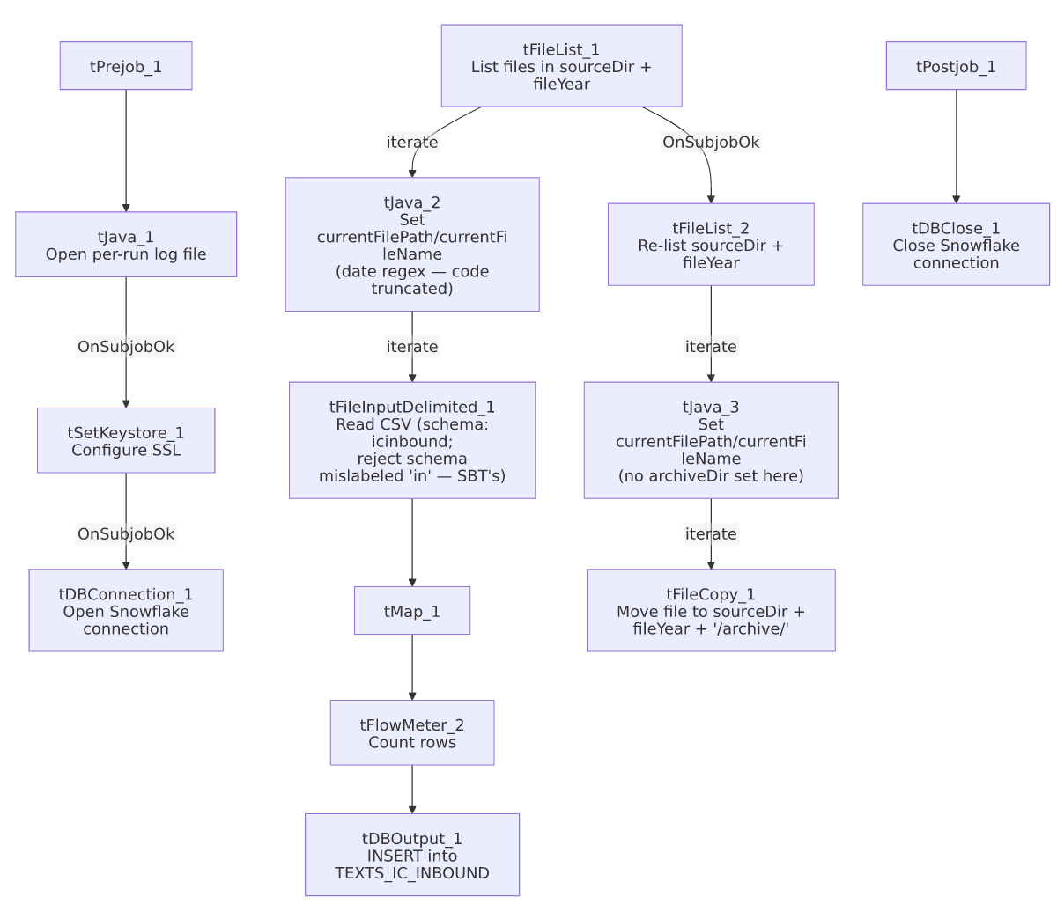

Settings tables

Source: `tFileList_1` / `tFileInputDelimited_1`
Setting | Value | What it means
DIRECTORY | context.sourceDir + context.fileYear | Year-partitioned source folder — files for a given calendar year live in their own subdirectory.
SCHEMA (main) | Repository schema "...- icinbound" | The IC-specific inbound layout (SHORTCODE, KEYWORD, MOBILE, CARRIER, CUSTOM1-10, OPTEDOUT, etc.).
SCHEMA_REJECT | Repository schema "...- in" | This is the same repository schema ID used as `SMS_Inbound_Load`'s (SBT) main/reject schema — not an IC-specific reject layout. See Issues observed.
DIE_ON_ERROR | false | Malformed rows don't fail the job...
Reject flow | Not wired | ...but no connection carries rejected rows anywhere — silently dropped.

Target: `tDBOutput_1` (`tSnowflakeOutput`)
Setting | Value | What it means
Table | TEXTS_IC_INBOUND | Destination table for inbound IC-platform text messages.
Output action / Table action | INSERT / NONE | Purely additive — no truncate step in this job.

Archive: `tFileCopy_1`
Setting | Value | What it means
DESTINATION | context.sourceDir + context.fileYear + "/archive/" | Built directly inline here, rather than via a context.archiveDir variable set in tJava_3 (contrast with SMS_IC_Outbound_Load, which does set context.archiveDir) — see Issues observed.
REMOVE_FILE / REPLACE_FILE | true / true | Effectively a move.

Dependencies & configuration
- Triggers/depends on other jobs: none — no tRunJob links found.
- Context variables used: currentFileName, currentFilePath, fileDate, fileYear, keystorePath, logDir, sourceDir.
- 3 hardcoded developer-workstation paths (tFileInputDelimited_1.TEMP_DIR, tFileCopy_1.SOURCE_DERECTORY, tSetKeystore_1.SSL_TRUSTSERVER_TRUSTSTORE) — same project-wide pattern documented in 05_operational_runbook.md.

Glossary
Component type | Plain-English meaning
tFileList | Lists files in a directory for the job to iterate over one at a time.
tFileInputDelimited | Reads a delimited (CSV-style) text file according to a schema.
tMap | Maps/transforms columns from one schema to another.
tFlowMeter | Counts rows passing through a point in the flow, for logging/monitoring.
tSnowflakeOutput / tSnowflakeConnection / tSnowflakeClose | Write rows to Snowflake / open and close the shared Snowflake connection.
tFileCopy | Copies a file to a destination path; with REMOVE_FILE=true this behaves as a move.
tSetKeystore | Configures SSL trust/keystore settings for the database connection.

Issues observed
- The reject schema is mislabeled. tFileInputDelimited_1.SCHEMA_REJECT:REPOSITORY_SCHEMA_TYPE points to the same repository schema ID (_FdnCEFBrEe-WgPpBzwqJtg, labeled "- in") that SMS_Inbound_Load uses as its own main and reject schema for the entirely different SBT inbound format. This job's main schema is the IC-specific "...- icinbound" layout, so its reject schema very likely does not match its own main schema's column layout — the same class of copy-paste mislabeling documented and confirmed in ADP_Payroll_Load (reject schema labeled "roster" in a payroll job). Whether this actually causes a column-count/type mismatch on a rejected row depends on how the two repository schemas compare — unable to determine from this metadata; verify directly in the Talend repository.
- `context.archiveDir` is not set in this job's `tJava_3`, unlike the outbound SMS_IC_Outbound_Load/SMS_IC_Outbound_Load_Backfill jobs, which do compute context.archiveDir there. This job instead builds its archive destination path inline in tFileCopy_1.DESTINATION. Functionally equivalent, but an inconsistency in how the "IC" family of jobs are structured — worth normalizing if these jobs are maintained as a family going forward.
- `tJava_2`'s date-extraction code is truncated in this metadata, same limitation as the SBT SMS jobs — unable to confirm exactly how context.fileDate is derived from the filename.
- No reject flow wired, no `TRUNCATE`/dedup step — same patterns as SMS_Inbound_Load/SMS_Outbound_Load; see those docs for the fuller discussion of the two-pass load/archive race-condition caveat, which applies identically here.

