Talend Job: SMS_IC_Outbound_Load

Overview
Loads outbound SMS/text-message campaign result files (one row per text sent: shortcode, keyword, message body, mobile number, carrier, recipient name/address/demographics, delivery status/reason, and opt-out flag) from a year-partitioned local directory into the Snowflake TEXTS_IC_OUTBOUND table, then moves each processed file into an archive subfolder. There is no merge/dimension step — rows are inserted as-is, and de-duplication across runs relies entirely on processed files being moved out of the source directory rather than a truncate-and-reload pattern.

Detail table
Field | Value
Job name | SMS_IC_Outbound_Load
Version | 0.1
Project | EDW2SF
Author | jmach@harriscollect.com
Created | 2025-07-14T12:03:05.353-0700
Last Modified | 2025-11-16T20:53:45.003-0800

Step-by-step data flow
Setup subjob: tPrejob_1 → tJava_1 opens a per-run log file at context.logDir + jobName + "_" + <timestamp> + ".log" → on success, tSetKeystore_1 configures SSL trust/keystore from context.keystorePath (passwords redacted) → tDBConnection_1 opens the Snowflake connection. This chain has no explicit link to the main subjob below — the two run as separate Talend subjobs, per the project's usual pattern (see ADP_Payroll_Load for the same shape).
Main subjob (load loop):
- tFileList_1 lists files in context.sourceDir + context.fileYear (an EXCLUDEFILEMASK of *.txt is configured but IFEXCLUDE is false, so — same as ADP_Payroll_Load — the exclusion is never actually applied; every file in the directory is picked up). Files are ordered by modified date, ascending.
- For each file (ITERATE), tJava_2 sets context.currentFilePath/context.currentFileName from the file-list iteration values and runs a regex (\d{8}) against the filename, apparently to extract an embedded date — the code capturing that match is truncated in this metadata before it's assigned to a context variable, so it's unclear exactly what it's stored as (see Issues observed).
- tFileInputDelimited_1 reads the CSV (comma-delimited, header row present, DIE_ON_ERROR=false) using repository schema "...- icout" for well-formed rows and reject schema "...- out" for rejects.
- tMap_1 passes the ~30 columns through to an uppercase-named target schema (DIE_ON_ERROR=true, so a mapping failure fails the job outright).
- tFlowMeter_2 counts rows passing through (labeled "MyLabel", not renamed for this job).
- tDBOutput_1 inserts the rows into Snowflake table TEXTS_IC_OUTBOUND (INSERT, no table-recreate action, no preceding TRUNCATE).
Main subjob (archive loop), triggered only after the load loop's subjob succeeds (`tFileList_1` → `OnSubjobOk` → `tFileList_2`):
- tFileList_2 re-lists the same directory (context.sourceDir + context.fileYear) independently from tFileList_1's earlier listing.
- For each file (ITERATE), tJava_3 re-derives context.currentFilePath/context.currentFileName and sets context.archiveDir = context.sourceDir + context.fileYear + "/archive".
- tFileCopy_1 copies the file into context.archiveDir (CREATE_DIRECTORY=true, REPLACE_FILE=true) and, because REMOVE_FILE=true, deletes the original — effectively a move rather than a copy.
Teardown subjob: tPostjob_1 → tDBClose_1 closes the Snowflake connection.
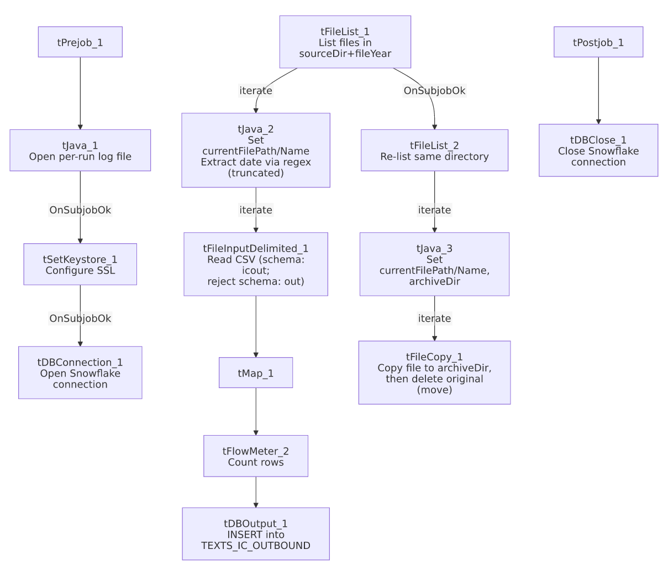

Settings tables

Source: `tFileInputDelimited_1`
Setting | Value | What it means
FILENAME | context.currentFilePath | The current file from tFileList_1's iteration.
FIELDSEPARATOR / HEADER | , / 1 header row | Comma-delimited CSV with a header row skipped.
SCHEMA (main) | Repository schema "...- icout" | Expected layout for a well-formed outbound-SMS row (~30 columns: shortcode, keyword, message, mobile, carrier, recipient demographics, delivery status/reason, opt-out).
SCHEMA_REJECT | Repository schema "...- out" | Reject-row schema (name truncated in this metadata to just "out" — the fuller repository label isn't captured).
DIE_ON_ERROR | false | Malformed rows do not fail the job...
Reject flow | Not wired | ...but no connection carries rejected rows anywhere in this job — they are silently dropped, same pattern flagged in ADP_Payroll_Load.
TEMP_DIR | "C:/Talend-Studio-20211109_1610-V8.0.1/workspace" | Hardcoded developer-workstation path — see 05_operational_runbook.md.

Target: `tDBOutput_1` (`tSnowflakeOutput`)
Setting | Value | What it means
Table | TEXTS_IC_OUTBOUND | Destination table for SMS outbound campaign results.
Output action | INSERT | Appends rows; there is no TRUNCATE step before this in the job, unlike the truncate-load pattern in ADP_Payroll_Load.
Table action | NONE | Table is not recreated/altered.

Archive step: `tFileCopy_1`
Setting | Value | What it means
FILENAME | context.currentFilePath | The file currently being archived (from tFileList_2's second, independent listing).
DESTINATION | context.archiveDir (= sourceDir + fileYear + "/archive") | Where the file is moved to after loading.
REMOVE_FILE / REPLACE_FILE / CREATE_DIRECTORY | true / true / true | Original file is deleted after the copy (net effect: a move), overwriting any same-named file already archived, creating the archive folder if it doesn't exist.
SOURCE_DERECTORY | "C:/Talend-Studio-20211109_1610-V8.0.1/workspace" | Hardcoded developer-workstation path (component parameter name itself is misspelled "DERECTORY" in the Talend metadata, not a transcription error here).

Dependencies & configuration
- Triggers/depends on other jobs: none — no tRunJob links found, and this job does not appear as a target in 06_dependency_matrix.md either.
- Context variables used: sourceDir, fileYear (both likely from StandardFolders_0.1, though fileYear isn't in that group as captured in _shared_context.json — see Issues observed), currentFilePath, currentFileName, archiveDir, fileDate (referenced but its assignment is not visible — see Issues observed), keystorePath, logDir.
- 3 hardcoded developer-workstation paths: tFileInputDelimited_1.TEMP_DIR, tFileCopy_1.SOURCE_DERECTORY (both the standard C:/Talend-Studio-20211109_1610-V8.0.1/workspace path), and tSetKeystore_1.SSL_TRUSTSERVER_TRUSTSTORE ("C:/clientTrustStore.trustStore") — same project-wide pattern documented in 05_operational_runbook.md.

Glossary
Component type | Plain-English meaning
tFileList | Lists files in a directory for the job to iterate over one at a time.
tFileInputDelimited | Reads a delimited (CSV-style) text file according to a schema.
tMap | Maps/transforms columns from one schema to another.
tFlowMeter | Counts rows passing through a point in the flow, for logging/monitoring.
tSnowflakeOutput / tSnowflakeConnection / tSnowflakeClose | Write rows to a Snowflake table / open and close the Snowflake connection used in the job.
tFileCopy | Copies a file to a new location; with REMOVE_FILE enabled (as here), the original is deleted afterward, making it function as a move.
tSetKeystore | Configures SSL trust/keystore settings used by the job's secure connections.

Issues observed
- The archive step re-lists the same source directory independently rather than reusing the file list already captured for loading. tFileList_2 runs only after tFileList_1's whole subjob succeeds, so in practice it should see the same set of files (since nothing else writes to context.sourceDir + context.fileYear mid-run) — but the two loops are not directly linked, so if a new file were dropped into that directory between the two listings, it would be archived without ever having been loaded, or vice versa. Unable to determine from metadata whether this is a meaningful real-world risk given how the directory is fed; worth confirming with the team.
- No `TRUNCATE` before `tDBOutput_1`'s `INSERT`, unlike the truncate-load-merge pattern in ADP_Payroll_Load. Correctness instead depends entirely on tFileCopy_1 successfully moving (not just copying) each processed file out of the source directory so it isn't picked up and re-inserted on the next run. If the copy step fails partway (e.g., permission error) but the load already succeeded, the source file could remain in place and get reloaded as a duplicate next run.
- `tJava_2`'s date-extraction logic is truncated in this metadata. The captured code compiles a regex (\d{8}) against context.currentFileName and starts building a Matcher, but the code that actually assigns the extracted value to a context variable is cut off ("...S..."). context.fileDate appears in this job's context_vars_referenced list, so it is very likely the target of that assignment, but this cannot be confirmed from the available metadata — verify directly in Talend Studio.
- No reject flow wired from `tFileInputDelimited_1`. DIE_ON_ERROR is false, so malformed rows don't fail the job, but there is also no connection carrying rejected rows anywhere — they are silently dropped with no record of how many, or which, rows failed to parse. Same pattern flagged in ADP_Payroll_Load.
- No merge/stored-procedure step and no `tDie`/`tWarn` logic anywhere in this job — a load failure would only surface as a generic Talend execution error, with no job-specific message to distinguish it in a shared log (same gap noted in i3_CallDetail_40_Load).
- `fileYear` is used to build both the source and archive paths but does not appear in any context group captured in _shared_context.json (StandardFolders_0.1 has sourceDir/archiveDir/logDir/sourceDCDir/keystorePath but no fileYear). Unable to determine from metadata where fileYear is actually set/defaulted — verify with the team.

