Talend Job: SMS_IC_Outbound_Load_Backfill

Overview
Reprocesses a whole year's worth of outbound-SMS extract files (one row per text message: mobile number, keyword, send date/time, message body, and per-debtor personalization fields like customer ID, court, case number, and pay link) from a source directory into the Snowflake TEXTS_IC_OUTBOUND table, then moves each processed file into an archive subfolder. The _Backfill naming and the year-level (rather than daily) directory scope indicate this is a catch-up/reload job rather than the project's regular day-to-day SMS load.

Detail table
Field | Value
Job name | SMS_IC_Outbound_Load_Backfill
Version | 0.1
Project | EDW2SF
Author | jmach@harriscollect.com
Created | 2025-07-14T14:40:41.530-0700
Last Modified | 2025-09-24T11:01:01.184-0700

Step-by-step data flow
Setup subjob: tPrejob_1 → tJava_1 opens a per-run log file at context.logDir+jobName+"_"+<timestamp>+".log" → on success, tDBConnection_1 opens the Snowflake connection.
Load pass (runs independently of the setup subjob):
- tFileList_1 lists files in context.sourceDir+context.fileYear (an EXCLUDEFILEMASK of *.txt is configured but IFEXCLUDE=false, so it has no effect — every file in the directory is picked up, ordered oldest-to-newest by modified date).
- For each file, tJava_2 sets context.currentFilePath/context.currentFileName from tFileList_1's globals, then compiles a \d{8} regex against the filename to extract an embedded date — the code that assigns the matched value to `context.fileDate` is truncated in this metadata, so the exact assignment logic isn't visible (see Issues observed).
- tFileInputDelimited_1 reads the CSV (comma-delimited, CSV_OPTION=true, header row present, DIE_ON_ERROR=false) at context.currentFilePath, using repository schema "icoutbound" for well-formed rows (14 columns: Mobile_Number, Keyword, Send_Date, Send_Time, SMS_Message, customerid, zip, firstname, paylink, creditor, pktbal, court, case_no, Txt_Msg_PH) and a differently-labeled reject schema ("out").
- tMap_1 (DIE_ON_ERROR=true) maps to a 16-column uppercase target schema (FILENAME, FILEDATE, MOBILE_NUMBER, KEYWORD, SEND_DATE, SEND_TIME, SMS_MESSAGE, CUSTOMERID, ZIP, FIRSTNAME, PAYLINK, CREDITOR, PKTBAL, COURT, CASE_NO, TXT_MSG_PH) — FILENAME/FILEDATE are added columns presumably populated from context.currentFileName/context.fileDate, though the actual mapping expressions aren't captured in this metadata.
- tFlowMeter_2 counts rows passing through (labeled "MyLabel", not renamed for this job).
- tDBOutput_1 inserts the rows into Snowflake table TEXTS_IC_OUTBOUND (INSERT, no table-recreate action).
Archive pass — starts once tFileList_1 finishes all iterations (SUBJOB_OK):
- tFileList_2 re-lists the same directory (context.sourceDir+context.fileYear).
- For each file, tJava_3 re-derives context.currentFilePath/context.currentFileName from tFileList_2's globals and computes context.archiveDir = context.sourceDir + context.fileYear + "/archive" — a job-local archive path, not the project-wide context.archiveDir convention used elsewhere (see Issues observed).
- tFileCopy_1 copies the file to context.archiveDir, with REMOVE_FILE=true and REPLACE_FILE=true (i.e., effectively moves each file into the archive subfolder, creating it if needed via CREATE_DIRECTORY=true).
Teardown subjob: tPostjob_1 → tDBClose_1 closes the Snowflake connection.
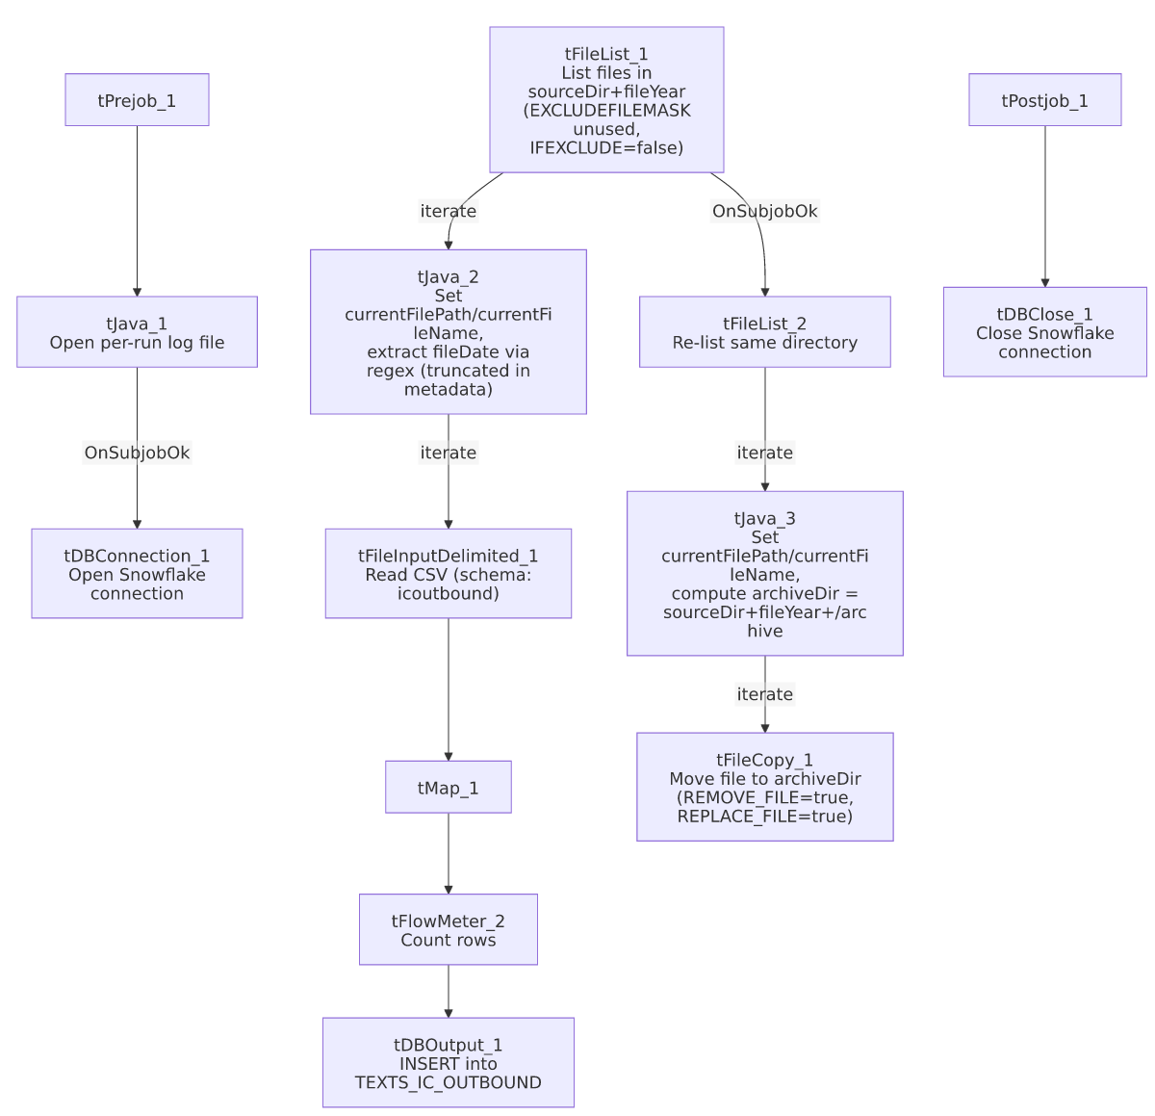

Settings tables

Source listing: `tFileList_1` / `tFileList_2`
Setting | Value | What it means
DIRECTORY | context.sourceDir + context.fileYear | Scoped to a whole year's worth of files, consistent with a backfill/reload job rather than a daily incremental one.
EXCLUDEFILEMASK / IFEXCLUDE | "*.txt" / false | Exclusion mask configured but not applied — every file in the directory is picked up (and later moved to archive), regardless of extension.
ORDER_BY_MODIFIEDDATE / ASC | true / true | Processes files oldest-to-newest by modification date.

Source: `tFileInputDelimited_1`
Setting | Value | What it means
FILENAME | context.currentFilePath | The current file from tFileList_1's iteration.
SCHEMA / SCHEMA_REJECT | Repository schema "icoutbound" / "out" | Main and reject schemas carry different labels.
DIE_ON_ERROR | false | Malformed rows don't fail the job...
Reject flow | Not wired | ...but no connection routes rejected rows anywhere in this job (no file, no log, no table) — they are silently dropped, the same pattern flagged in ADP_Payroll_Load.

Target: `tDBOutput_1` (`tSnowflakeOutput`)
Setting | Value | What it means
Table | TEXTS_IC_OUTBOUND | Destination table for outbound SMS/text records.
Output action | INSERT | Appends rows — no truncate/staging step is present in this job.
Table action | NONE | Table is not recreated/altered by this job.

Archive step: `tJava_3` / `tFileCopy_1`
Setting | Value | What it means
tJava_3 archiveDir assignment | context.archiveDir = context.sourceDir + context.fileYear + "/archive" | Computes a job-local archive path rather than using the project's shared context.archiveDir convention (see Issues observed).
REMOVE_FILE / REPLACE_FILE / CREATE_DIRECTORY (tFileCopy_1) | true / true / true | Effectively moves (copy-then-delete-original) each source file into the archive subfolder, creating that subfolder if it doesn't exist.

Dependencies & configuration
- Triggers/depends on other jobs: none — no tRunJob links found, and this job does not appear as a call target anywhere in 06_dependency_matrix.md's 65-link orchestration table.
- Context variables used: archiveDir (locally computed, not from StandardFolders_0.1), currentFileName, currentFilePath, fileDate, fileYear, logDir, sourceDir.
- 2 hardcoded developer-workstation paths in tFileInputDelimited_1.TEMP_DIR and tFileCopy_1.SOURCE_DERECTORY (both C:/Talend-Studio-20211109_1610-V8.0.1/workspace, SOURCE_DERECTORY as spelled in the component's own parameter name) — same project-wide portability risk documented in 05_operational_runbook.md.

Glossary
Component type | Plain-English meaning
tFileList | Lists files in a directory for the job to iterate over one at a time.
tJava | Runs custom Java code — here used to open a log file, parse filenames, and compute paths.
tFileInputDelimited | Reads a delimited (CSV-style) text file according to a schema.
tMap | Maps/transforms columns from one schema to another.
tFlowMeter | Counts rows passing through a point in the flow, for logging/monitoring.
tSnowflakeOutput / tSnowflakeConnection / tSnowflakeClose | Write rows to a Snowflake table / open and close the Snowflake connection used by the job.
tFileCopy | Copies (and here, with REMOVE_FILE=true, effectively moves) a file from one location to another.

Issues observed
- No reject flow is wired from `tFileInputDelimited_1`. DIE_ON_ERROR is false, and a reject schema ("out") is configured, but there is no connection carrying rejected rows anywhere — they are silently dropped with no record of how many rows, or which ones, failed to parse. Same pattern flagged in ADP_Payroll_Load.
- `tJava_2`'s filename-date-extraction code is truncated in this metadata after the regex Matcher is constructed — the statement that actually assigns a value to context.fileDate is not visible. Unable to confirm from metadata whether fileDate is being set correctly (or at all) for every file; verify directly in Talend Studio.
- `EXCLUDEFILEMASK="*.txt"` is configured on both `tFileList_1` and `tFileList_2` but `IFEXCLUDE=false`, so it has no effect. Every file in the year directory is read as SMS data and later moved into the archive subfolder — if the source directory ever accumulates a non-data file (e.g., a stray .txt log or readme), it would be processed and moved along with the real extracts.
- The archive path is computed locally (context.sourceDir + context.fileYear + "/archive" in tJava_3) rather than using the shared context.archiveDir convention (StandardFolders_0.1) used by most other jobs in this project. This may be intentional for a backfill job that shouldn't touch the shared archive location, or it may be an oversight — unable to determine intent from metadata.
- This backfill job has no `tRunJob` relationship to any other job in the project's metadata (it neither calls nor is called by anything). Unable to determine from metadata how or when it's meant to be run relative to whatever the project's regular (non-backfill) SMS IC Outbound load job is — verify with the team.

