Talend Job: SMS_Inbound_Load

Overview
Loads inbound SMS/text-message records (consumer replies) from a delimited export file dropped by the "SBT" texting platform into the Snowflake TEXTS_SBT_INBOUND table — one row per received message, with brand/group identifiers, consent category, the sender's mobile number (Msisdn), message content, and delivery/read timestamps. After each file loads, a second pass moves the source file into a sourceDir + "archive/" subfolder. The table naming (TEXTS_SBT_*) and field set (BrandId, ConsentCategory, Msisdn) both point to this being a specific SMS vendor's compliance-oriented texting feed, distinct from the "IC" SMS family documented separately (SMS_IC_Inbound_Load, SMS_IC_Outbound_Load).

Detail table
Field | Value
Job name | SMS_Inbound_Load
Version | 0.1
Project | EDW2SF
Author | jmach@harriscollect.com
Created | 2024-08-06T15:16:53.345-0700
Last Modified | 2025-11-16T20:53:32.787-0800

Step-by-step data flow
Setup subjob: tPrejob_1 → tJava_1 opens a per-run log file at context.logDir + jobName + "_" + <timestamp> + ".log" and redirects System.out/System.err to it → on success, tSetKeystore_1 configures SSL trust/keystore from context.keystorePath (passwords redacted) → tDBConnection_1 opens the Snowflake connection.
Main subjob (load):
- tFileList_1 lists files in context.sourceDir (an EXCLUDEFILEMASK of *.txt is configured but IFEXCLUDE is false, so it isn't actually applied — every file in the directory is picked up, same non-functional-exclusion pattern seen in ADP_Payroll_Load).
- For each file, tJava_2 sets context.currentFilePath/context.currentFileName from the iteration and runs an 8-digit regex match against the filename (the code that assigns the matched value to context.fileDate/context.fileYear is truncated in this metadata — see Issues observed).
- tFileInputDelimited_1 reads the CSV (comma-delimited, header row present, DIE_ON_ERROR=false) using repository schema "...- in" for both the main and reject schema.
- tMap_1 passes the ~24 source columns through to an uppercase-named target schema, prefixed with FILENAME/FILEDATE (DIE_ON_ERROR=true).
- tFlowMeter_2 counts rows (labeled "inb").
- tDBOutput_1 inserts the rows into Snowflake table TEXTS_SBT_INBOUND (INSERT, table action NONE — no TRUNCATE anywhere in this job, so the load is purely additive).
Main subjob (archive), triggered once the load loop finishes (`tFileList_1` → `tFileList_2` on `OnSubjobOk`):
- tFileList_2 re-lists the same context.sourceDir directory.
- For each file, tJava_3 sets context.currentFilePath/context.currentFileName.
- tFileCopy_1 copies the current file to context.sourceDir + "archive/" and, with REMOVE_FILE=true/REPLACE_FILE=true, effectively moves it there.
Teardown subjob: tPostjob_1 → tDBClose_1 closes the Snowflake connection.
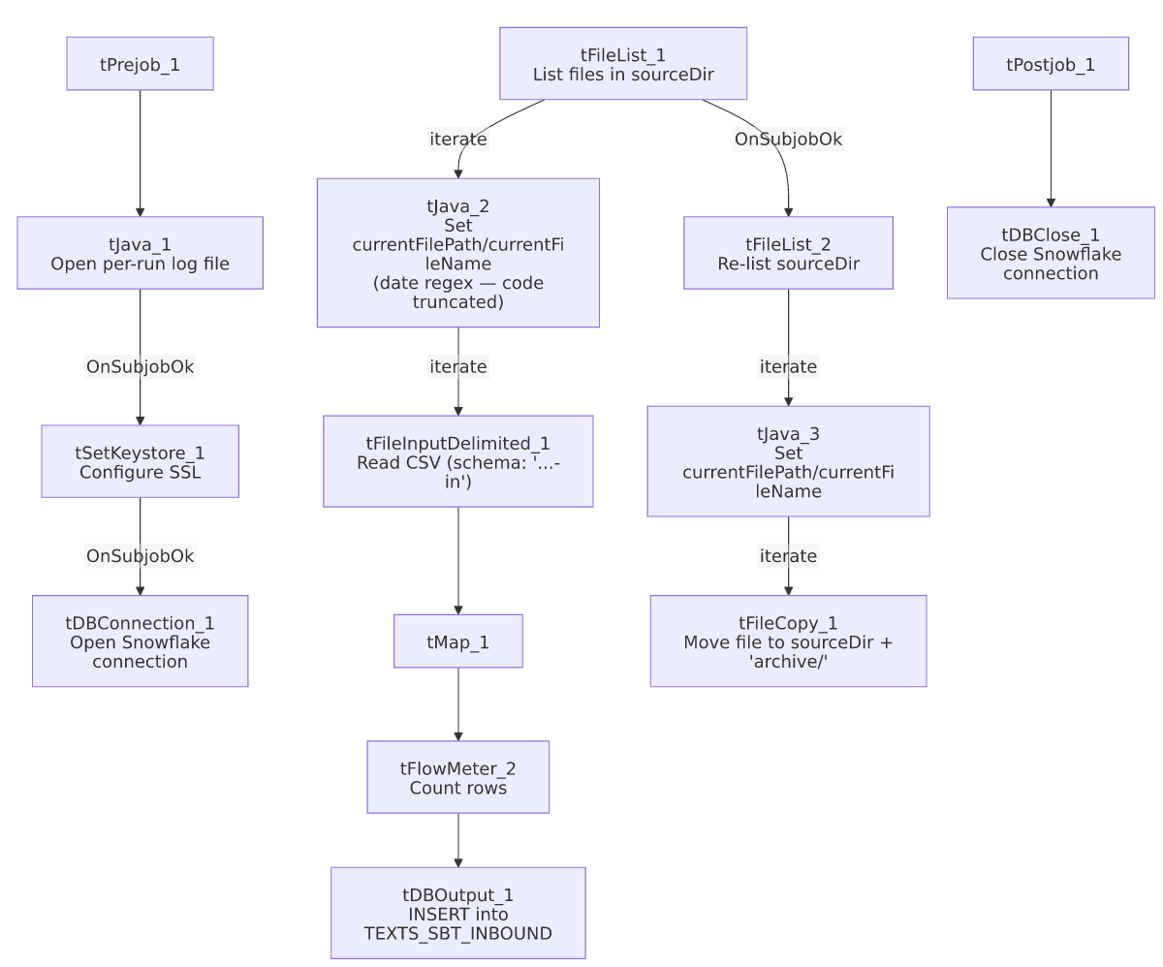

Settings tables

Source: `tFileList_1` / `tFileInputDelimited_1`
Setting | Value | What it means
DIRECTORY | context.sourceDir | Flat scan, no year/date subfolder (unlike the SMS_IC_* family — see Issues observed).
EXCLUDEFILEMASK / IFEXCLUDE | "*.txt" / false | Exclusion mask configured but not applied — every file in the directory is listed.
SCHEMA / SCHEMA_REJECT | Repository schema "...- in" (same label for both) | Main and reject schemas both point to the same repository schema entry — a self-consistent choice, unlike the mismatch seen in the SMS_IC_* jobs (see their own docs).
DIE_ON_ERROR | false | Malformed rows don't fail the job...
Reject flow | Not wired | ...but no connection carries rejected rows anywhere — they are silently dropped with no record.

Target: `tDBOutput_1` (`tSnowflakeOutput`)
Setting | Value | What it means
Table | TEXTS_SBT_INBOUND | Destination table for inbound SBT text messages.
Output action / Table action | INSERT / NONE | No truncate step exists anywhere in this job — every run is purely additive; the file-archive-and-remove step is the only thing preventing the same file from being reloaded.

Archive: `tFileCopy_1`
Setting | Value | What it means
FILENAME | context.currentFilePath | The full absolute path of the current file from tFileList_2's iteration.
SOURCE_DERECTORY (sic) | "C:/Talend-Studio-20211109_1610-V8.0.1/workspace" | Hardcoded developer path; appears unused in practice since FILENAME already supplies a full path — see Issues observed.
DESTINATION | context.sourceDir + "archive/" | Destination archive subfolder.
REMOVE_FILE / REPLACE_FILE | true / true | Source file is deleted after copying — functionally a move.

Dependencies & configuration
- Triggers/depends on other jobs: none — no tRunJob links found.
- Context variables used: currentFileName, currentFilePath, fileDate, fileYear (referenced but not used to build tFileList_1's directory in this job — see Issues observed), keystorePath, logDir, sourceDir.
- 3 hardcoded developer-workstation paths (tFileInputDelimited_1.TEMP_DIR, tFileCopy_1.SOURCE_DERECTORY, tSetKeystore_1.SSL_TRUSTSERVER_TRUSTSTORE), all C:/Talend-Studio-20211109_1610-V8.0.1/... or C:/clientTrustStore.trustStore — same portability risk documented project-wide in 05_operational_runbook.md.

Glossary
Component type | Plain-English meaning
tFileList | Lists files in a directory for the job to iterate over one at a time.
tFileInputDelimited | Reads a delimited (CSV-style) text file according to a schema.
tMap | Maps/transforms columns from one schema to another.
tFlowMeter | Counts rows passing through a point in the flow, for logging/monitoring.
tSnowflakeOutput / tSnowflakeConnection / tSnowflakeClose | Write rows to Snowflake / open and close the shared Snowflake connection.
tFileCopy | Copies a file to a destination path; with REMOVE_FILE=true this behaves as a move.
tSetKeystore | Configures SSL trust/keystore settings for the database connection.

Issues observed
- `tJava_2`'s date-extraction code is truncated in this metadata (ends mid-statement after the regex Matcher is built). Unable to determine from metadata exactly how context.fileDate/context.fileYear are derived from the filename, or whether the job behaves correctly if a filename doesn't contain an 8-digit run — verify directly in Talend Studio.
- `context.fileYear` is referenced by this job but not used to build `tFileList_1`'s scan directory — DIRECTORY is just context.sourceDir, whereas the related SMS_IC_Inbound_Load/SMS_IC_Outbound_Load jobs use context.sourceDir + context.fileYear for a year-partitioned folder structure. Unable to determine from metadata whether fileYear is simply unused here, used only for logging, or a vestige of an earlier version of this job.
- No reject flow wired from `tFileInputDelimited_1`. DIE_ON_ERROR=false, so malformed rows don't fail the job, but there's also no connection carrying rejected rows anywhere — they're silently dropped with no record of how many, or which, rows failed to parse.
- No `TRUNCATE`/dedup step anywhere in this job — every run purely inserts. The only safeguard against reprocessing the same file twice is the separate archive-and-delete pass (tFileList_2/tFileCopy_1), which runs as its own listing of the directory rather than being wired inline with the load loop per file.
- The load pass and the archive pass are two independent scans of the same directory (tFileList_1 for loading, tFileList_2 for archiving, triggered afterward via OnSubjobOk). If a new file were dropped into context.sourceDir between the two scans, tFileList_2 could pick it up and move it to archive/ without it ever having been loaded through tFileInputDelimited_1/tDBOutput_1 — a narrow but real race window. Unable to determine from metadata how likely this is in practice (depends on how often the source system writes new files during this job's run window).
- `tFileCopy_1.SOURCE_DERECTORY` (note the source metadata's own typo, preserved here) is a hardcoded developer path that appears functionally unused, since FILENAME is already set to the full absolute context.currentFilePath. Not confirmed harmful, but worth flagging alongside the other hardcoded-path findings in 05_operational_runbook.md.

