Talend Job: SMS_Outbound_Load

Overview
Loads outbound SMS/text-message records (messages sent to consumers) from a delimited export file dropped by the "SBT" texting platform into the Snowflake TEXTS_SBT_OUTBOUND table — one row per sent message, with brand/group identifiers, the recipient's mobile number (Msisdn), message template/category, send/delivery status and timestamps. Structurally a near-mirror of SMS_Inbound_Load (same setup/teardown, same two-pass load-then-archive design), but for the sent side of the same SBT texting platform, with delivery-status fields (STATUS, STATUSCODE, DELIVEREDTIME) that inbound messages don't have.

Detail table
Field | Value
Job name | SMS_Outbound_Load
Version | 0.1
Project | EDW2SF
Author | jmach@harriscollect.com
Created | 2024-08-01T18:09:34.343-0700
Last Modified | 2025-11-16T20:53:28.013-0800

Step-by-step data flow
Setup subjob: tPrejob_1 → tJava_1 opens a per-run log file → on success, tSetKeystore_1 configures SSL trust/keystore from context.keystorePath (passwords redacted) → tDBConnection_1 opens the Snowflake connection.
Main subjob (load):
- tFileList_1 lists files in context.sourceDir (EXCLUDEFILEMASK="*.txt" configured but IFEXCLUDE=false, so not actually applied).
- For each file, tJava_2 sets context.currentFilePath/context.currentFileName and runs the same 8-digit filename regex seen in SMS_Inbound_Load (code truncated in this metadata — see Issues observed).
- tFileInputDelimited_1 reads the CSV (DIE_ON_ERROR=false) using a built-in (non-repository) main schema and a repository reject schema labeled "...- out".
- tMap_1 passes the source columns through to an uppercase-named target schema prefixed with FILENAME/FILEDATE (DIE_ON_ERROR=true).
- tFlowMeter_2 counts rows (labeled "outb").
- tDBOutput_1 inserts the rows into Snowflake table TEXTS_SBT_OUTBOUND (INSERT, table action NONE — no TRUNCATE anywhere in this job).
Main subjob (archive), triggered after the load loop finishes:
- tFileList_2 re-lists context.sourceDir.
- For each file, tJava_3 sets context.currentFilePath/context.currentFileName.
- tFileCopy_1 copies the current file to context.sourceDir + "archive" and, with REMOVE_FILE=true/REPLACE_FILE=true, effectively moves it there.
Teardown subjob: tPostjob_1 → tDBClose_1 closes the Snowflake connection.
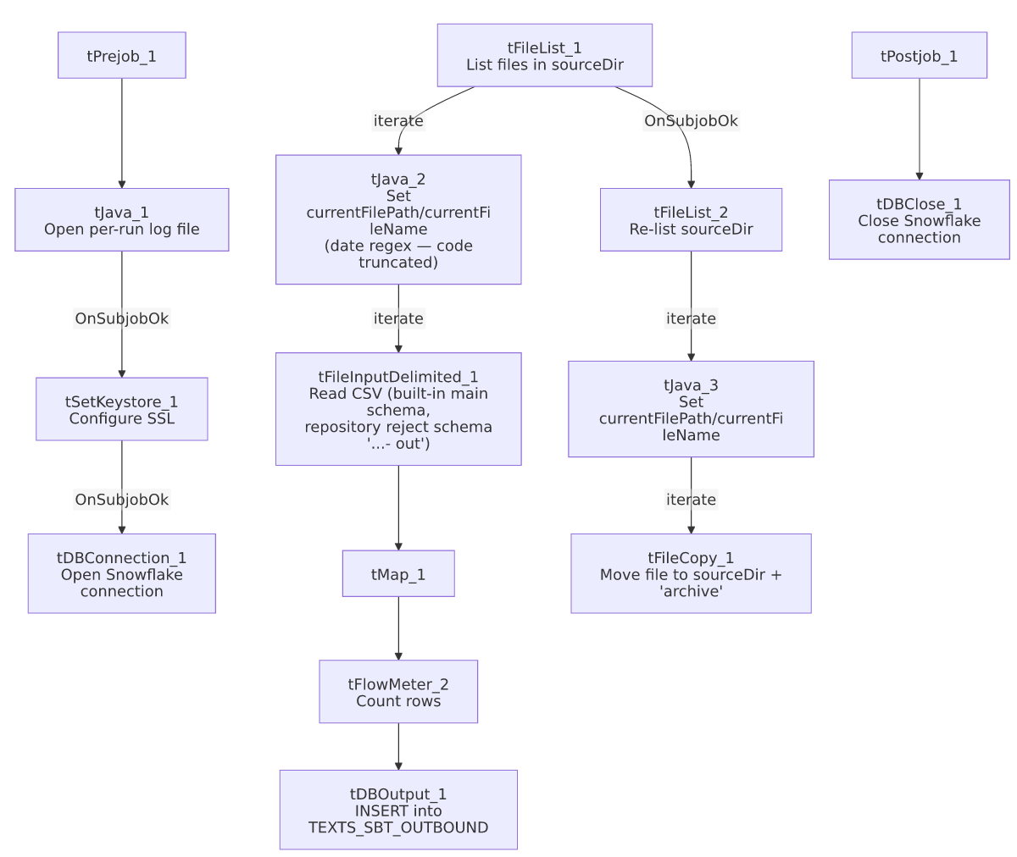

Settings tables

Source: `tFileList_1` / `tFileInputDelimited_1`
Setting | Value | What it means
DIRECTORY | context.sourceDir | Flat scan, no year subfolder.
EXCLUDEFILEMASK / IFEXCLUDE | "*.txt" / false | Exclusion mask configured but not applied.
SCHEMA (main) | Built-in (no repository schema captured) | Unlike its own reject schema and unlike SMS_Inbound_Load's main schema, this job's well-formed-row schema is embedded in the component itself, not a repository reference.
SCHEMA_REJECT | Repository schema "...- out"
DIE_ON_ERROR | false | Malformed rows don't fail the job...
Reject flow | Not wired | ...but no connection carries rejected rows anywhere — silently dropped.

Target: `tDBOutput_1` (`tSnowflakeOutput`)
Setting | Value | What it means
Table | TEXTS_SBT_OUTBOUND | Destination table for outbound SBT text messages.
Output action / Table action | INSERT / NONE | Purely additive — no truncate step in this job.

Archive: `tFileCopy_1`
Setting | Value | What it means
DESTINATION | context.sourceDir + "archive" | Note: no trailing slash, unlike SMS_Inbound_Load's "archive/" — likely harmless (Talend/OS path joining typically tolerates this) but a small inconsistency between the two sibling jobs.
REMOVE_FILE / REPLACE_FILE | true / true | Effectively a move.
PRESERVE_LAST_MODIFIED_TIME | false | Differs from SMS_Inbound_Load's true — archived outbound files will show their copy time, not their original modified time.

Dependencies & configuration
- Triggers/depends on other jobs: none — no tRunJob links found.
- Context variables used: currentFileName, currentFilePath, fileDate, fileYear (not used to build this job's scan directory — same as SMS_Inbound_Load), keystorePath, logDir, sourceDir.
- 3 hardcoded developer-workstation paths (tFileInputDelimited_1.TEMP_DIR, tFileCopy_1.SOURCE_DERECTORY, tSetKeystore_1.SSL_TRUSTSERVER_TRUSTSTORE) — same project-wide pattern documented in 05_operational_runbook.md.

Glossary
Component type | Plain-English meaning
tFileList | Lists files in a directory for the job to iterate over one at a time.
tFileInputDelimited | Reads a delimited (CSV-style) text file according to a schema.
tMap | Maps/transforms columns from one schema to another.
tFlowMeter | Counts rows passing through a point in the flow, for logging/monitoring.
tSnowflakeOutput / tSnowflakeConnection / tSnowflakeClose | Write rows to Snowflake / open and close the shared Snowflake connection.
tFileCopy | Copies a file to a destination path; with REMOVE_FILE=true this behaves as a move.
tSetKeystore | Configures SSL trust/keystore settings for the database connection.

Issues observed
- `tJava_2`'s date-extraction code is truncated in this metadata, same as SMS_Inbound_Load — unable to confirm exactly how context.fileDate/context.fileYear are derived or used.
- No reject flow wired from `tFileInputDelimited_1` — malformed rows are silently dropped with DIE_ON_ERROR=false and no reject connection.
- No `TRUNCATE`/dedup step anywhere in this job — purely additive inserts; the load pass and the archive-and-delete pass are two independent directory scans (see the same race-condition caveat documented in SMS_Inbound_Load's Issues section, which applies identically here).
- Minor inconsistencies vs. its sibling `SMS_Inbound_Load`: the archive DESTINATION omits a trailing slash ("archive" vs "archive/"), and PRESERVE_LAST_MODIFIED_TIME is false here vs true there. Neither looks functionally significant, but both suggest the two jobs were built/edited somewhat independently rather than from one shared template that stayed in sync.
- Main input schema is a built-in schema here, but a repository schema in `SMS_Inbound_Load`. Not necessarily a problem, but it does mean any future column change to the SBT outbound format would need to be edited directly in this job rather than in a shared repository schema — worth confirming with the team whether that's intentional.

