Talend Job: Semaphore_Check

Overview
This is a gatekeeper/alert job: it doesn't load any data itself. It checks whether the upstream "CUBS extract" process has dropped its completion marker ("semaphore") files by 7am Central Time, and emails IT Support if one is missing — once for a general/looped set of client logons, and once specifically for the "DC" site.

Detail table
Field | Value
Job name | Semaphore_Check
Version | 0.1
Project | EDW2SF
Author | jmach@harriscollect.com
Created | 2024-04-15T09:43:12.473-0700
Last Modified | 2026-08-10T09:15:54.488-0700

Step-by-step data flow
The job runs two independent checks in parallel (tParallelize_1):
- General logon check. tForeach_1 loops over a list of values (labeled "ForEachLogon" — the actual list of logon names isn't captured in this metadata, see Issues observed). For each value, tFileExist_1 checks whether a file named context.sourceDir + <the current logon value> exists. If it does not exist, tSendMail_1 emails ITSupport@harriscollect.com (cc: jmach@harriscollect.com, bireporting@harriscollect.com) with the subject "Missing CUBS Extract Semaphore File", naming the specific missing file, then tWarn_1 logs "CUBS Extract job not completed on time." (severity 42) — a warning, not a job failure.
- DC-specific check. tFileExist_2 checks whether context.sourceDirDC + "DC-EDW-COMPLETE.txt" exists. If not, tSendMail_2 emails the same recipients with the subject "Missing CUBS DC Extract Semaphore File", then tWarn_2 logs "CUBS Extract job for DC not completed on time." (severity 42).
Neither branch fails the job outright (tWarn, not tDie) — a missing semaphore file produces an email and a warning-level log entry, and the job otherwise completes normally.
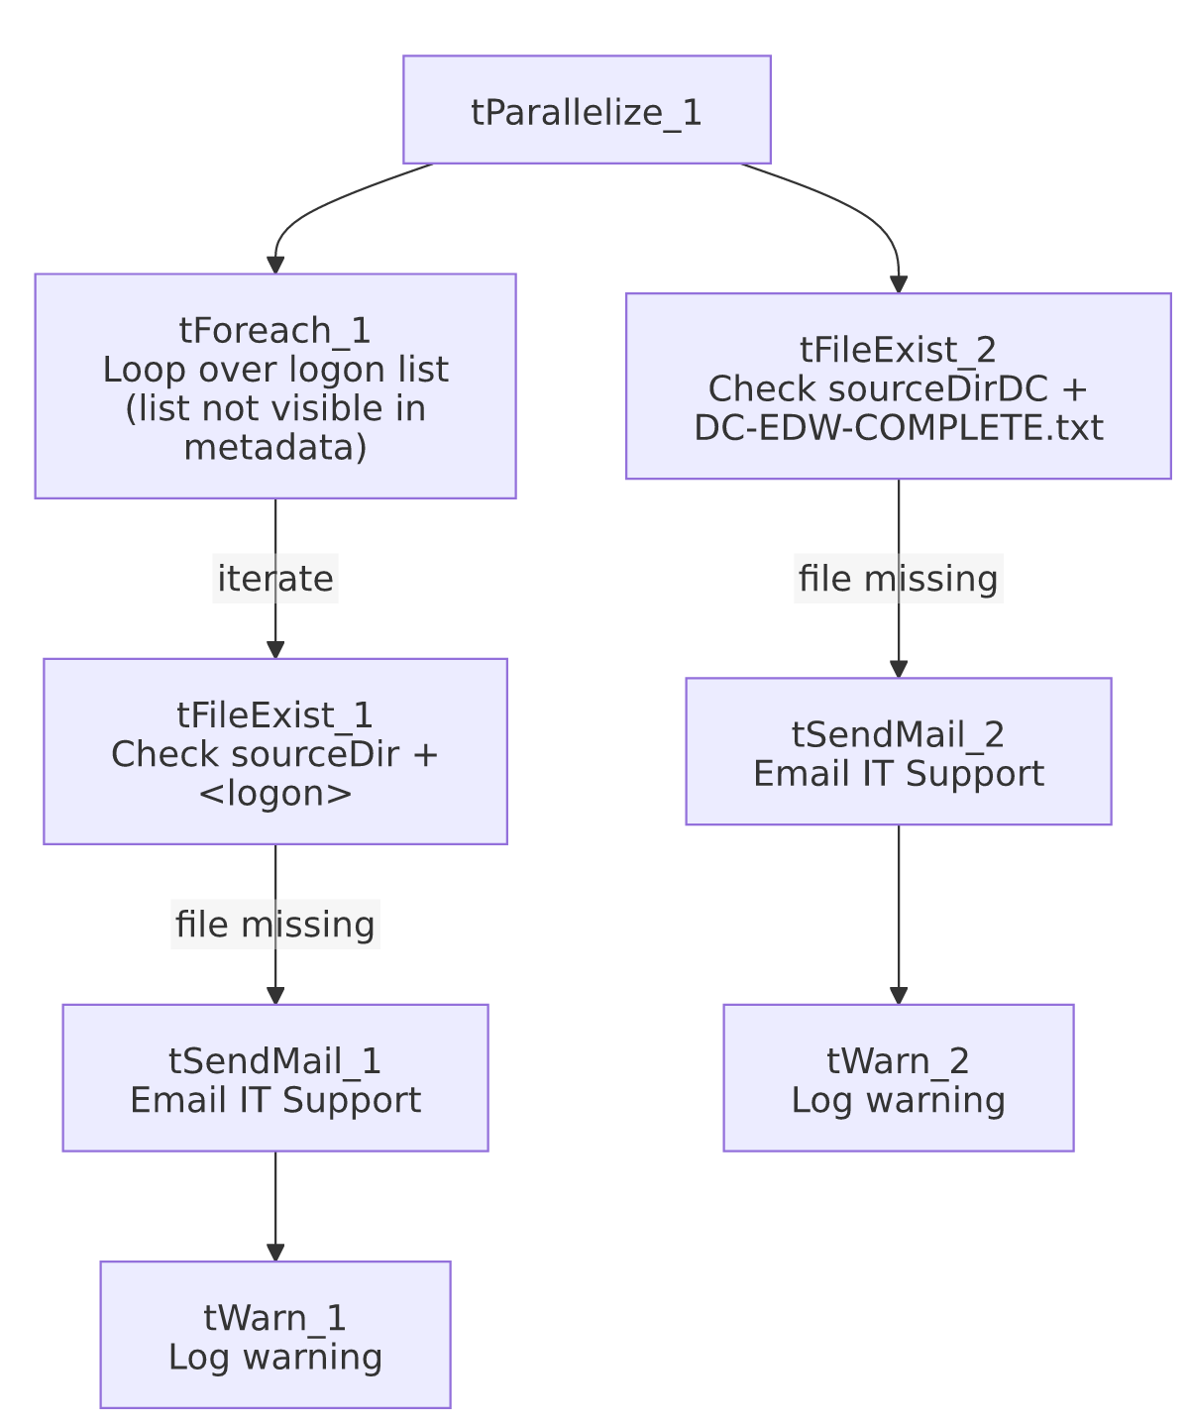

Settings tables

Check 1: `tFileExist_1` / `tSendMail_1` / `tWarn_1`
Setting | Value | What it means
FILE_NAME (tFileExist_1) | context.sourceDir + <current logon value> | Looks for a per-logon semaphore file in the shared source directory; which logon names are checked comes from tForeach_1's list, not visible in this metadata.
SUBJECT / MESSAGE (tSendMail_1) | "Missing CUBS Extract Semaphore File" / names the specific missing file and says it hasn't appeared "as of 7am Central Time" | Tells the recipient exactly which extract to check.
TO / CC | ITSupport@harriscollect.com / jmach@harriscollect.com, bireporting@harriscollect.com | Goes to a shared IT support inbox, not just one person.
tWarn_1 message | "CUBS Extract job not completed on time." (severity 42) | Logged after the email, regardless of whether the email succeeded — a warning, not a job failure.

Check 2: `tFileExist_2` / `tSendMail_2` / `tWarn_2`
Setting | Value | What it means
FILE_NAME (tFileExist_2) | context.sourceDirDC + "DC-EDW-COMPLETE.txt" | A fixed, DC-specific semaphore filename — unlike the general check, this one isn't looped, it's a single hardcoded file.
SUBJECT / MESSAGE (tSendMail_2) | "Missing CUBS DC Extract Semaphore File" / same 7am Central Time framing, DC-specific wording
tWarn_2 message | "CUBS Extract job for DC not completed on time." (severity 42)

Dependencies & configuration
- Triggers/depends on other jobs: none — no tRunJob links found.
- Context variables used: context.sourceDir (likely from StandardFolders_0.1, the project's shared-paths group — see 06_dependency_matrix.md) and context.sourceDirDC, a DC-specific path variable not confirmed against any documented context group in _shared_context.json.
- This job exists to *watch* the CUBS extract process referenced throughout the project's CUBS_Raw_* jobs — it doesn't call them or get called by them directly, but it's operationally tied to whatever process actually produces the semaphore files it's checking for.

Glossary
Component type | Plain-English meaning
tForeach | Loops over a fixed list of values (defined in the component's own configuration), running the same downstream steps once per value.
tFileExist | Checks whether a specific file exists on disk, without reading its contents — used here purely as a yes/no completion signal.
tParallelize | Runs its downstream branches at the same time rather than one after another — here, the general logon check and the DC-specific check run concurrently.
tSendMail | Sends an email — used here purely as an alert.
tWarn | Logs a warning without failing the job — used here so a missing semaphore file is recorded but doesn't stop this checker job itself from completing.

Issues observed
- The actual list of logon names `tForeach_1` iterates over is not captured in this metadata — Talend stores a tForeach's value list in a way this extraction didn't retain (only its label, "ForEachLogon", survived). Unable to determine from metadata how many logons are checked or which ones; verify directly in Talend Studio.
- The DC check is hardcoded and separate from the general loop, rather than DC simply being one more value in the tForeach_1 list. This may be intentional (DC's semaphore file has a different, fixed name pattern — DC-EDW-COMPLETE.txt vs. a per-logon filename), but it does mean adding a similar dedicated check for another site would require copying this pattern rather than just adding a value to a list.
- Both branches only warn, never fail the job — appropriate for a monitoring job that shouldn't itself show as "failed" in a scheduler, but it means detection relies entirely on someone reading the email or the job's warning-level log output; there's no escalation if the email itself silently fails to send (unlike tSendMail jobs elsewhere in this project that set DIE_ON_ERROR to stop the job on a mail failure — this job does set DIE_ON_ERROR=true on both tSendMail components, so a failed send would in fact fail the job at that point, which is worth knowing since it's not obvious from the warning-only framing above).

