Talend Job: SendGrid_Report_Load

Overview
Loads SendGrid email-event report files (bounce/open/click/etc. events tied to a specific collection letter and debtor account) from a local source directory into the Snowflake FACT_EMAILS_SENDGRID table, then archives every file found in that directory. The job computes a "report year" value from yesterday's date but does not appear to use it anywhere in the visible flow — see Issues observed.

Detail table
Field | Value
Job name | SendGrid_Report_Load
Version | 0.1
Project | EDW2SF
Author | jmach@harriscollect.com
Created | 2024-05-28T14:58:27.908-0700
Last Modified | 2025-11-16T21:25:26.722-0800

Step-by-step data flow
Setup subjob (independent of the main flow): tPrejob_1 → tJava_3 opens a per-run log file (context.logDir + jobName + "_" + <timestamp> + ".log") → tSetKeystore_1 configures SSL trust/keystore from context.keystorePath (passwords redacted). tSetKeystore_1 has no further outgoing connection in this job — it configures JVM-wide SSL state rather than feeding a specific downstream connection component.
Main subjob:
- tJava_1 computes context.reportYear as the year of yesterday's date (TalendDate.addDate(currentDate, -1, "dd")), then prints it.
- On success, tFileList_1 lists files in context.sourceDir (EXCLUDEFILEMASK is set to *.txt but IFEXCLUDE=false, so the exclusion is not actually applied — every file in the directory is picked up, same pattern seen elsewhere in this project).
- For each file, tJava_2 sets context.fileName/context.fullFilePath from the current file and iterates into tFileInputDelimited_1, which reads the file as pipe-delimited (|) text with a repository schema of 10 SendGrid event columns (Letter_Code, Letter_ID, Customer, Email_Address, Event, Comment, Event_Date, Account_Number, Account_Number_2, Logon, VariableField5); DIE_ON_ERROR=false, no reject flow wired.
- tMap_1 renames the columns to their Snowflake target names (e.g. Comment → EVENT_COMMENT) and passes all 11 columns through unchanged otherwise.
- tFlowMeter_2 counts rows passing through (labeled "MyLabel", not renamed for this job).
- tDBOutput_1 inserts the rows into Snowflake table FACT_EMAILS_SENDGRID (INSERT, no table-recreate action).
Separately, on `tFileList_1`'s success (not gated on the read/load actually finishing): tFileList_2 re-lists the same context.sourceDir, and for each file found, tFileCopy_1 copies it to context.archiveDir and removes the original (REMOVE_FILE=true, REPLACE_FILE=true) — effectively a move/archive step run as a second, independent listing of the same directory rather than being wired to only the files that were actually loaded.
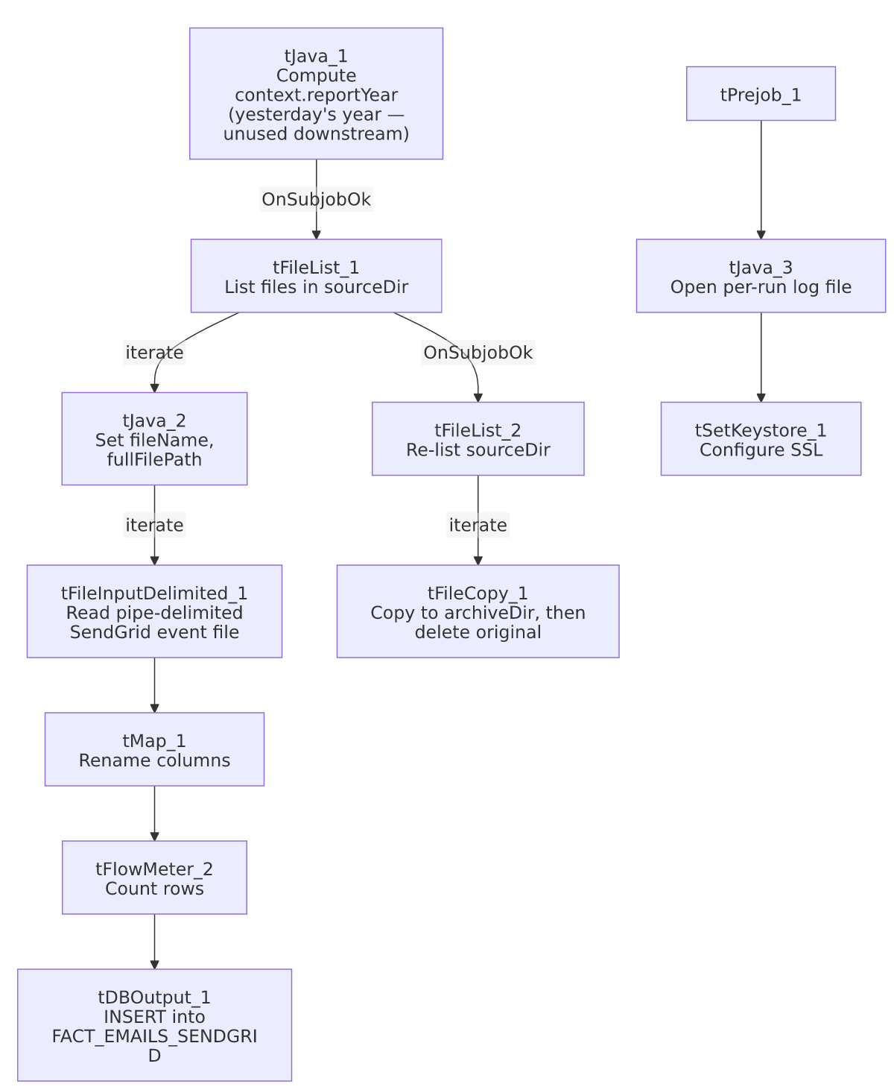

Settings tables

Source: `tFileInputDelimited_1`
Setting | Value | What it means
FILENAME | context.fullFilePath | The current file from tFileList_1's iteration.
FIELDSEPARATOR / HEADER | `\ | ` / 1 header row
SCHEMA | Repository schema (10 SendGrid event columns) | Letter_Code, Letter_ID, Customer, Email_Address, Event, Comment, Event_Date, Account_Number, Account_Number_2, Logon, VariableField5.
DIE_ON_ERROR | false | Malformed rows don't fail the job...
Reject flow | Not wired | ...but no connection carries rejected rows anywhere — they are silently dropped, with no captured SCHEMA_REJECT in this job's metadata at all.
TEMP_DIR | "C:/Talend-Studio-20211109_1610-V8.0.1/workspace" | Hardcoded developer-workstation path (see Dependencies & configuration).

Target: `tDBOutput_1` (`tSnowflakeOutput`)
Setting | Value | What it means
Table | FACT_EMAILS_SENDGRID | Destination fact table for SendGrid email events.
Output action | INSERT | Appends rows; there is no TRUNCATE step visible in this job, so repeated runs against the same file(s) would duplicate rows unless the archive step reliably removes processed files before the next run.
Table action | NONE | Table is not recreated/altered by this job.

Archive step: `tFileCopy_1`
Setting | Value | What it means
FILENAME | globalMap("tFileList_2_CURRENT_FILEPATH") | Uses the second, independent file listing rather than the file(s) actually processed by the load branch.
DESTINATION | context.archiveDir | Where processed files are moved.
REMOVE_FILE / REPLACE_FILE | true / true | Deletes the original after copying — functions as a move, and overwrites an existing file of the same name at the destination.

Dependencies & configuration
- Triggers/depends on other jobs: none — no tRunJob links found.
- Context variables used: archiveDir, fileName, fullFilePath, keystorePath, logDir, reportYear, sourceDir.
- 3 hardcoded developer-workstation paths: tFileInputDelimited_1.TEMP_DIR, tFileCopy_1.SOURCE_DERECTORY, and tSetKeystore_1.SSL_TRUSTSERVER_TRUSTSTORE (all C:/Talend-Studio-20211109_1610-V8.0.1/...) — same portability risk documented project-wide in 05_operational_runbook.md.

Glossary
Component type | Plain-English meaning
tFileList | Lists files in a directory for the job to iterate over one at a time.
tFileInputDelimited | Reads a delimited text file according to a schema.
tMap | Maps/transforms columns from one schema to another.
tFlowMeter | Counts rows passing a point in the flow, for logging/monitoring.
tSnowflakeOutput | Writes rows to a Snowflake table.
tFileCopy | Copies a file to a new location, optionally deleting the source (used here as an archive/move step).
tSetKeystore | Configures SSL trust/keystore settings used by subsequent database connections in the job.

Issues observed
- `context.reportYear`, computed in `tJava_1` from yesterday's date, is not referenced anywhere else in this job's metadata — not in DIRECTORY, FILENAME, or any other captured parameter. Unable to determine from metadata whether it's consumed by a downstream process outside this job (e.g., another job reading the same shared context) or is simply dead code left over from an earlier version; verify with the team.
- No reject flow is wired from `tFileInputDelimited_1`, and `DIE_ON_ERROR` is `false`. Malformed rows are silently dropped with no file, log, or table capturing which rows failed to parse or why.
- The archive step re-lists `context.sourceDir` independently (`tFileList_2`) rather than archiving specifically the file(s) the main branch just loaded. Both listings run off the same tFileList_1 success trigger, so in the normal case they see the same files, but the archive step has no direct data dependency on the load actually succeeding for each individual file — a file that failed to parse (and was silently dropped, per the point above) would still be archived and removed as if it had loaded successfully.
- `EXCLUDEFILEMASK` is set to `"*.txt"` on both `tFileList_1` and `tFileList_2`, but `IFEXCLUDE` is `false`, so the exclusion is configured but not actually applied — every file in context.sourceDir is picked up regardless of extension. This is the same non-functional-exclusion pattern documented in job_ADP_Payroll_Load.md.
- No `TRUNCATE` step precedes the `INSERT` into `FACT_EMAILS_SENDGRID`, and the archive/delete step is the only mechanism preventing a re-run from reprocessing (and duplicating) the same file. If the archive step fails after the load succeeds (or vice versa), a subsequent run could either reload the same data or skip it — no reconciliation logic is visible in this job's metadata.

