Talend Job: Skip_Costs_Load

Overview
Loads "skip trace" cost records (a per-debtor transaction/vendor cost record: TID, DNUM, TYPE, DATE, COST, VENDOR) from tab-delimited files in a source directory into the Snowflake SKIP_COSTS table, using an upsert rather than a plain insert, then archives each processed file. "Skip costs" most likely refers to costs charged by a skip-tracing vendor used to locate debtors — not otherwise defined in the metadata.

Detail table
Field | Value
Job name | Skip_Costs_Load
Version | 0.1
Project | EDW2SF
Author | jmach@harriscollect.com
Created | 2025-05-02T11:01:21.739-0700
Last Modified | 2025-09-24T11:00:54.127-0700

Step-by-step data flow
Setup subjob: tPrejob_1 → tJava_2 opens a per-run log file → on success, tDBConnection_2 opens the Snowflake connection.
Main subjob:
- tFileList_1 lists files in context.sourceDir (EXCLUDEFILEMASK="*.txt" is set but IFEXCLUDE=false, so no files are actually excluded).
- For each file, tJava_1 sets context.filePath/context.fileName, then tFileInputDelimited_1 reads it as tab-delimited text using a repository schema labeled "skipcost" (TID, DNUM, TYPE, DATE, COST, VENDOR); DIE_ON_ERROR=false, and a SCHEMA_REJECT is configured (also labeled "skipcost" — the same schema as the main input, not a distinct reject-specific layout), but no reject flow is wired downstream — see Issues observed.
- tJavaRow_1 converts COST from a string to BigDecimal (the visible code also references DATE, consistent with a type-conversion pass over the raw text fields).
- tMap_1 adds FILEDATE, FILENAME, and LOGON columns alongside the passthrough TID/DNUM/TYPE/DATE/COST/VENDOR fields. The tMap's own expressions aren't captured in this metadata, so how FILEDATE/LOGON are actually derived (most likely parsed from context.fileName, a common pattern elsewhere in this project) is unable to determine from metadata — verify directly in Talend Studio.
- tFlowMeter_7 counts rows passing through (labeled "MyLabel").
- tDBOutput_1 upserts the rows into Snowflake table SKIP_COSTS.
Separately, on `tFileList_1`'s success: tFileList_2 re-lists context.sourceDir, and for each file tJava_3 sets context.filePath/context.fileName, then tFileCopy_1 copies the file to context.archiveDir and deletes the original (REMOVE_FILE=true, REPLACE_FILE=true).
Teardown subjob: tPostjob_1 → tDBClose_1 closes the Snowflake connection.
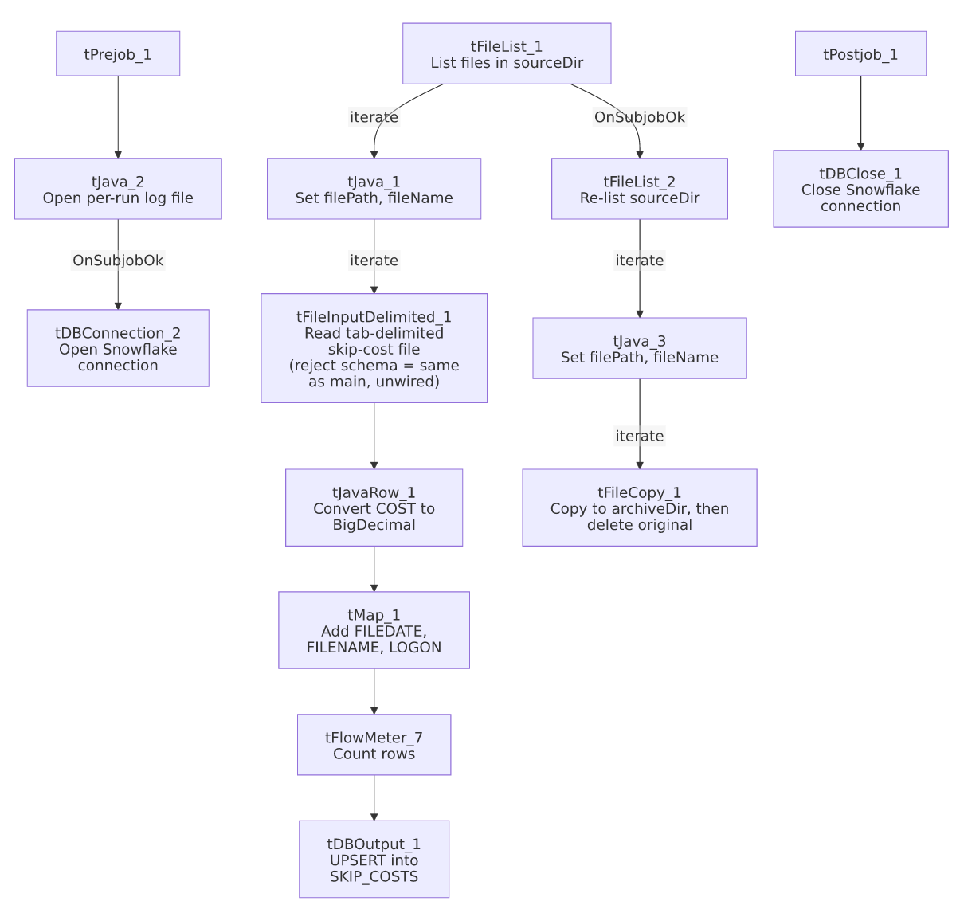

Settings tables

Source: `tFileInputDelimited_1`
Setting | Value | What it means
FILENAME | context.filePath | The current file from tFileList_1's iteration.
FIELDSEPARATOR / HEADER | \t / 1 header row | Tab-delimited with a header row skipped.
SCHEMA / SCHEMA_REJECT | Repository schema "skipcost" (both) | The main and reject schemas point to the identical repository schema — there is no distinct reject-row layout defined for this job.
DIE_ON_ERROR | false | Malformed rows don't fail the job...
Reject flow | Not wired | ...but no connection carries rejected rows anywhere — they are silently dropped.
TEMP_DIR | "C:/Talend-Studio-20211109_1610-V8.0.1/workspace" | Hardcoded developer-workstation path.

Target: `tDBOutput_1` (`tSnowflakeOutput`)
Setting | Value | What it means
Table | SKIP_COSTS | Destination table for skip-cost records.
Output action | UPSERT | Updates existing rows and inserts new ones based on a key (likely TID, the one column marked NOT NULL in this job's schema) rather than a plain append — appropriate if the same cost record can appear in more than one source file/run.
Table action | NONE | Table is not recreated/altered by this job.

Dependencies & configuration
- Triggers/depends on other jobs: none — no tRunJob links found.
- Context variables used: archiveDir, fileName, filePath, logDir, sourceDir.
- 2 hardcoded developer-workstation paths: tFileInputDelimited_1.TEMP_DIR and tFileCopy_1.SOURCE_DERECTORY (both C:/Talend-Studio-20211109_1610-V8.0.1/...).

Glossary
Component type | Plain-English meaning
tFileList | Lists files in a directory for the job to iterate over one at a time.
tFileInputDelimited | Reads a delimited text file according to a schema.
tJavaRow | Runs custom Java code once per input row — here used for a type conversion (string to BigDecimal).
tMap | Maps/transforms columns from one schema to another.
tFlowMeter | Counts rows passing a point in the flow, for logging/monitoring.
tSnowflakeOutput / tSnowflakeConnection / tSnowflakeClose | Write rows to a Snowflake table / open and close the Snowflake connection used throughout the job.
tFileCopy | Copies a file to a new location, optionally deleting the source (used here as an archive/move step).

Issues observed
- The reject schema on `tFileInputDelimited_1` is set to the same repository schema as the main input ("skipcost"), and no reject flow is wired regardless. With DIE_ON_ERROR=false, any row that fails to parse against the main schema is silently dropped — there is no file, log, or table capturing which rows failed or why.
- `tMap_1`'s derivation logic for `FILEDATE` and `LOGON` is not captured in this metadata (only the resulting schema is visible, not the expression each output column uses). These are very likely parsed from context.fileName following the pattern seen elsewhere in this project, but that is an assumption — unable to confirm from metadata; verify directly in Talend Studio.
- The archive step (`tFileList_2`/`tFileCopy_1`) re-lists `context.sourceDir` independently of the load branch, rather than being wired to only the specific file(s) the load branch processed — the same pattern flagged in job_SendGrid_Report_Load.md. A file that silently failed to parse would still be archived and removed as if it had loaded successfully.
- `EXCLUDEFILEMASK` is set to `"*.txt"` but `IFEXCLUDE` is `false` on both tFileList_1 and tFileList_2, so the exclusion is configured but not actually applied.

